Proof of Brouwer’s Fixed-Point Theorem

To what extent can Brouwer’s Fixed-Point Theorem be proved using Sperner’s Lemma?

Word Count: 3,929
Candidate Number:
Contents

1 Introduction to Brouwer’s Fixed-Point Theorem
- Brouwer’s Fixed-Point Theorem………………………………………………… 3
- Conditions…………………………………………………………………………………. 3
- Uses in Mathematics…………………………………………………………………. 4-5
2 Proof of Sperner’s Lemma
- Setting up a Triangle for Sperner’s Lemma………………………………… 5-8
- Proof of Sperner’s Lemma in two dimensions……………………………. 8-13
- Proof of Sperner’s Lemma in k dimensions………………………………… 14

3 Proof of Brouwer’s Fixed-Point Theorem
- Using Sperner’s Lemma in a three-dimensional plane……………….. 15-18
- Applying the Bolzano Weierstrass Theorem………………………………. 18-20
- Conclusion…………………………………………………………………………………. 20-21

Appendices………………………………………………………………………………………………. 22-27
Bibliography…………………………………………………………………………………………….. 28

1 Introduction to Brouwer’s Fixed-Point Theorem
- Brouwer’s Fixed-Point Theorem
Brouwer’s Fixed-Point Theorem is defined as true for points within a set B^{k} where B is a closed ball in the kth-dimension. The theorem asserts when a function f is applied to all points, p, within B^{k}, there will always be at least one fixed point where f(p)=p (Biel, 2018). This theorem can be demonstrated in the 2nd-dimension by sending a compact convex set onto itself. For example, if you placed a closed disk on top of itself, no matter how much you twist, shrink or distort the top disk (as long as it stays within the original bounds), there will always be one point that is directly above the corresponding point on the bottom disk. This theorem was stated and proved in 1912 by L.E.J Brouwer. Brouwer’s Fixed-Point Theorem is different from other Fixed-Point theorems because of its wide variety of applications. It can be applied to figures of the kth dimension (Biel, 2018).
- Conditions
Brouwer’s Fixed-Point Theorem is applicable to a domain of points that is bounded, closed within an area and without holes. A set is considered bounded if it is a finite size with bounds in all dimensions and it is considered closed within an area if the set includes its bounds. Figure 1.1 is bounded, however its area is non-inclusive of the boundary (as shown by the dashed line) (Gallup, n.d). Brouwer’s Fixed Point Theorem would be applicable to Figure 1.2, but not Figure 1.1.
Bounded, Closed Within an Area

Figure 1.2
Bounded
Figure 1.1

c. Uses in Mathematics
Brouwer’s Fixed-Point Theorem has many applications in mathematics, and it is commonly used in topology, game theory and economics. The theorem is considered a fundamental theorem in topology (the study of the properties of geometric spaces when continuous transformations are applied) (“Topology,”n.d). The theorem defines one property of some geometric spaces (a fixed point). Topological ideas arise regularly in calculus when dealing with limits and continuity as well as in analysis and modern number theory.
Furthermore, the theorem has many uses in game theory. For example, the game of Hex is a board game for two players. It is played on a hexagonal grid of any theoretical size and several possible shapes. Players alternate placing markers in unoccupied spaces, the goal for each player is to link their own sides of the board (which are opposite each other) together with a chain as shown in Figure 1.3.
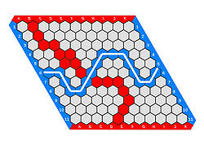
Figure 1.3

The Hex theorem states that in the game one player must win; draws are impossible. Even if red and blue tokens are just randomly placed on the board, if the entire board is filled, one player must still win. Brouwer’s Fixed-Point theorem can be used to prove this (Gale, 1979). In the broader context of game theory, it can be used to answer questions about whether it possible for both players of a game to have a winning strategy (a strategy that guarantees they win).
Similarly, the theorem’s use in proving equilibrium has played a critical role in two different economists winning Nobel Prizes (Arrow in 1972) and (Nash in 1994)(“The Joy of Hex,” 2013). Kenneth Arrow helped show how a competitive economy in equilibrium is efficient, meaning the government could use lump-sum taxes to redistribute wealth (creating equilibrium) and then leave the market to work (a counter argument to price controls). Nash used the theorem in game theory. In a game, if each player is making the best decisions that they can while taking into account the other players’ strategy, the players are said to be in Nash Equilibrium. Nash proved that there is a Nash equilibrium for every finite game using the theorem. To prove Brouwer’s Fixed Point Theorem, we can use a combinatorial proof called Sperner’s Lemma.

2 Proof of Sperner’s Lemma
- Setting up a Triangle for Sperner’s Lemma
In 1928, Emmanuel Sperner found a proof of Brouwer’s Fixed-Point Theorem by sub triangulating a triangle and labeling its vertices. To set up Sperner’s Lemma, triangulate a triangle into smaller triangles. It does not matter how it’s triangulated as long as the smaller triangles only meet at a common edge or a common vertex. (See Appendix A)
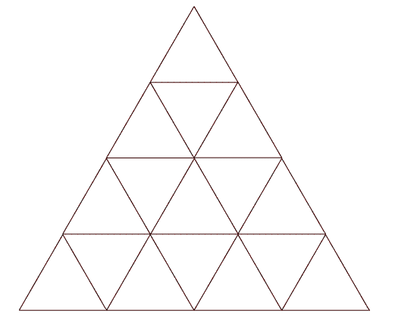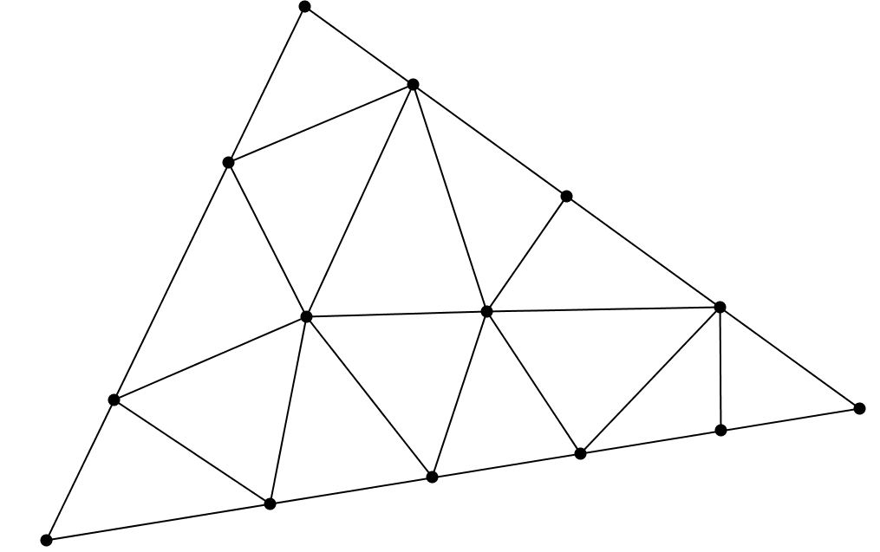
or

Figure 2.2
Figure 2.1

Once the triangle has been divided into smaller triangles, label each vertex of the large triangle using the numbers 1, 2 and 3. Since we are dealing with so many triangles, I will call the large triangle W to a avoid confusion. I will call the side of W between the vertex labeled 1 and the vertex labeled 2 the 1-2 edge; it is highlighted in red in Figure 2.3. The side between the vertex labeled 1 and the vertex labeled 3 will be called the 1-3 edge (highlighted in blue) and the other side is the 2-3 edge (highlighted in green).
Figure 2.3
1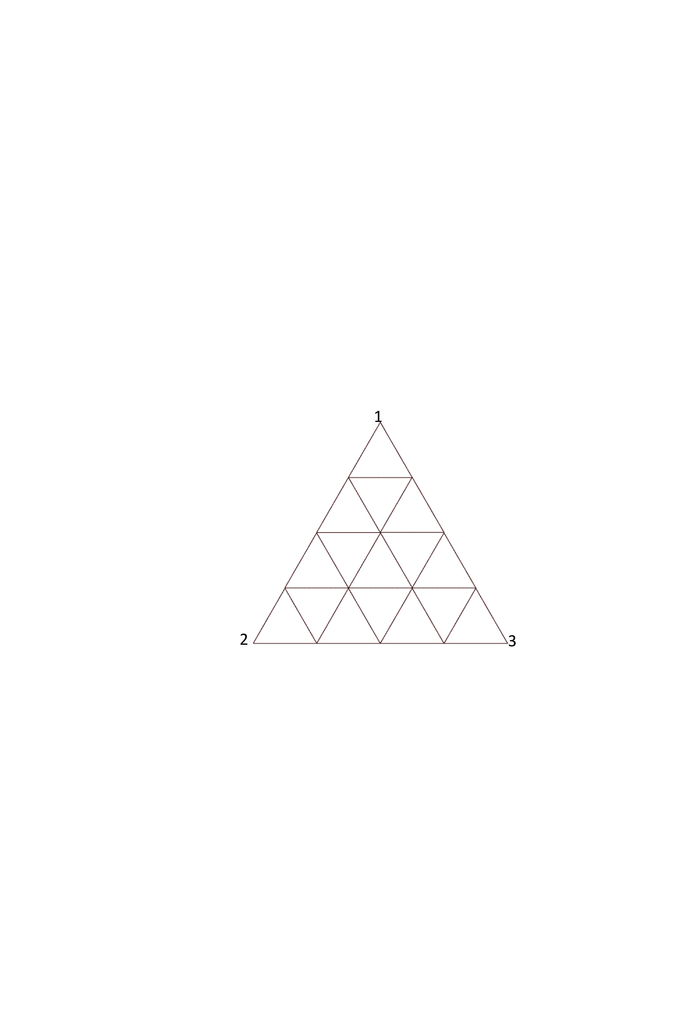
2
3

Next, label all the vertices of the smaller triangles that exist on the edges of W. The conditions of Sperner’s Lemma state that vertices on each edge of W can only be labeled with the numbers of the two vertices that it is between. Vertices on the 1-2 edge of W can be labeled with 1s or 2s but not 3s, vertices on 1-3 edge of W can only be labeled with 1s and 3s etc. (Su, n.d). Here is a possible configuration: (Figure 2.4)
1
2
3
1
3
1
2
2
2
3
3
3
Figure 2.4

Finally, all of the verticies not on the edges of W can be labled with any of the three numbers. I chose to label them like this: (Figure 2.5).
1
2
3
1
3
1
2
2
2
3
3
3
2
3
3
Figure 2.5

Now that I have labeled each vertex of W using the rules above. Sperner’s Lemma states that regardless of how many smaller triangles exsist and regardless of how each vertex is labled (so long as the rules above are followed) there will always be at least one smaller triangle that has all three of the different vertices 1,2 and 3. Lets call this type of triangle a 1-2-3 triangle. In Figure 2.6 there is one, I have shaded it in.
1
2
3
1
3
1
2
2
2
3
3
3
2
3
3
Figure 2.6

- Proof of Sperner’s Lemma in two dimensions
Sperner’s Lemma can be proved in many different ways, but here is a proof of Sperner’s Lemma using combinatorics, a field in math that deals with combinations of objects in a finite set. To prove Sperner’s Lemma, first we need to look at the sides of the small triangles that lie on the edges of W. The sides that start and end in two different types of vertices are of particular concern. Since the edges of W end in two different vertices, there has to be at least one line segment on every edge of W that starts and ends with different vertices. For example, lets look at the 1-2 edge of W.

1
2
3
1
3
1
2
2
2
3
3
3
2
3
3
Figure 3.1

Since the 1-2 edge of W starts with a 2 and ends at 1 (or vice-versa), at least one of the sides of the small triangle must change from a 2 to a 1. In this case, there is only one small side between vertices with different labels; these sides will be called green line segments and are highlighted in green in Figure 3.1. All of the other sides start and end with vertices of the same number. I will call these sides red line segments; they are highlighted red in Figure 3.1. I am going classify the vertices between each line segment into two types. Type A vertices are vertices that are between two red line segments and Type B vertices are vertices between one red segment and one green segment. For clarification, I have classified the vertices by their type in Figure 3.2.
Figure 3.2
1
2
3
1
3
1
2
2
2
3
3
3
2
3
3
Type A
Type B
Type B

Of course the way that I have numbered the vertices is just one of many possible ways I could have numbered them. So, lets change the labeling. To cover all possible ways that the vertices could be numbered. I need to see how changing each type of vertex effects the number of green segments on a side. First lets change the Type A vertex, then we will change the Type B vertices. In Figure 3.3 I have changed the Type A vertex from a 2 to a 1.
Figure 3.3
1
2
3
1
3
1
2
2
3
3
3
2
3
3
1

1

In Figure 3.3, this creates two new green segments that used to be red. However, now we have created a new type of vertex, a vertex that is between two green segments, let’s call this type, Type C. If we were to change this Type C vertex from a 1 back to a 2 we would create two red segments and loose two green segments (like Figure 3.1). Type C vertices, like Type A vertices are between two segments of the same color (two green for Type C, two red for Type A). So when changing vertices between segments of the same color we either add two green segments (in the case of changing a Type A) or subtract two green segments (in the case of changing a Type C). Now lets change a Type B vertex. I have changed the vertex circled in Figure 3.4 from a 1 in Figure 3.3 to a 2 in Figure 3.4.
1
2
3
2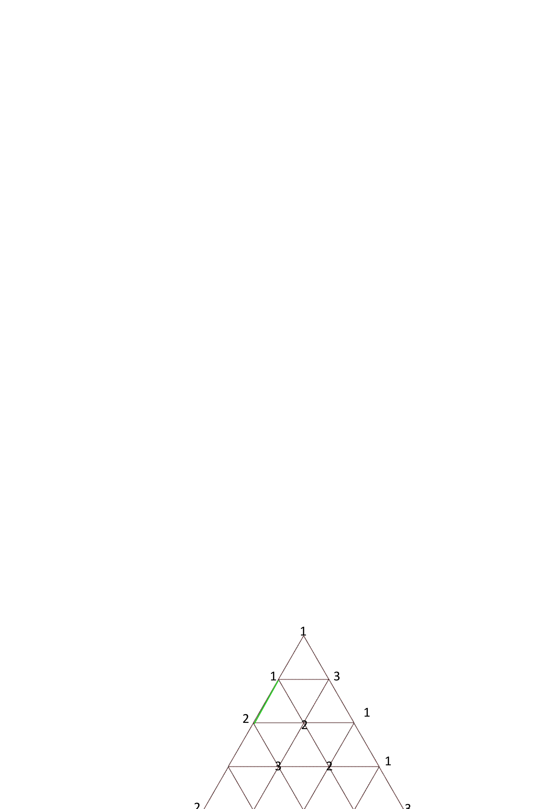
3
1
2
2
3
3
3
2
3
3
Figure 3.4

1

The number of green segments has not changed from Figure 3.3 to Figure 3.4. Essentially this switch results in a green segment switching places with a red segment. If this vertex were changed back to a 1, the segments would just switch back to how they were in Figure 3.3. So, changing a Type B vertex causes a switch in segment position but not an actual change in the number of segments that are green. Therefore, changing vertices on the edge of W can only result in the addition (Type A) or subtraction (Type C) of two green segments or no change in the number of green segments (Type B). So the number of green segments on each edge of W will never change from odd to even. This is true for all three sides of any triangle in the Lemma no matter how it is divided up and labeled.
Let X₁ (where X₁ is always odd) denote the total number of green segments for a side of any triangle that follows the rules of the Lemma. The subscript in X₁ represents the fact the line segments are in the 1st-dimension. The odd nature of X₁ has an important link to the number of 1-2-3 triangles and proving why one must exist. Using the triangle from Figure 2.5, I have colored the remaining line segments on the edges of W in Figure 3.5.

1
2
3
1
1
2
2
2
3
3
3
2
3
3
3
Figure 3.5

To demonstrate the relationship between 1-2-3 triangles and these green segments, I am going to draw pathways through W that enter it via the green segments. If I place a restriction on how these pathways can be drawn, I will be able to show why there is always at least one 1-2-3 triangle (Bazett, 2018). The restriction is that as these pathways go through W, they can only pass through segments that have the same labeling as the green segments that they entered through. For example, if I choose to draw a path through a green segment that is between a 1 and a 3, the path can only pass between other segments that are between a 1 and a 3. See Figure 3.6.

Figure 3.6
1
2
3
1
1
2
2
2
3
3
3
2
3
3
3
This line passes through these two green segments

In Figure 3.6, the pathway enters W and passes through segments that are between 1 and 3 (indicated by the arrows) until it is able to exit the triangle through another green segment of the same labeling, meaning a path will always exit on the same edge of W as the segment it entered through). However, if we try this again using a different green segment, for example the segment between 2 and 3 the pathway gets stuck.
1
2
3
1
1
2
2
2
3
3
3
2
3
3
3
Figure 3.7
The line passes through one green segment

In Figure 3.7, the pathway has gotten stuck at the 1-2-3 triangle because this triangle only has one segment between a 2 and a 3. (See Appendix B) We can conclude there are two types of pathways. Type J pathways pass through W and exit, let J₂ (J in the 2nd-dimension) represent the number of these per edge. Type R pathways get stuck in W, let R₂ (R in the 2nd-dimension) represent the number of these per edge. In scenario 1, pathways pass through two green segments. In scenario 2, pathways pass through only one green segment. Recall X₁ is the total number of green segments per side, so 2J₂+R₂=X₁. Since X₁ is odd, R₂ must also be odd so R₂≠0, meaning there must be at least one path per side that gets stuck and thus, at least one 1-2-3 triangle.

- Proof of Sperner’s Lemma in k Dimensions
In the 2-dimensional Lemma, the pathways are drawn through 1-dimensional edges. In the k^{th}-dimension, pathways are drawn through the (k-1)^{th}-dimension where k is an integer >1. When k=2, the green segments are denoted as line segments that are between 2 different numbers, therefore in the k^{th}-dimension, pathways must enter through faces with k different labels, let call these faces green faces (note that for our use the term face does not refer to a figure of 2-dimensions, but rather a figure of k-1 dimensions). Green faces are labeled by a set of k different numbers from the set {1,2,…k+1}. By this reasoning, in the 3rd-dimensional case, pathways are drawn through 2-dimensional triangles labeled with three different numbers from the set {1,2,3,4}. The triangles that the pathways can enter the figure through are essentially 1-2-3 triangles (although they could include a different iteration of labeling including a 4) I will call this category of triangles green triangles. So the total number of green triangles that pathways can enter through on a face equals X₂.
As pathways enter the tetrahedron through these green triangles, the same two scenarios present themselves as in the 2nd-dimensional case. Either a path passes through two green triangles on a face (by entering one green triangle and exiting out another on the same face), let J₃ represent the number of these paths for a face), or the paths get stuck in the tetrahedron (let R₃ represent the number of these paths for a face). We get the equation 2J₃+R₃=X₂.
Since 2J₃ is even, and X₂ is odd (See Appendix C) R₃ must be odd too, so there must be at least on tetrahedron labeled {1,2,3,4}.
Since X_{k} becomes the number of paths drawn per face in the (k+1)^{th}-dimension (See Appendix D) we get the equation, X_{k}=R_{k+1}+2J_{k+1}, R_{k+1} must be odd. So by induction, we have proven R_{k}≠0 and there must always be a path that gets stuck (Sperner’s Lemma is true in the k^{th}-dimension).
3 Proof of Brouwer’s Fixed-Point Theorem
a. Using Sperner’s Lemma in a three-dimensional plane
Lets look at a triangle placed in 3-dimensional space, specifically a triangle with its vertices at (0,0,1) (1,0,0) and (0,1,0). (See Appendix E)
This is called the 2-simplex and is denoted as Δ² and defined as:
Δ²={(x,y,z)|x+y+z=1, x≥0, y≥0,z≥0}

y
x
z
Figure 5.1
(0,1,0)
(1,0,0)
(0,0,1)

One of the definitions of Δ² is that x+y+z=1. The sum of the coordinates at any point on this triangle is 1. Brouwer’s Fixed-point Theorem deals with how points in this figure, can be transformed into other points by the function f. Since the theorem requires a closed and bounded area, a function that results in the shift of the entire triangle or an enlargement of the triangle is not possible; all points must stay within the bounds of Δ² , so the condition x+y+z=1 must always be met. Imagine a function f is applied to points in Δ². Since the sum of the values in each dimension must always equal 1, f can never strictly increase or decrease the coordinates of a point in all dimensions. So an increase in one dimension means a decrease in one or both of the other two or vice-versa. So all functions f cause at least one dimension to increase and at least one to decrease, unless the values in all dimensions to stays the same. In this scenario, there is a fixed point that isn’t changing and Brouwer’s Fixed-Point Theorem stays true. For all other functions, the value in one of the dimensions is changing in a different way than the values in the other dimensions. While this way could be increasing or decreasing, I have chosen this direction to be decreasing. (By proving it true for functions that decrease in strictly one direction, it is also true for functions that increase in only one direction). Using these properties, I will label points acted on by f accordingly:
Points that are decreased by f in only the z direction will be labeled-1
Points that are decreased by f in only the x direction will be labeled-2
Points that are decreased by f in only the y direction will be labeled-3
Start by labeling the points that are the vertices of Δ² . Take the point (0,0,1) a vertex of Δ², functions that are applied to this point can only decrease the value of z because x and y are already equal to 0 and negative values are not within the bounds of Δ² . This point is labeled 1. By the same logic, functions applied to the vertex (1,0,0) can only decrease the value of x (labeled 2), and functions applied to the vertex (0,1,0) can only decrease the value of y (labeled 3).
y
x
z
1
2
3

Figure 5.2
For all points on the 1-2 side, y=0 so y can’t be decreased by f. Therefore, points on that side can never be labeled with 3s. Additionally, on the 1-3 side points can’t be labeled with 2s since x=0. Points on the 2-3 side can’t be labeled with 1s since z=0. Points in the middle of the triangle could be decreased by f in any of the three dimensions so they could be labeled 1, 2 or 3. Thus, the conditions of Sperner’s Lemma are met.
y
x
z
1
2
3
1
3
2
Figure 5.3

Through triangulating Δ² in Figure 5.3, I can create a set of points (the vertices) to examine. In this triangulation, I know that there must be a 1-2-3 triangle. I have colored in and labeled one hypothetical one in Figure 5.3. To make a set, more points could be created by sub triangulating the triangle again, as shown in Figure 5.4. Again there must be at least one 1-2-3 triangle, I have shaded another hypothetical one to illustrate and I have placed yellow dots on the labeled vertices to emphasize them.

y
x
z

1
2
3
1
1
3
2
3
2
Figure 5.4

- Applying Bolzano Weierstrass Theorem
The 1-2-3 triangles could be located anywhere within Δ², all that is known is that they exist. So as I keep creating more points by sub triangulating again and again, I create this sequence of 1-2-3 triangles all around this larger triangle that keep getting smaller and smaller. In fact, since I can keep triangulating forever, I have an infinite sequence of these triangles. However, I want to focus on the points that lie on the vertices of these 1-2-3 triangles. If I keep track of only these points, I will have 3 infinite sequences of points: an infinite sequence of points labeled 1, an infinite sequence of points labeled 2, and an infinite sequence of points labeled 3. For example, if I used the hypothetical triangulation above, I would have the points shown in Figure 6.1. Figure 6.2 shows a hypothetical set of only the points labeled 1 if I had continued triangulating.
Figure 6.2
y
x
z

1
1

1
1
1
1
1
Figure 6.1
y
x
z

1
2
3
1
1
3
2
3
2

Lets look at Figure 6.2. While I have drawn a finite number of points, there would be an infinite number of them in the actual sequence. The Bolzano-Weierstrass Theorem states that every bounded sequence has a convergent subsequence. (Biele, 2018) In other words, in a bounded space, as an infinite amount of points are plotted, there must be some location within the space where points begin to accumulate in a subsequence. In this triangle, because there are infinitely many points labeled 1, there must be somewhere on the triangle where they begin to accumulate. If I focus on this spot I would be looking at a convergent subsequence of points labeled 1. And within any convergent subsequence (which also has infinitely many points) there would be another convergent subsequence of points accumulating around some point. So there is some spot in this triangle, where the points labeled 1 are accumulating. Since this theorem is true for every bounded sequence, there must be some spot where all the points labeled 2 are converging on, and a spot where all the points labeled 3 are converging on.
Remember these points have been picked out by triangulating over and over again and using the vertices of 1-2-3 triangles. Since the 1-2-3 triangles keep getting smaller, the distance between their vertices keep getting smaller and smaller, so the three different sequences keep on getting closer and closer to each other (they are converging). So some point that has the 1s converging on it also has the 2s and the 3s converging on it. Thus, there is some point that is a 1 and a 2 and a 3. Now, lets remember how we defined each of these points. 1s were points where f(x) strictly decreases in the z direction, 2s were points where f(x) strictly decreases in the x direction, and 3s were points where f(x) strictly decreases in the y direction. So when the function f is applied to this point (where all the sequences are converging) all three dimensions would decrease or stay equal. While our initial condition said “strictly decreasing in one direction”, because of the way convergent subsequence work the point could be on the boundary, a limit point. Because the sequences keep converging on this smaller and smaller spot, the amount x,y,or z is decreasing is getting smaller, approaching 0. So the Limit point equals 0, therefore we can say a point where all three directions are decreasing or staying equal. It is not possible to decrease in all three directions because x+y+z must always equal 1. If the coordinates can’t all be decreasing, then they must be staying equal in all directions, meaning there is some fixed-point where f(p)=p. While we have proven the theorem true for a triangle, it is also true for a disk because a triangle and circle are topologically equivalent. A triangle could be turned into a disk using a homeomorphism (a continuous transformation) (Bazett, 2018).
Since Sperner’s Lemma remains true in the kth-dimension, Brouwer’s Fixed Point Theorem has been proven for B^{k} where B is a closed ball in the k^{th} dimension.

- Conclusion
In conclusion, I was able to prove Brouwer’s Fixed Point Theorem using Sperner’s Lemma. By following the specific rules of the Lemma, I created a 2-dimensional triangle, which I sub triangulated and then labeled with a specific set of conditions. Proving the existence of a 1-2-3 triangle in every sub triangulation of the Lemma, allowed me to create a set of points in Δ². Because of the way the Δ² plane was defined in 3-dimensional space, I was able to define the properties of three different subsequences of points. Furthermore, I demonstrated that these sequences had to converge on each other as the 1-2-3 triangles got smaller and smaller, meaning that a point with the properties of all three of the converging subsequences must exist and this point had to be a fixed point due to the definition of Δ², X+Y+Z=1. While a proof involving pathways has been had been done before in 2 dimensions, I created my own original proof by induction for this pathway method to show that Sperner’s Lemma is true in the k^{th}-dimension when k>1. To do this I had to prove X₂ was odd with an equation relating the number of 1-2-3 triangles to the number of paths that get stuck in the large triangle (See Appendix C). Then I explained why this equation could be generalized to the (k+1)^{th}-dimension.
Brouwer’s Fixed-Point Theorem differs from other fixed-point theorems because of its wide variety of applications (being defined for a ball in the k^{th}-dimension), meaning it has fewer limitations than most other fixed-point theorems. However, the limitation of my inductive proof is in the 1st-dimension because in the k^{th}-dimension, paths are drawn through the (k-1)^{th}-dimension, but pathways can not be drawn through figures of the 0th dimension, my induction is only true when k>1.
The limitation of Brouwer’s Fixed-Point Theorem, is that it is only defined for B^{k}, a ball in the k^{th}-dimension. Therefore, the theorem is only true for balls and homeomorphisms of balls, such as triangles and tetrahedrons. Shapes that are not topologically equivalent to balls aren’t covered under Brouwer’s Fixed-Point Theorem. Even with these limitations, the theorem remains useful in a wide variety of fields from economics to game theory.

Appendices

Appendix A
Creating Triangles In Sperner’s Lemma
It is important to note that Sperner’s Lemma does not require that the larger triangle be equilateral or that the smaller triangles be the same size or congruent, thus there can be many variations of Sperner’s Lemma.

Appendix B
Reason Why Pathways Only Get Stuck in 1-2-3 Triangles
A 1-2-3 triangle has only one 1-2 segment, one 2-3 segment, and one 1-3 segment. So the pathways will always get stuck in these triangles that have three different vertices (the pathways enter the 1-2-3 triangle but do not have a second segment of the same labeling to exit the 1-2-3 triangle through) Triangles that are not 1-2-3 triangles would either have two of the necessary segments so the pathway could pass through it or none of the necessary segments (the pathway would never enter the triangle).

Appendix C
Proof X₂ is Odd
To prove X₂ is odd, lets look at a hypothetical 1-2-3 face of the tetrahedron (Figure 4.1).
1
2
3
1
1
2
1
2
3
3
3
2
3
3
3
Figure 4.1

In Figure 4.2, I have drawn paths following the same rules as in section b., but in the reverse direction. The paths start in the green triangles (1-2-3 triangles). Every 1-2-3 triangle has 3 paths (one for each side). So the total number of paths that exit the large triangle equals 3X₂ (X₂ is the number of green triangles on a face). However, this is not true because some 1-2-3 triangles share paths that do not exit the large triangle, these paths are highlighted in blue and orange. In Figure 4.2, blue paths go through one side of one 1-2-3 triangles to another side of a different 1-2-3 triangle (a total of 2 sides). Orange paths go through only one side, however this side is shared by two 1-2-3 triangles, so it can be counted twice. Let B₂ be the number of blue paths and O₂ be the number of orange paths. Thus the total number of paths that exit the triangle (black paths) equals the number of sides of the 1-2-3 triangles (3X₂) minus the sides taken up by blue or orange paths (2B₂+2O₂)= 3X₂-2B₂-2O₂
1
2
3
1
1
2
1
2
3
3
3
2
3
3
3
Figure 4.2

Remember from part b. that R₂ is the number of paths from each edge that get stuck in the triangle. And since these paths only get stuck in 1-2-3 triangles, then the paths that start in the 1-2-3 triangles and exit the large triangle are essentially all of the Type R paths from every side, just in reverse. The total number of paths in the Lemma is the sum of the paths from each edge. Since R₂ denotes the number of paths from any one edge that get stuck in a 1-2-3 triangle, let R₂¹⁻² denote the number of paths that from the 1-2 edge of the triangle that get stuck, R₂²⁻³ denote the number from the 2-3 edge, and R₂¹⁻³ denote the number from the 1-3 edge. Hence, the total number of paths would then be R₂¹⁻²+R₂²⁻³+R₂¹⁻³. So R₂¹⁻²+R₂²⁻³+R₂¹⁻³=3X₂-2B₂-2O₂
If R₂¹⁻² + R₂²⁻³ + R₂¹⁻³= 3X₂ - 2B₂ - 2O₂, then
2B₂ + 2O₂ + R₂¹⁻² + R₂²⁻³ + R₂¹⁻³ = 3X₂.
Anything multiplied by 2 must be even so 2B₂ and 2O₂ are even. R₂¹⁻², R₂²⁻³, and R₂¹⁻³ are odd since we have proven R₂ is odd for any triangle in the Lemma.
So, 3X₂ = even + even + odd + odd + odd,
3X₂ = odd
X₂ = odd

Appendix D
X_{k =} R_{k+1} + 2J_{K+1}
X_{k} represents the number of green faces of the k^{th}-dimension (X₁ represents the number of green line segments, X₂ represents the number of green triangles). Since we established paths in the k^{th}-dimension are drawn through the green faces of the (k-1)^{th} dimension, X_{k-1} equals the total number of paths in the k^{th}-dimension (2J_{k} + 2R_{k}). As an equation: X_{k-1} = 2J_{k} + 2R_{k}. This equation can be rewritten as X_{k =} R_{k+1} + 2J_{K+1}. X_{k} is odd (X₁ and X₂ are odd), so R_{k+1} is odd too.

Appendix E
Nature of the 2-Simplex (Δ²)
Δ² is a 2-dimensional plane positioned in three-dimensional space. It is important to know it is not a 3-dimensional tetrahedron. The dashed lines in Figure 5.1 represent the X, Y and Z axes and do not illustrate faces of a tetrahedron.

Bibliography

Bazett, T. (Producer). (2018). A beautiful combinatorical proof of the Brouwer
Fixed Point Theorem - Via Sperner's Lemma [Motion picture]. Youtube.
Biele, Katrina & Oman, Greg. (2018). A short proof of the Bolzano-Weierstrass
Theorem. The College Mathematics Journal.
David GaleThe American Mathematical Monthly Vol. 86, No. 10 (Dec., 1979), pp.
818-827
Gallup, N. (n.d.). MAT25 Lecture Notes. Retrieved from
https://www.math.ucdavis.edu/~npgallup/m17_mat25/lecture_notes/lecture_12/
m17_mat25_lecture_12_notes.pdf
Su, Francis E., et al. "Sperner's Lemma." Math Fun Facts.
<http://www.math.hmc.edu/funfacts>.
The Joy of Hex and Brouwer's Fixed Point Theorem. (2013, September 30).
Vigorous Handwaving.

