Citing Sources

Book:
1) Author’s name (last name, first name) – followed by a period
2) Title of book (underlined or italicized) – followed by a period
3) Copyright date – followed by a period
EX1: Barber, James. Presidents. 2000.
Ex2: Barber, James. Presidents. 2000.

Website:
- Author’s name if you can find it (last, first) – followed by a period
- Title of article (in quotes) – followed by a period
- Web address/URL – followed by period
- Date you visited the website (day, month, year) – followed by a period
Ex: “Facts About George Washington”. www.findfast.org . 1 March, 2016

How to CITE articles from Britannica on-line:
Find the box with the white check mark and click on it. Highlight the words at the bottom (under the MLA box), CTRL C to copy and then CTRL V to paste into your bibliography. See example below.
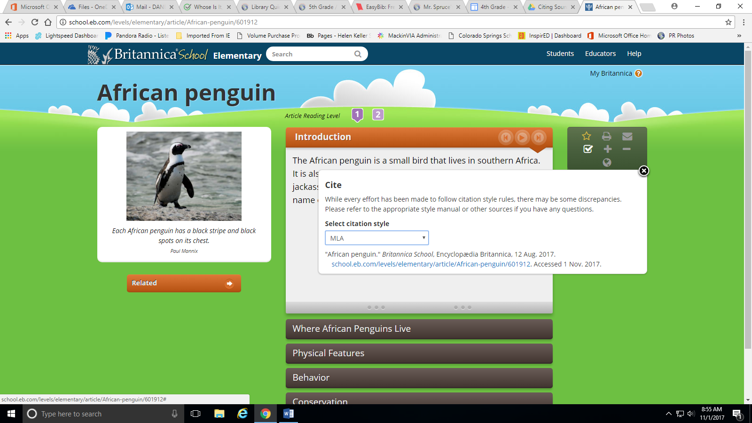

"African penguin." Britannica School, Encyclopedia Britannica, 12 Aug. 2017. school.eb.com/levels/elementary/article/African-penguin/601912. Accessed 1 Nov. 2017.

