2023-2024 schedules are viewable in Campus. If you believe there is an error in your schedule, you may complete a Course Change Request Form. Examples of errors are: incorrect course, duplicate course, or missing course. Course change requests are not granted for teacher, peer, or lunch preference. Requests due to a student changing their mind about which music course to take cannot be granted. Parents/guardians should complete this form with their student when the student is logged into their @apps.district833.org Google account.

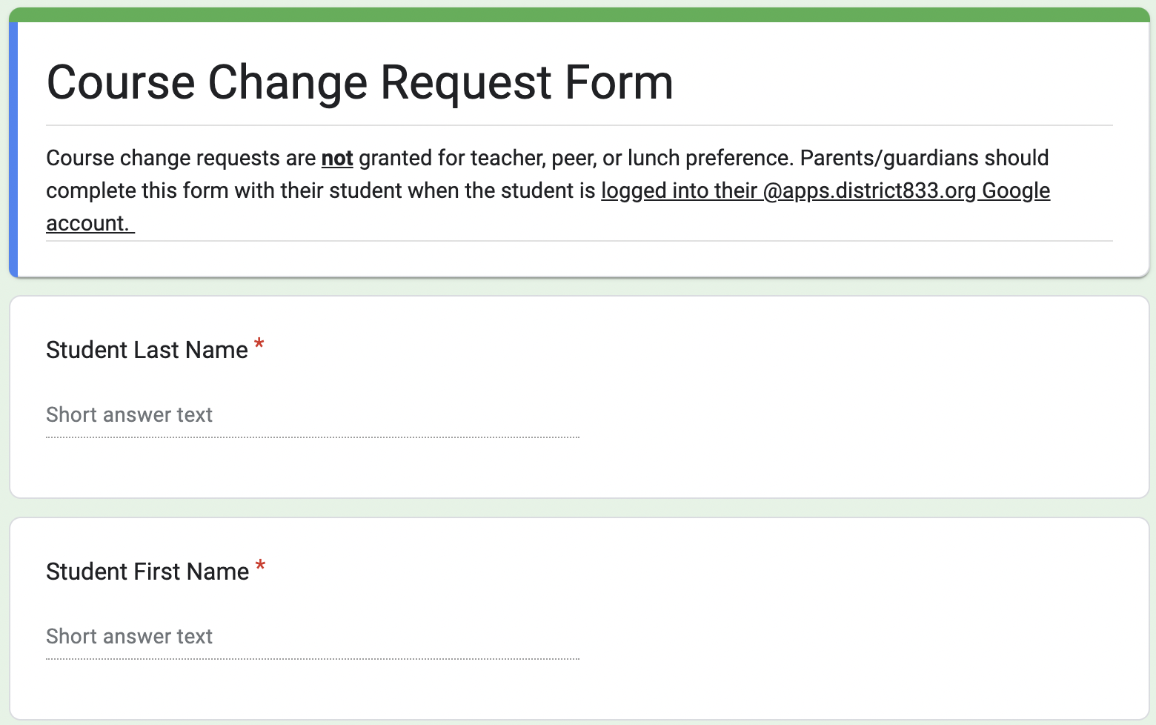
Course Change Request form.

