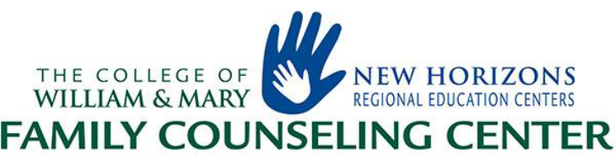

Referral to NHFCC/NHREC Family Counseling Center

(Please provide all requested information)

School Division: ___________________ School Name: __________________________ Date: ______________
School Address: _______________________________________Race/Ethnicity_____________________________
Student Name: ___________________________________ Student DOB: ______________ Grade: ____________
Parent/Guardian Name: _________________________________________________________________________
Address: _____________________________________________________________________________________
Telephone (home): ________________________________Telephone (work): ______________________________
Reason for Referral (Check all that apply):
___ Academics ___ Aggression ___ Peer/Social Skills ___ Divorce/Separation
___ School Discipline ___ Depression ___ Family Communication ___ Self-Esteem
___ Suicidal ___ Family Death ___ Abuse/Neglect ___ Substance Abuse
___ Parent-Initiated ___ ADHD ___ Physical Health ___ Developmental Delays

Additional Information: ________________________________________________________________________
____________________________________________________________________________________________
Referred by: _____________________________________Title:________________________________________
Address: _________________________________________Telephone: __________________________________

CONSENT TO EXCHANGE CONFIDENTIAL RECORDS

I, the parent/guardian of _____________________ do request a referral to the New Horizons Regional Education Center Family Counseling Center for the above services. I hereby consent to the exchange of confidential information regarding my son/daughter between _________________________________ Public Schools and NHREC Family Counseling Center. I understand that this material is confidential and will be used only by professionals working with my child.

I would like for NHREC Family Counseling Center to contact me upon receiving this referral form: ___yes ___no

________________________________ __________________________________________
(Date) (Parent/Guardian Signature)

Original Referral MUST be mailed to:

New Horizons Regional Education Centers
Attn: Kimberly Bracy
520 Butler Farm Road

Hampton, VA 23666
In addition to mailed copy from above, please FAX referral form to
New Horizons Family Counseling Center at: (757)221-1983
Updated 9/18/2019

