USING THE ELINK PARENT PORTAL FOR KENNEDALE TX

Bring up the Altoona ELink website https://www.thebusportal.com/KennedaleTX/elinkrp
- Log in using your Student ID for your username and password
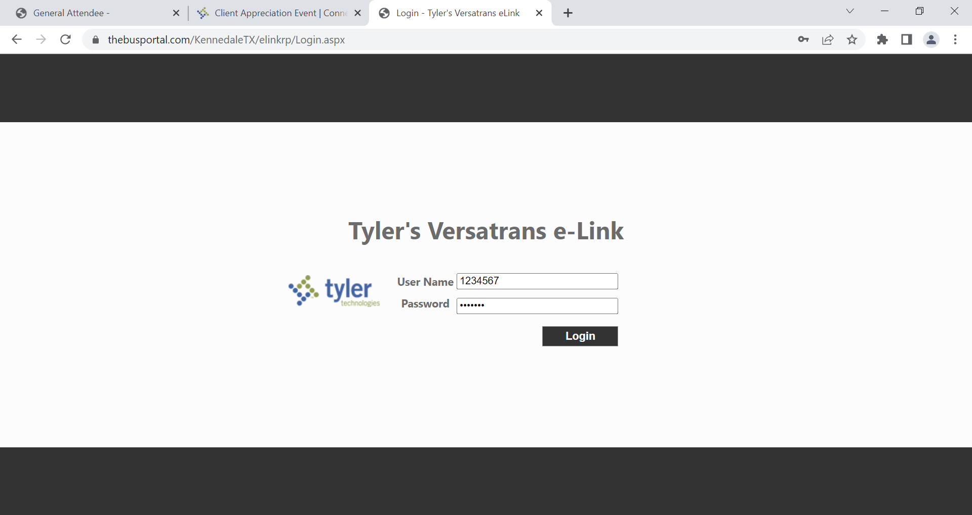

- Click on Work with Students
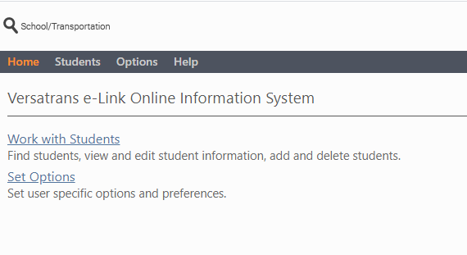
- Click on View My Students to look up your child’s bus stop information
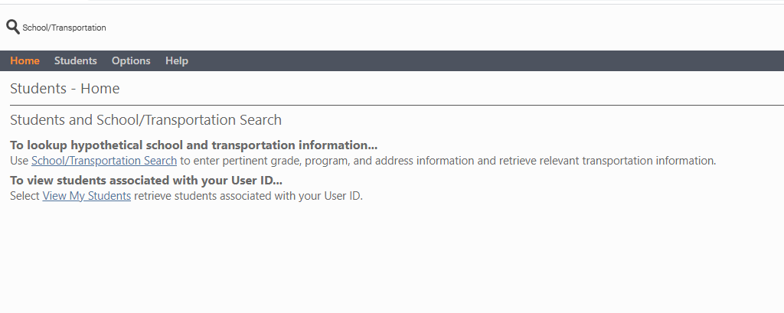

- Click on the student’s name to view their information
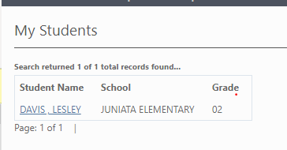
- View Student Information. You will be able to see the bus stop and route assigned along with the pickup/dropoff time. If you wish to view emergency contact information you can click on Show Basic Information.
