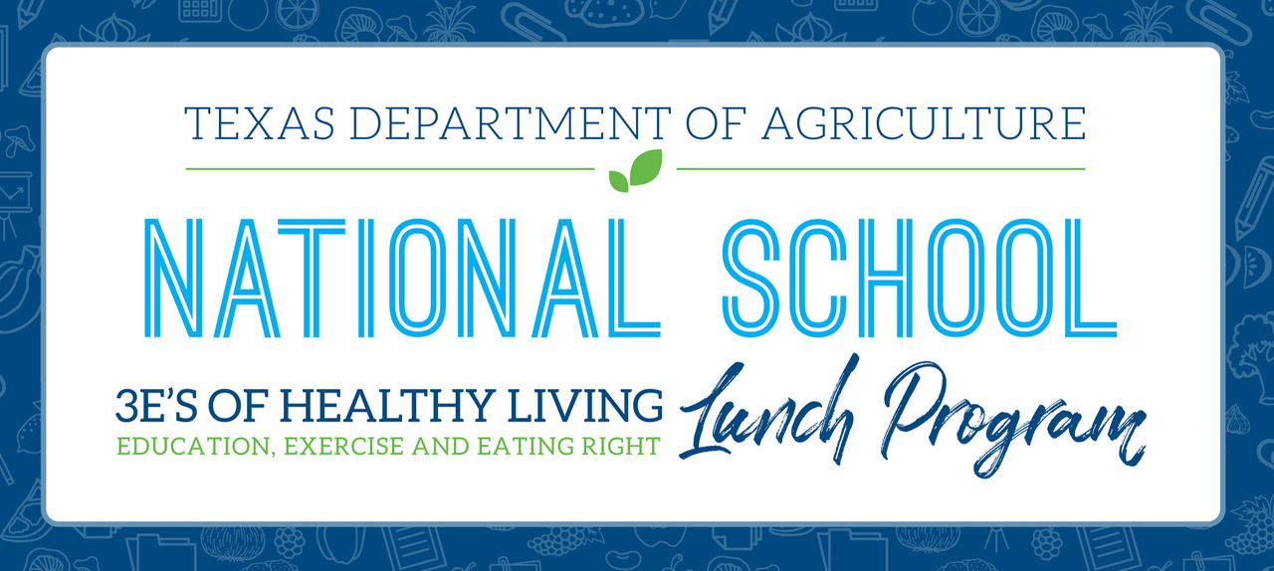

August 18, 2021

P-EBT Announcements
The Pandemic-Electronic Benefits Transfer (P-EBT) helped millions of Texas children who temporarily lost access to free school meals during the 2020-2021 school year. The U.S. Department of Agriculture recently added a one-time summer P-EBT summer benefit. Eligible families may be able to receive an additional $375 to supplement their family's budget during the covered summer period
Families that submit a household application before August 28 and meet one of the following criteria may receive the $375 Summer Pandemic-Electronic Benefit Transfer (P-EBT) through a direct distribution from the Texas Health and Human Services Commission (HHSC).
- Are newly eligible for P-EBT based on a change in family income after June 30, 2021 or are income eligible and did not have a household application on file during the 2020-2021 school year.
- Have not yet applied for P-EBT and have children who were certified for free or reduced-price meals through the National School Lunch Program (NSLP) and enrolled in an NSLP school in the last month of the 2020-2021 school year. Note: These families must submit applications through MyTexasBenefits.
Schools should ensure parents can access the NSLP household application so families can obtain summer PEBT benefits.
*Campuses that will be operating CEP for the first time in SY 21/22 MAY ONLY process TEA's Socio Economic Status (SES) Form to demonstrate eligibility for children.*

Additional Information for Schools and Families
The deadline to apply for P-EBT benefits through https://yourtexasbenefits.com/Learn/PEBT. (The link is case sensitive.) is September 13.
Household eligibility for the 2020-21 school year P-EBT benefits cannot be changed at this time. We are working with the HHSC call center to field questions from families and to ensure that correct information is being shared.
Household applications received after August 28, 2021, should be processed but cannot be used to determine eligibility for Summer P-EBT.

More Reasons to Encourage Families to Complete their Household Applications before the August 28 Deadline
Families that experienced a reduction in income over the covered summer period may be eligible for Summer P-EBT Benefits
Completing a household application may benefit their family and your school.
Use this flyer to encourage families to complete a household application now or in the future to ensure they have access to the many benefits it provides.


A Message for Families:
If your household experienced a reduction in income after June 30, 2021 or did not complete an household application in SY 2020-2021, now is the time to complete the household school meal application to determine eligibility for the Summer P-EBT benefit. Submit this form to your child nutrition department before August 28, 2021, to demonstrate eligibility for Summer P-EBT.
Summer PEBT provides a $375 to supplement a family's food budget during the covered summer period with a EBT benefit card.
Eligible families are encouraged to demonstrate eligibility for a one-time summer Pandemic-Electronic Benefit Transfer (P-EBT) benefit by submitting the household school meal application before August 28, 2021. P-EBT for the 2020–2021 school year (August 2020 to June 2021) was for families with children who were certified for free or reduced-price meals through the National School Lunch Program and families with children born after Aug. 1, 2014, who receive Supplemental Nutrition Assistance Program (SNAP) food benefits. Eligibility for these benefits has already been established and cannot be updated at this time.

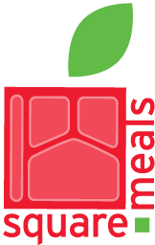
  
  TEXAS DEPARTMENT OF AGRICULTURE
  COMMISSIONER SID MILLER
  This product was funded by USDA.
  This institution is an equal opportunity provider.
   |  | 
   |  | 

Texas Department of Agriculture | P.O. Box 12847, Austin, TX 78711

Share this email:
 |  |  | 

Manage your preferences | Opt out using TrueRemove¨
Got this as a forward? Sign up to receive our future emails.
View this email online.
P.O. Box 12847
Austin, TX | 78711 US
This email was sent to cafeteria@sierrablancaisd.net.
To continue receiving our emails, add us to your address book.

CYNTHIA IBARRA
Food Service Manager
Sierra Blanca ISD
(915)369-3741 ext. 511
cafeteria@sierrablancaisd.net
"Once A Vaquero, Always A Vaquero"

