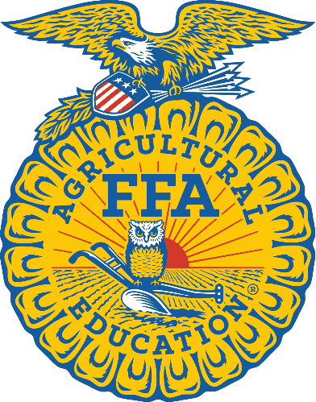
Sierra Blanca FFA
Texas FFA is a dynamic youth organization that makes a positive difference in the lives of students by developing
their potential for premier leadership, personal growth, and career success through agricultural education.
https://www.texasffa.org/

