Chromebooks

How to find your DPS Number on your Chromebook.

The DPS Number on your Chromebook helps us to identify your Chromebook in our system. This lets us check and adjust settings for your chromebook quicker.

There are three locations on most chromebooks that have the DPS Number on them:
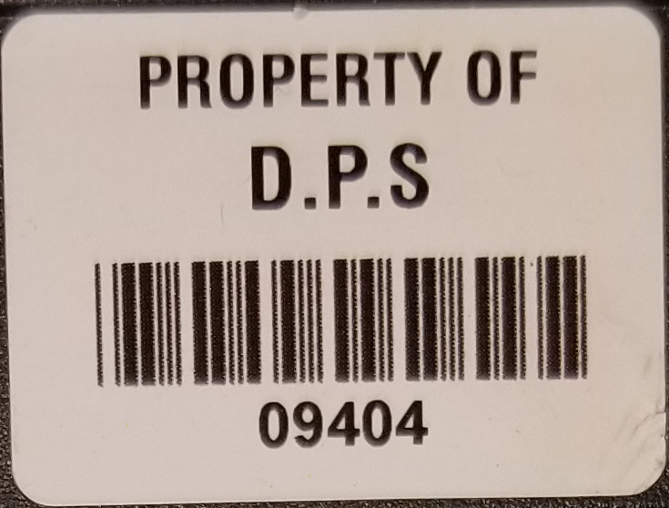

- On the Property of D.P.S. Barcode Sticker.

2 . Written on the back of the chromebook (on some chromebooks.

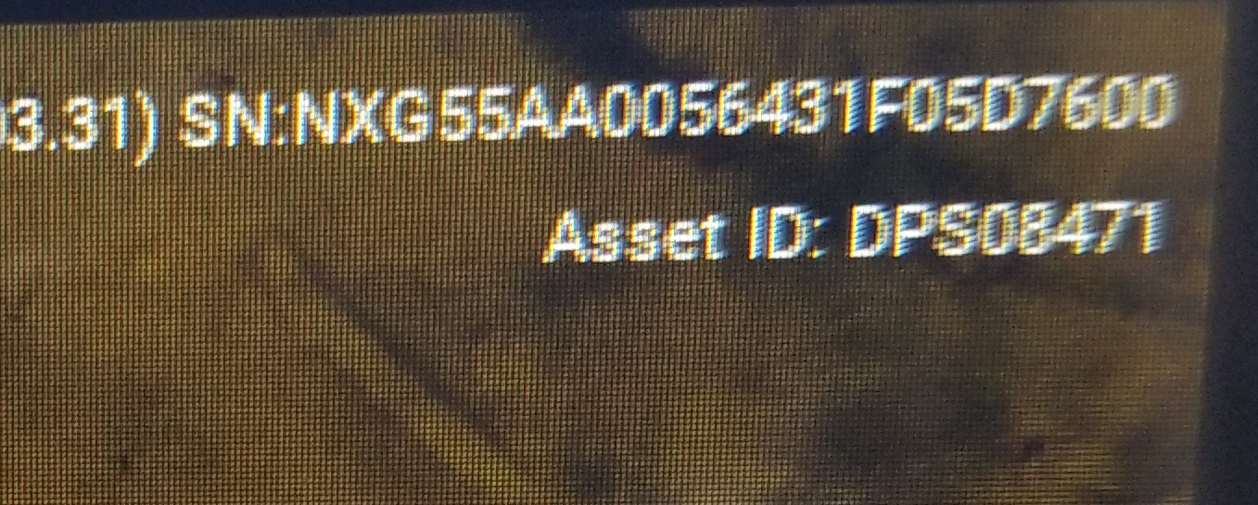

3. Displayed on the screen from the login page. Before you log onto the chromebook. Hit the Alt + V keys together. It will display information about the chromebook in the upper right hand corner.

