

Middle School Facilities Master Plan
Survey Results

Burley Middle School

Albemarle County Public Schools
May 24 - June 5, 2023



I am:
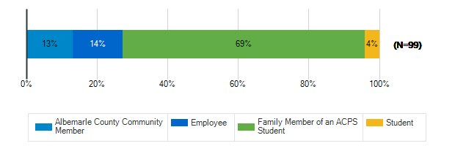

What are the most important qualities for middle school sites/grounds in the 21st century? : Safety & Security
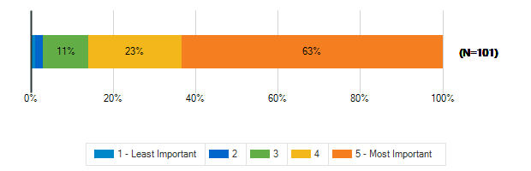

What are the most important qualities for middle school sites/grounds in the 21st century? : Growth & Capacity
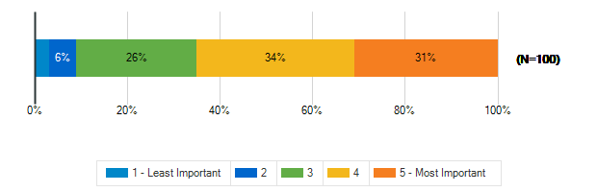

What are the most important qualities for middle school sites/grounds in the 21st century? : Outdoor Spaces
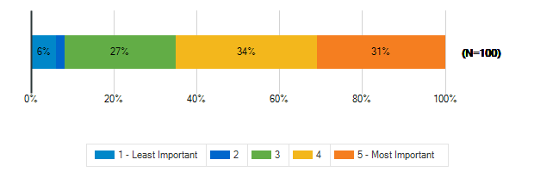

What are the most important qualities for middle school sites/grounds in the 21st century? : Sustainability & Natural Resources
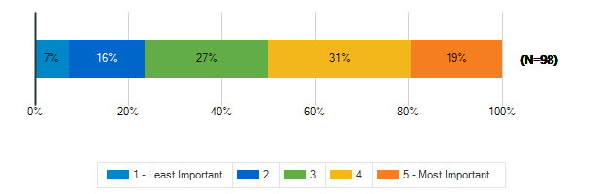

What are the most important qualities for middle school sites/grounds in the 21st century? : Community Access & Amenities
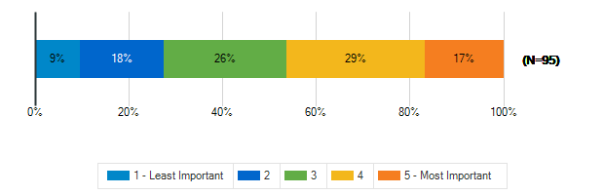

What are the most important qualities for middle school sites/grounds in the 21st century? : Positive, Healthy Culture
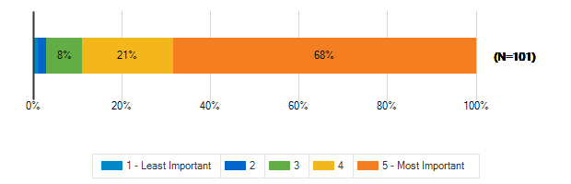

What are the most important qualities for middle school sites/grounds in the 21st century? : Welcoming, Comfortable, Aesthetic Spaces
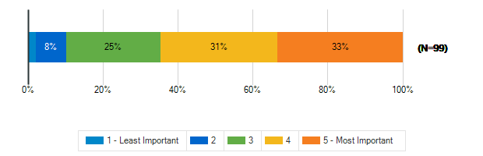

What are the most important qualities for middle school sites/grounds in the 21st century? : Durability, Flexibility, Cost-Efficiency
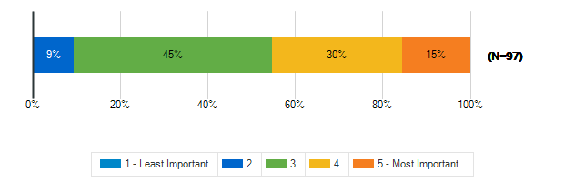

What are the most important qualities for middle school sites/grounds in the 21st century? : Sustainable/Net-Zero Construction
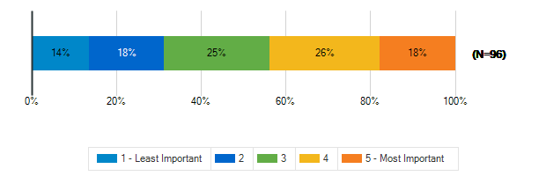

To what extent does your middle school support the following?: A sense of pride and well-being in staff and students
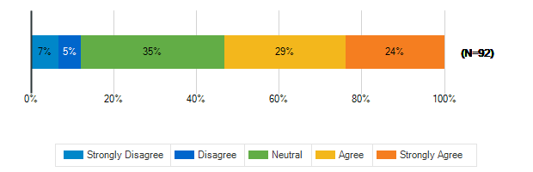

To what extent does your middle school support the following?: Prioritizing the outdoor environment
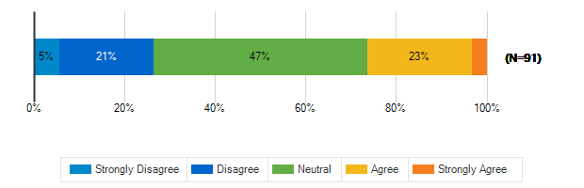

To what extent does your middle school support the following?: Natural resources available to students, staff, and the community
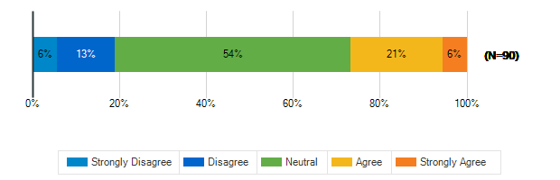

To what extent does your middle school support the following?: Educational resources available to students, staff, and the community
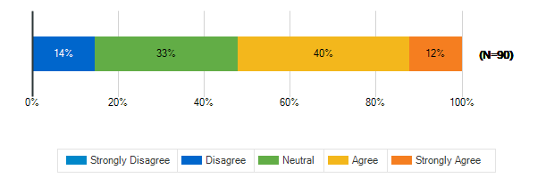

To what extent does your middle school support the following?: Health and fitness
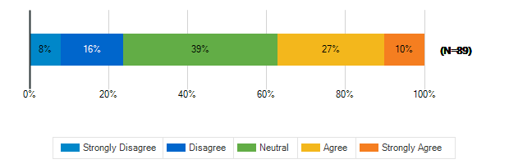

To what extent does your middle school support the following?: Diversity and inclusion
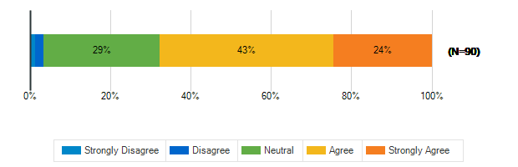

To what extent does your middle school support the following?: Environmental sustainability
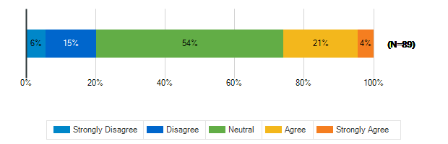

In a few words, what do you think is the greatest opportunity facing our middle school students today?
1. | Opportunity to learn
2. | Peer pressure, and bullying
3. | Learning how to study and not be hand held
4. | Access to diverse student body
5. | Save the planet and recreate how we live
6. | Helping students be respectful
7. | Social Media..
8. | Bullying, safety, and mental health of students
9. | Incorporating technology into their learning
10. | Participation in a wide range of experiences
11. | Learning should be the best it’s ever been.
12. | To become more active citizens in their world
13. | Social Media
14. | Community engagement
15. | Technology
16. | Opportunity for growth coming out of the pandemic
17. | Embracing emerging technology
18. | Bad students/bullies should be expelled, period.
19. | technology, access to information, open-mindedness
20. | unlimited information
21. | technology helps them
22. | Talking to them.
23. | I don't know
24. | The schools are outdated
25. | Exploration and independence
26. | Expansion of educational topics beyond traditional
27. | To create a more equitable, sustainable society
28. | Build kind, cooperative, unselfish future leaders
29. | project based learning, language learning
30. | Todo
31. | increase socialization and decrease technology
32. | empathy; using technology as a tool
33. | Developmental strengths of socializing and risk ta
34. | Diversity & inclusion
35. | Providing a safe and engaging learning environment
36. | Economic disparity between schools
37. | High school level courses and the arts
38. | community engagement with Charlottesville + UVA
39. | To think critically; filter the noise
40. | Opportunity to build community
41. | a growing, diverse community
42. | Learning mastery of concepts (at own pace)
43. | Achieving to be the best they can be
44. | Discovering and fostering talents in students
45. | engagement in environmentalism and STEM
46. | rethink how humans organize their world
47. | AI
48. | Charting a course for connected, healthy lives
49. | Sustainable, meaningful community engagement by al
50. | Embrasing traditional values.
51. | zero resources for struggling and advanced kids
52. | A world full of technology and medical advancement
53. | Immense amounts of knowledge available
54. | the opportunity to mature their voice
55. | Safety and improved educational standards
56. | Diverse community to learn in.
57. | to develop healthy and well rounded young adults
58. | Lab School but there is more need than available
59. | Keeping kids safe both physically and emotionally
60. | their ability to learn new skills quickly
61. | diversity
62. | Being able to fit into the social environment.
63. | Technological advances
64. | more opportunities/experiences with use of tech
65. | chance to become thought-leaders
66. | project based learning

In a few words, what do you think is the greatest challenge facing our middle school students today?
1. | Peer pressure and bullying
2. | I think one of the biggest challenging, but I am m
3. | Not having enough resources
4. | That schools lost focus on teaching.
5. | social media
6. | Lack of access to sports
7. | Defining boundaries
8. | Disrespectful behavior
9. | Social Media
10. | Mental health and confidence
11. | Being interested in school, they do not find it im
12. | Safety, bullying, classroom behavior
13. | Lack of safely and support
14. | Leftist political views taking over classrooms
15. | Safety and emotional well being
16. | Overcrowding and not enough outdoor time
17. | Feeling that their education is relevant to future
18. | Peers
19. | Critical thinking
20. | Social media and fitting in
21. | wokeism
22. | Technology overload
23. | learning loss coming out of the pandemic
24. | Maintaining strong writing and critical thinking
25. | Bad students/bullies should be expelled, period.
26. | Safety, bullying
27. | unlimited information, robots/AI taking jobs
28. | respecting adults
29. | Making them pay attention
30. | The worrying possibility of school shootings
31. | respecting teachers
32. | Social Media
33. | Social pressure
34. | WOKE! Get back to basic, fundamental education.
35. | To create a more equitable, sustainable society
36. | Divisiveness in the world, mental health struggles
37. | Social Media
38. | School safety and well-being
39. | too much screen time/social media,
40. | La seguridad
41. | Isolation and lack of connection
42. | academic rigor; high behavioral expectations
43. | Feeling like they belong.
44. | Vaping/substance use, racism, bullying
45. | Sentirse seguros de ellos mismos
46. | Safety due to legislation around fun control
47. | Safety
48. | Economic disparity between schools
49. | Little support for differentiating
50. | social media
51. | Social media, disconnection
52. | Again, building of community
53. | social pressure, still catching up from covid loss
54. | People not getting along or listening
55. | Violence and bullying
56. | Bullying
57. | Social media influences
58. | Their safety
59. | School security and social media
60. | mental health and self confidence - peer pressure
61. | social media and mental health
62. | Sometimes voices or actions
63. | Sense of respect for students staff and property
64. | Disengaged teachers and disruptive peers
65. | Woke ideology
66. | social media
67. | Good learning skills
68. | Mental health, critical thinking, &writing skills
69. | Lack of differentiated learning
70. | lack of structure
71. | Early access to new technology careers, books
72. | Budgets
73. | the dumbing down of society
74. | Over crowding
75. | school shootings and safety in general.
76. | lack of consequences and social media influence
77. | Keeping kids safe both physically and emotionally
78. | Feeling connected and part of a bigger group
79. | mental, emotional, phsyical safety
80. | Being able to support a diverse student body.
81. | Emotional well being, stress
82. | addiction to technology - mental health concerns
83. | safety, achievement gap
84. | bully culture
85. | anxiety and social media
86. | Acceptance and having a safe space to be a kid

To meet the needs of students, educators, families and the community, a middle school facility in Albemarle County MUST HAVE
1. | Kind, engaged staff
2. | Communication, resources and proper discipline
3. | Schools that teach
4. | an ability to meet the needs of ALL students
5. | Strong academic expectations
6. | Security and inclusive environment
7. | Clear guidelines for discipline
8. | Need to have more parent/teacher meets.
9. | The trust of all stakeholders
10. | A Big Carrot
11. | Forward-looking technology
12. | Learning labs
13. | At this point an oversight committee
14. | Safety, educational ease, natural light
15. | Enough spaces and staff to support students
16. | Not that I know of
17. | Balance
18. | Faculuty & staff empowered to do their best
19. | Enough teachers and resources to challenge all kid
20. | Ability to easily remove bad students/bullies.
21. | engaged faculty and staff, security
22. | enough room for kids and staff to keep them safe
23. | more discipline talk
24. | Translate words or have someone who can help
25. | Enthusiastic teachers who WANT to be there
26. | better internet and computers so people can work
27. | Natural lighting
28. | A safe, accountable environment
29. | Flexible learning spaces
30. | Teachers who care about education not gvmt agendas
31. | A policy of equity, inclusion, and sustainability
32. | Resources for physical & mental health and safety
33. | Inclusive educators that care about all students.
34. | Safety plans and secure facilities
35. | great teachers who are not overworked/stressed
36. | El amor a Dios respeto y seguridad
37. | Healthy, happy teachers
38. | natural light/outdoor views/windows
39. | Spaces to feel physically safe and emotionally saf
40. | Loving, capable staff that honor every student
41. | A diverse approach to student learning
42. | The proper learning tools and resources
43. | Adequate funding, clear expectations consequenses
44. | Proper staffing
45. | dedicated, well paid teachers + healthy cafe food
46. | Mental health support; safe spaces
47. | Ability to create connection to each other/outdoor
48. | more dedicated less over-stretched staff members
49. | Spaces for everyone to feel safe and comfortable
50. | A safe place to be themselves and learn at their p
51. | Skills and communication
52. | Transportation
53. | A safe, welcoming environment & STEM resources
54. | good teachers including those for IEP students
55. | the input from its students, parents, & community
56. | people we can talk to and be more closer and talk
57. | An environment they can feel proud of
58. | Supported teachers
59. | Commitment to reject the racist goals of "Equity"
60. | security
61. | A well sense of neutralization
62. | Direct instruction for reading & math intervention
63. | Coursework to challenge kids
64. | no resource officers or metal detectors.
65. | More books, technological equipm, tech classes
66. | High level teachers with advanced degrees
67. | advanced education opportunities for students
68. | Space to grow/learn including outdoor learning
69. | Space for school counselors and social workers
70. | org/leadership that listens to the staff re: needs
71. | more school sponsored sports, mental health
72. | safe space for physical & emotional well-being
73. | small learning community for all to know each othe
74. | Strong community, support from the top.
75. | Healthy sense of community
76. | mental health/safety focus; highly qualified staff
77. | funding and administrative support
78. | outdoor space

Tell us more about the following resource spaces in your school & grounds?

How often do you use?: Teacher Work Rooms
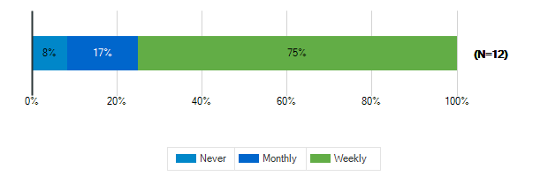

How often do you use?: Teacher Lounge
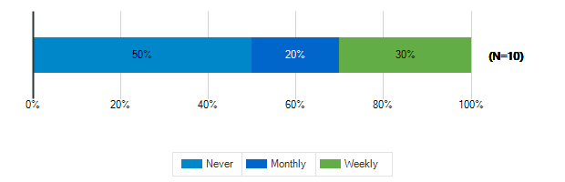

How often do you use?: Library
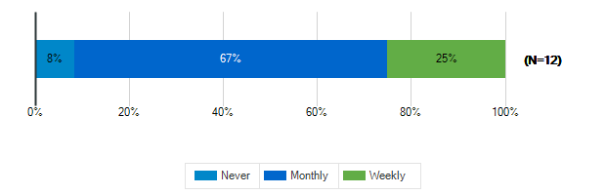

How often do you use?: Stage/Auditorium
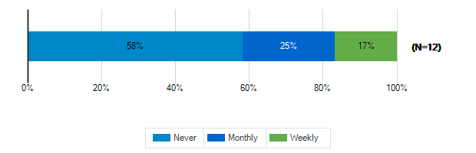

How often do you use?: Outdoor Classrooms
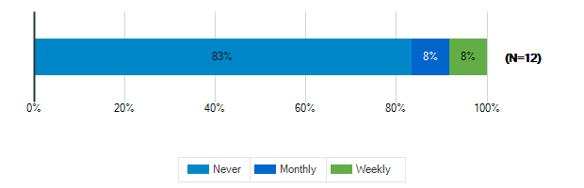

How often do you use?: Administrative Offices
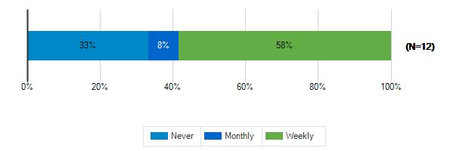

How often do you use?: Conference Room
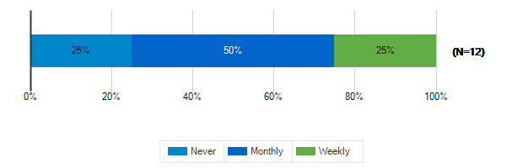

How often do you use?: Cafeteria

How often do you use?: Shared Spaces
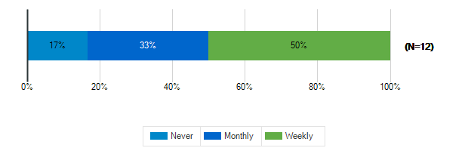

Tell us more about the following resource spaces in your school & grounds?

How would you rate the quality?: Teacher Work Rooms
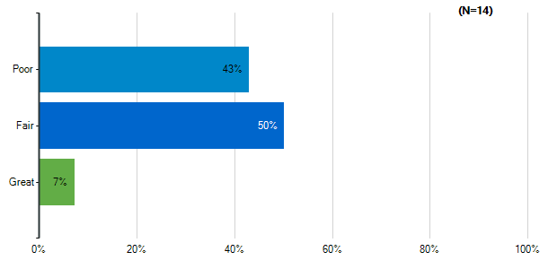
Note: Multiple answers per participant possible. Percentages added may exceed 100 since a participant may select more than one answer for this question.

How would you rate the quality?: Teacher Lounge
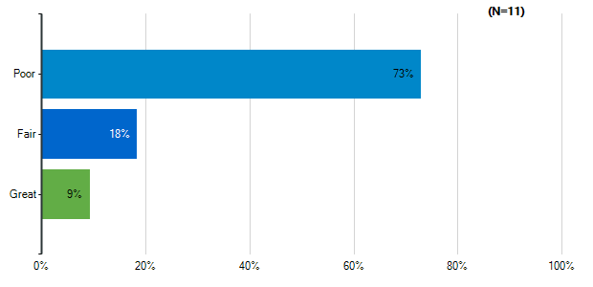
Note: Multiple answers per participant possible. Percentages added may exceed 100 since a participant may select more than one answer for this question.

How would you rate the quality?: Library
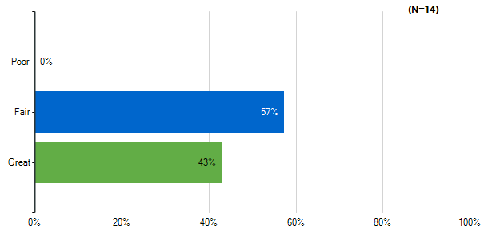
Note: Multiple answers per participant possible. Percentages added may exceed 100 since a participant may select more than one answer for this question.

How would you rate the quality?: Stage/Auditorium
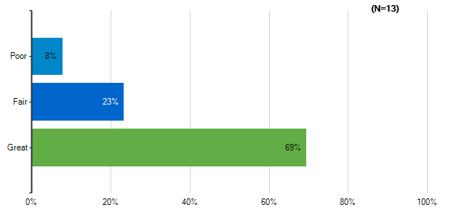
Note: Multiple answers per participant possible. Percentages added may exceed 100 since a participant may select more than one answer for this question.

How would you rate the quality?: Outdoor Classrooms
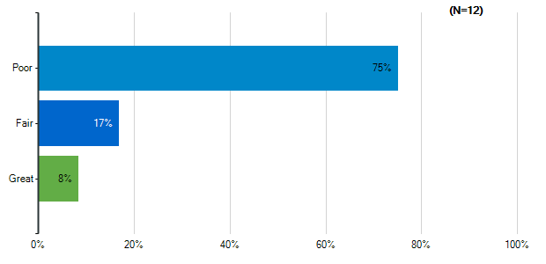
Note: Multiple answers per participant possible. Percentages added may exceed 100 since a participant may select more than one answer for this question.

How would you rate the quality?: Administrative Offices
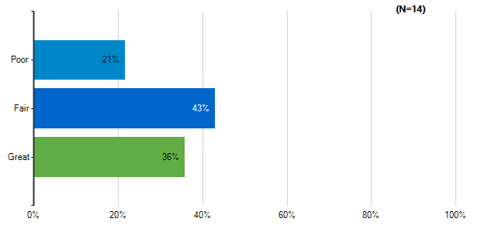
Note: Multiple answers per participant possible. Percentages added may exceed 100 since a participant may select more than one answer for this question.

How would you rate the quality?: Conference Room
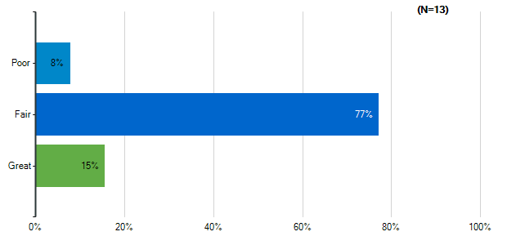
Note: Multiple answers per participant possible. Percentages added may exceed 100 since a participant may select more than one answer for this question.

How would you rate the quality?: Cafeteria
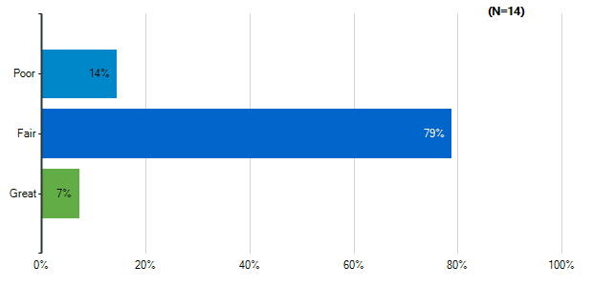
Note: Multiple answers per participant possible. Percentages added may exceed 100 since a participant may select more than one answer for this question.

How would you rate the quality?: Shared Spaces
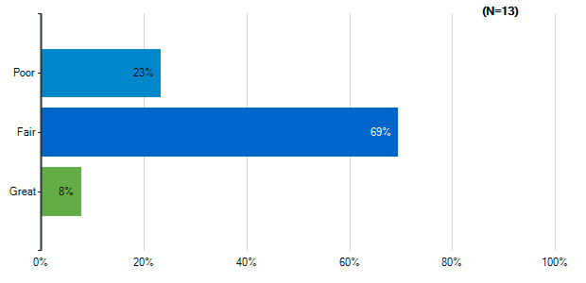
Note: Multiple answers per participant possible. Percentages added may exceed 100 since a participant may select more than one answer for this question.

Please indicate how satisfied you are with the following characteristics of your middle school building:: Cleanliness & Maintenance
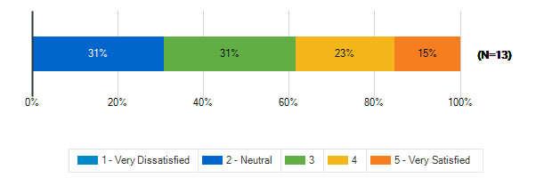

Please indicate how satisfied you are with the following characteristics of your middle school building:: Security & Safety
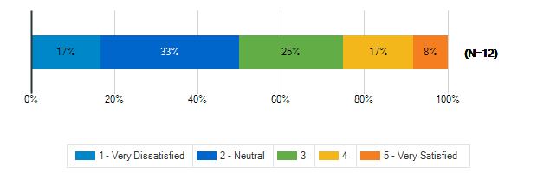

Please indicate how satisfied you are with the following characteristics of your middle school building:: Signage and Wayfinding
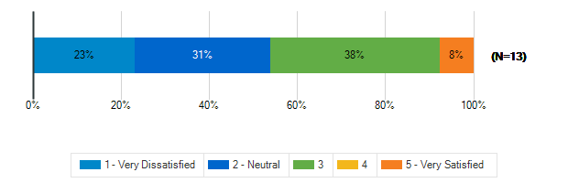

How frequently do your students engage in the following activities in your classroom: Lecture/Lessons
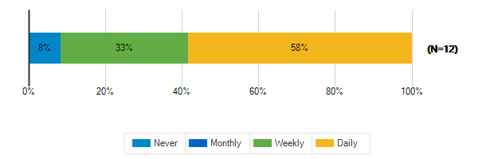

How frequently do your students engage in the following activities in your classroom: Learning Centers/Listening Stations
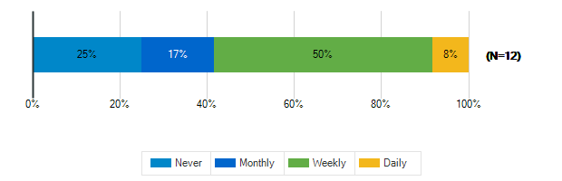

How frequently do your students engage in the following activities in your classroom: Student Presentations Performances
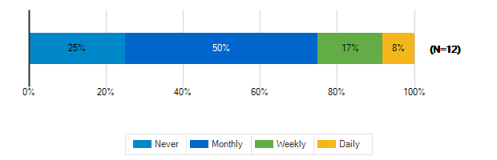

How frequently do your students engage in the following activities in your classroom: Group Activities/Projects
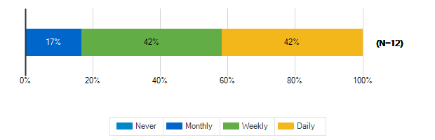

How frequently do your students engage in the following activities in your classroom: Individual Work
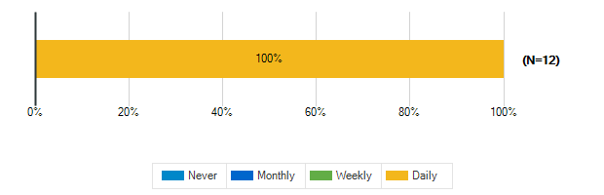

How frequently do your students engage in the following activities in your classroom: Technology/Computer
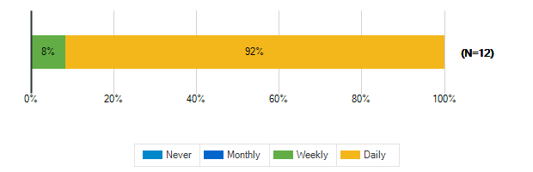

How frequently do your students engage in the following activities in your classroom: Physical Activity/Movement Breaks
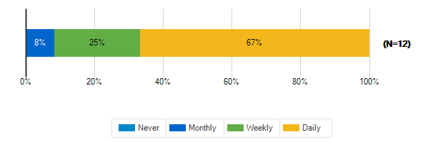

How would you describe the following characteristics of your classroom?: Location
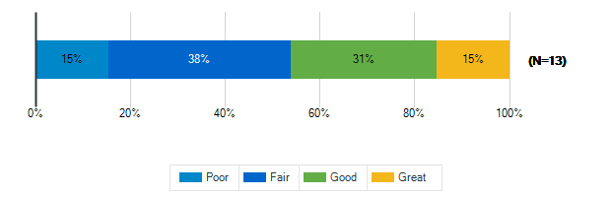

How would you describe the following characteristics of your classroom?: Size
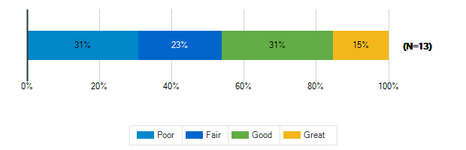

How would you describe the following characteristics of your classroom?: Security & Safety
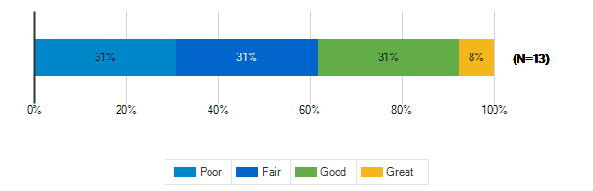

How would you describe the following characteristics of your classroom?: Storage (Amount, Design, Location)
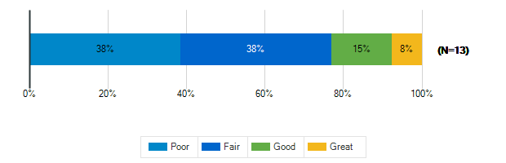

How would you describe the following characteristics of your classroom?: Cleanliness & Maintenance
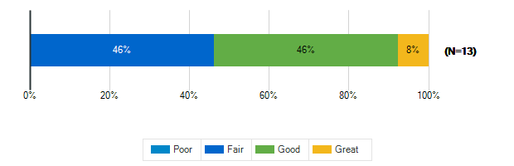

How would you describe the following characteristics of your classroom?: Availability of Technology (including WiFi & power outlets)
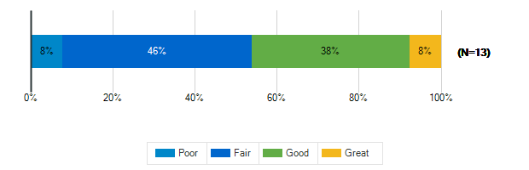

How would you describe the following characteristics of your classroom?: Functionality (including versatility and adaptability)
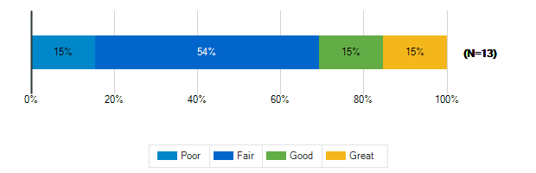

How would you describe the following characteristics of your classroom?: Natural Lighting/Ventilation
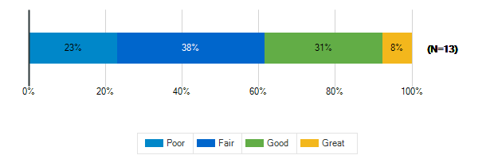

How would you describe the following characteristics of your classroom?: Access to Outdoor Spaces and/or Outdoor Visibility
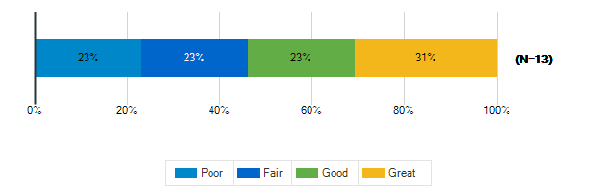

How would you describe the following characteristics of your classroom?: Electric Lighting
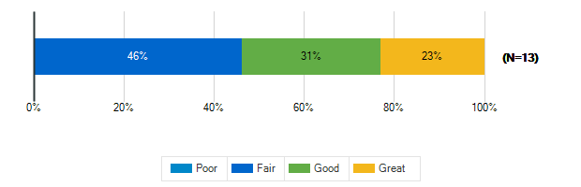

How would you describe the following characteristics of your classroom?: Air quality
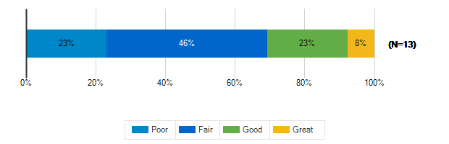

How would you describe the following characteristics of your classroom?: Acoustics
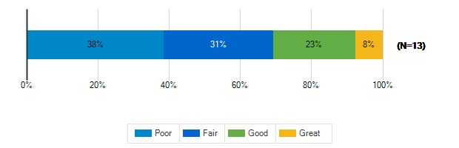

How would you describe the following characteristics of your classroom?: Furniture
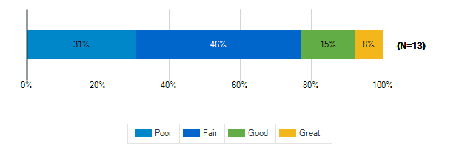

How would you describe the following characteristics of your classroom?: Dry Erase Boards/Display Boards/Bulletin Boards
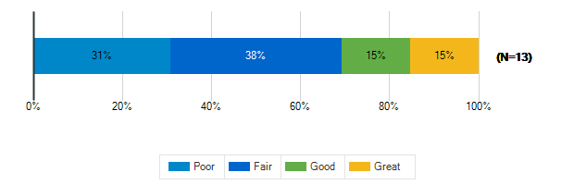

How would you describe the following characteristics of your classroom?: Finishes (Floors/Walls/Ceiling/etc.)
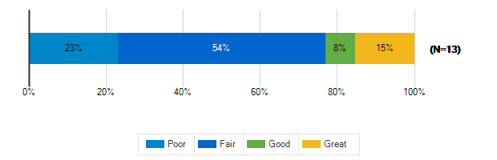

Please rank the following indoor amenities in order of priority for future spaces
Responses | Rank 1 | Rank 2 | Rank 3 | Rank 4 | Weighted Score | Relative Weighted Score | Overall Rank
Dedicated teacher work areas and personal storage area | 4 | 4 | 2 | 2 | 34 | 100 | 1
Dedicated restrooms for staff | 4 | 4 | 1 | 3 | 33 | 97 | 2
Spaces designed for versatility to accommodate a variety of uses | 1 | 3 | 6 | 2 | 27 | 79 | 3
Outdoor access for science and other specialty classrooms | 3 | 1 | 3 | 5 | 26 | 76 | 4

If you’ve taught at or seen a middle school with a feature that doesn’t exist at ACPS that you think should be here, please identify it:
1. | Spacious work areas and lots of natural light.
2. | Classroom doors that automatically lock.
3. | Flexible spaces that are actually able to be used flexibly—dedicated to that use and placed conveniently for teachers to access (not used as an assigned classroom for most of the day). One thing I’ve seen at High Tech High/Middle schools is classroom pods for teams—two classrooms (Language arts and history) connected by a movable wall, across from another set of rooms (math and science), separated by a flexible student space. This also included a teacher office for teamed teachers to share.
4. | indoor activity spaces wildly inconsistent e.g. Henley 3 indoor gyms Burley 1
5. | n/a
6. | dedicated communities within a school to promote positive culture
7. | a garden

What is your grade level?
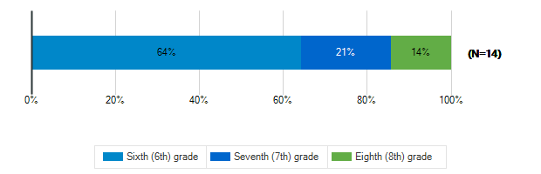

Tell us about the spaces in your school and on your school grounds:

How often do you use these spaces?: Media Center
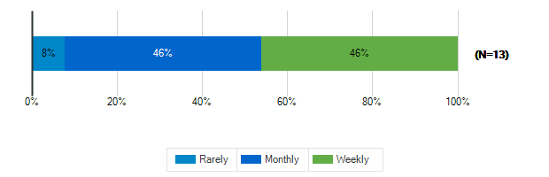

How often do you use these spaces?: Cafeteria
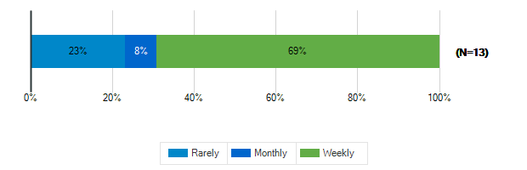

How often do you use these spaces?: Gymnasium
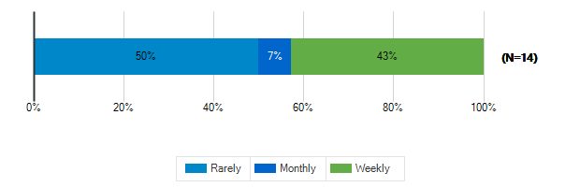

How often do you use these spaces?: tage/Auditorium
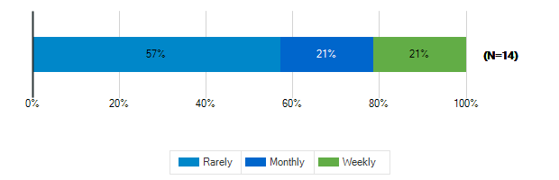

How often do you use these spaces?: Outdoor Classrooms
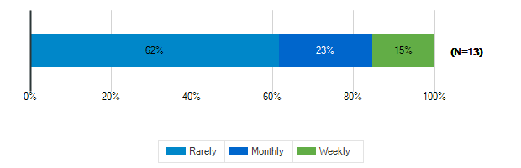

How often do you use these spaces?: Outdoor Recreation/Athletic Fields
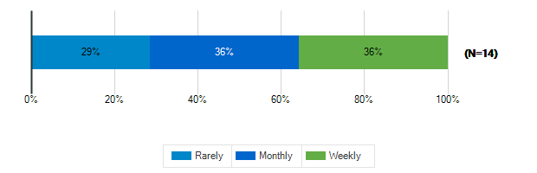

Tell us about the spaces in your school and on your school grounds:

How would you rate these spaces?: Media Center
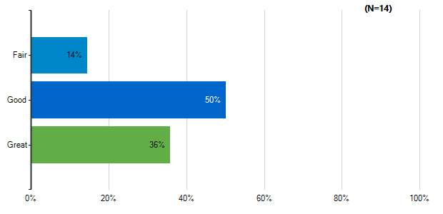
Note: Multiple answers per participant possible. Percentages added may exceed 100 since a participant may select more than one answer for this question.

How would you rate these spaces?: Cafeteria
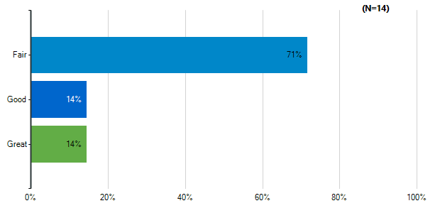
Note: Multiple answers per participant possible. Percentages added may exceed 100 since a participant may select more than one answer for this question.

How would you rate these spaces?: Gymnasium
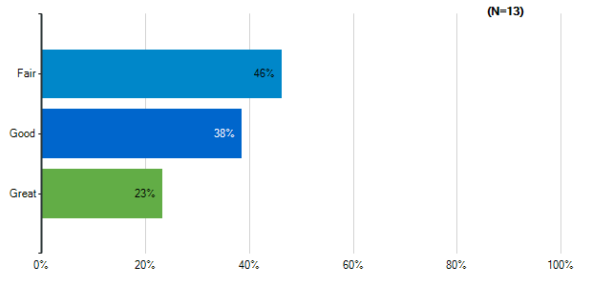
Note: Multiple answers per participant possible. Percentages added may exceed 100 since a participant may select more than one answer for this question.

How would you rate these spaces?: tage/Auditorium
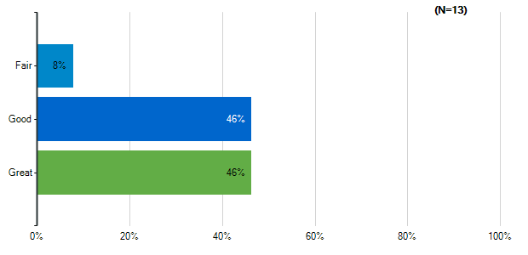
Note: Multiple answers per participant possible. Percentages added may exceed 100 since a participant may select more than one answer for this question.

How would you rate these spaces?: Outdoor Classrooms
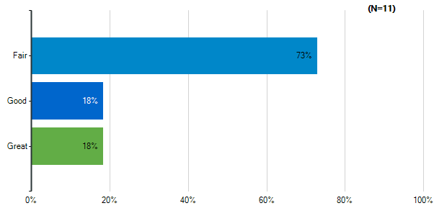
Note: Multiple answers per participant possible. Percentages added may exceed 100 since a participant may select more than one answer for this question.

How would you rate these spaces?: Outdoor Recreation/Athletic Fields
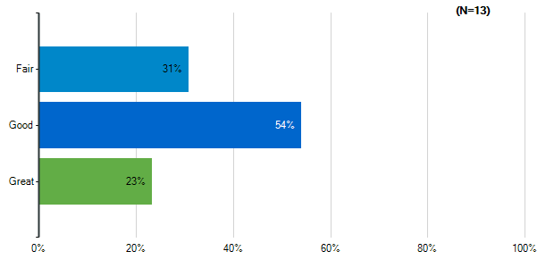
Note: Multiple answers per participant possible. Percentages added may exceed 100 since a participant may select more than one answer for this question.

How would you rate the quality of the following characteristics of your classrooms?: Size
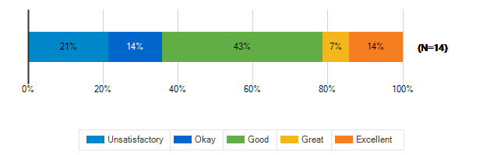

How would you rate the quality of the following characteristics of your classrooms?: Cleanliness
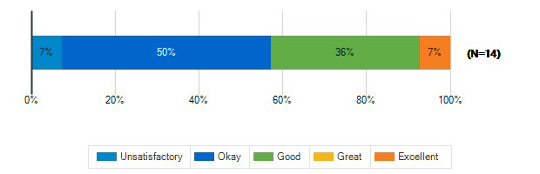

How would you rate the quality of the following characteristics of your classrooms?: Furniture
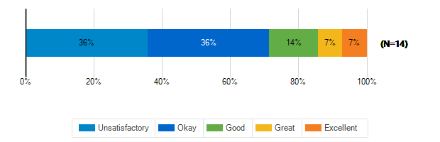

How would you rate the quality of the following characteristics of your classrooms?: Color Scheme/Décor
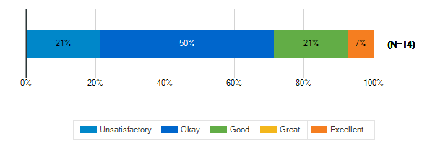

How would you rate the quality of the following characteristics of your classrooms?: Security & Safety
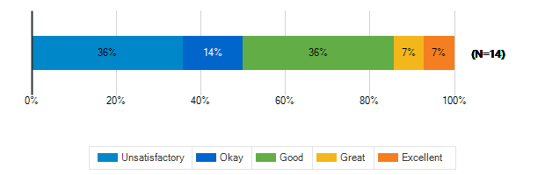

How would you rate the quality of the following characteristics of your classrooms?: Technology (including WiFi and power outlets)
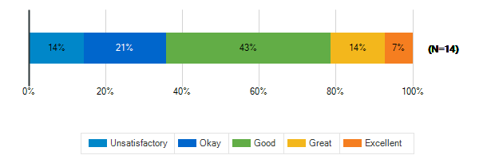

How would you rate the quality of the following characteristics of your classrooms?: Natural Lighting
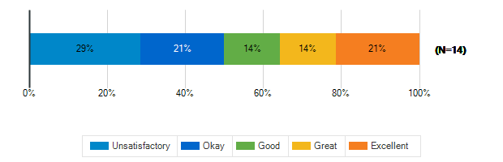

How would you rate the quality of the following characteristics of your classrooms?: Access to Outdoor Spaces and/or Outdoor Visibility
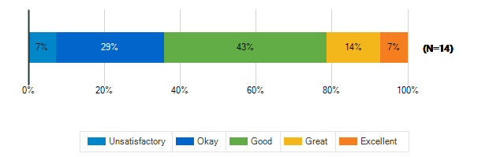

What is the best thing about your middle school?
1. | Friends
2. | It has character
3. | central location
4. | staff
5. | The baseball field.
6. | the band room
7. | The dedicated staff and students
8. | the kids
9. | diversity
10. | pride in the history of the school

What is the worst thing about your middle school?
1. | Bullies
2. | It's age, classrooms
3. | old design, poor security, lack of indoor gyms
4. | students disrespect for adults
5. | Fights, bullies
6. | the cafeteria
7. | Building is old, air quality, poor natural light
8. | the student bathrooms, no outdoor spaces
9. | unsafe, hiding places, confusing layout
10. | upkeep of the grounds

How satisfied are you with the following characteristics of your child’s school?: Availability of Parking
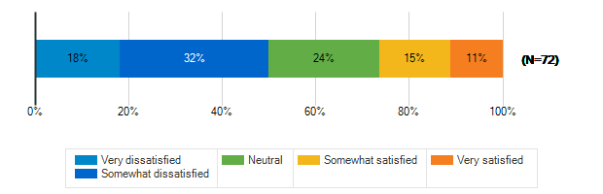

How satisfied are you with the following characteristics of your child’s school?: Design/Flow of CAR Drop-Off and Pick-Up for Students
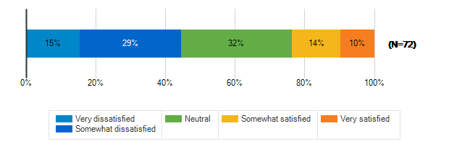

How satisfied are you with the following characteristics of your child’s school?: Design/Flow of BUS Drop-Off and Pick-Up for Students
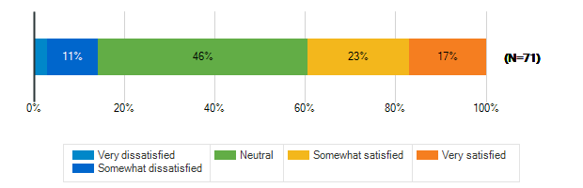

How satisfied are you with the following characteristics of your child’s school?: Entryway into the School
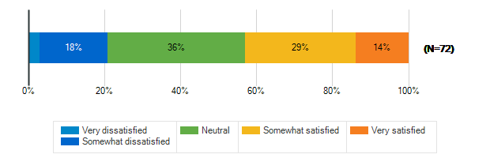

How satisfied are you with the following characteristics of your child’s school?: Classroom
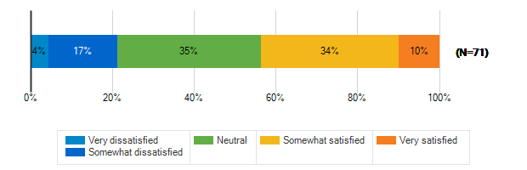

How satisfied are you with the following characteristics of your child’s school?: Security & Safety
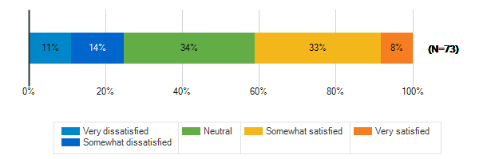

How satisfied are you with the following characteristics of your child’s school?: Technology
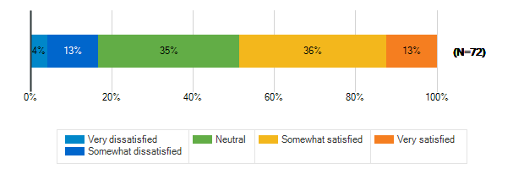

How satisfied are you with the following characteristics of your child’s school?: Learning Environment
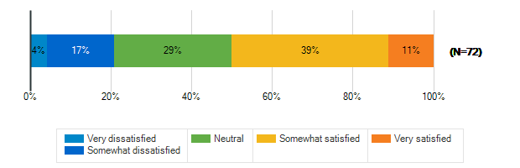

How satisfied are you with the following characteristics of your child’s school?: Natural Lighting/Outdoor Visability
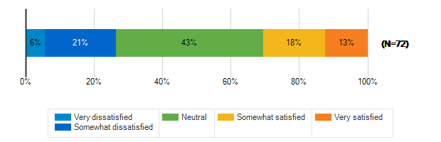

How satisfied are you with the following characteristics of your child’s school?: Performance spaces
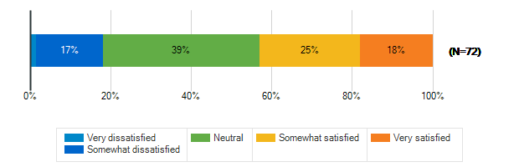

How satisfied are you with the following characteristics of your child’s school?: Outdoor spaces/Athletic fields
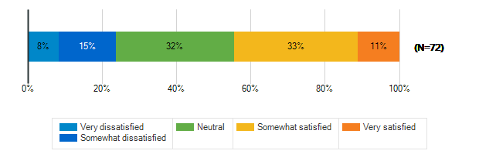

Please rank the following outdoor amenities in order of priority
Responses | Rank 1 | Rank 2 | Rank 3 | Rank 4 | Rank 5 | Rank 6 | Weighted Score | Relative Weighted Score | Overall Rank
Outdoor areas for socializing and relaxing | 16 | 18 | 17 | 12 | 4 | 6 | 304 | 100 | 1
Protected outdoor space (fenced or in a courtyard) | 22 | 12 | 10 | 9 | 11 | 9 | 290 | 95 | 2
Covered outdoor structure for play and events during inclement weather | 7 | 20 | 13 | 13 | 13 | 7 | 266 | 88 | 3
New or improved athletic/recreational fields | 15 | 10 | 12 | 9 | 11 | 16 | 253 | 83 | 4
Dedicated natural areas | 9 | 8 | 10 | 20 | 13 | 13 | 233 | 77 | 5
Walking trails/Bike paths | 4 | 5 | 11 | 10 | 21 | 22 | 187 | 62 | 6

How does your child usually get to school?
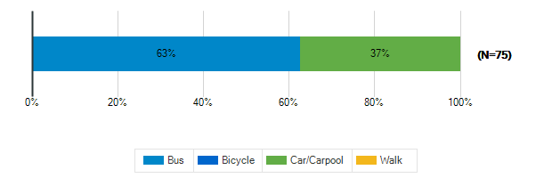

Does your child participate in any afterschool programs at their middle school?
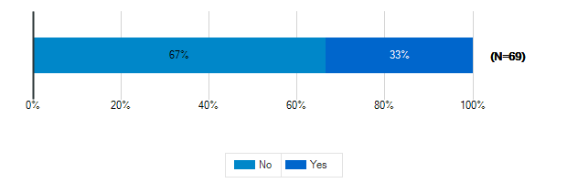

Please specify which programs
1. | Volleyball, track
2. | Basketball
3. | EDEP
4. | Basketball, volleyball, bearettes
5. | Basketball and cross country
6. | EDEP
7. | Athletics
8. | Fall County Basketball Team
9. | Cross Country
10. | Sports and dances Chorus
11. | Sports and choral concerts
12. | cross country/track
13. | sports
14. | Karate
15. | Our child is in elementary school but we wish to have her in after school programs now and in the future
16. | Cross country, volleyball, chorus
17. | Rising 5th graders, likely to participate in after school programs but unknown which ones yet
18. | Chorus, volleyball
19. | Science club at SRES
20. | not there yet, but will

