Family Access - Getting Started

Family Access enables you to view information about your child or children in Skyward Qmlativ. You can also view class schedules, course requests, grades, assignments, report cards, attendance, disciplinary incidents, standardized test scores, graduation plans, endorsements, food service balances, transportation information, the staff directory, and schedule classes for an upcoming year for your children. You can also add absence requests for your child, complete online forms for your child, and submit online applications for Food Service.

In this guide, you’ll find information regarding:
- Navigating Family Access
- Changing Password and Color Preferences
- Accessing Additional Help

Navigating Family Access
The following guidance will help you navigate to specific information about your student(s). Refer to the following figure for visual reference.

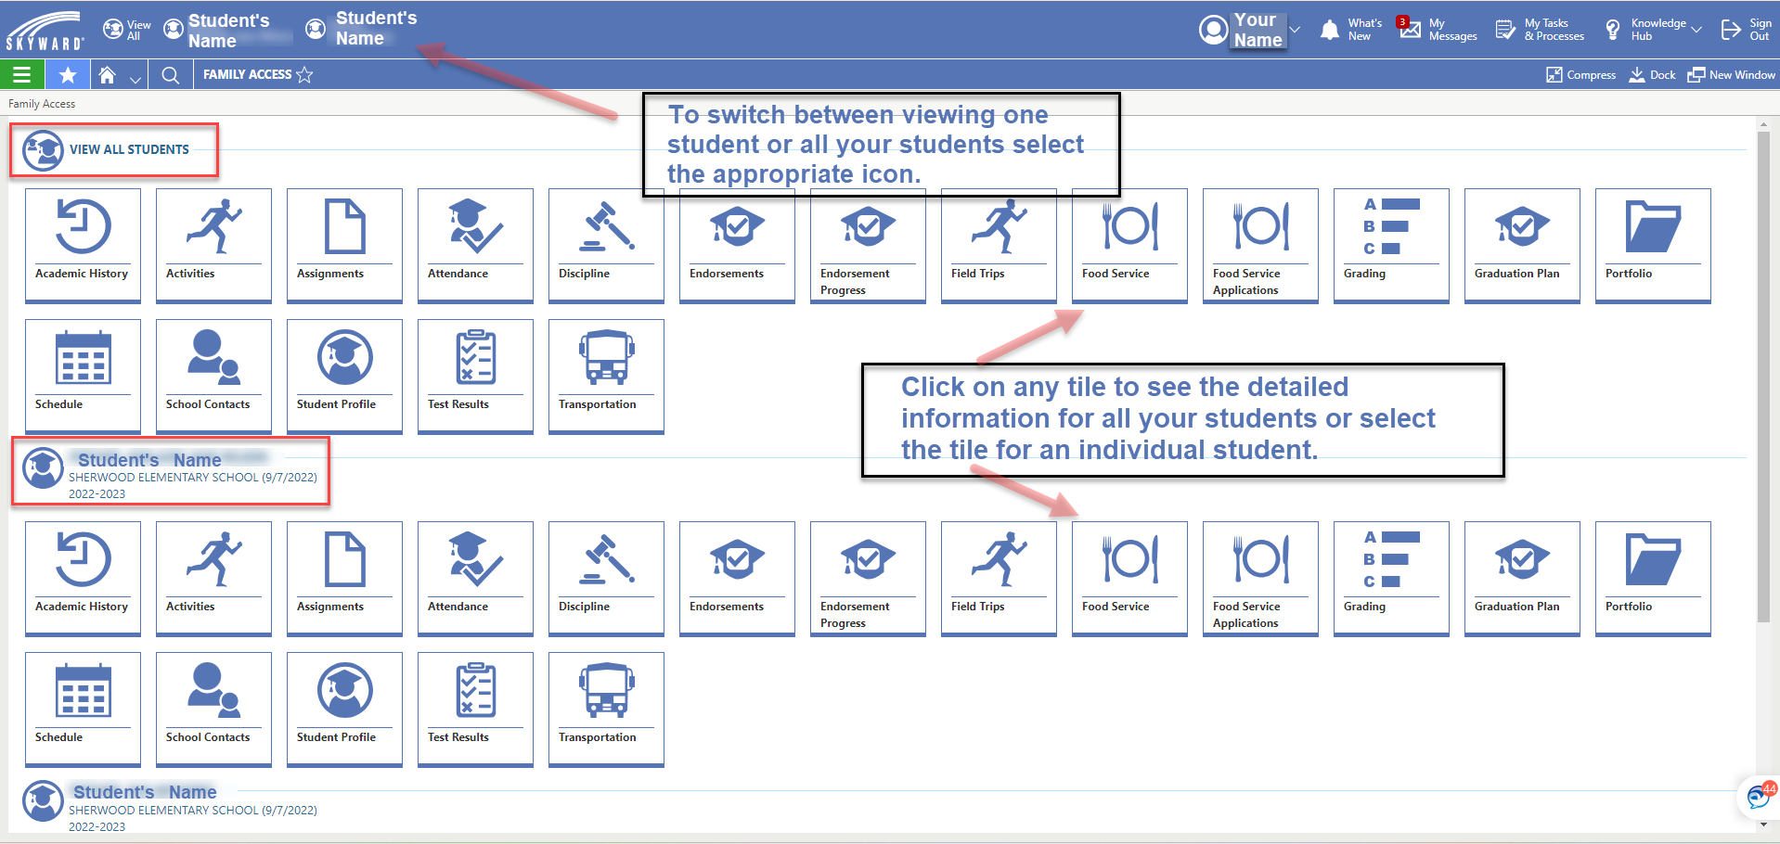

Selecting a Student to View
To select a specific student to view, click the student name in the top left corner of the screen. If you want to view all of your students’ information, select, “View All.” The tiles and sections will adjust based on your selection.

Navigating to Detail Information
Once you have selected your students, click the applicable tile to view specific information pertaining to this topic and student. For guidance on specific tiles, please Edmonds School District’s other guides and tutorials, which can be found on Edmonds School District’s website.

Returning to the Homescreen of Tiles
When you are finished reviewing the details, click the Skyward logo or the icon to return to the homescreen with all of the tiles.

Changing Password and Color Preferences
You can update your password and change your color preferences.
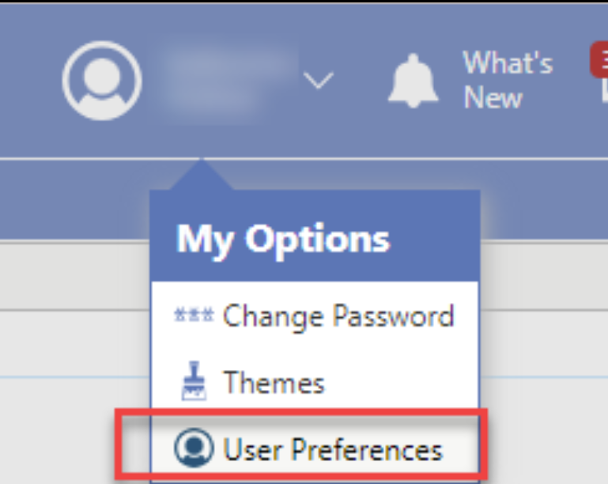
In the top right corner, click the down arrow to the right of your name.

Accessing Additional Help
You can find additional information about specific tiles and about things you can do in Family Access by visiting Edmonds School District’s website.

You can also visit Skyward Qmlativ’s built-in Help Center. To visit Help Center, click the down arrow next to Knowledge Hub. Then select, Help Center.
