




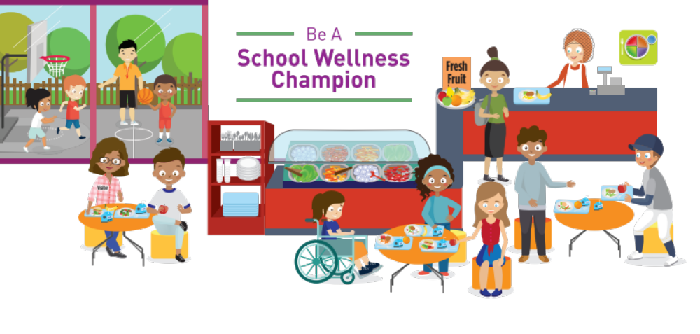

Examples of activities the Wellness Team supports:
- Morning recess options: XXX [Tu/ Wed/Th] and
Yoga [Mon/Fri]
- Walk and Bike to School when the weather is nice instead of driving.
- Healthy food and drink options during classroom and school celebrations.
- Mindful classroom activities such as brain breaks.
- March Wellness Month fun activities.
- Events outside of school hours such as join a gym, go bike riding, or take a walk.
- Sharing wellness news and ideas Laton’s social media sites.






Paid for in part by USDA
Offer equipment. If you have sports equipment to donate for recess or cooking equipment for preparing healthy classroom snacks,
email XXX.
Support school events with healthy foods and activities. Keep health in mind when planning. Find ideas here:
Join the Wellness Team. We meet once a month and work on projects to help support health. You do not need any special training to join, just an interest in keeping our school healthy! Next meeting:
Talk with your children about the fun activities we support! Let us know what programs your child/family enjoys, and send in new ideas via an email to
XXX.
Laton Parents, we need your help
to make our school healthier!
Children spend a lot of their day at school. So, it’s important that healthy choices are easy choices for kids. We’re looking forward to working with you to ensure our school continues to be a healthy place that supports growth and learning.
1 way parents can help:

