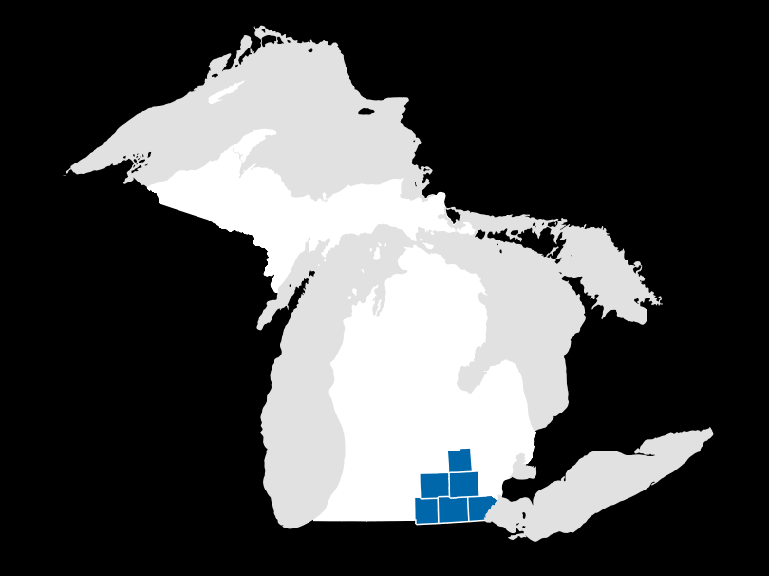
HOT JOBS
SOUTHEAST MICHIGAN

Hillsdale • Jackson • Lenawee • Livingston • Monroe • Washtenaw  Demand Occupations | Wage Range | Projected Growth 2014-2024 | Projected Annual Job Openings | Education and Training Beyond High School
Accountants and Auditors | $24- 41 | 13.2% | 109 | Bachelor's degree, license
Architectural and Engineering Managers | $52- 76 | 10.5% | 53 | Bachelor's degree, license
Chemists | $29- 52 | 14.6% | 24 | Bachelor's degree
Computer and Information Systems Managers | $45- 73 | 14.5% | 22 | Bachelor's degree
Computer Systems Analysts | $34- 48 | 23.8% | 28 | Bachelor's degree
Electrical Power-Line Installers and Repairers | $30- 44 | 34.3% | 50 | Long-term OJT
Electricians | $23- 37 | 13.5% | 41 | Apprenticeship, license
Financial Managers | $36- 67 | 9.3% | 41 | Bachelor's degree
Industrial Engineers | $33- 47 | 15.2% | 128 | Bachelor's degree, license
Industrial Machinery Mechanics | $20- 29 | 27.2% | 57 | Long-term OJT
Industrial Production Managers | $38- 71 | 9.2% | 41 | Bachelor's degree
Machinists | $14- 23 | 18.9% | 170 | Long-term OJT
Management Analysts | $28- 45 | 12.6% | 46 | Bachelor's degree
Market Research Analysts & Marketing Specialists | $24- 37 | 22.3% | 37 | Bachelor's degree
Mechanical Engineers | $32- 48 | 15.9% | 117 | Bachelor's degree, license
Nurse Practitioners | $42- 54* | 22.7% | 22 | Master's degree, license
Personal Financial Advisors | $26- 62 | 24.8% | 28 | Bachelor's degree, license
Physical Therapists | $33- 45 | 20.8% | 40 | Doctoral or prof. degree, license
Physician Assistants | $43- 61 | 19.5% | 24 | Master's degree, license
Registered Nurses | $28- 37* | 12.2% | 441 | Bachelor's degree, license
Sales Managers | $38- 79 | 9.6% | 31 | Bachelor's degree
Sales Representatives, Technical and Scientific Products | $25- 53 | 13.5% | 25 | Bachelor's degree
Sales Representatives, Wholesale and Manufacturing | $20- 43 | 8.9% | 145 | Moderate-term OJT
Software Developers, Applications | $33- 57 | 25.8% | 99 | Bachelor's degree
Software Developers, Systems Software | $36- 58 | 17.2% | 38 | Bachelor's degree

How we make this list

This list includes occupations that show a favorable mix of projected long-term job growth, projected annual job openings, and median wages. It does not necessarily reflect current hiring demand.
All occupations require education or training beyond high school and have a median hourly wage above the regional median wage. Hourly wage range represents the 25th to 75th percentiles. OJT = On-the-Job Training.
Source: Michigan DTMB, Bureau of Labor Market Information and Strategic Initiatives
*Regional wages unavilable; Statewide wage data shown.

Most jobs that pay a desirable wage require some type of formal education or training after high school. The purpose of this tool is to help identify these medium- to high-paying, in-demand jobs in your region as well as the relevant training for these positions. It is important to explore the various postsecondary education and training programs at community colleges, universities, and reputable training institutions in your region and across Michigan. Filling out the FAFSA (Free Application for Federal Student Aid) is a great first step in identifying sources of funding to pursue postsecondary education.

Middle-Skill Jobs Bachelor’s Degree or Higher
Job title
Electrical Power-Line Installers and Repairers
Electricians
Industrial Machinery Mechanics
Machinists
Sales Rep., Wholesale & Manufacturing

Job title
Industrial Engineers
Mechanical Engineers
Physical Therapists
Registered Nurses
Software Developers, Applications

In-Demand Jobs by Education
The donut chart below shows the breakdown of real-time job advertisements in the region
grouped by required education level. This data is a snapshot of job advertisements posted online.

Wages by Education

The bar chart below shows the median wage of occupations broken down by the required level of education. It shows that there is a strong correlation between high levels of education and higher median wages.

Bachelor's Degree or higher
High School Diploma or less

Bachelor’s Degree
$11
$18
$38
or higher

Middle-Skill

High School Diploma or less

Middle-Skill
0 5 10 15 20 25 30 35 40

SOUTHEAST MICHIGAN
TOP JOBS BY EDUCATION
Source: Conference Board Help Wanted Online data series Source: DTMB, LMISI, Occupational Employment Statistics 2016

Middle-skill jobs are those that require education or training beyond high school but less than a Bachelor’s degree.

