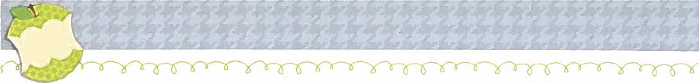
Dear Families,
Welcome to kindergarten! It's August and the beginning of a new school year is just around the corner. We are very excited about the coming school year! Kindergarten, here at Maugham, is a wonderful place to learn and grow!
Please have your child come to school each day with a backpack (no wheels, please) and a healthy snack. The backpack is essential for carrying things back and forth to school and we enjoy a snack each day at
Snack Time. We also request that your child  have in his/her locker for personal use:
- a seasonal change of clothes (labeled with name)  for community use:
- 2 boxes of Kleenex
- 2 boxes of "baby wipes" (Huggies brand works well)
- 2 boxes Crayola markers
Fine Line Classic Colors (10 count)
2 boxes of Crayola markers
Broad Line Classic Colors (10 count)
4 boxes of Crayola Crayons (24 count)
- 4 large glue sticks (Elmer's brand works well)
- 1 box of large 'Glad' bags (gallon size)
- I box of small 'Glad' bags (sandwich size)
- If you ordered your school supplies through the HSA Program, please note that the underlined items will not be included in your package.
As the year progresses, if you have any questions or concerns, please feel free to contact us at any time. Open communication between family and school is vital to each child's academic, social and emotional growth.
Enjoy what is left of the summer! We can't wait to see you on our ISt day!
Sincerely, 