Google Classroom Information
During the school year your child is part of Mrs. Cimler’s Google Classroom. Your child will have access to our Google Classroom at home. Being a member of Google Classroom allows your child to have access to websites and apps that we use throughout the year to enhance our learning.

To access our Google Classroom follow the steps below.
- Go to Google.com on your server (Chrome works best)
- In the top right corner click sign in
- Use the attached username and password to login
- In the top right corner click the square made of 9 dots
- From the dropdown menu, select classroom
- Click on Mrs. Cimler’s Classroom
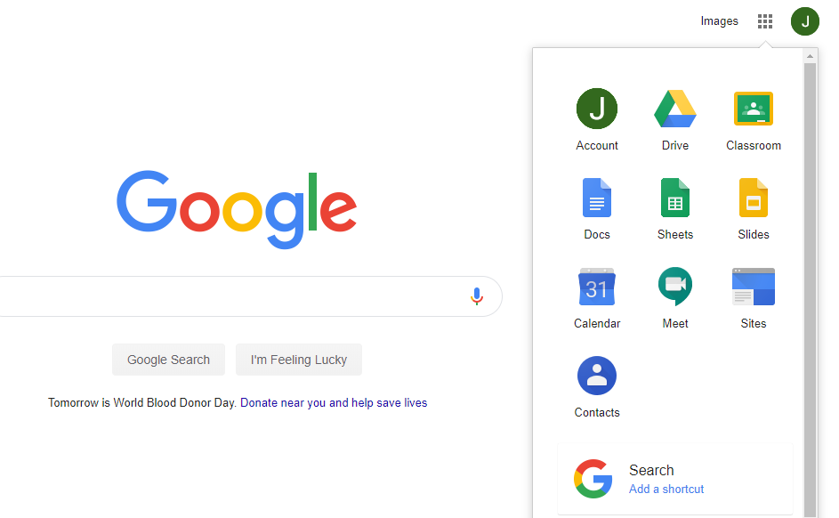
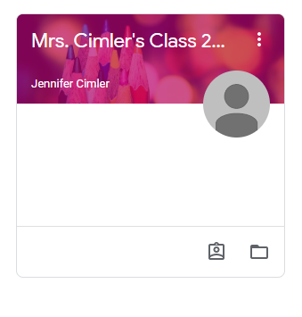
- Click on any posted assignment to have access to websites and apps

Username and password

