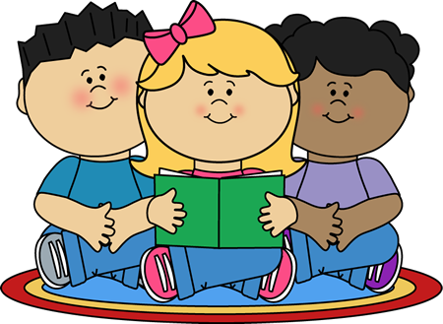
Guided Reading and Strategy Lessons
Guided reading is an instructional time when the teacher works with small groups of children showing them how to read, and supporting them as they read through texts. The goal is to help readers develop and use effective reading strategies as they read increasingly more difficult levels of text. Students will work with different groups as their needs change.
Shared Reading
The teacher uses a text that all students have a copy of or can clearly see. (This may be a Big Book, poem, directions, etc.) The text is used to teach and model specific reading and writing strategies. It often includes choral reading and active participation by the students.
Independent Reading
Each child has his/her own “book pot” with about 6-7 “just right” books in it. Students read on their own or sometimes with partners. Independent reading requires students to do independent word solving, practicing the strategies that they have learned. Sometimes students engage in partner reading, allowing opportunities to talk and respond to what they are reading. As students read, the teacher confers with individuals or partners.
Read Alouds
When reading aloud to the students, teachers demonstrate that reading is fun! It is an opportunity to model fluent reading behaviors, and to demonstrate the use of reading and comprehension strategies, when needed. It is also an opportunity to extend students’ knowledge of the world, expand language development, and provide opportunities to think and talk about both the text and illustrations. Read alouds are a valuable component of our literacy program.

