Track Static Warm Up
Feet Together – Hang
Right Over Left – Hang
Left Over Right – Hang
Spread Feet – Right Hang
Spread Feet – Left Hang
Sumo Squat

Hip Flexor – Right
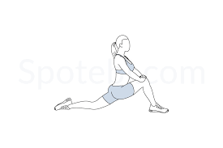
Hip Flexor – Left
Pigeon Right
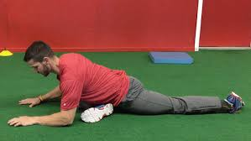

Pigeon Left

Figure 4 Right
Figure 4 Left
Seated Twist Right
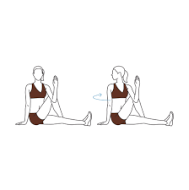
Seated Twist Left
Downward Facing Dog
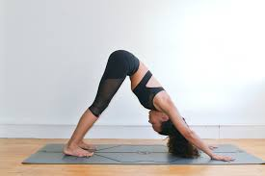
Downward Facing with Crossover

