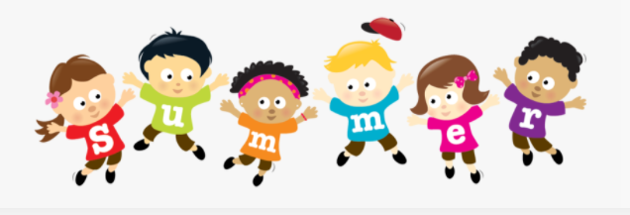  June | 2023

Sunday | Monday | Tuesday | Wednesday | Thursday | Friday | Saturday
 | *Student’s Choice | *Student’s Choice |  | 1 | 2 | 3
 | Allows the child to choose from snacks offered previously in the week. | Offered at the Program Coordinator’s discretion. |  | Fruit Cups  Cheese Stick/Cubes  Water | Breakfast Bar  *Milk  -or-  *Student’s Choice
4 | 5 | 6 | 7 | 8 | 9 | 10
 | Breakfast Bar  *Milk | Baked Chips  Cheese Stick/Cubes  Water | Muffin  *Milk | Cheez-its  Fruit Cups  Water | Animal Crackers  *Milk  -or-  *Student’s Choice
11 | 12 | 13 | 14 | 15 | 16 | 17
 | Multi-grain Chips  Fruit Cups  Water | Animal Crackers  *Milk | Chex Mix  Fruit Cups  Water | Muffin  *Milk
18 | 19 | 20 | 21 | 22 | 23 | 24
25 | 26  *Allergy Alternative Available | 27 | 28 | 29 |   30

