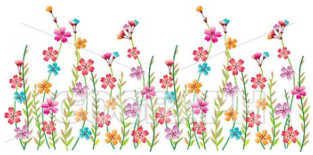  April | 2023

Sunday | Monday | Tuesday | Wednesday | Thursday | Friday | Saturday
*Student’s Choice | *Student’s Choice |  |  |  |  | 1
Allows the child to choose from snacks offered previously in the week. | Offered at the Program Coordinator’s discretion. |  | 
2 | 3 | 4 | 5 | 6 | 7 | 8
*Allergy Alternative Available | Multi-grain Chips  Fruit Cups  Water | Apple Slices w/Nutella  *Milk | Goldfish  Yogurt  Water | Chex Mix  Cheese Stick/Cubes  Water | Breakfast Bar  *Milk  -or-  *Student’s Choice
9 | 10  Spring Break | 11 | 12 | 13 |  | 15
 | 
16 | 17 | 18 | 19 | 20 | 21 | 22
 | Baked Chips  Fruit Cup  Water | Breakfast Bar  *Milk | Chex Mix  Cheese Stick/Cubes  Water | Muffin  Yogurt  Water | Cereal  *Milk  -or-  *Student’s Choice
23 | 24 | 25 | 26 | 27 | 28 | 29
 | Cereal  *Milk | Goldfish  Cheese Stick/Cubes  Water | Breakfast Bar  *Milk | Multi-grain Chips  Fruit Cups  Water | Animal Crackers  *Milk  -or-  *Student’s Choice
 |  |  |  |  | 

