  March | 2023
Sunday | Monday | Tuesday | Wednesday | Thursday | Friday | Saturday
*Student’s Choice |  |  | 1 | 2 | 3 | 4
Allows the child to choose from snacks offered previously in the week. |  |  | Breakfast Bar  *Milk | Baked Chips  Cheese Stick/Cubes  Water | Muffin  *Milk  -or-  *Student’s Choice
*Student’s Choice | 6 | 7 | 8 | 9 | 10 | 11
Offered at the Program Coordinator’s discretion. | Baked Chips  Cheese Stick/Cubes  Water | Apple Slices w/Nutella  *Milk | Chex Mix  Fruit Cups  Water | Granola Bar  *Milk | Breakfast Bar  Water  -or  *Student’s Choice
12 | 13 | 14 | 15 | 16 |   17 | 18
 | Muffin  *Milk | Animal Crackers  Yogurt  Water | Breakfast Bar  *Milk | Multi-grain Chips  Fruit Cups  Water | Cereal  *Milk  -or-  *Student’s Choice
19 | 20 | 21 | 22 | 23 | 24 | 25
 | Goldfish  Cheese Stick/Cubes  Water | Breakfast Bar  *Milk | Baked Chips  Fruit Cup  Water | Apple Slices w/Nutella  *Milk | Animal Crackers  Yogurt  Water  -or-  *Student’s Choice
26 | 27 | 28 | 29 | 30 | 31
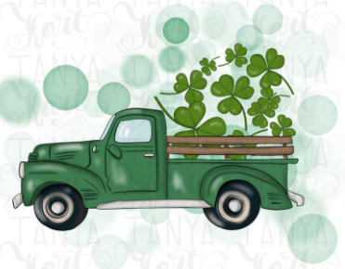 | Cereal  *Milk | Goldfish  Cheese Stick/Cubes  Water | No School | Chex Mix  Fruit Cup  Water | Apple Slices w/Nutella  *Milk | *Allergy Alternative Available

