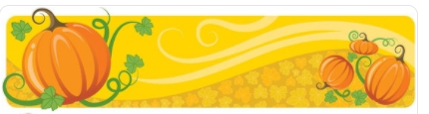  October | 2022
Sunday | Monday | Tuesday | Wednesday | Thursday | Friday | Saturday
*Student’s Choice | *Student’s Choice |  |  |  |  | 1
Allows the child to choose from snacks offered previously in the week. | Offered at the Program Coordinator’s discretion.
2 | 3 | 4 | 5 | 6 | 7 | 8
*Allergy Alternative Available | Goldfish  Cheese Stick/Cubes  Water | Apple Slices w/Nutella  *Milk | Multi-grain Chips  Fruit Cups  Water | Muffin  *Milk | Baked Chips  Fruit Cup  Water  -or-  *Student’s Choice
9 | 10 | 11 | 12 | 13 | 14 | 15
 | Muffin  *Milk | Cheez-Its  Cheese Stick/Cubes  Water | Apple Slices w/Nutella  *Milk | Breakfast Bar  Fruit Cup  Water | Cereal  *Milk  -or-  *Student’s Choice
16 | 17 | 18 | 19 | 20 | 21 | 22
 | Animal Crackers  *Milk | Breakfast Bar  Fruit Cup  Water | Muffin  *Milk | Cheez-Its  Yogurt  Water | No School!  Teacher Professional Development
23 | 24 | 25 | 26 | 27 | 28 | 29
 | No School!  Optional Teacher Workday | Cereal  *Milk | Goldfish  Cheese Stick/Cubes  Water | Multi-grain Chips  Yogurt  Water | Breakfast Bar  *Milk  -or-  *Student’s Choice
30 | Halloween 31
 | Apple Slices w/Nutella  *Milk |  |  |  |  | 