How to push in assignments from other gradebooks or add them to the current gradebook
Share assignments between classes but your gradebooks are not linked? You can still share some assignments by going to the dashboard of the gradebook and click on Manage and then Assignments.
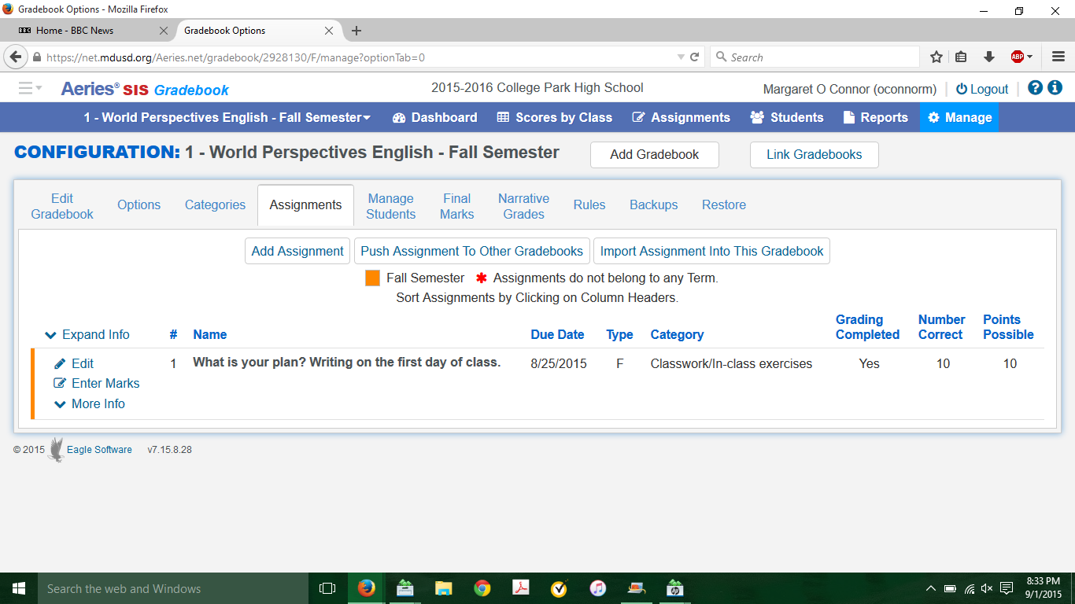
You import assignments into this gradebook from anyone else’s gradebook at CP who is on aeries. While it is a bit Big Brother-ish, it might be handy if someone has an assignment that you are using.
You can send an assignment to another of your gradebooks.
You can simply add an assignment as you have been doing.

