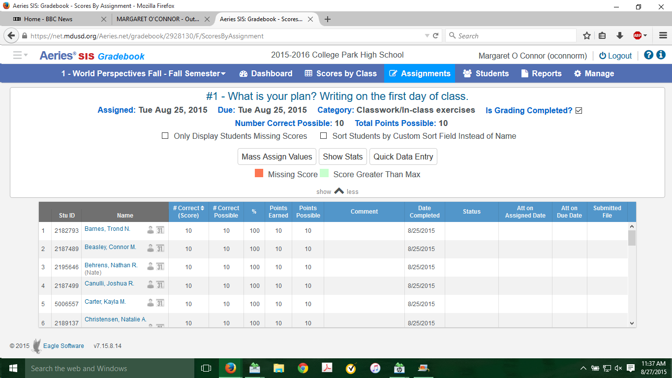
Notice that you have the ability to display MORE information (to mass assign values—super helpful when giving credit for a “for credit” assignment or locating students who have not turned something in—in case that ever happens in your class). You find this under the assignment where the arrow is that says SHOW MORE.

