HOW TO GET RID OF THESE STUDENTS IN YELLOW
As students drop/transfer from our classes, it might be important to know how to delete them. From the gradebook, go to the right side tab that says “Manage” and drop the menu down and go to Manage Students.

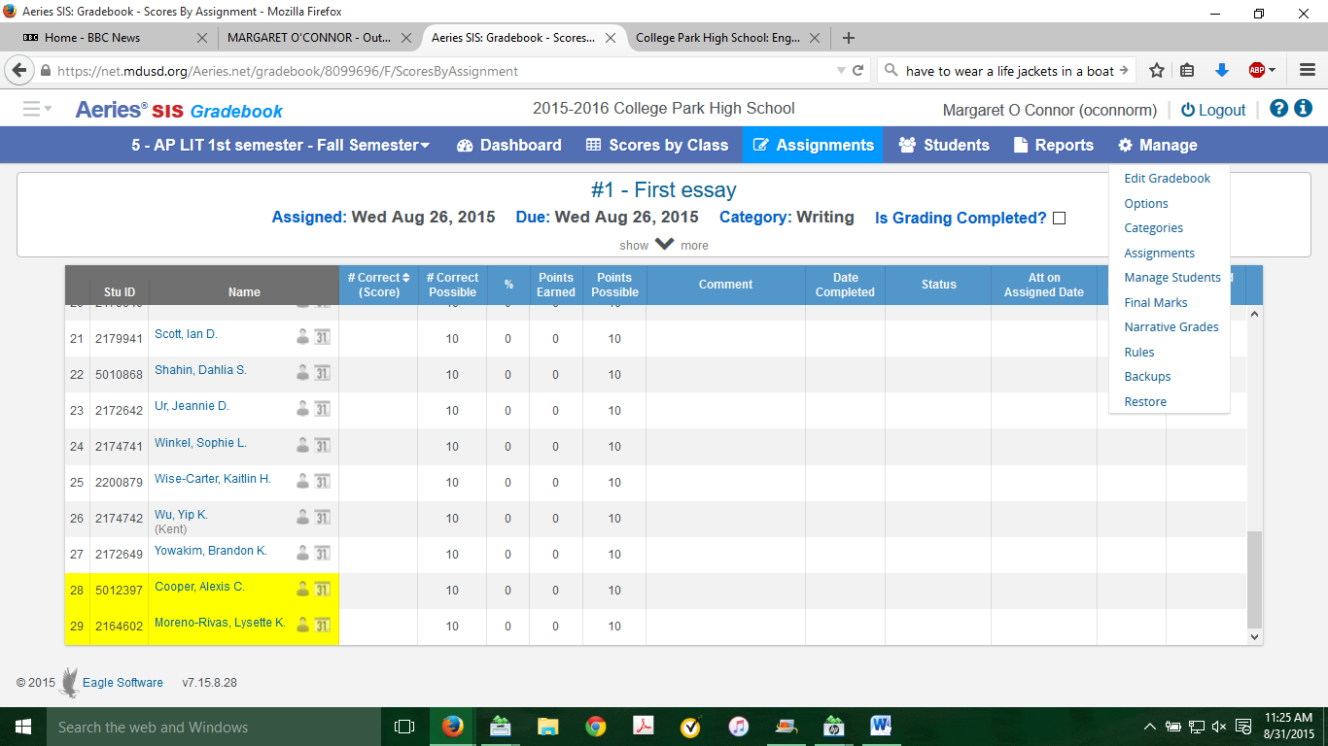

In order to make these important changes, you must click on the Allow deletes “button” on the top. If you don’t check this button, you will not have the delete option in the drop down menu next to each student’s name.
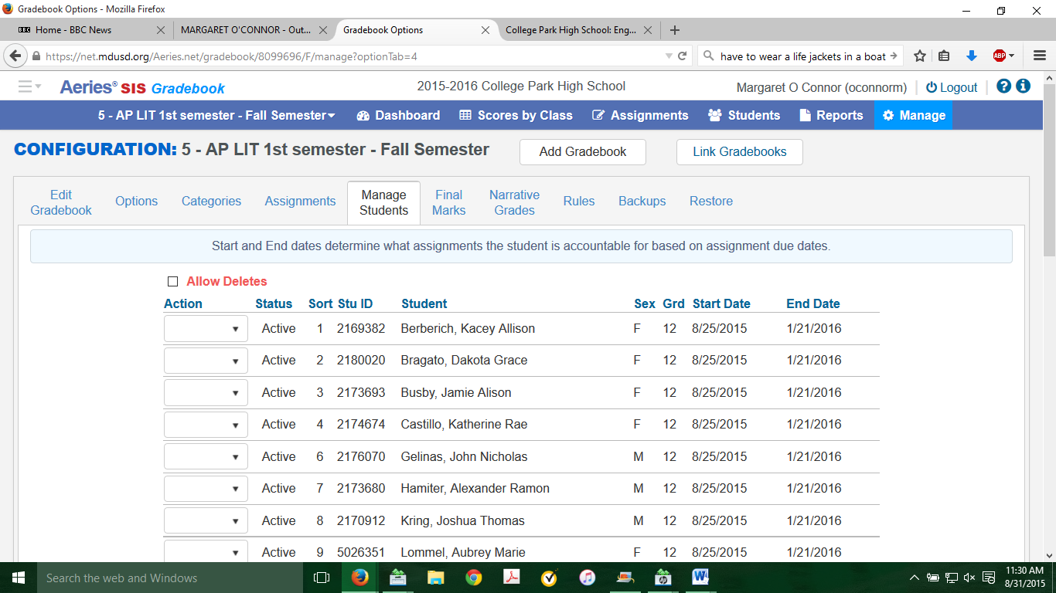
Although it is tedious, it has to be done one agonizing delete at a time. Fortunately, the students are in yellow, so that helps. By selecting delete, students in yellow will disappear from your gradebooks. As long as you don’t delete them, they will show up on homelink in your gradebook. This is frustrating for parents and students.

