Registration is open for the 21/22 school year. Please follow the steps below to register your student.
YOU MUST UPLOAD PROOF OF ADDRESS, BIRTH CERTIFICATE AND SHOT RECORDS! WE ARE NOT ACCEPTING HARD COPIES OF THESE DOCUMENTS. Failure to do so will result in a delayed registration acceptance. This includes all returning students.

Current and/or returning students:
Sign into your existing ParentVue account at mystudent.aps.edu In the upper right hand corner, you will see online registration. Click that tab to begin your registration.

If you already have a student in APS AND need to add a new student, this is where you will add them to your ParentVue account and register them.
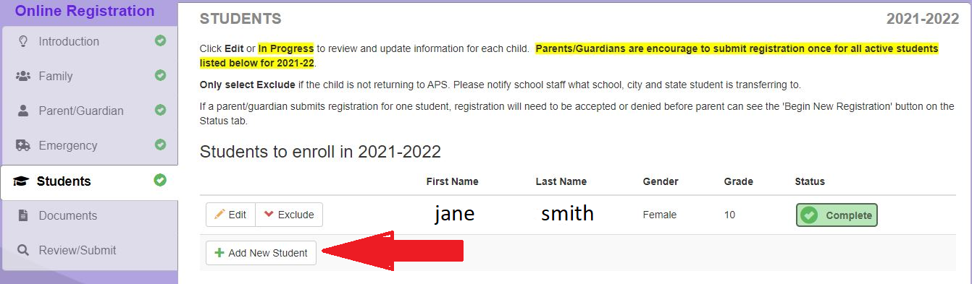

**DO NOT CREATE A NEW ACCOUNT IF YOU FORGOT YOUR USERNAME.** Please call the office until 6/9/21 to get that information. If you create a new account, it will create a duplicate student and we will not be able to accept that registration.
If you are BRAND NEW to APS and DO NOT have a student ID number, you must go to enroll.aps.edu to create an ID number and your ParentVue account. From there, you will complete your student registration.
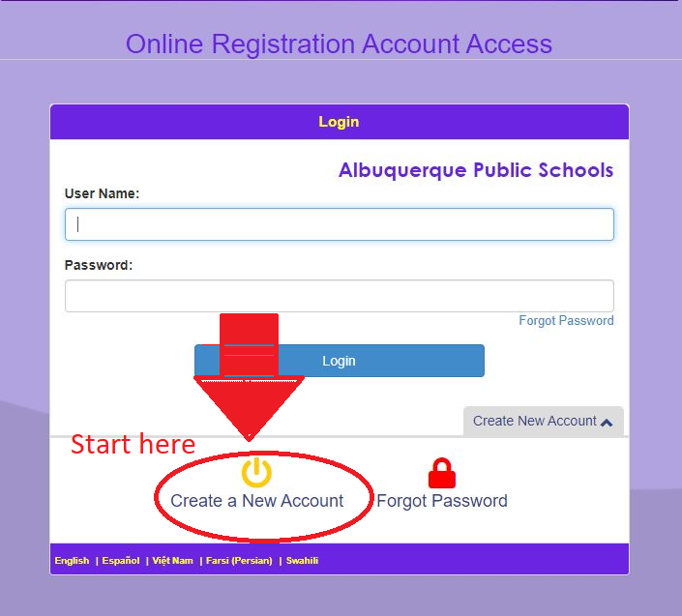

If you need to complete the registration in a different language, you can change the language from the options on the main page.


If it tells you that you need an activation code, it means you already have a student with an ID number. Call the office until 6/9/21 to get that code to set up your account.

YOU MUST UPLOAD PROOF OF ADDRESS, BIRTH CERTIFICATE AND SHOT RECORDS! WE ARE NOT ACCEPTING HARD COPIES OF THESE DOCUMENTS. Failure to do so will result in a delayed registration acceptance.

