
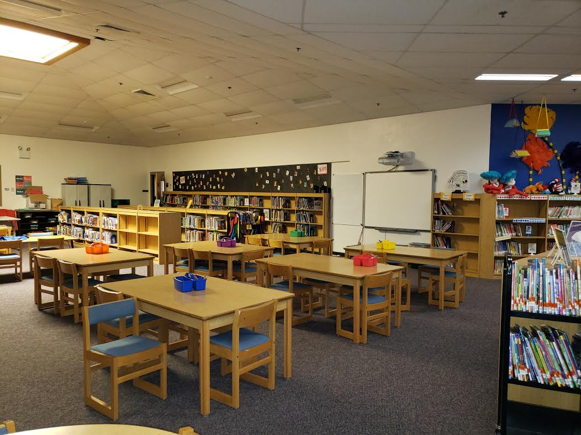

LMC (LIBRARY)

5830 Devoro Road
Fitchburg, Wi. 53711
To reserve this facility,
please fill out and submit this Facility Request Form.

For more information please contact:

Jeanene Ennis
Facility and Event Scheduling Coord.
608-845-4329
ennisj@verona.k12.wi.us

- 8 tables
  - 6 rectangular tables w/ 6 chairs each
  - 2 round tables w/ 4 chairs each
- Projector and screen/whiteboard on wall
- 3,381 sqft.

