
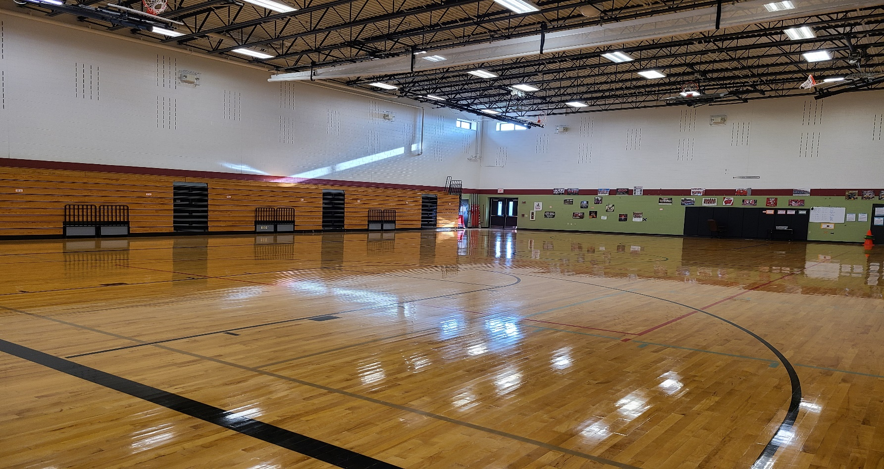

GYMNASIUM

5830 Devoro Road
Fitchburg, Wi. 53711
To reserve this facility,
please fill out and submit this Facility Request Form.

For more information please contact:

Jeanene Ennis
Facility and Event Scheduling Coord.
608-845-4329
ennisj@verona.k12.wi.us

- 1 main basketball court
  - Can be split into 2 side courts; mesh divider available
- 6 hoops
- Bleachers on one side
- 8,262 sqft.

