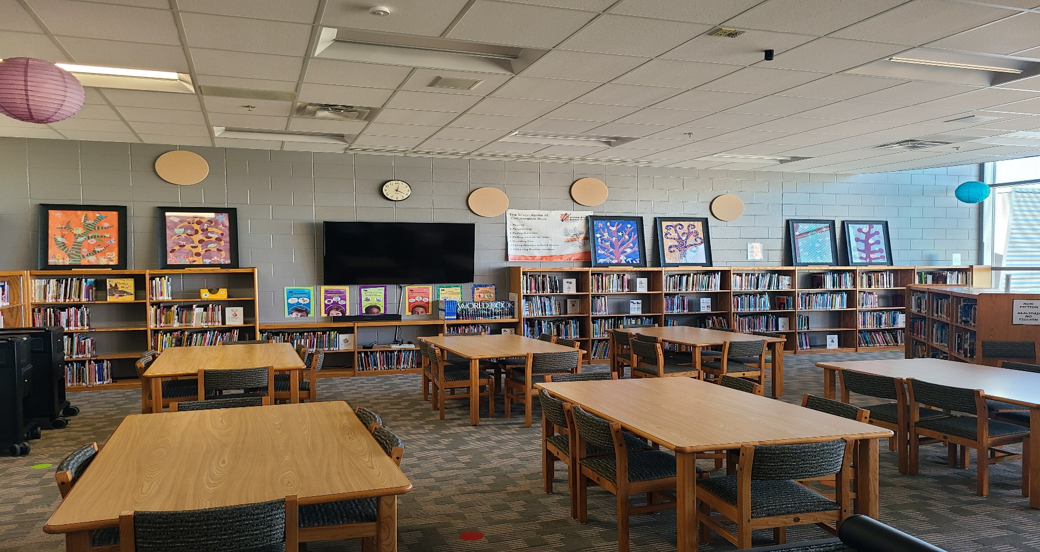


- 6 tables w/ 6 chairs each; seats 36
- 1 smart TV on wall
- 3,199 sqft.

LMC (LIBRARY)

800 Kimball Lane
Verona, Wi. 53593
To reserve this facility,
please fill out and submit this Facility Request Form.

For more information please contact:

Jeanene Ennis
Facility and Event Scheduling Coord.
608-845-4329
ennisj@verona.k12.wi.us

