DAVID SOMMERS ‘74
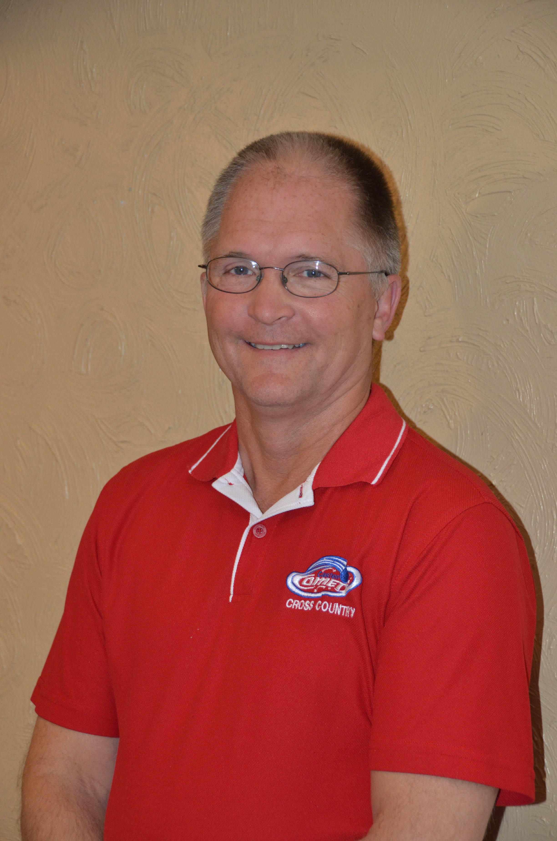

Multi-tasking and lifelong learning has been a way of life for David Sommers. A ‘74 graduate, he was active in music, drama, and sports, as well as National Honor Society, Student Council, Fellowship of Christian Athletes, Future Farmers of America and Student Rotarian. Each of these experiences at Caston helped Dave develop skills he continues to utilize today.

Dave attended Purdue University after high school and returned home to farm near Grass Creek. He felt called to serve as a pastor, and become a certified lay speaker filling in for vacationing or ill pastors with Sunday morning messages and kid’s moments by the time he was 30 years old. In 1991, Dave became a licensed Local Pastor for the United Methodist Church. He served at Fletcher’s Lake and Lucerne Zion UMC until 2012, and currently serves at Fletcher’s Lake and Grass Creek UMC’s. He impacts the community through his parishioner care providing comfort and encouragement in difficult times for those in need. Dave presently continues his education through the United Methodist Church.

Dave’s mission work extends beyond the local community. In 2007, he founded the Loaves of Love Mission; a ministry of the Fletcher’s Lake UMC, and is the chief baker and marketer for over 90 flavors of bread raising an average of $15,000 per year for mission work. He has also led multiple mission trips to Red Bird Mission in Kentucky, Henryville, Indiana and many local mission projects including the Grass Creek UMC Mission House.

Dave has also made a mark in seed sales while working for various seed companies since 1979. Since 1991 he has worked for Stine Seed Company, currently as a District Sales Manager. Having covered 17 counties in northeast Indiana, he has successfully seen district sales grow exponentially as he has developed the regions within those counties.

Through the years, Dave has actively worked with youth at Caston, coaching Varsity X-Country, Track and Elem. Basketball. He was named the Midwest Conference Coach of the Year for X-Country, and annually organized a training week at Brown Country State Park; a highlight of many kid’s X-Country experience. He also fills in as a substitute bus driver. Dave has volunteered in the Elementary School by conducting Junior Achievement classes and has organized educational farming programs for the kids as well.

Active in the Indiana Farm Bureau since 1978, Dave became a board member in 1986 and has continued to hold multiple offices until present, including ten years as Vice President of Fulton Country Farm Bureau. He currently serves as the District 2 Farm Bureau Elect Chairman. He has served on advisory committees for Representatives Steve Buyer and Joe Donnelly, and in 2002 was the Indiana Farm Bureau ACE Ambassador to France. He has also been an active member of the Grass Creek Lion’s Club and has also held multiple offices in that organization through the years.

Dave and his wife Dottie were married in 1977 and live near Kewanna. They have four grown children: Nick, Abby, Chris, and Kassie, whom they took into their home in 2006. They now enjoy their 13 grandchildren whenever they can. Dave shared that his faith in the Lord is the driving force that has allowed him to do all that he does. His favorite Bible verse, 2nd Tim. 4:6-8 “to fight the good fight, keep the faith and finish the race” inspires him daily.

AARON SHERRICK ‘90
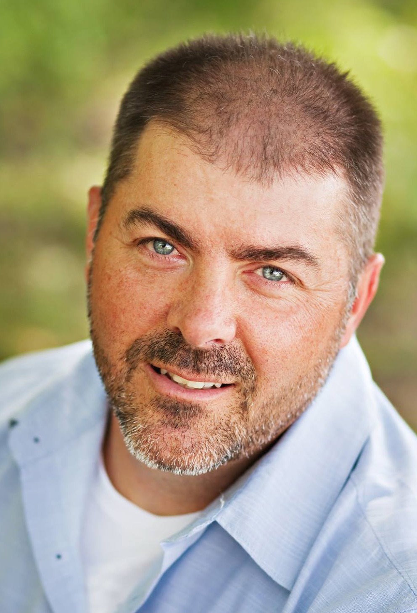

Growing up in the "Biggest Little Town in the World" has had a huge impact on who Aaron is today. Playing a part in such a small community allowed him to get involved and make a difference in the lives of people. He learned to be humble and work really hard in order to achieve his goals.

Aaron is a 1990 graduate of Caston and attended from Kindergarten through 12th grade. He participated in football, wrestling, and track all four years of high school while being active in many clubs, a member of the National Honor Society and Caston Athletic Hall of Fame.

Aaron graduated from Purdue University in 1997 with a Bachelor's degree in Computer Graphics. He began his professional career as a technical illustrator for The Boeing Company in St. Louis, MO. While there he was promoted into the role as Webmaster for the Technical Publications department. For nearly 20 years, Aaron has worked in the IT field for both the manufacturing and healthcare industries as a web designer and developer. His current position is Lead Technical Consultant for Perficient, based out of St. Louis with a branch in Carmel, Indiana. He is also co-owner of Jen Sherrick Photography, a small business his wife and he started in 2005.

From 2006 to 2010, Aaron was president of Nehemiah Vision Ministries (NVM), a non-profit organization that is a grassroots effort in a small community outside of Port-au-Prince, Haiti. The vision of the ministry is focused on moving people from darkness to light and from hopelessness to eternal life. During the time that Aaron served this ministry, a school/church was built, a feeding program was established to provide a single meal to the students in school, a sponsorship program started which helped support the students and teachers, medical and construction mission teams began, and a children’s home was started for several orphans in the community.

Aaron currently lives in Westfield, Indiana with his wife Jen and their four children: Madison, Christian, Connor, and Caleb. They are very active in the community and at Imagine Church, a local church that they helped to launch in 2012. Aaron and his wife have also been leading life groups in their home for over 10 years and have gone on international mission trips to Mexico and Haiti.

In an effort to improve communication and awareness is his Westfield neighborhood of 1200 homes, Aaron began working with the police department to implement a neighborhood watch by using a secure social network for neighborhoods called NextDoor (www.nextdoor.com). The social network has now been extended to all 32 neighborhoods in Westfield and is used by the police and city's communication department to share important alerts, local events, and city news.

Aaron gives credit to God for all things, especially for opening up the doors to so many people and opportunities. He is grateful for his parents, Jim and Midge Sherrick, for modeling to him a strong work ethic, but most importantly for believing in him during each step of his journey. His life motto is, “Never stop serving, always help others, and keep learning something new everyday.” He would like to share it with you so that the message can continue to be passed along as a blessing to others.

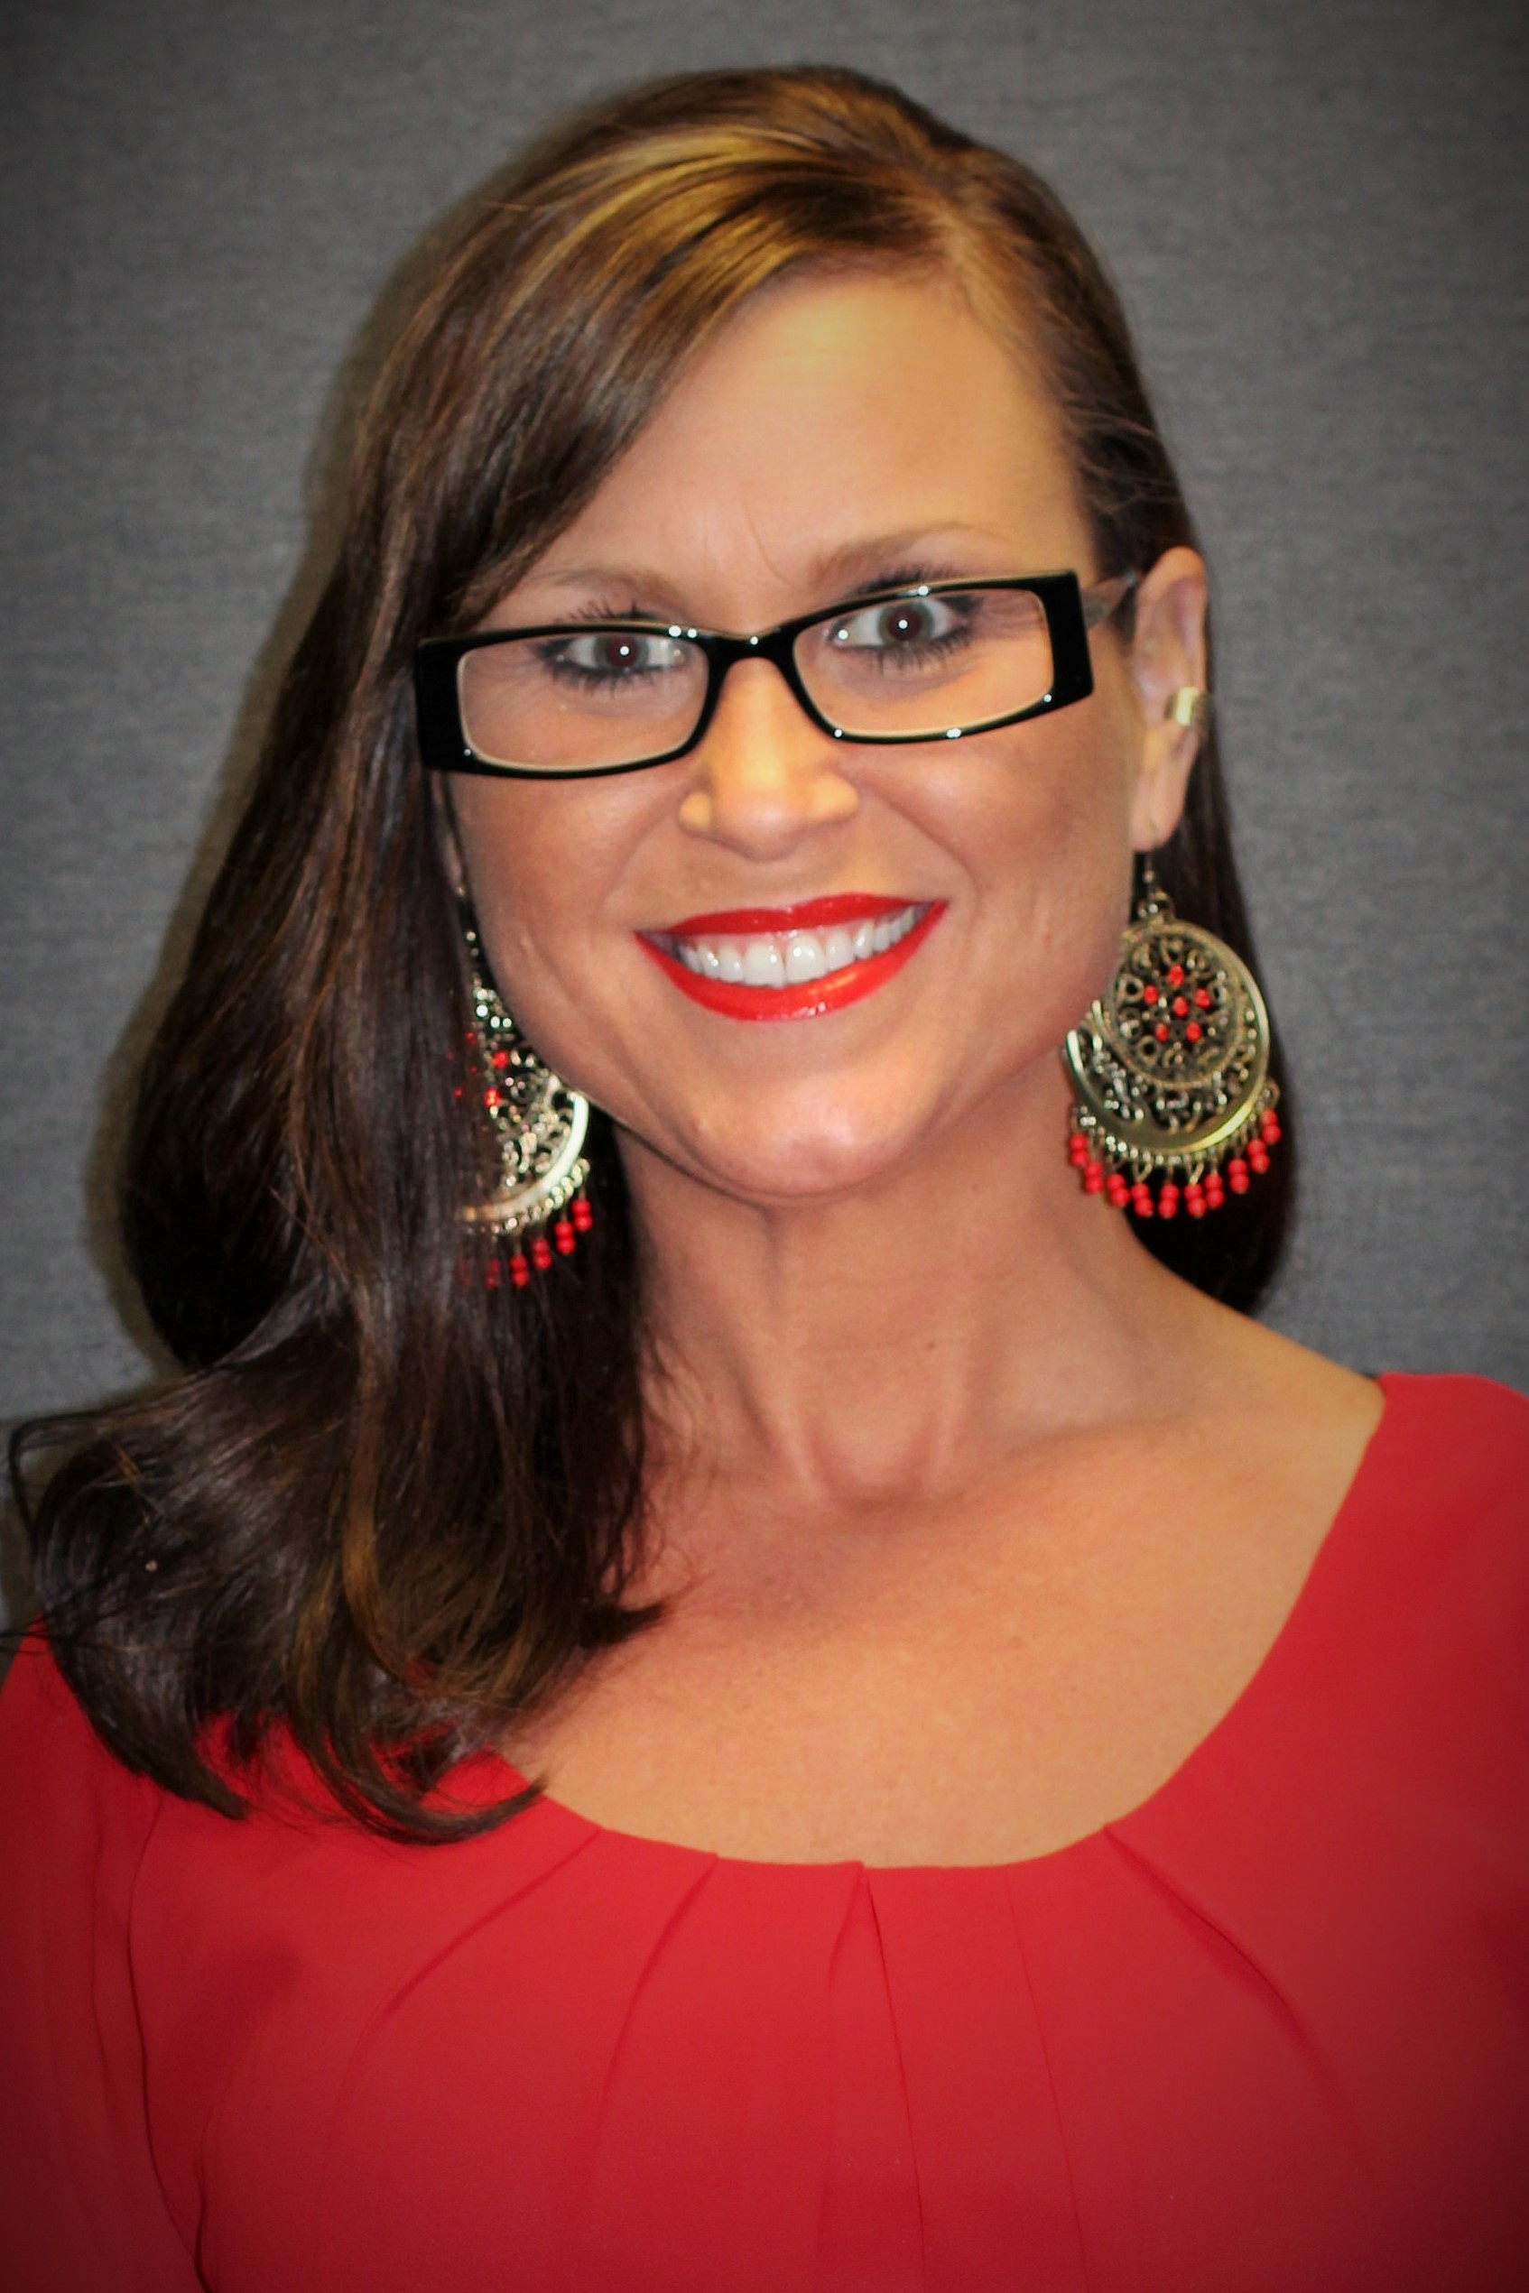
HEATHER AULT CLARK ‘95
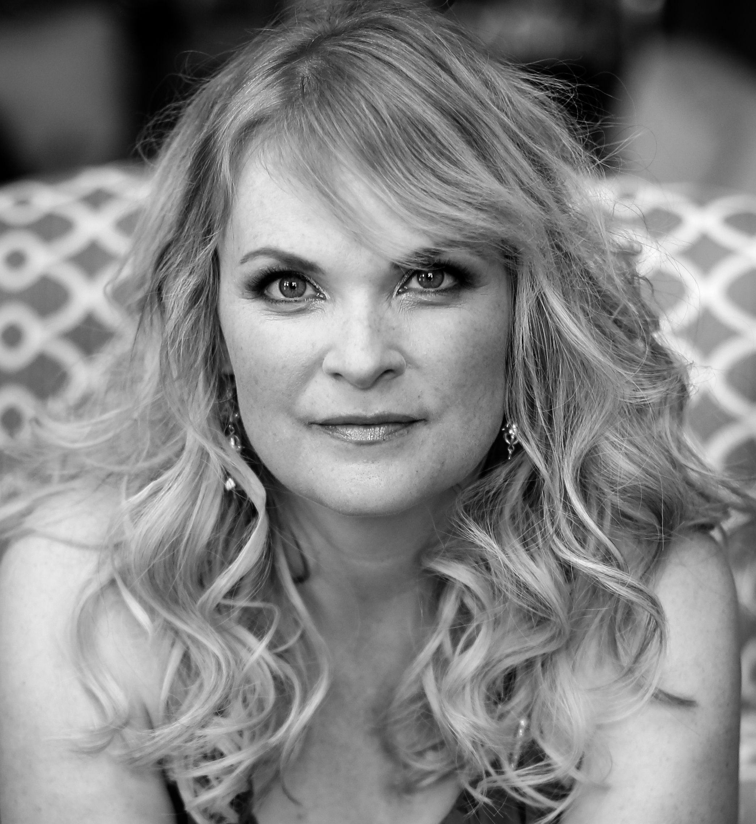

It’s no surprise that Heather devoted a great deal of time in High School to the fine arts through participation in Drama & Art Club, Plays, Band, Chorus & Swing Choir. Heather also weighed in with academic accomplishments; she was class Salutatorian, a member of National Honor Society, and competed in the Art & Science academic teams, Spell Bowl, and both Spanish and Science Club. Add to that FFA, FHA, Cross Country, Track and Cheerleading and you have a well-rounded girl ready to take on the world. That, in fact, is what Heather has attempted since graduating from Caston in 1995.

Heather attended Purdue University, graduating with a Bachelor’s degree in Education. She also attended IUPUI, furthering her post-secondary education in New Media. Heather has combined her love and talent for music, education, and ambition to establish herself as an internationally recognized recording artist and performer. Since 2004 she has been the owner and artist of Heather Ramsey Clark Music. As an acclaimed soul, jazz and R&B vocalist she brings her unique vocal and piano styling to songs from every era. She is a vocal artist, producer, arranger and songwriter and has released two albums to critical acclaim. She recently completed a European tour and is preparing for the release of her first EP of originals later this year in partnership with renowned producer/writer Michael Whittaker of Nashville, TN. (heatherramseyclark.com)

In addition to performance work, Heather shares her passion for music as co-founder and vocal and performance instructor at the Midwest School of Voice. (discovermsv.com) She also founded and directs Young Voices Inspire, a group allowing young vocal artists the opportunity to work in a semi-professional setting performing popular music in service to their community at large. A strong advocate for women in the arts, Heather founded the Overture Institute and D.I.V.A. Songwriting Camp in 2010 with her longtime friend and collaborator, Dr. Monika Herzig (beagooddiva.org). Their work continues to inspire countless young women to create and explore their own passion for music and songwriting.

Since 2007, Heather has also been the Founder, Marketing/Branding Consultant & Designer for Ingredients Design (ingredientsdesign.com); a small marketing firm that creates relevant, cutting edge products to market other small businesses – one of which includes the remodel/redesign of Grubb Restaurant in Fulton, as well as creation and branding for The Boss Hogg & The Boss Hogg Challenge.

In 2014, Heather became the Founder/President of The Warehouse; a 1950’s machine shop turned live music venue and art space. It now includes state of the art stage and lighting equipment, a bar, and an art gallery. The Warehouse is a hip, edgy, fun place to enjoy all varieties of live performance and is available, as well, for private events. (liveforthemusic.com)

With all of Heather’s professional ventures, it’s amazing that she finds time to do even more community service. Since 2013 she has served as Marketing & Logistics Committee Chairperson for the Carmel PorchFest (carmelporchfest.org).

Heather resides in Carmel, Indiana with her husband, Blair Clark, stepson, Blair Clark Jr. and their adorable shih-tzu, Chewie. Her music is available on iTunes and CDBaby.com – and be sure to check out her Pandora Station!

KRISTIN HURST VANSOEST ‘98

Kristin left her mark on Caston as a graduate of the class of ’98 when humorously voted by her classmates as the loudest in the class. The ability to be heard, however, has been a notable strength as she leads a thriving business with an incredible reputation for quality service in multiple aspects of occupational health and safety. “Saving Lives. Saving Companies” is the mission she lives by daily.

A graduate of Indiana University with a B.S. in Occupational Health and Safety Management and an MBA from Indiana Wesleyan University, Kristin is a certified OSHA Outreach Instructor for General Industry as well as a Certified Slip and Fall Accident Prevention Specialist. Kristin now serves as the President and CEO of Safety Resources. Safety Resources is a Certified Woman-Owned Business with the City of Indianapolis, a Certified Woman-Owned Business with the State of Indiana, A Certified Woman-Owned Business with the National Council, and a Certified Disadvantaged Business Enterprise through the Indiana Department of Transportation (INDOT).

Kristin is a board member (Program Chair) of the Central Indiana Chapter of the American Society of Safety Engineers (ASSE). She is on the Safety Program Committee with the Metro Indianapolis Coalition for Construction Safety (MICCS). She is an active participant in the Indiana Construction Association (ICA) and a member of the ICA Joint Safety Committee as well as the ICA Membership Committee. She is a professional member of the American Society of Safety Engineers (ASSE), the National Association for Women in Construction (NAWIC) and the International Contact Group for Slips, Trips and Falls. Kristin has most recently been involved with NAWBO (National Association of Women Business Owners) and the Indiana Construction Roundtable (ICR).

Specializing in General Industry, with a focus on the measurement of coefficient of friction on walking/working surfaces, Kristin's article on Slips, Trips and Falls was recently published in the trade magazine Sealant, Waterproofing and Restoration. Kristin has been a recurring speaker for Business and Legal Reports audio conferences, casing Slips and Falls Management as well as OSHA 300 Recordkeeping Laws. She has also been invited as a guest speaker from a local association discussing Accident Investigation Strategies.

Kristin was the moderator for a panel discussion casing OSHA partnerships at the project level, company level and for association involvement in 2011 for the Indiana Construction Association. She has been a guest speaker for multiple events and organizations, and continues to stay active in the following charities: TheraPlay, Leukemia and Lymphoma Society, Indy Do Day, Bosma Enterprises, Toys for Tots and St. Mary’s Child Center.

Kristin received an "Outstanding and Dedicated Vendor Support" award and the "Outstanding Client Services" award in 2004-2007 from a national client for her insight and risk liability assessments at both the management and operations levels. Kristin is a member of the National Association of Professional Women. She is especially known for her servant leadership, encompassing her drive, dedication, work ethic, family values and generosity.

Kristin lives in Avon, Indiana, with her husband, Jeremy, and two daughters, Ainslee and Anniston. She enjoys reading, camping and spending time with her children.

