

Middle School Facilities Master Plan
Survey Results

Journey Middle School

Albemarle County Public Schools
May 24 - June 5, 2023



I am:
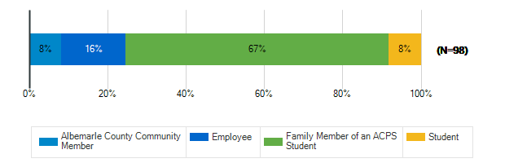

What are the most important qualities for middle school sites/grounds in the 21st century? : Safety & Security
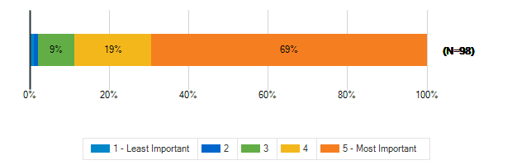

What are the most important qualities for middle school sites/grounds in the 21st century? : Growth & Capacity
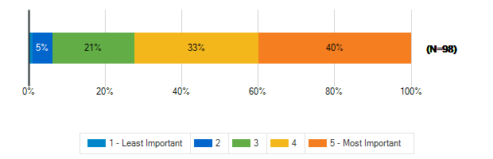

What are the most important qualities for middle school sites/grounds in the 21st century? : Outdoor Spaces
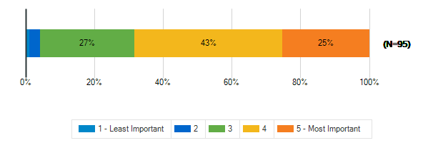

What are the most important qualities for middle school sites/grounds in the 21st century? : Sustainability & Natural Resources
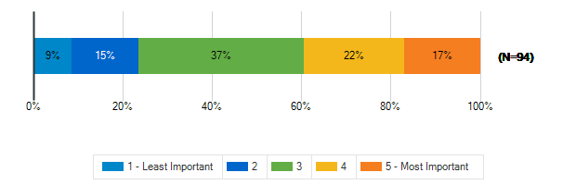

What are the most important qualities for middle school sites/grounds in the 21st century? : Community Access & Amenities
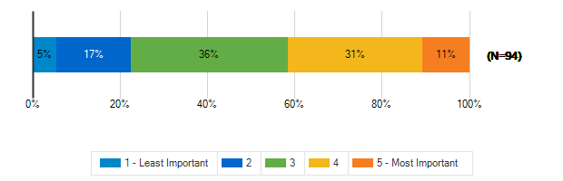

What are the most important qualities for middle school sites/grounds in the 21st century? : Positive, Healthy Culture
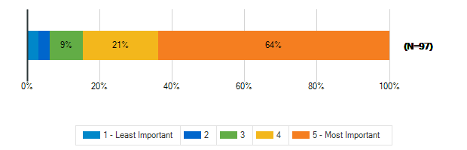

What are the most important qualities for middle school sites/grounds in the 21st century? : Welcoming, Comfortable, Aesthetic Spaces
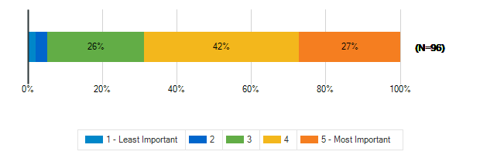

What are the most important qualities for middle school sites/grounds in the 21st century? : Durability, Flexibility, Cost-Efficiency
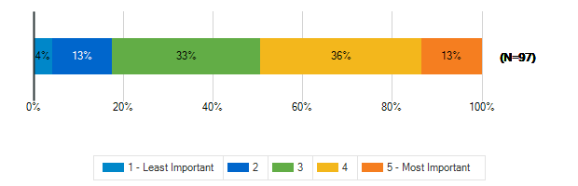

What are the most important qualities for middle school sites/grounds in the 21st century? : Sustainable/Net-Zero Construction
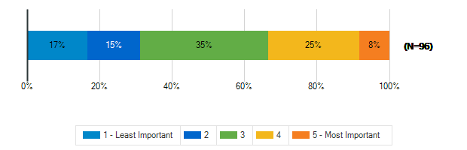

To what extent does your middle school support the following?: A sense of pride and well-being in staff and students
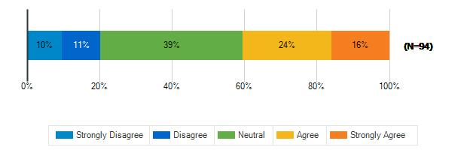

To what extent does your middle school support the following?: Prioritizing the outdoor environment
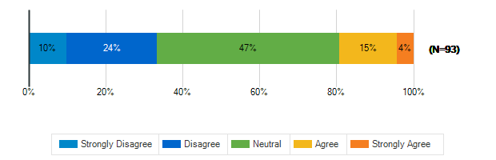

To what extent does your middle school support the following?: Natural resources available to students, staff, and the community
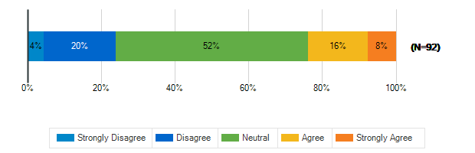

To what extent does your middle school support the following?: Educational resources available to students, staff, and the community
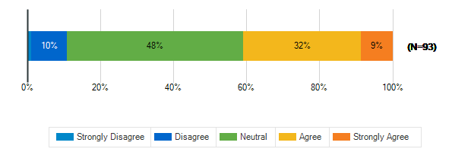

To what extent does your middle school support the following?: Health and fitness
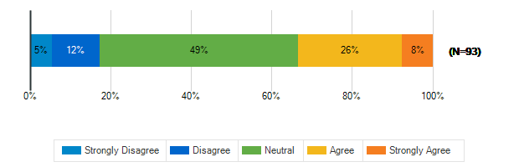

To what extent does your middle school support the following?: Diversity and inclusion
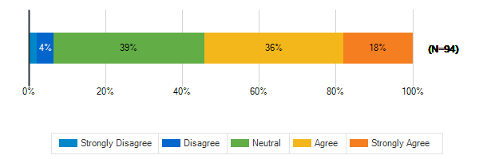

To what extent does your middle school support the following?: Environmental sustainability
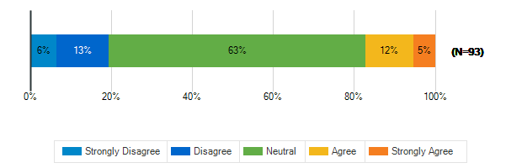

In a few words, what do you think is the greatest opportunity facing our middle school students today?
1. | Bullying
2. | there are few opportunities for children today
3. | None
4. | Providing opportunities for kids who want to learn
5. | Student engagement in their role in community
6. | Technology
7. | Ability to learn without outside interferences
8. | Increased use of technology
9. | The growth of technology and project based learnin
10. | Knowledge
11. | diversity, options to pursue interests
12. | To help around the school and be part of pto.
13. | How to be successful and motivating ourselves
14. | Pathway to higher education/deepening capacity of
15. | Becoming a bilingual nation.
16. | Access to technology
17. | Everything available to them
18. | I am not sure
19. | We need more schools, specifically north of cville
20. | Ability to be amazing and excel with materials
21. | Power of technology, to create and effect changes
22. | Project based learning, tailored instruction
23. | Opportunity and ability to access information
24. | Learning real world applicable skills
25. | Space, safety, respect,
26. | Preparation for advancement in high school
27. | Having a DEIA culture as a norm and not a long
28. | AI and how to use it appropriately
29. | Knowing what their comfortable with
30. | Opportunity to have roles in and around the school
31. | Access to information through the web
32. | Being free thinkers
33. | Getting an excellent education
34. | try different things and find out their skill sets
35. | Study world language
36. | A focus on athletics or other extracurricular acti
37. | Learning with information at their fingertips.
38. | The ability to learn from talented teachers and pr
39. | Greatest opportunity is a free education
40. | Empowered to understand/disrupt systemic oppresion
41. | The ability to learn from our diverse community.
42. | Access to teachers that care about the whole child
43. | many opportunities and access to information
44. | Exposure to racial diversity
45. | The relevance of their education in their lives.
46. | Interacting with others
47. | No lo se
48. | Bullies
49. | The ability to meet and a diverse group of people.
50. | Inclusion and diversity, and a sense of community.
51. | Exploring individual interests at school
52. | Feeling safe in the classroom
53. | Learning
54. | Journey has great orchestra, band and art teachers
55. | Connecting with learning in a way that is engaging
56. | Technology
57. | Emotional development
58. | Technology
59. | Inclusivity, overcrowding & behavioral issues
60. | they need social-emotional well being
61. | Diverse material and Diverse student placement
62. | opportunities greatest asset, materials,motivation
63. | This survey doesn't help capture the needs of our
64. | the opportunity to work with diverse populations
65. | Op for ACPS to REinvent instruct plan to support
66. | to be a security guard
67. | lots of electives/opportunities early in school
68. | Conscientiousness and openness
69. | The possibilities are endless.
70. | Growing pains

In a few words, what do you think is the greatest challenge facing our middle school students today?
1. | societal opinions on HOW a school should be run
2. | Caring staff & inspiring learning environment
3. | Unsafe atmosphere
4. | Peer pressure and self identity
5. | having a safe environment and quality education
6. | Ability to feel safe at school
7. | Social media
8. | Socail Media
9. | Safety and overcrowded aging buildings
10. | Technology dependence
11. | Phones, social media, anti-education
12. | social media, healthy peer interactions
13. | Dark environment, not enough light, and negative v
14. | Mental health
15. | Education to be used as tool for self growth
16. | Getting off screens
17. | Social media/ balancing access to technology
18. | The reach of Social Media,skewed personal percepti
19. | Safety and Bullying
20. | We need more schools, specifically north of cville
21. | Limited resources in school schools
22. | Social dynamics, online vs real relationships
23. | Overcrowding
24. | Behavior issues and chaos in the classroom
25. | Social media
26. | Social separation and division - lack of inclusion
27. | too many students, not enough support for teachers
28. | Sense of community and respect
29. | The age and quality of existing facilities
30. | safety
31. | Social media/cell phones; lack of community
32. | Resetting learning norm/expectations post covid
33. | Solving conflict in a positive way and belonging
34. | Using bad words(their annoying)
35. | drama
36. | Access to social media through the web
37. | Ability to question everything
38. | School shootings & wokeness
39. | Digital devices, social media
40. | Appropriate use of personal technology
41. | Trash talk / Bullying
42. | Cell phones in schools.
43. | Lack of accountability
44. | Structure and discipline is a thing of the past
45. | Detaching from tech and healthy relationships
46. | Feeling safe while holding people accountable.
47. | Too many choices that are narrowly defined
48. | school safety,respect toward others,too much onlin
49. | violence in the community, safety
50. | Lack of racial equity
51. | The burnout of teachers, negative view of schools
52. | Online media access
53. | No se
54. | Peer pressure
55. | Alienation common for students in huge schools
56. | COVID left a broken sense of social norms/civility
57. | Maintaining a positive self image
58. | Safety and security.
59. | Bullying
60. | Basic education, reading, math, science
61. | Too much screen time, poorly paid staff, ineffect.
62. | Classroom size
63. | Social media and screen addiction
64. | Safety and security
65. | Emotional support
66. | Technology
67. | capacity of space
68. | Equitability
69. | cops should not be in school they are dangerous
70. | Bad parenting
71. | The lack of safety and assurance and respect.
72. | Having support at home and school
73. | current middle schools but rather asks what the
74. | social media
75. | lack of diversity at Henley/ Western
76. | Mental health and getting basic needs met
77. | fire drills
78. | safety concerns and social media
79. | Enthusiasm for in-person learning and engagement
80. | Electronic's distractions

To meet the needs of students, educators, families and the community, a middle school facility in Albemarle County MUST HAVE
1. | money/knowledge/open mind/willingness to change
2. | Sufficient space and staffing that cares about ALL
3. | Enough staff and space to help students feel heard
4. | Enough room for all the students w/o crowding
5. | Support
6. | Safety
7. | A lot of space and upgraded fixtures/walls
8. | Journey needs more space
9. | Lots of teachers!
10. | flexibility, responsiveness
11. | More light and positivity in the learning environm
12. | Mental health support
13. | Extra curricular and be close to home
14. | Paper learning. Decreased use of screens in schoo
15. | Enough room to keep class sizes manageable
16. | Fitness Center. Adequate/available sporting facili
17. | Plans just in case ,Punishment's for kids if need
18. | Room for students, faculty and staff
19. | Spaces for community, needs, rooms for sm groups
20. | Windows, technology, open and smaller spaces
21. | Space
22. | Great outdoor space and programming to utilize it
23. | More schools
24. | Physical Education, at least 20 min study hall
25. | another high school or you are not fixing problem
26. | Enough space to accommodate growth
27. | A flexible and developing master plan
28. | more space
29. | Safe learning environments
30. | a commitment to healthy relationships
31. | Art that isn't too controlled
32. | More support from counselors
33. | Passionate, qualified instructors enabled by admin
34. | Safe bathrooms free of fights and drugs
35. | Must have facilities to enable students to attend
36. | library, gym, auditorium and an activity lab
37. | Strong world language instruction
38. | Great indoor and outdoor communal spaces
39. | a no cell phone policy.
40. | Gathering spaces for classes and families
41. | Resource officers and consistency
42. | Accessible indoor & outdoor community spaces
43. | A large enough space and workers to accomodate all
44. | Adequate HVAC, #s of classrooms and offices, & out
45. | student accountabiity
46. | technology, safe and inviting spaces, accessible
47. | Resources (Financial and staff)
48. | Professional Learning to support novices
49. | Small class sizes and multiple counselors & TAs
50. | Más seguridad
51. | Enough teachers
52. | a close knit faculty and student body
53. | Enough space without ruining the environment
54. | A good staff to student ratio
55. | The ability to remove disruptive and violent stude
56. | Great communication
57. | Solid education plan
58. | Well paid staff. Outside time.
59. | Happy teachers
60. | Security and safety plan for mass shooting
61. | I don’t know
62. | Enough counselors to meet mental health needs
63. | adequate space
64. | A sustainable, building that's size is equipped s
65. | black faculty; anti-racism mandatory training
66. | Welcoming, Comfortable, Aesthetic Spaces
67. | Engaged parents, faculty pay increase
68. | Resources and a choice of interest. Support.
69. | Discipline and rules
70. | division wants to find. We need a better survey
71. | outdoor space for students to get fresh air
72. | a diverse student population
73. | An innovative instruct plan to meet needs of all
74. | a safe space
75. | kindness
76. | well designed safety plan all staff can implement
77. | Highly qualified and engaging teachers
78. | Set Rules and boundaries and enough counselors
79. | Security and safety

Tell us more about the following resource spaces in your school & grounds?

How often do you use?: Teacher Work Rooms
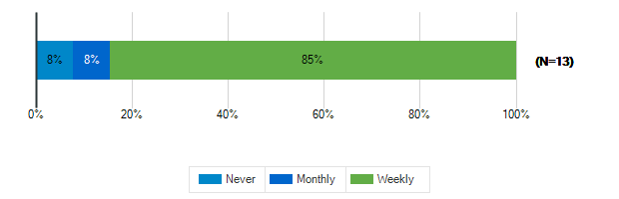

How often do you use?: Teacher Lounge
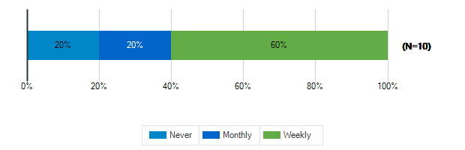

How often do you use?: Library
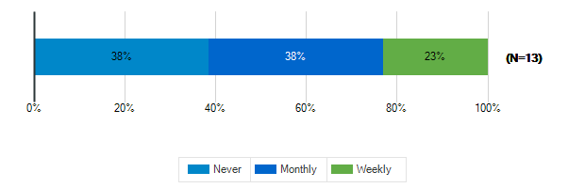

How often do you use?: Stage/Auditorium
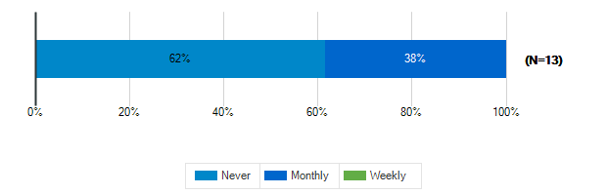

How often do you use?: Outdoor Classrooms
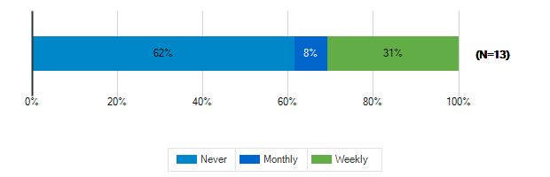

How often do you use?: Administrative Offices
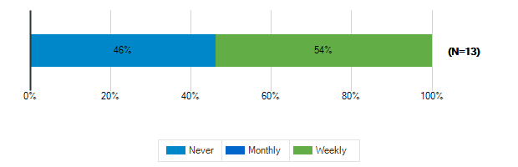

How often do you use?: Conference Room
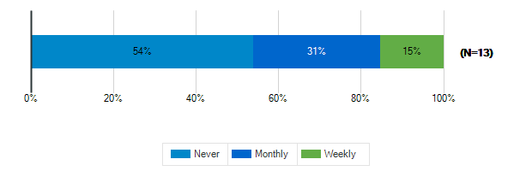

How often do you use?: Cafeteria
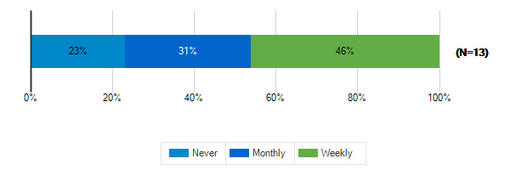

How often do you use?: Shared Spaces
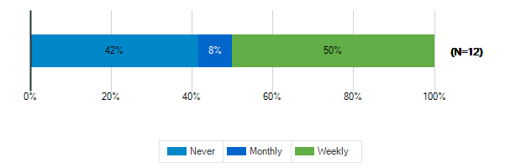

Tell us more about the following resource spaces in your school & grounds?

How would you rate the quality?: Teacher Work Rooms
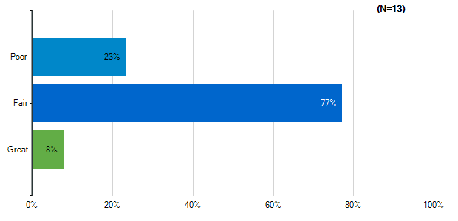
Note: Multiple answers per participant possible. Percentages added may exceed 100 since a participant may select more than one answer for this question.

How would you rate the quality?: Teacher Lounge
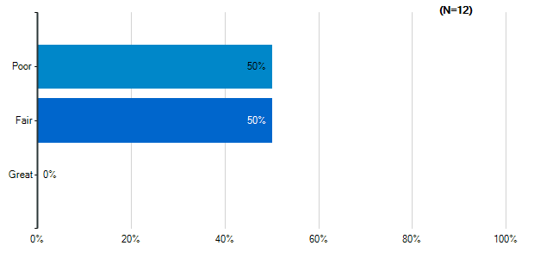
Note: Multiple answers per participant possible. Percentages added may exceed 100 since a participant may select more than one answer for this question.

How would you rate the quality?: Library
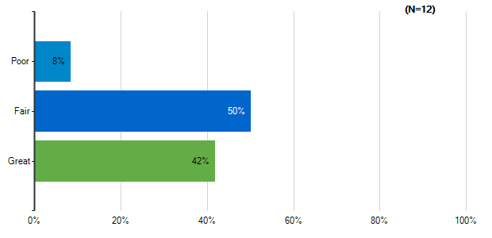
Note: Multiple answers per participant possible. Percentages added may exceed 100 since a participant may select more than one answer for this question.

How would you rate the quality?: Stage/Auditorium
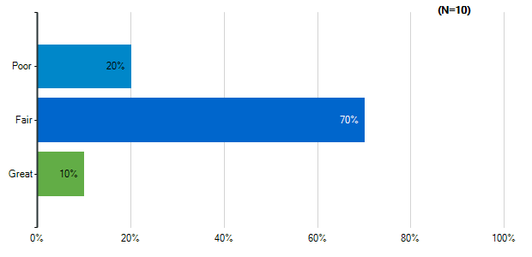
Note: Multiple answers per participant possible. Percentages added may exceed 100 since a participant may select more than one answer for this question.

How would you rate the quality?: Outdoor Classrooms
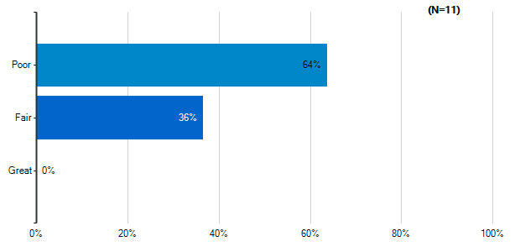
Note: Multiple answers per participant possible. Percentages added may exceed 100 since a participant may select more than one answer for this question.

How would you rate the quality?: Administrative Offices
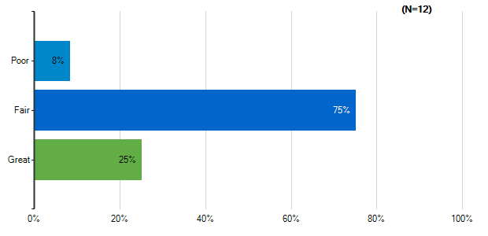
Note: Multiple answers per participant possible. Percentages added may exceed 100 since a participant may select more than one answer for this question.

How would you rate the quality?: Conference Room
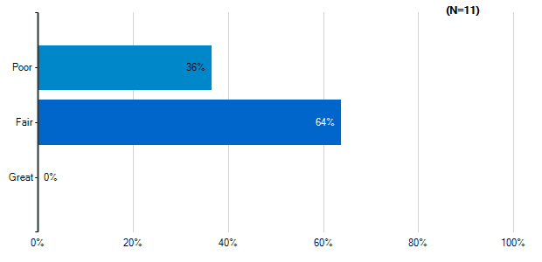
Note: Multiple answers per participant possible. Percentages added may exceed 100 since a participant may select more than one answer for this question.

How would you rate the quality?: Cafeteria
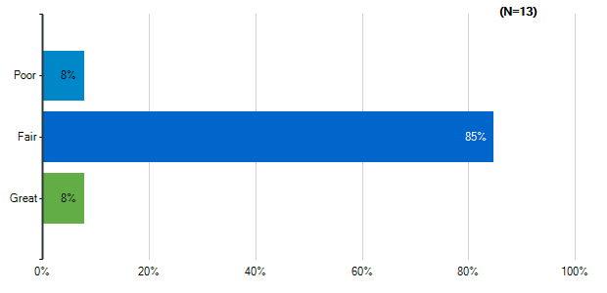
Note: Multiple answers per participant possible. Percentages added may exceed 100 since a participant may select more than one answer for this question.

How would you rate the quality?: Shared Spaces
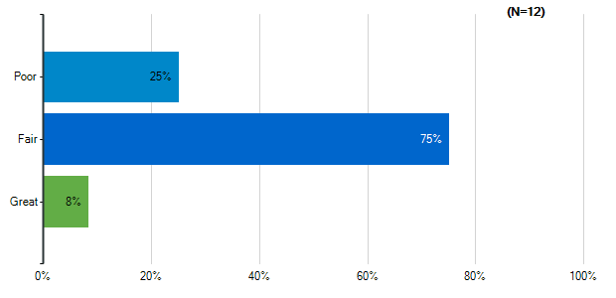
Note: Multiple answers per participant possible. Percentages added may exceed 100 since a participant may select more than one answer for this question.

Please indicate how satisfied you are with the following characteristics of your middle school building:: Cleanliness & Maintenance
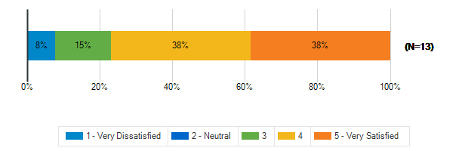

Please indicate how satisfied you are with the following characteristics of your middle school building:: Security & Safety
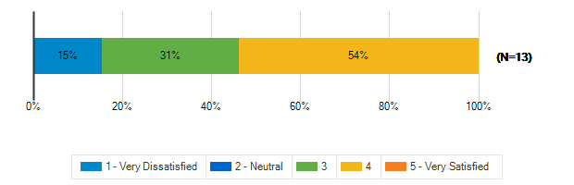

Please indicate how satisfied you are with the following characteristics of your middle school building:: Signage and Wayfinding
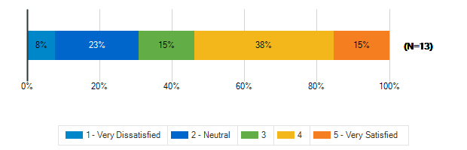

How frequently do your students engage in the following activities in your classroom: Lecture/Lessons
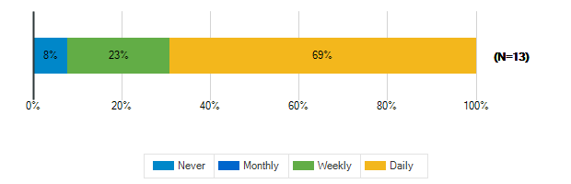

How frequently do your students engage in the following activities in your classroom: Learning Centers/Listening Stations
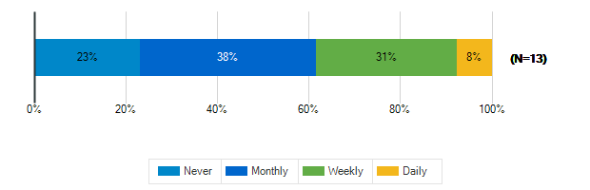

How frequently do your students engage in the following activities in your classroom: Student Presentations Performances
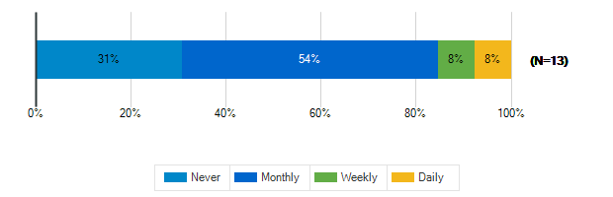

How frequently do your students engage in the following activities in your classroom: Group Activities/Projects
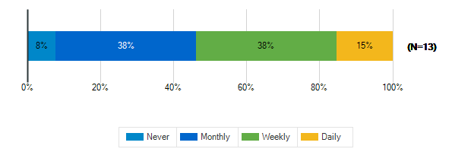

How frequently do your students engage in the following activities in your classroom: Individual Work
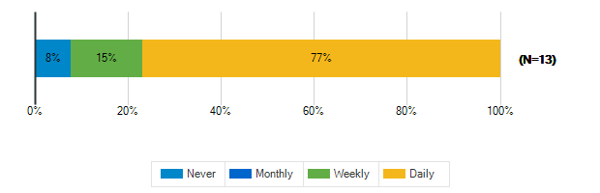

How frequently do your students engage in the following activities in your classroom: Technology/Computer
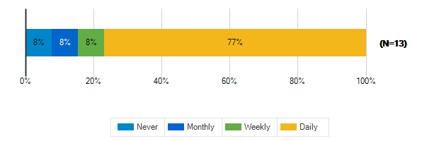

How frequently do your students engage in the following activities in your classroom: Physical Activity/Movement Breaks

How would you describe the following characteristics of your classroom?: Location
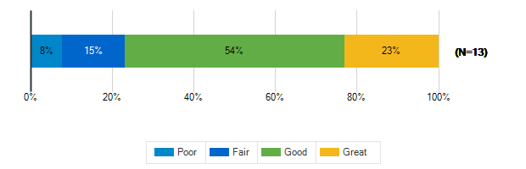

How would you describe the following characteristics of your classroom?: Size
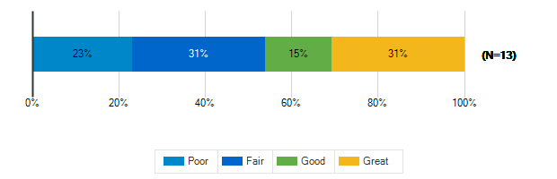

How would you describe the following characteristics of your classroom?: Security & Safety
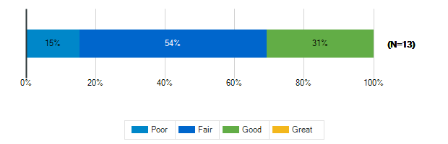

How would you describe the following characteristics of your classroom?: Storage (Amount, Design, Location)
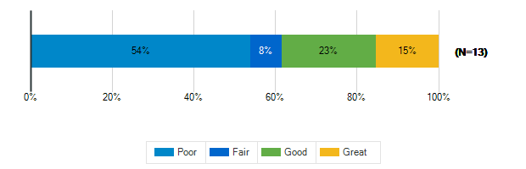

How would you describe the following characteristics of your classroom?: Cleanliness & Maintenance
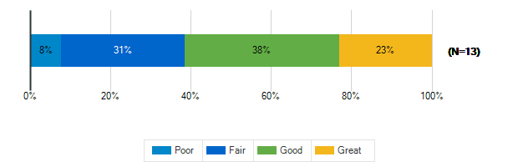

How would you describe the following characteristics of your classroom?: Availability of Technology (including WiFi & power outlets)
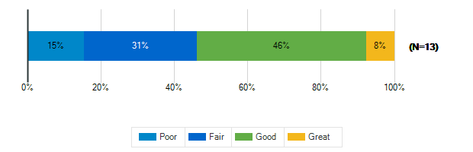

How would you describe the following characteristics of your classroom?: Functionality (including versatility and adaptability)
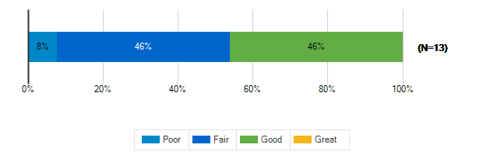

How would you describe the following characteristics of your classroom?: Natural Lighting/Ventilation
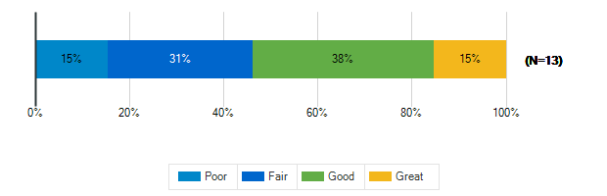

How would you describe the following characteristics of your classroom?: Access to Outdoor Spaces and/or Outdoor Visibility
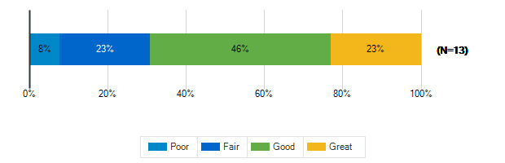

How would you describe the following characteristics of your classroom?: Electric Lighting
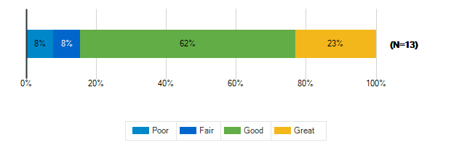

How would you describe the following characteristics of your classroom?: Air quality
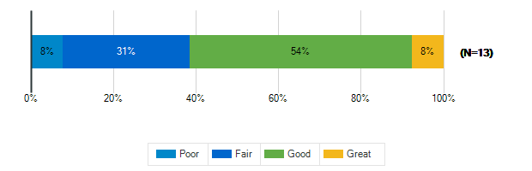

How would you describe the following characteristics of your classroom?: Acoustics
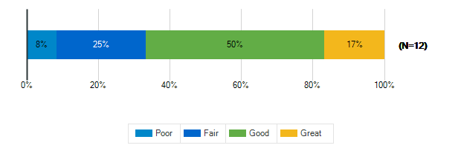

How would you describe the following characteristics of your classroom?: Furniture
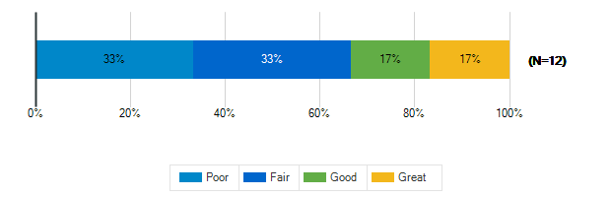

How would you describe the following characteristics of your classroom?: Dry Erase Boards/Display Boards/Bulletin Boards
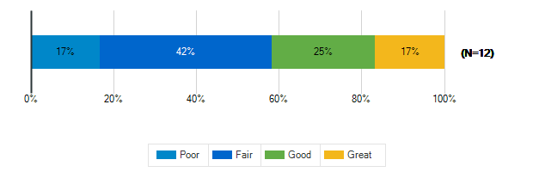

How would you describe the following characteristics of your classroom?: Finishes (Floors/Walls/Ceiling/etc.)
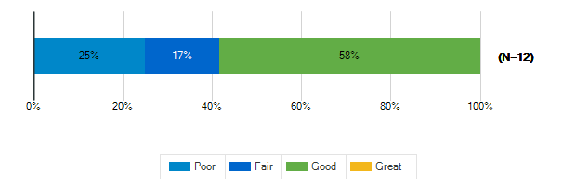

Please rank the following indoor amenities in order of priority for future spaces
Responses | Rank 1 | Rank 2 | Rank 3 | Rank 4 | Weighted Score | Relative Weighted Score | Overall Rank
Spaces designed for versatility to accommodate a variety of uses | 6 | 6 | 1 | 2 | 46 | 100 | 1
Dedicated restrooms for staff | 5 | 3 | 4 | 3 | 40 | 87 | 2
Outdoor access for science and other specialty classrooms | 3 | 3 | 2 | 7 | 32 | 70 | 3
Dedicated teacher work areas and personal storage area | 1 | 3 | 8 | 3 | 32 | 70 | 3

If you’ve taught at or seen a middle school with a feature that doesn’t exist at ACPS that you think should be here, please identify it:
1. | A tool that can come down from the ceiling to block the door and prevent an intruder/shooter from coming in
2. | Sensory Room
3. | "houses" for each grade level to build community
4. | aesthetically pleasing outside spaces that are flexible (can be a classroom/place to study) and find ways for it to be integrated into a part of the curriculum such as an extension of 7th grade biology.
5. | Outdoor dining areas with picnic tables, auditorium, maker spaces, calm rooms, conference spaces for meetings with families, multilingual signage, age-appropriate play-ground
6. | N/A
7. | A quiet workspace that is always available for all students to visit with a teacher able to assist.
8. | middle school athletics program; outdoor spaces
9. | bells for class change

What is your grade level?
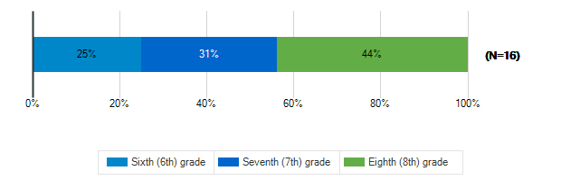

Tell us about the spaces in your school and on your school grounds:

How often do you use these spaces?: Media Center
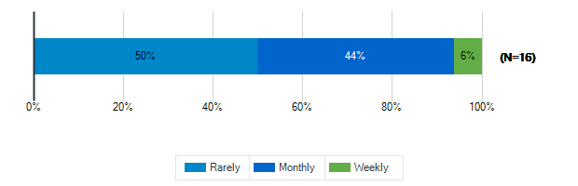

How often do you use these spaces?: Cafeteria
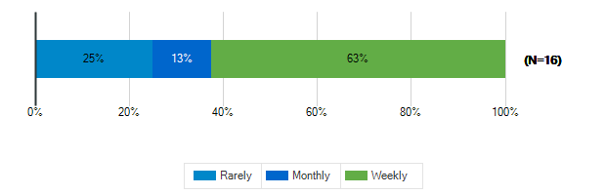

How often do you use these spaces?: Gymnasium
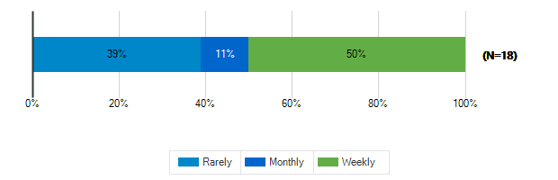

How often do you use these spaces?: tage/Auditorium
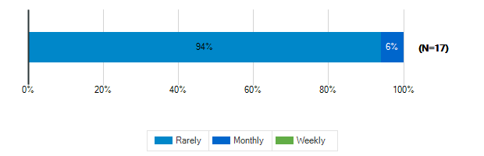

How often do you use these spaces?: Outdoor Classrooms
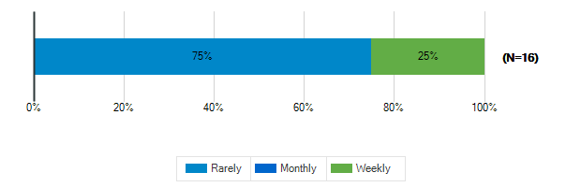

How often do you use these spaces?: Outdoor Recreation/Athletic Fields
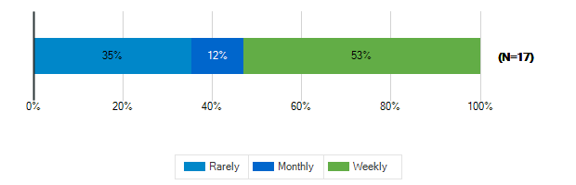

Tell us about the spaces in your school and on your school grounds:

How would you rate these spaces?: Media Center
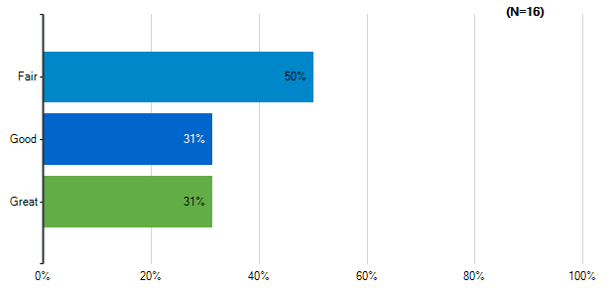
Note: Multiple answers per participant possible. Percentages added may exceed 100 since a participant may select more than one answer for this question.

How would you rate these spaces?: Cafeteria
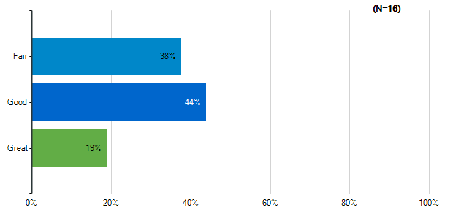
Note: Multiple answers per participant possible. Percentages added may exceed 100 since a participant may select more than one answer for this question.

How would you rate these spaces?: Gymnasium
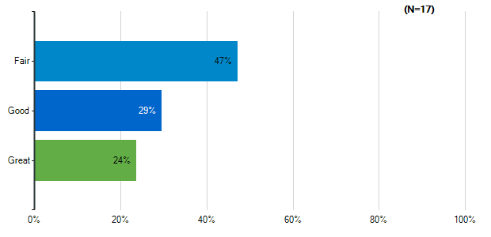
Note: Multiple answers per participant possible. Percentages added may exceed 100 since a participant may select more than one answer for this question.

How would you rate these spaces?: tage/Auditorium
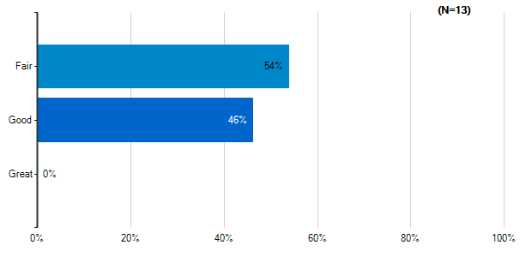
Note: Multiple answers per participant possible. Percentages added may exceed 100 since a participant may select more than one answer for this question.

How would you rate these spaces?: Outdoor Classrooms
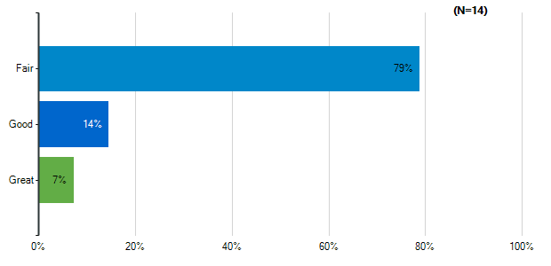
Note: Multiple answers per participant possible. Percentages added may exceed 100 since a participant may select more than one answer for this question.

How would you rate these spaces?: Outdoor Recreation/Athletic Fields
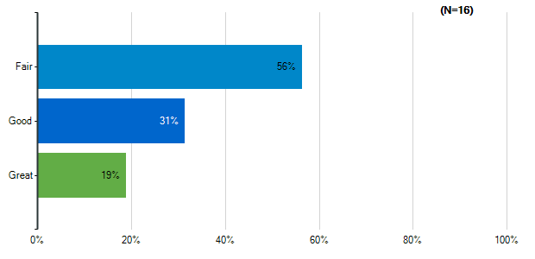
Note: Multiple answers per participant possible. Percentages added may exceed 100 since a participant may select more than one answer for this question.

How would you rate the quality of the following characteristics of your classrooms?: Size
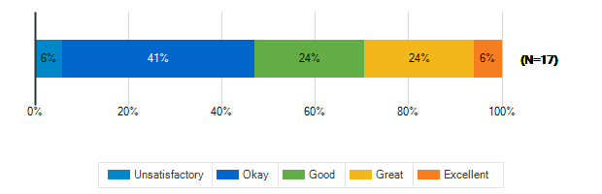

How would you rate the quality of the following characteristics of your classrooms?: Cleanliness
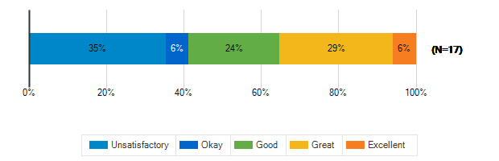

How would you rate the quality of the following characteristics of your classrooms?: Furniture
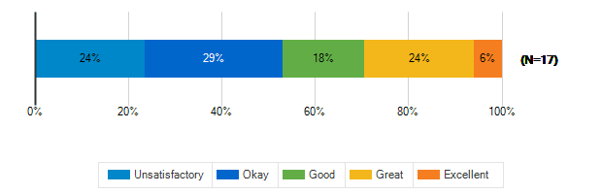

How would you rate the quality of the following characteristics of your classrooms?: Color Scheme/Décor
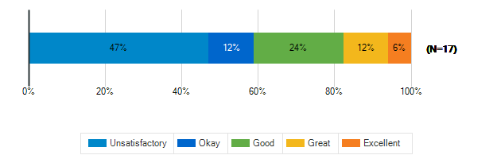

How would you rate the quality of the following characteristics of your classrooms?: Security & Safety
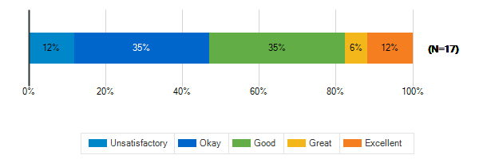

How would you rate the quality of the following characteristics of your classrooms?: Technology (including WiFi and power outlets)
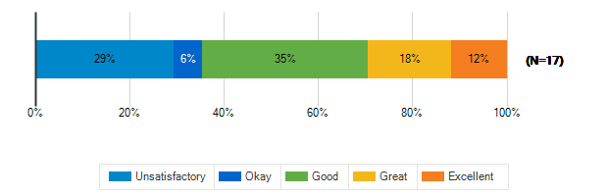

How would you rate the quality of the following characteristics of your classrooms?: Natural Lighting
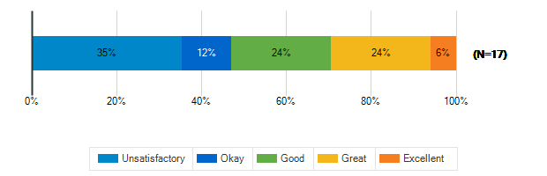

How would you rate the quality of the following characteristics of your classrooms?: Access to Outdoor Spaces and/or Outdoor Visibility
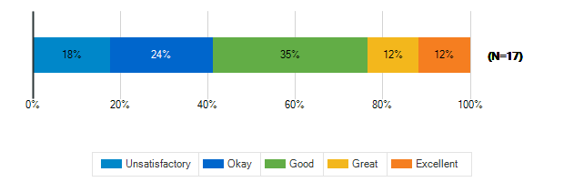

What is the best thing about your middle school?
1. | SCA sponsored events
2. | The staff and the administration
3. | Friends, ELA, and P.E.
4. | The People
5. | Diverse
6. | My 7th grade LA teacher aka Ms. Beneke
7. | my friends
8. | Access to outside spaces
9. | The team I work with.
10. | It’s not lakeside
11. | diversity
12. | nothing
13. | I have lots of friends in my schoo;

What is the worst thing about your middle school?
1. | The safety, class materials, and lunches
2. | We need more support
3. | Dark mood.
4. | Certain social things
5. | Color, old furniture, old flooring
6. | Art
7. | drama
8. | The kids trash the outside and no consequences
9. | Adult/student concern for shared spaces
10. | The overcrowding/class size
11. | No auditorium
12. | capacity; outdated facilities
13. | nonprofessional behavior of safety coaches
14. | everything
15. | there are lots of drills that we have to practice

How satisfied are you with the following characteristics of your child’s school?: Availability of Parking
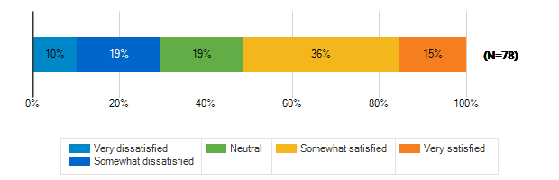

How satisfied are you with the following characteristics of your child’s school?: Design/Flow of CAR Drop-Off and Pick-Up for Students
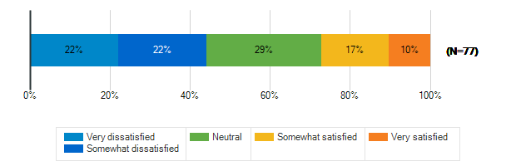

How satisfied are you with the following characteristics of your child’s school?: Design/Flow of BUS Drop-Off and Pick-Up for Students
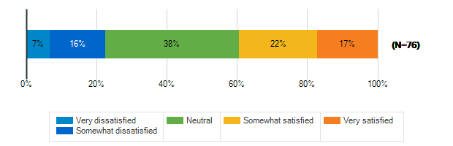

How satisfied are you with the following characteristics of your child’s school?: Entryway into the School
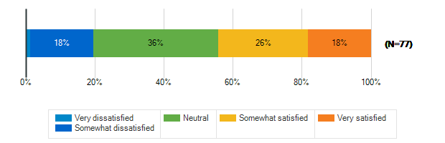

How satisfied are you with the following characteristics of your child’s school?: Classroom
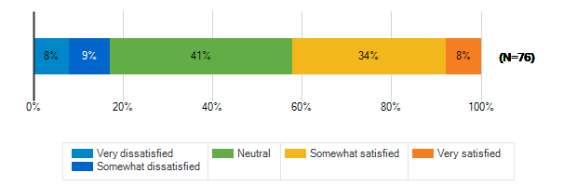

How satisfied are you with the following characteristics of your child’s school?: Security & Safety
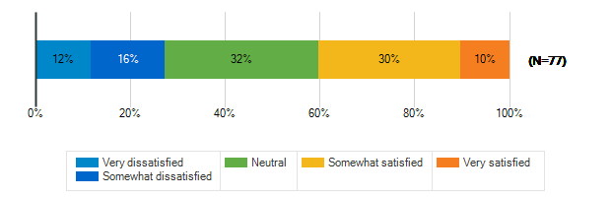

How satisfied are you with the following characteristics of your child’s school?: Technology
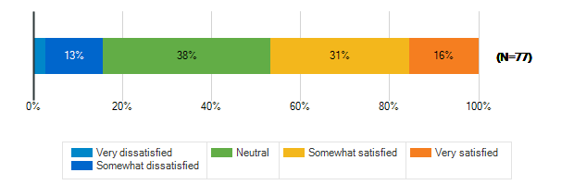

How satisfied are you with the following characteristics of your child’s school?: Learning Environment
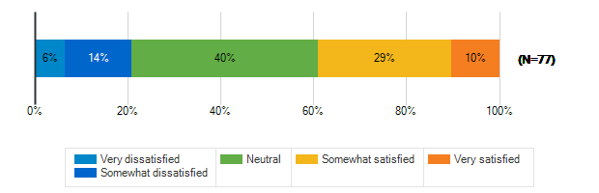

How satisfied are you with the following characteristics of your child’s school?: Natural Lighting/Outdoor Visability
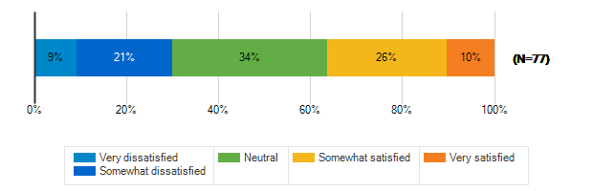

How satisfied are you with the following characteristics of your child’s school?: Performance spaces
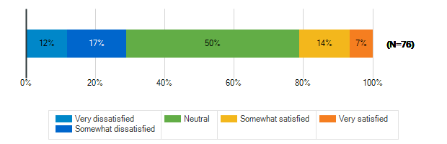

How satisfied are you with the following characteristics of your child’s school?: Outdoor spaces/Athletic fields
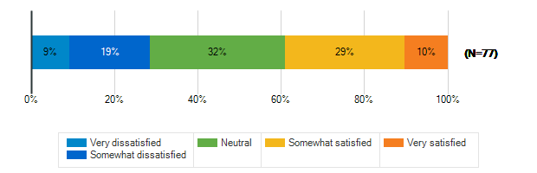

Please rank the following outdoor amenities in order of priority
Responses | Rank 1 | Rank 2 | Rank 3 | Rank 4 | Rank 5 | Rank 6 | Weighted Score | Relative Weighted Score | Overall Rank
Outdoor areas for socializing and relaxing | 17 | 16 | 16 | 16 | 8 | 7 | 317 | 100 | 1
Protected outdoor space (fenced or in a courtyard) | 21 | 8 | 17 | 12 | 12 | 10 | 304 | 96 | 2
Covered outdoor structure for play and events during inclement weather | 9 | 17 | 18 | 16 | 12 | 8 | 291 | 92 | 3
New or improved athletic/recreational fields | 16 | 9 | 13 | 9 | 16 | 17 | 269 | 85 | 4
Dedicated natural areas | 9 | 15 | 10 | 16 | 13 | 17 | 260 | 82 | 5
Walking trails/Bike paths | 8 | 15 | 6 | 11 | 19 | 21 | 239 | 75 | 6

How does your child usually get to school?
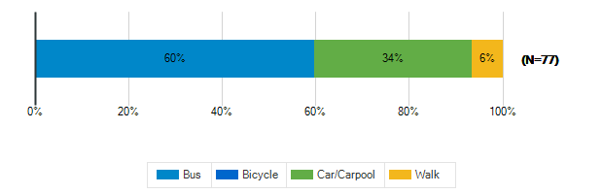

Does your child participate in any afterschool programs at their middle school?
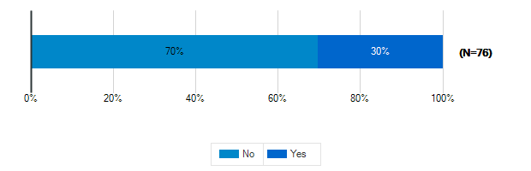

Please specify which programs
1. | clubs
2. | Track
3. | Parks and Rec Sports
4. | ACAC
5. | Basketball
6. | Sports
7. | Sports. Volleyball tennis. Track
8. | Cross country and track
9. | volleyball
10. | Jazz Band
11. | Extra Algebra I sessions provided by Ms Mariscal (Thank you Ms Mariscal!!!)
12. | ACPS needs to start middle school athletics. Our students would have more connections with their school, build closer relationships with their peers and coaches, it would drive students to keep their grades up and attend class. They deserve that.
13. | Band
14. | volleyball, x country
15. | Volleyball
16. | Volleyball
17. | sports
18. | They need a middle school athletics program in ACPS, like surrounding schools and every other middle school I know
19. | art club when it happens
20. | athletics - tennis, track

