

Middle School Facilities Master Plan
Survey Results

Lakeside Middle School

Albemarle County Public Schools
May 24 - June 5, 2023



I am:
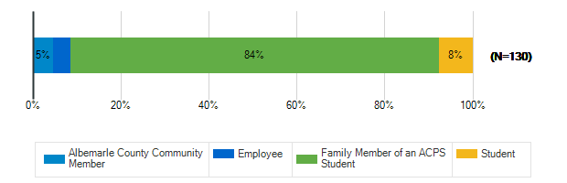

What are the most important qualities for middle school sites/grounds in the 21st century? : Safety & Security
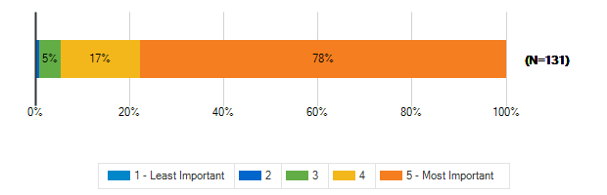

What are the most important qualities for middle school sites/grounds in the 21st century? : Growth & Capacity
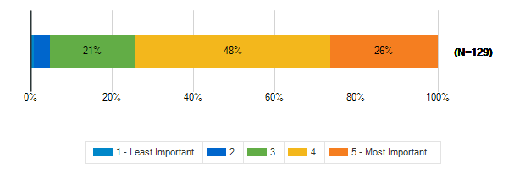

What are the most important qualities for middle school sites/grounds in the 21st century? : Outdoor Spaces
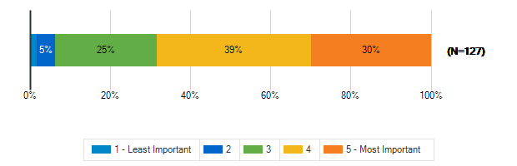

What are the most important qualities for middle school sites/grounds in the 21st century? : Sustainability & Natural Resources
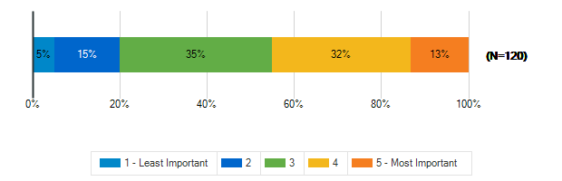

What are the most important qualities for middle school sites/grounds in the 21st century? : Community Access & Amenities
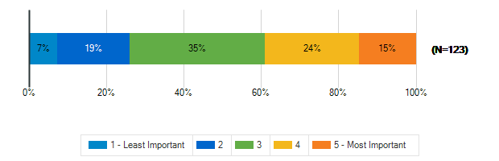

What are the most important qualities for middle school sites/grounds in the 21st century? : Positive, Healthy Culture
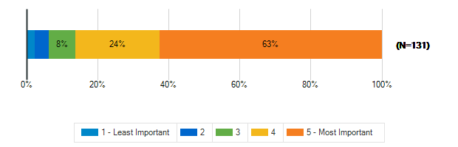

What are the most important qualities for middle school sites/grounds in the 21st century? : Welcoming, Comfortable, Aesthetic Spaces
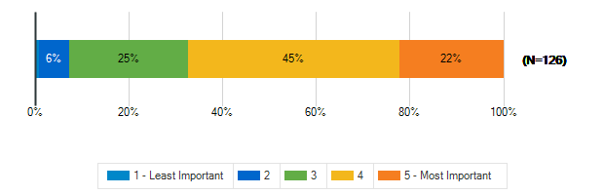

What are the most important qualities for middle school sites/grounds in the 21st century? : Durability, Flexibility, Cost-Efficiency
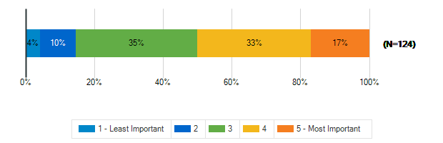

What are the most important qualities for middle school sites/grounds in the 21st century? : Sustainable/Net-Zero Construction
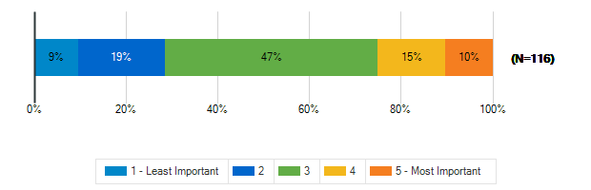

To what extent does your middle school support the following?: A sense of pride and well-being in staff and students
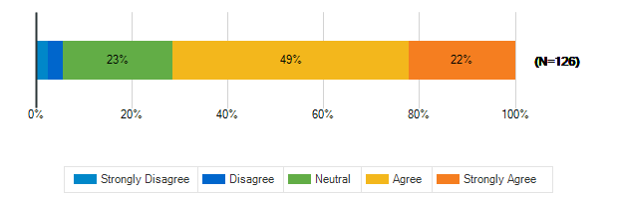

To what extent does your middle school support the following?: Prioritizing the outdoor environment
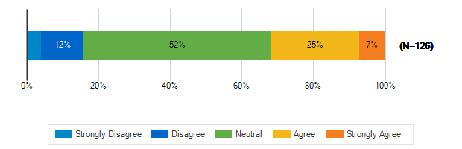

To what extent does your middle school support the following?: Natural resources available to students, staff, and the community
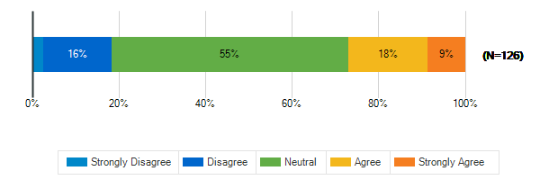

To what extent does your middle school support the following?: Educational resources available to students, staff, and the community
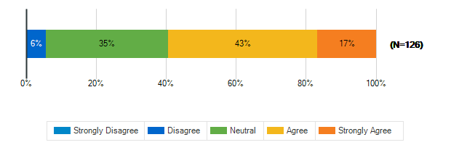

To what extent does your middle school support the following?: Health and fitness
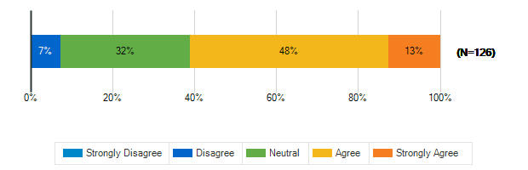

To what extent does your middle school support the following?: Diversity and inclusion
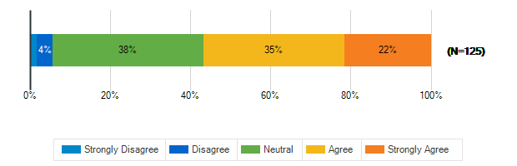

To what extent does your middle school support the following?: Environmental sustainability
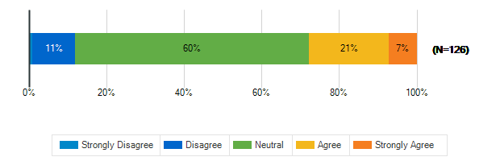

In a few words, what do you think is the greatest opportunity facing our middle school students today?
1. | safety, inclusion, and space.
2. | Develop strong strong global citizens
3. | Ability to connect with others, and use technology
4. | Growth into a newer world
5. | AI/ML technology
6. | To accelerate advancement in math and science
7. | Diversity of educational opportunities
8. | better experience for all students thru Inclusion
9. | Utilizing technology to enhance education
10. | Diversity complementing growth is important.
11. | Technology and advancements in knowledge
12. | We need to start learning stuff we'll USE
13. | Being actually educated with an ok understanding
14. | Technology
15. | Improving critical thinking skills, focus on DEI
16. | Access to a good highschool
17. | Preparation for high school
18. | Creating spaces for students to connect w/o tech
19. | Amazing teachers
20. | Choosing multiple learning paths.
21. | The opportunity for all to succeed together
22. | Schools need to focus on teaching kids
23. | Diversity of student population
24. | So many learning opportunities.
25. | Opportunity to change the negative US outlook
26. | incorporating new ideas
27. | Expansive world view
28. | New and interesting ideas and technologies
29. | Access to a variety of learning experiences.
30. | the opportunity to become a better person
31. | People owning automatic weapons
32. | The community sports
33. | To grow and develop new skills and friendships
34. | Giving us options, for our futures.
35. | innovating solutions to mitigate climate change
36. | A caring staff of teachers.
37. | opportunity to grow in a transitional life phase
38. | Diversity
39. | Life long learning skills
40. | Teleconnection beyond classroom walls
41. | Technology allows kids to reach the world.
42. | Facing new challenges and to grow.
43. | to learn kindness, community, integrity
44. | Opportunity for growth and development and communi
45. | Real-world education and community partnership
46. | in person instruction
47. | This question does not make sense
48. | fast pace of our future
49. | They have the world at their fingertips
50. | Access to information
51. | Wide range of educational classes
52. | Our richly diverse community
53. | To let them know hardworking and honesty is cool.
54. | N/A
55. | Obviously continued educational development
56. | greater open-mindedness
57. | Safety, outdoor facilities for sports
58. | Transitions (age level)
59. | Potential for their future, adaptability, technolo
60. | inclusive culture
61. | Using technology to expand their education
62. | Access to technology and a broad world view
63. | Learning that allows them to excel & not held back
64. | An in-depth understanding of technology.
65. | The ability to make our world a better place
66. | Fun in learning
67. | Preparing for high school
68. | Fostering hope in a better planet & better humans
69. | Teaching them about new technologies
70. | Educating with choice theory
71. | Technology
72. | technology- access to information and resources
73. | education quality
74. | Diversity with the growth of our community
75. | Availability of fine tuning their interests
76. | Capacity and age
77. | Gaining confidence through healthy social interact
78. | Diversity is our greatest opportunity!!
79. | Opportunities to socialize and make new friends
80. | Being able to understand how to live sustainably
81. | Embrace the future as an opportunity not judgement
82. | trailblaze the growth of tech & sustainability
83. | global culture, accessible technology
84. | Diversity and inclusion. Stop the bullying.
85. | Peer relationships

In a few words, what do you think is the greatest challenge facing our middle school students today?
1. | safety and inclusion
2. | Social media and cell phones
3. | Having to constantly be on due to social media
4. | Guns, social media
5. | Safety and political influence
6. | Dumbing down our schools educational curriculum
7. | Being challenged
8. | Vaping, drugs, peer pressure
9. | Political and social pressures
10. | Math, science and civil obedience are the ones
11. | Safety, kindness, reduced self absorption
12. | Fear of safety
13. | Themselves(some be dumb or mentally sad ect…)
14. | Safety
15. | mental health,social media impact,chatgpt,safety
16. | Inclusion
17. | Social emotional well being. School safety
18. | Overcrowding, limited space for small group work
19. | Space
20. | Not enough focus on the higher functioning student
21. | School capacity. We need additional schools
22. | We try to push a social agenda that isn’t needed
23. | Overcrowding
24. | Overcrowding and safety from outside threats.
25. | Social media and mental health
26. | veering away from traditional teaching
27. | Internet usage, social media, reliance on tech.
28. | physical and emotional safety
29. | Screen addiction and lack of critical thinking
30. | Capacity and equity across the county
31. | drugs
32. | Families owning automatic weapons
33. | Bullying, no personal responsibility, social media
34. | bullying and gang violence
35. | Feelings of disconnection
36. | Stress with schoolwork, and the feeling to fit in
37. | harmful effects of social media, technology
38. | Combo of safety and more ways to social stigmatize
39. | De-leveling of classes.
40. | no real community, exclusion, isolation
41. | over crowding and differing needs of students
42. | Technology, lack of dress code and accountability
43. | Filter out the noise of the media and agendas
44. | Balancing core skills vs. advanced thinking
45. | Separate restrooms for Trans children
46. | SEL and getting off screens
47. | They worry to much about what others thinks.
48. | to learn kindness, community, integrity
49. | Diversity and change
50. | Over capacity
51. | Maintaining their mental health
52. | Teacher burnout.
53. | Motivation in a quickly changing world
54. | Peer pressure/social pressure,
55. | Work ethic and motivation
56. | Learning how to be kind to one another.
57. | low expectations, peer pressure
58. | They have the world at their fingertips
59. | Managing technology
60. | Less online work , more hands on activities.
61. | School facilities ill equipped for modern educatio
62. | Too much freedom of choice/not enough discipline.
63. | safety, as there are bully, drugs, guns, and gangs
64. | N/A
65. | The distraction of today's social media
66. | social media/anxiety; gun violence
67. | Safety, internet bullying and obesity
68. | Overcrowding and transportation
69. | Quickly advancing technology, social media
70. | Tech changes too fast, peers, media, time manageme
71. | social/emotional well being
72. | Safety and security.
73. | Balancing the use of technology
74. | Social media
75. | Social media, bullying, sedentary lifestyle
76. | Education is too politicized & needs parents
77. | 1Social medial 2Critical thinking 3fact vs fiction
78. | Physical safety and emotional well-being
79. | Surprised to see no text books are used in school
80. | Distractions
81. | Lack of preparation for high school & deadlines
82. | Fostering hope in a better planet & better humans
83. | Expecting timely and good work
84. | Cell phones and social media
85. | Technology’s impact on their mental health and lea
86. | Safety
87. | mental health/social problems due to media access
88. | education quality
89. | Capacity, crowded classes, lacking advanced crs’s
90. | The negative influence of social media.
91. | Safety
92. | Social and emotional learning
93. | The lowered expectations accommodating minimal eff
94. | Safety in schools. Our children are scared!
95. | Fear of mass school shootings
96. | extremist parents who want to erase history
97. | Mental, physical and emotional saftey
98. | no recess, computer based learning, block schedule
99. | navigating maturity/ethics of tech/sustainability
100. | social life with technology
101. | Bullying and social media
102. | Peer relationships

To meet the needs of students, educators, families and the community, a middle school facility in Albemarle County MUST HAVE
1. | Safety features
2. | Enough space for all students
3. | Advanced labs, highest quality educators
4. | Durability, and inviting spaces
5. | Additional schools for growth on the northern feed
6. | Ample infrastructure for special ed
7. | Extra curriculum activities inside schools
8. | Safe spaces!
9. | Better lunches
10. | People with experience and degree to teach
11. | Security measures and protocols
12. | student development/outcomes,curriculum,class size
13. | Access to a lot outdoor/natural resources
14. | Safety, access to counselors, tutoring
15. | Quality teachers, so many are leaving
16. | Great teachers, be close for students to get to
17. | Proper amount of room for all the students.
18. | Facilities that can accommodate all student
19. | Safe schools, good teachers, high expectations
20. | population diversity, cultural diversity
21. | Room for growth.
22. | Strong athletic academic and social spaces
23. | open minded teachers and staff
24. | Safe, clean school that offers room for flexibilit
25. | sense of community
26. | Balance of social, emotional, & educational needs
27. | Up to date facilities and adequate space
28. | a safe learning environment
29. | Alarm systems
30. | Enough space and low teacher to student ratio
31. | mental health and resources to make kids safe
32. | Safety, support for the students, outdoor time
33. | idk
34. | sufficient, skilled staff to support students
35. | leveled classes in core subjects
36. | community spaces that are actually ran well
37. | Flexibility in teaching methods
38. | Enough space to grow into and have enough staff
39. | More facilities to ease crowding and meet growth
40. | Flexibility/adaptability for future needs
41. | separate spaces for trans children
42. | inclusivity, accessiblity, accessible sports
43. | The communication and connection to their student
44. | Good communication skills
45. | Uncrowded classroom and room for growth
46. | Well-trained and emphathetic staff
47. | Lots of outdoor spaces
48. | screen-free time/zones
49. | Supportive staff, good communication with parents
50. | Inclusion
51. | Great counseling
52. | Open, safe spaces
53. | safety, flexibility, and zero impact.
54. | Consistent expectations
55. | More inviting and flexible learning spaces
56. | Access to the latest technology for hands on learn
57. | Small class sizes, we'll trained and caring teache
58. | More focus on physical/health education facilities
59. | kids best interest, instead of indoctrination
60. | N/A
61. | Resilience
62. | unsure
63. | Track and field, baseball and outdoor sports
64. | Small classroom sizes
65. | Retention of high quality teachers and staff
66. | Environmental safety, outdoor space, full library
67. | spaces that match a positive culture
68. | An updated, modern facility with enough space for
69. | social emotional development classes for kids
70. | Safety from gun threats. Spaces that are joyful.
71. | Parents involved and kept aware
72. | Up to date technology. Good communication
73. | Safety measures
74. | Meaningful enrichment programs
75. | Good athletic stuff
76. | Adequate space for growth… no more “temp” trailers
77. | Lots of natural light and views of the outdoors
78. | Hands on science and learning activities outdoors
79. | A zero tolerance policy for cell phones
80. | Discipline -Students must be physically saf
81. | Rezoning schools, safety drills, better technology
82. | no phones, less access to gaming, less junk food
83. | Inclusive environments & updated technology
84. | STEM center
85. | Advanced courses and capacity across all levels
86. | The adequate staff capacity
87. | Appropriate safety measures
88. | Gender neutral restrooms, sports field
89. | room to grow
90. | Quality staff
91. | Higher standards not concern with being PC always
92. | Safety alarms and sirens to stop intruders.
93. | Safe environment
94. | Counseling, libraries, technology
95. | challenging classes
96. | Small enough community for all to be known
97. | plans for ALL students- challenging gifted student
98. | caring & consistent instruction & a growth mindset
99. | Safety.Resources.Comfort seats. Charging for all
100. | A student council
101. | classwork on paper and technology, space
102. | Counseling services
103. | Empathetic supportive school counselors

Tell us more about the following resource spaces in your school & grounds?

How often do you use?: Teacher Work Rooms
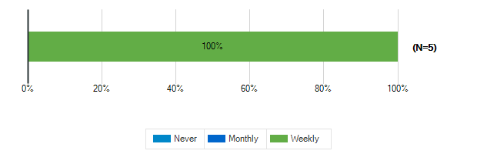

How often do you use?: Teacher Lounge
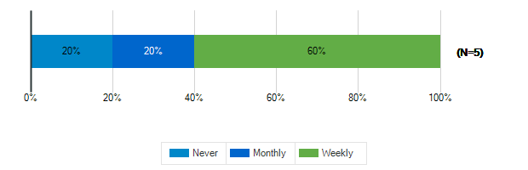

How often do you use?: Library
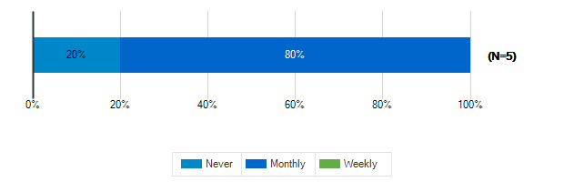

How often do you use?: Stage/Auditorium
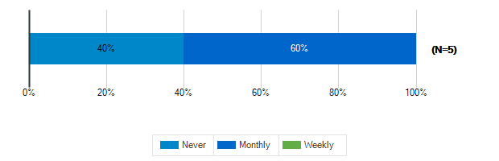

How often do you use?: Outdoor Classrooms
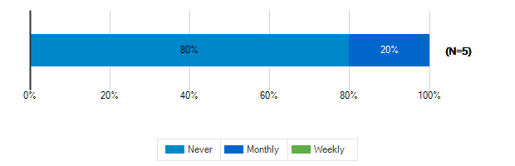

How often do you use?: Administrative Offices

How often do you use?: Conference Room
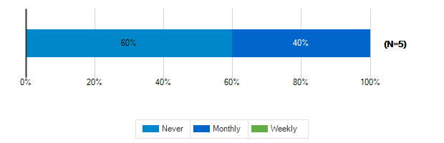

How often do you use?: Cafeteria

How often do you use?: Shared Spaces
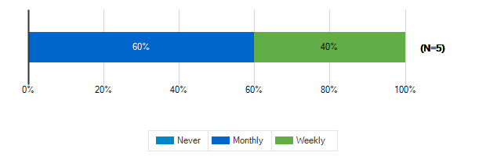

Tell us more about the following resource spaces in your school & grounds?

How would you rate the quality?: Teacher Work Rooms
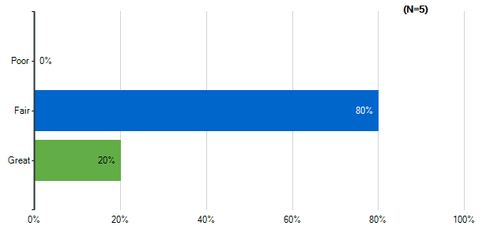
Note: Multiple answers per participant possible. Percentages added may exceed 100 since a participant may select more than one answer for this question.

How would you rate the quality?: Teacher Lounge
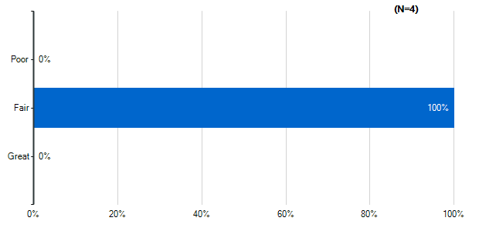
Note: Multiple answers per participant possible. Percentages added may exceed 100 since a participant may select more than one answer for this question.

How would you rate the quality?: Library
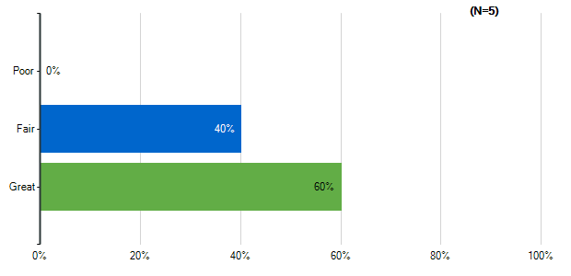
Note: Multiple answers per participant possible. Percentages added may exceed 100 since a participant may select more than one answer for this question.

How would you rate the quality?: Stage/Auditorium
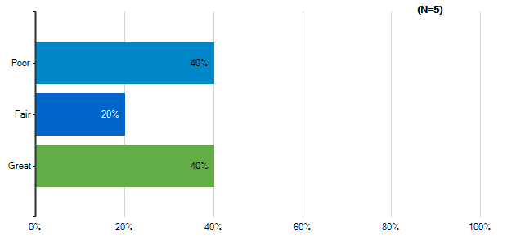
Note: Multiple answers per participant possible. Percentages added may exceed 100 since a participant may select more than one answer for this question.

How would you rate the quality?: Outdoor Classrooms
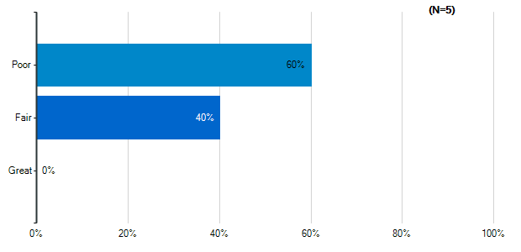
Note: Multiple answers per participant possible. Percentages added may exceed 100 since a participant may select more than one answer for this question.

How would you rate the quality?: Administrative Offices
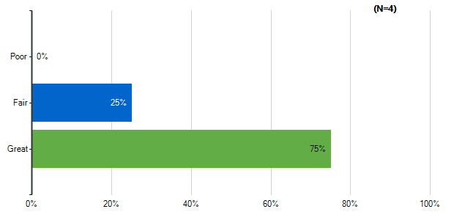
Note: Multiple answers per participant possible. Percentages added may exceed 100 since a participant may select more than one answer for this question.

How would you rate the quality?: Conference Room
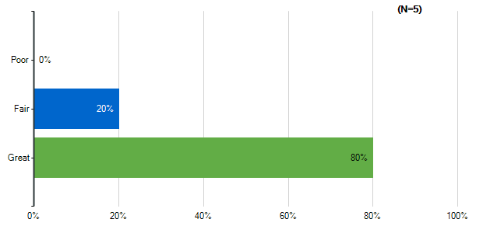
Note: Multiple answers per participant possible. Percentages added may exceed 100 since a participant may select more than one answer for this question.

How would you rate the quality?: Cafeteria
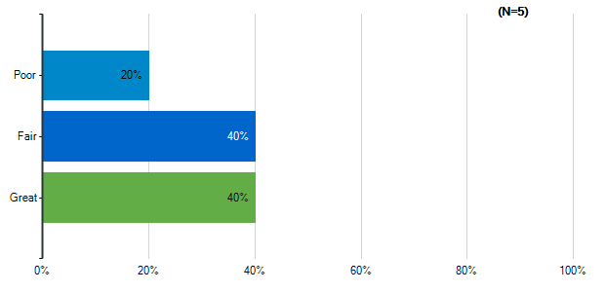
Note: Multiple answers per participant possible. Percentages added may exceed 100 since a participant may select more than one answer for this question.

How would you rate the quality?: Shared Spaces
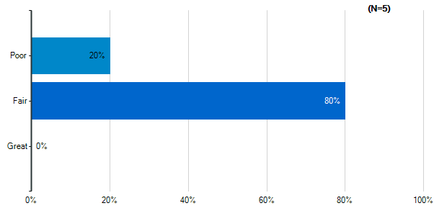
Note: Multiple answers per participant possible. Percentages added may exceed 100 since a participant may select more than one answer for this question.

Please indicate how satisfied you are with the following characteristics of your middle school building:: Cleanliness & Maintenance
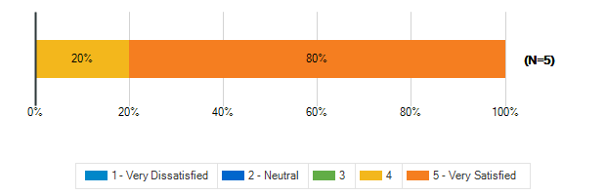

Please indicate how satisfied you are with the following characteristics of your middle school building:: Security & Safety
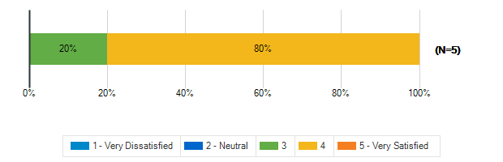

Please indicate how satisfied you are with the following characteristics of your middle school building:: Signage and Wayfinding
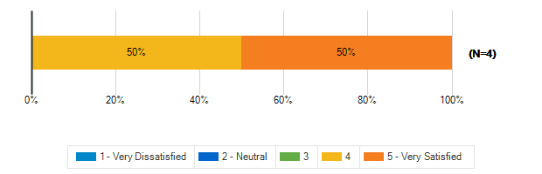

How frequently do your students engage in the following activities in your classroom: Lecture/Lessons
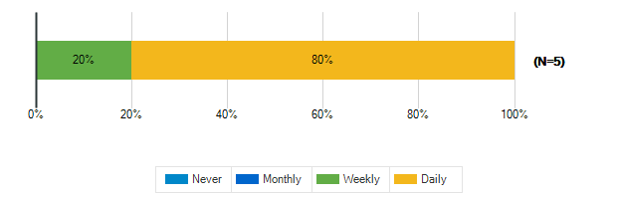

How frequently do your students engage in the following activities in your classroom: Learning Centers/Listening Stations
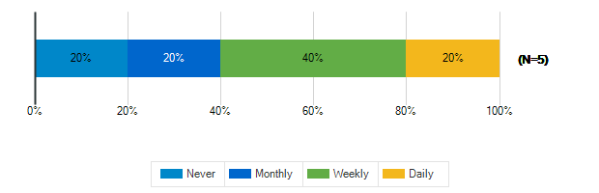

How frequently do your students engage in the following activities in your classroom: Student Presentations Performances
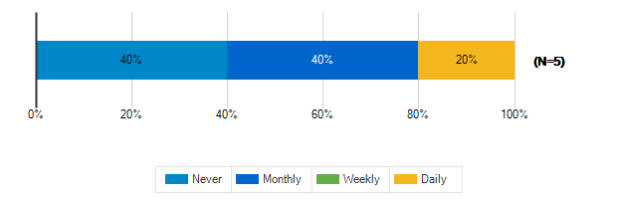

How frequently do your students engage in the following activities in your classroom: Group Activities/Projects

How frequently do your students engage in the following activities in your classroom: Individual Work

How frequently do your students engage in the following activities in your classroom: Technology/Computer

How frequently do your students engage in the following activities in your classroom: Physical Activity/Movement Breaks
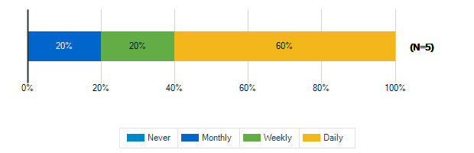

How would you describe the following characteristics of your classroom?: Location
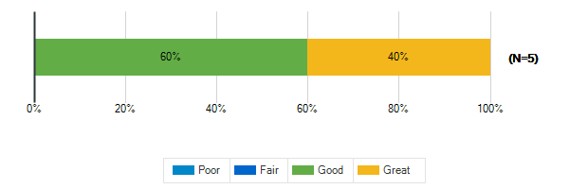

How would you describe the following characteristics of your classroom?: Size
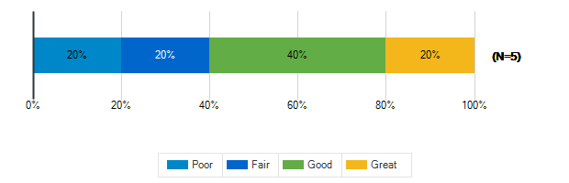

How would you describe the following characteristics of your classroom?: Security & Safety
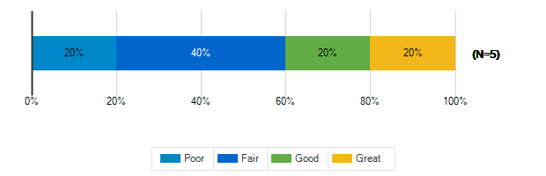

How would you describe the following characteristics of your classroom?: Storage (Amount, Design, Location)
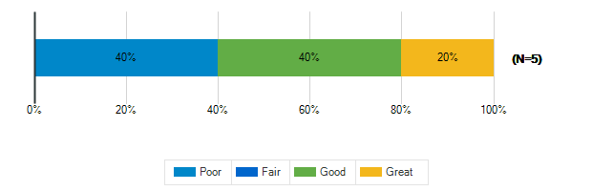

How would you describe the following characteristics of your classroom?: Cleanliness & Maintenance
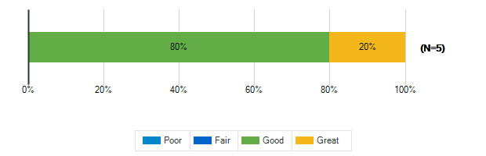

How would you describe the following characteristics of your classroom?: Availability of Technology (including WiFi & power outlets)
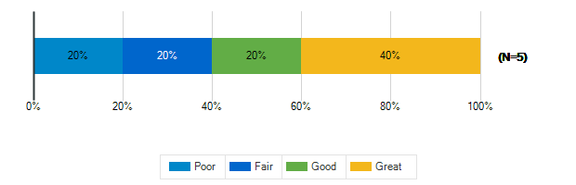

How would you describe the following characteristics of your classroom?: Functionality (including versatility and adaptability)
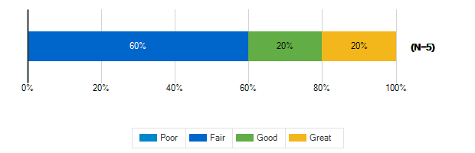

How would you describe the following characteristics of your classroom?: Natural Lighting/Ventilation
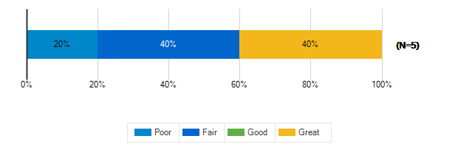

How would you describe the following characteristics of your classroom?: Access to Outdoor Spaces and/or Outdoor Visibility

How would you describe the following characteristics of your classroom?: Electric Lighting
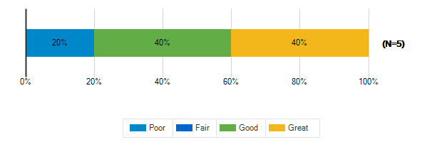

How would you describe the following characteristics of your classroom?: Air quality
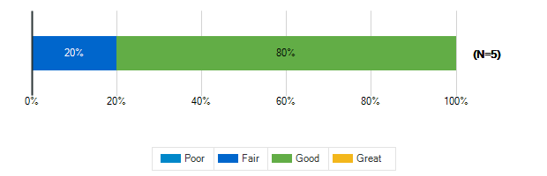

How would you describe the following characteristics of your classroom?: Acoustics
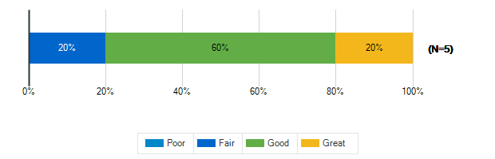

How would you describe the following characteristics of your classroom?: Furniture
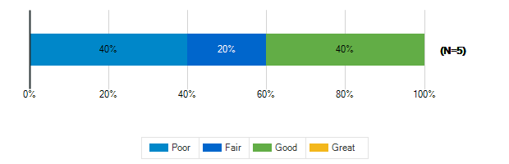

How would you describe the following characteristics of your classroom?: Dry Erase Boards/Display Boards/Bulletin Boards
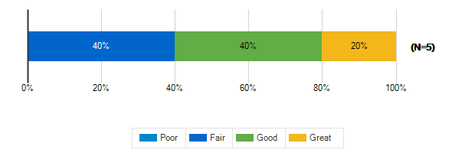

How would you describe the following characteristics of your classroom?: Finishes (Floors/Walls/Ceiling/etc.)

Please rank the following indoor amenities in order of priority for future spaces
Responses | Rank 1 | Rank 2 | Rank 3 | Rank 4 | Weighted Score | Relative Weighted Score | Overall Rank
Spaces designed for versatility to accommodate a variety of uses | 2 | 2 | 0 | 1 | 15 | 100 | 1
Dedicated teacher work areas and personal storage area | 1 | 1 | 3 | 0 | 13 | 87 | 2
Outdoor access for science and other specialty classrooms | 1 | 1 | 1 | 2 | 11 | 73 | 3
Dedicated restrooms for staff | 1 | 1 | 1 | 2 | 11 | 73 | 3

If you’ve taught at or seen a middle school with a feature that doesn’t exist at ACPS that you think should be here, please identify it:
1. | Outdoor seating and work areas
2. | Other ACPS middle schools have a larger kitchen lab space. Ours is not large enough for full size classroom. A more functional room/s should be designed for exploratory courses. The room also does not have any windows. Also, my students think that middle schoolers would still use outdoor playscapes and swings. I agree!

What is your grade level?
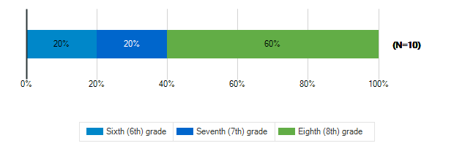

Tell us about the spaces in your school and on your school grounds:

How often do you use these spaces?: Media Center
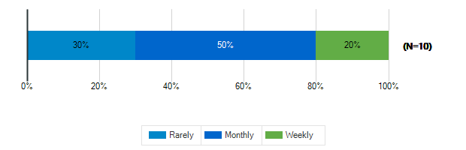

How often do you use these spaces?: Cafeteria
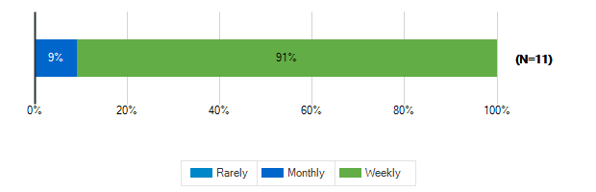

How often do you use these spaces?: Gymnasium
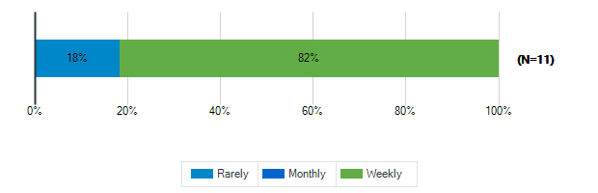

How often do you use these spaces?: tage/Auditorium
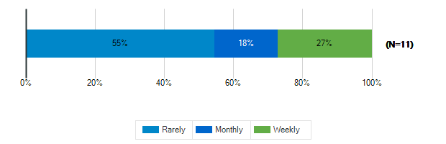

How often do you use these spaces?: Outdoor Classrooms
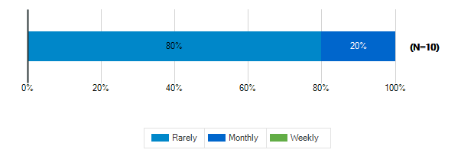

How often do you use these spaces?: Outdoor Recreation/Athletic Fields
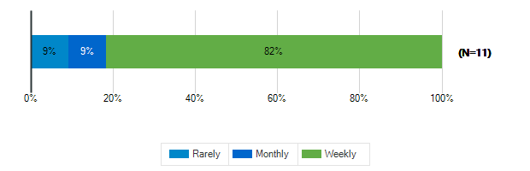

Tell us about the spaces in your school and on your school grounds:

How would you rate these spaces?: Media Center
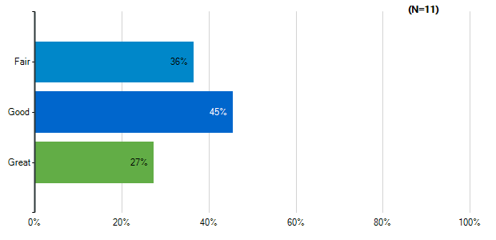
Note: Multiple answers per participant possible. Percentages added may exceed 100 since a participant may select more than one answer for this question.

How would you rate these spaces?: Cafeteria
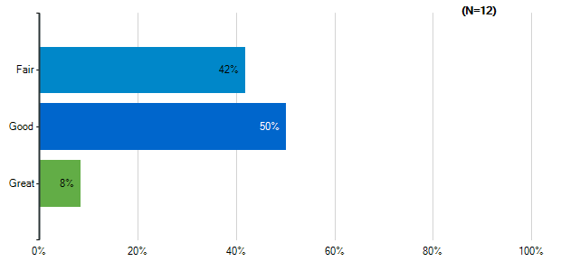
Note: Multiple answers per participant possible. Percentages added may exceed 100 since a participant may select more than one answer for this question.

How would you rate these spaces?: Gymnasium
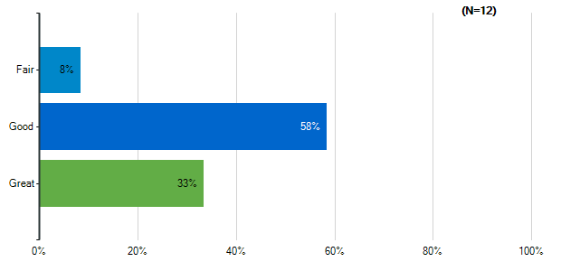
Note: Multiple answers per participant possible. Percentages added may exceed 100 since a participant may select more than one answer for this question.

How would you rate these spaces?: tage/Auditorium
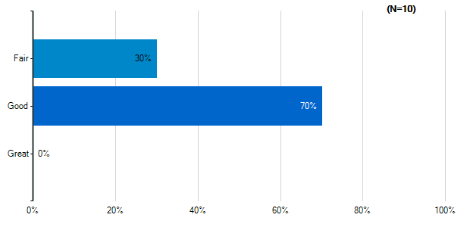
Note: Multiple answers per participant possible. Percentages added may exceed 100 since a participant may select more than one answer for this question.

How would you rate these spaces?: Outdoor Classrooms
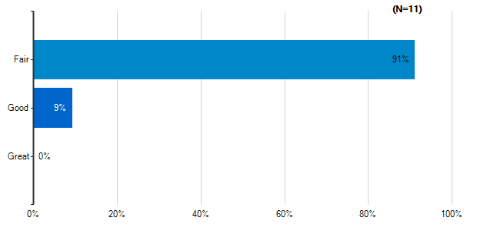
Note: Multiple answers per participant possible. Percentages added may exceed 100 since a participant may select more than one answer for this question.

How would you rate these spaces?: Outdoor Recreation/Athletic Fields
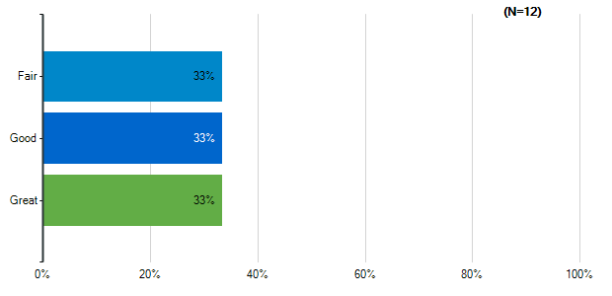
Note: Multiple answers per participant possible. Percentages added may exceed 100 since a participant may select more than one answer for this question.

How would you rate the quality of the following characteristics of your classrooms?: Size
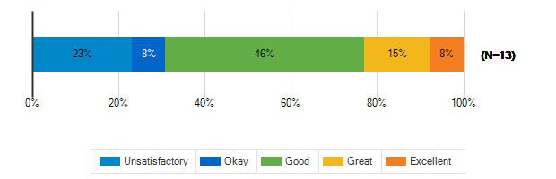

How would you rate the quality of the following characteristics of your classrooms?: Cleanliness
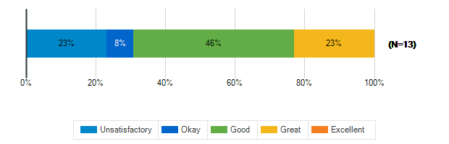

How would you rate the quality of the following characteristics of your classrooms?: Furniture
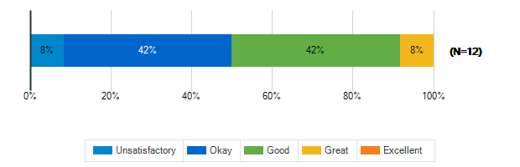

How would you rate the quality of the following characteristics of your classrooms?: Color Scheme/Décor
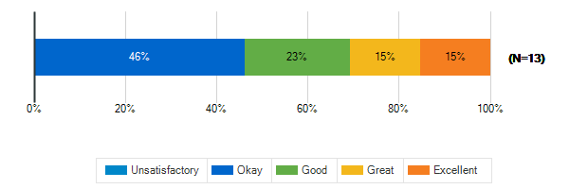

How would you rate the quality of the following characteristics of your classrooms?: Security & Safety
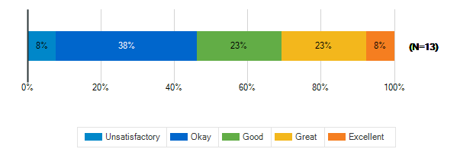

How would you rate the quality of the following characteristics of your classrooms?: Technology (including WiFi and power outlets)
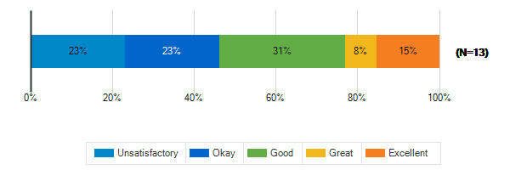

How would you rate the quality of the following characteristics of your classrooms?: Natural Lighting
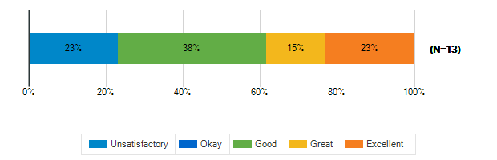

How would you rate the quality of the following characteristics of your classrooms?: Access to Outdoor Spaces and/or Outdoor Visibility
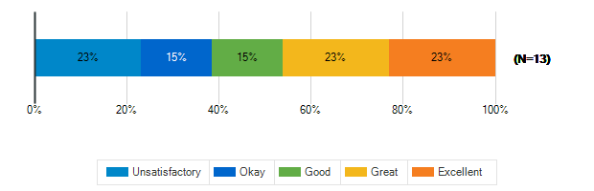

What is the best thing about your middle school?
1. | The library
2. | It is a school where one can learn with many kids
3. | Access to a lot of media-related technology
4. | graduating
5. | Some of the teachers and being able to see friends
6. | I love the big windows in the classroom
7. | The environment
8. | Staff is excellent
9. | Football
10. | spacious, great teachers, good classes, lighting

What is the worst thing about your middle school?
1. | The safety concerns
2. | Some kids have trouble not sing a class problem
3. | The aesthetics
4. | drugs
5. | The overloading schoolwork
6. | I have a fake wall so not enough outlets
7. | Soccer field
8. | Student behavior challenges.
9. | kids

How satisfied are you with the following characteristics of your child’s school?: Availability of Parking
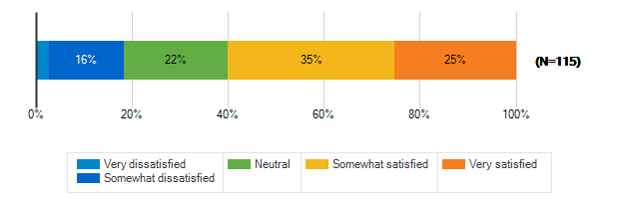

How satisfied are you with the following characteristics of your child’s school?: Design/Flow of CAR Drop-Off and Pick-Up for Students
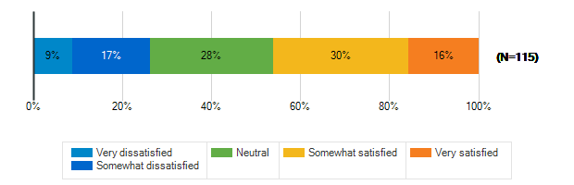

How satisfied are you with the following characteristics of your child’s school?: Design/Flow of BUS Drop-Off and Pick-Up for Students
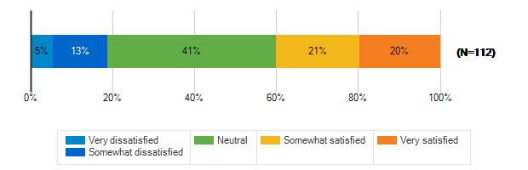

How satisfied are you with the following characteristics of your child’s school?: Entryway into the School
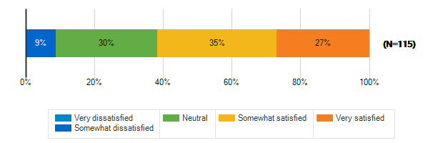

How satisfied are you with the following characteristics of your child’s school?: Classroom
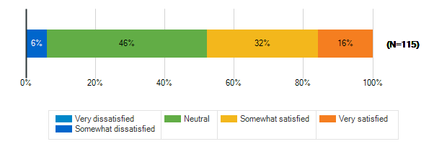

How satisfied are you with the following characteristics of your child’s school?: Security & Safety
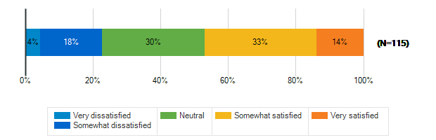

How satisfied are you with the following characteristics of your child’s school?: Technology
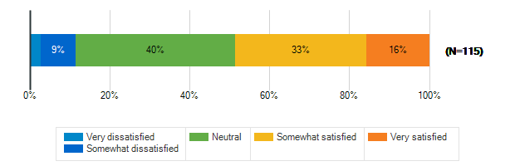

How satisfied are you with the following characteristics of your child’s school?: Learning Environment
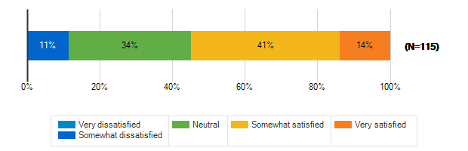

How satisfied are you with the following characteristics of your child’s school?: Natural Lighting/Outdoor Visability
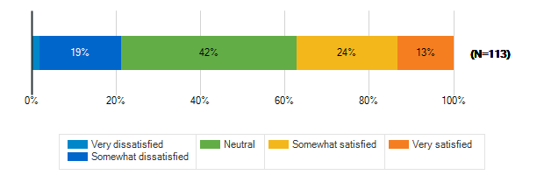

How satisfied are you with the following characteristics of your child’s school?: Performance spaces
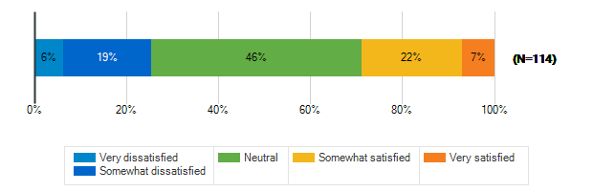

How satisfied are you with the following characteristics of your child’s school?: Outdoor spaces/Athletic fields
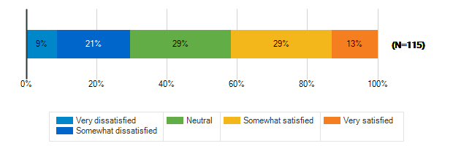

Please rank the following outdoor amenities in order of priority
Responses | Rank 1 | Rank 2 | Rank 3 | Rank 4 | Rank 5 | Rank 6 | Weighted Score | Relative Weighted Score | Overall Rank
Outdoor areas for socializing and relaxing | 31 | 22 | 22 | 16 | 14 | 10 | 470 | 100 | 1
Covered outdoor structure for play and events during inclement weather | 19 | 25 | 24 | 15 | 19 | 13 | 431 | 92 | 2
Protected outdoor space (fenced or in a courtyard) | 24 | 24 | 15 | 13 | 13 | 26 | 415 | 88 | 3
New or improved athletic/recreational fields | 24 | 14 | 16 | 20 | 22 | 19 | 401 | 85 | 4
Dedicated natural areas | 8 | 18 | 21 | 25 | 24 | 19 | 364 | 77 | 5
Walking trails/Bike paths | 9 | 12 | 17 | 26 | 23 | 28 | 334 | 71 | 6

How does your child usually get to school?
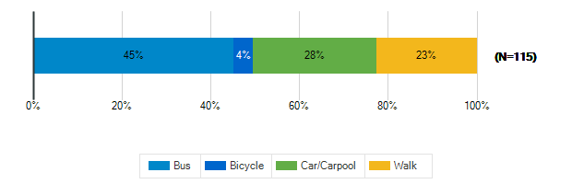

Does your child participate in any afterschool programs at their middle school?
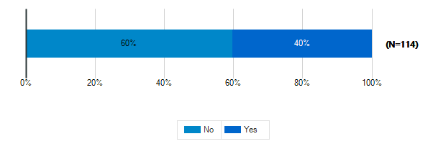

Please specify which programs
1. | Jazz band.
2. | scouts, karate AIMS
3. | Track
4. | Flag football
5. | Sports and Music
6. | Sports
7. | Minecraft club
8. | After school
9. | Volleyball, tennis, and orchestra
10. | Athletics
11. | Jazz band
12. | cross country/track/tutoring
13. | Soccer and cross country
14. | dnd, tennis etc
15. | D&D club Minecraft/Gamers
16. | Basketball, volleyball
17. | Basketball
18. | High school sports
19. | Tutoring Cross country Jazz band
20. | Xc
21. | Jazz Band
22. | Jazz Band
23. | Tutoring, gaming club
24. | Biking chess
25. | Clubs, volleyball
26. | track
27. | Debate and jazz band
28. | Running
29. | Jazz Band, Flag Football, Running Club
30. | Debate team
31. | Drama
32. | Girls volleyball, when offered. Young Women's Leadership Program, Student council
33. | volleyball, jazz band
34. | Vollyball
35. | Volleyball
36. | Soccer
37. | Soccer

38. | Basketball
39. | Gaming Club
40. | sports and clubs

