

Middle School Facilities Master Plan
Survey Results

Henley Middle School

Albemarle County Public Schools
May 24 - June 5, 2023



I am:
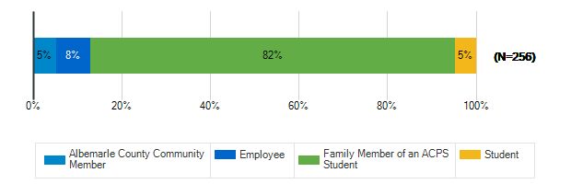

What are the most important qualities for middle school sites/grounds in the 21st century? : Safety & Security
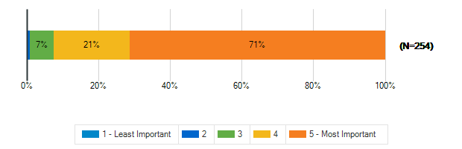

What are the most important qualities for middle school sites/grounds in the 21st century? : Growth & Capacity
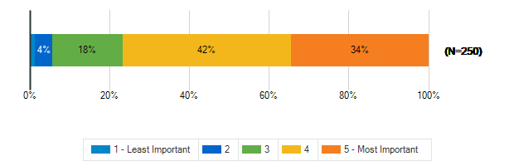

What are the most important qualities for middle school sites/grounds in the 21st century? : Outdoor Spaces
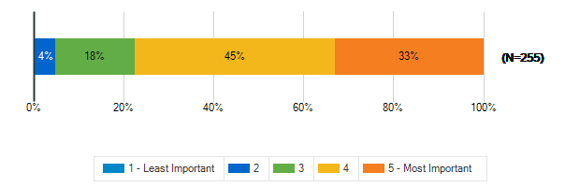

What are the most important qualities for middle school sites/grounds in the 21st century? : Sustainability & Natural Resources
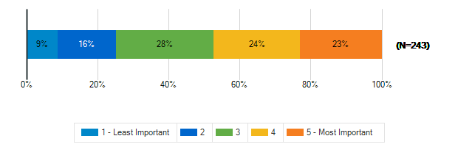

What are the most important qualities for middle school sites/grounds in the 21st century? : Community Access & Amenities
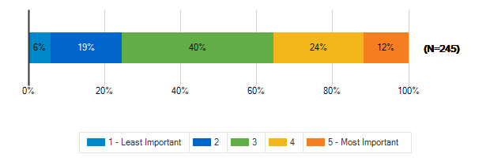

What are the most important qualities for middle school sites/grounds in the 21st century? : Positive, Healthy Culture
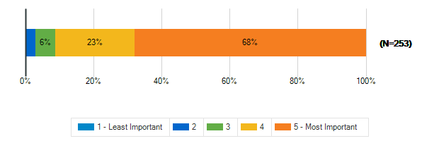

What are the most important qualities for middle school sites/grounds in the 21st century? : Welcoming, Comfortable, Aesthetic Spaces
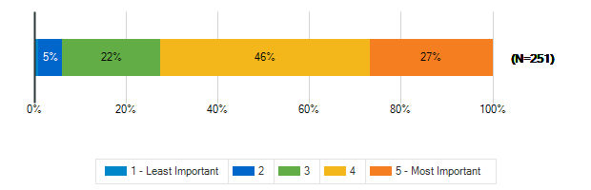

What are the most important qualities for middle school sites/grounds in the 21st century? : Durability, Flexibility, Cost-Efficiency
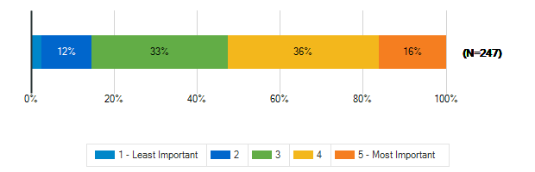

What are the most important qualities for middle school sites/grounds in the 21st century? : Sustainable/Net-Zero Construction
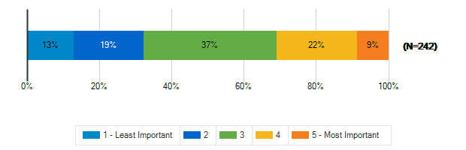

To what extent does your middle school support the following?: A sense of pride and well-being in staff and students
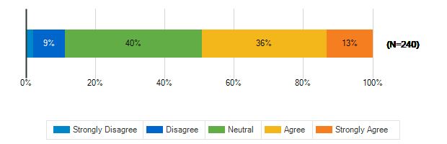

To what extent does your middle school support the following?: Prioritizing the outdoor environment
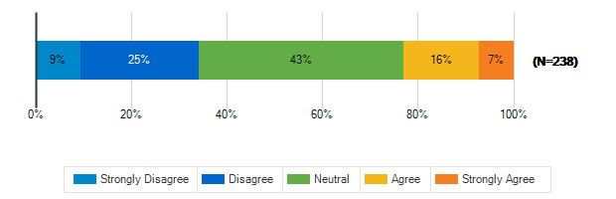

To what extent does your middle school support the following?: Natural resources available to students, staff, and the community
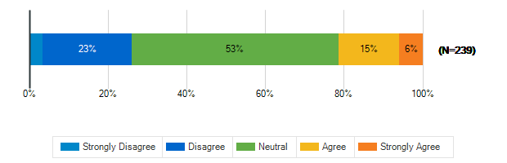

To what extent does your middle school support the following?: Educational resources available to students, staff, and the community
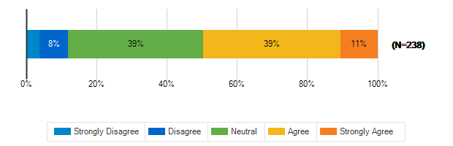

To what extent does your middle school support the following?: Health and fitness
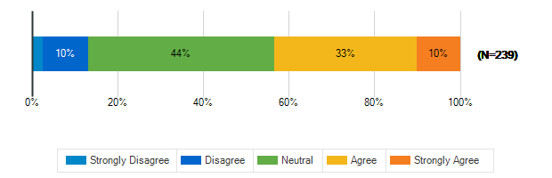

To what extent does your middle school support the following?: Diversity and inclusion
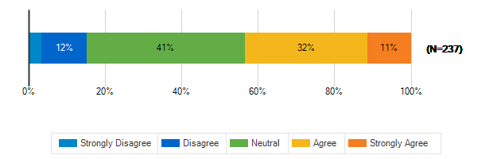

To what extent does your middle school support the following?: Environmental sustainability
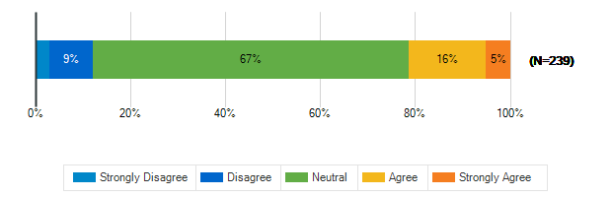

In a few words, what do you think is the greatest opportunity facing our middle school students today?
1. | Not sure
2. | changing our relationship with the planet
3. | New models of education
4. | Their social-emotional needs and time in seats
5. | Incorporating technology
6. | Opportunities to be involved in community
7. | Social media
8. | Not enough space, classes are too large
9. | To change middle school culture
10. | Freedom of speech!
11. | accessibility of henley to wahs
12. | access to beautiful nature around
13. | Too many kids, over crowdin. Need another middle s
14. | To become respectable citizens
15. | Helping the community
16. | Having access to so much data and knowledge
17. | technology advancements
18. | Address mental health before highschool
19. | No bullying, no e-cigarettes, no drugs, no racism.
20. | Need more recess
21. | There could be more friendly classrooms.
22. | Building long-term relationships with neighbors
23. | None
24. | Tech, global business
25. | 6th graders need to be moved back to elementary
26. | Learning how to build relationships
27. | Peer connection
28. | Creating an environmentally friendly space.
29. | Updated facilities to meet majority of student nee
30. | Development of math and science based skills
31. | Opportunity to improve is great.
32. | high lvl teaching
33. | Technology and environmental sustainability
34. | expand space to meet incoming elementary @ Henley
35. | Not having access to trained supportive staff
36. | To be a part of reversing climate change
37. | Belonging, Healthy relationships, mental health
38. | Bring a modern POV to traditional education
39. | potential impact on their community and world
40. | N/a
41. | New learning pathways (CSC's)
42. | learn in a creative, embracing space
43. | Recess
44. | To contribute to solving our greatest challenges
45. | Focusing in on interests by exploring new subjects
46. | More after school sports / outdoor time
47. | Acceptance of many viewpoints and diversity
48. | Hands on learning
49. | Opportunity
50. | Technological advances & future careers
51. | The open slate of their future.
52. | Choice in learning while feeling included
53. | Learning with no politics involved. (BLM, CRT, etc
54. | adding more active, outdoor time (no screens)
55. | Capacity and more aesthetic spaces.
56. | Project based learning, social/emotional support
57. | Safety
58. | Capacity
59. | Turning point, make change
60. | Diversity and inclusion
61. | Technology
62. | Helping kids learn and be engaged citizens
63. | Technology
64. | New innovations in technology and society
65. | pushed in the STEM subjects; restored patriotism
66. | I am not sure
67. | unsure
68. | safety from bullying, enforcement by the school
69. | creating social change
70. | Mental health and socialization
71. | Learning empathy for people and nature
72. | The ability to learn holistically.
73. | Becoming kind, inclusive, earth-conscious citizens
74. | To be a fresh light in a world with great division
75. | creating positive culture
76. | Generational wealth
77. | Living in a diverse environment
78. | preparing for the futures
79. | Leveraging technology to deliver customzd learning
80. | build respect for themselves and each other
81. | Excellence in academics
82. | Creativity, energy to engage in DEI and climate
83. | I am not sure how to answer that.
84. | Lack of learning Space. Rapid Growth.
85. | Open mindedness and inclusivity
86. | Our students need more after school sports!!
87. | Excited to learn new things, develop new interests
88. | Learning to identify motivational life opportunity
89. | Strong Community
90. | rapidly changing world
91. | Opportunities new technology brings
92. | Technology
93. | supporting mental health and academic interest
94. | Increased independence and personal responsibility
95. | diverse population
96. | To learn how to make the world fairer and kinder.
97. | Strong foundation for high school
98. | Not having adequate recess/ breaks during the day.
99. | Cultivating a safe and caring environment
100. | Diversity and inclusion
101. | Overcrowding
102. | Excelling in learning, athletics, making friends.
103. | Building skills necessary for high school.
104. | Technological advancements
105. | A sense of stability and preparation for future
106. | More and safer spaces, physically and mentally
107. | Too little space to answer. Few opportunities.
108. | Better focus on differences
109. | The opportunity to explore who they want to be.
110. | Development of the sense of self
111. | Technology as a resource
112. | Access to technology, great teachers, & community
113. | Colegio
114. | Embracing technology, but in a measured way
115. | Inclusion
116. | An opportunity to say no to a screen meditated lif
117. | Safety
118. | I honestly can’t think of one. It’s miserable.
119. | Provide foundation for academics in high school
120. | A learning environment that mimimizes computers.
121. | Technology and opportunities for jobs with techno
122. | Opportunities to try new things at a younger age
123. | Community - diversity and inclusion
124. | Surviving
125. | The resources they have available.
126. | STEM
127. | New technology
128. | Affluent PTO
129. | To develop connections and think deeply
130. | To learn from a global community
131. | Learning with the help of advanced technology
132. | The use of technology to enhance learning and teac
133. | encouraging flexible mindsets
134. | Diversity, equity, and rigor
135. | Creating a diverse &positive MS experience
136. | growth of self
137. | Safety - physically and emotionally.
138. | The ability to utilize diverse technologies
139. | Staff encouraging a sense of self and acceptance.
140. | A fresh future ahead of them, full of potential.
141. | Learn to enjoy the art of how to learn
142. | Terrible principal
143. | Access to information
144. | Inclusiveness and sense of belonging
145. | Working together to tackle complex 21st challenges
146. | technologypreparing for the real 21st century worl
147. | technology
148. | Community growth/integration.
149. | build community and collaboration skills
150. | preparation for life
151. | so many interesting careers to choose from
152. | No recess
153. | The interconnectivity of all life.
154. | POSSIBILITY FOR GROWTH
155. | Facilitation of positive, safe spaces.
156. | Mental Environment - being challenged
157. | They are more inclusive
158. | A chance to work and grow with other students.
159. | many resources and technology
160. | Trying out various fields and pursuits
161. | use of technology to help slow global warming
162. | How to get along well with others, respect others.
163. | Learning?
164. | Access of information
165. | To better retain teachers, pay more
166. | we need to blow up all the prometheans
167. | Encouraging kids to be part of a community
168. | Offering foreign languages
169. | building confidence
170. | to see their potential to influence the world
171. | access to technology
172. | Technological Advances
173. | There is an opportunity to mentor younger students

In a few words, what do you think is the greatest challenge facing our middle school students today?
1. | Mental health
2. | Lack of real work experience with trades
3. | misinformation and inability to identify facts
4. | Coping with technology
5. | Academically trying to catch up from virtual learn
6. | Every other day Math and LA classes/ bullying
7. | Technology
8. | Unlimited access to low quality technology
9. | Developing respectful conflict resolution
10. | Social media; work ethic and aspiration to be the
11. | Responsibility and accountability
12. | Bullying and the schools lack of dealing with it
13. | Inclusion and respect for others
14. | People are racist to me because i'm black and asia
15. | social media pressures
16. | Safety-gun violence and bullying
17. | Mentalhealth
18. | Security: from violence, bullying, and politics
19. | Social media
20. | Kids being scared to ask questions
21. | Social media
22. | balancing education lost during covid
23. | Screens, connection
24. | Bullying, racism, addictions, social media
25. | The really long class periods=students skipping
26. | Uncertainty/being split up from friends
27. | Too much screen time. Not enough outdoor free time
28. | Over crowded!!! They can not learn in big classes
29. | Low academic rigor, safety (guns), self esteem
30. | Bullying
31. | Too much restrictive structure
32. | Social media, screen time
33. | Creating a safe haven for our children
34. | Safe environments to interact/ socialize
35. | Safety and security
36. | Lack of rigorous education, lack of consequences,
37. | Diversity and inclusion
38. | Social media and the state of the world
39. | Population increase in Crozet
40. | Over crowded middle schools and bullying
41. | Advocating for themselves without parent interfern
42. | Bullying, social media, mental health issues
43. | A strong sense of belonging
44. | the greatest challenge is distractions like phones
45. | Over involved adults that can’t agree on anything
46. | Bullying!!!!!!
47. | not enough outdoors, focus on grades
48. | Lack of sports and physical fitness/too much DEI
49. | Social media
50. | Uninspiring campus
51. | Recess
52. | Social media, safetyism, race essentialism
53. | Too much access to content + online communication
54. | Technology and social media
55. | Safety from /fear of gun violence; social media
56. | Violence and Over use of technology
57. | The threat of gun violence
58. | Kindness, anti-bullying, inclusivity
59. | Having most of school done on a computer
60. | Creating an environment where S's feel welcome
61. | Safety from classmates and outside Ed
62. | Political and radical staff and agendas
63. | Not being able to use lockers
64. | internet/phone/social media addictions
65. | Security
66. | Bullying/drama from fellow students
67. | Mental health, low rigor & expectations
68. | Safety, inclusion
69. | Violence, crime, drugs
70. | Capacity
71. | Stay in present, no outside noise
72. | Social media and building security
73. | Mental health
74. | Technology
75. | Acceptance of differences and civility
76. | Mental Health
77. | falling behind academically
78. | Social media; distractions from superficial issues
79. | Making new friends especially after the pandemic
80. | safety, social media pressures
81. | slowed down academic standards
82. | social media (and bullying)
83. | Accountability
84. | Population growth and space, safety of campus
85. | Social media
86. | Cell phone usage.
87. | Climate change and rapidly changing technology
88. | Social media
89. | depression/anxiety related to social media
90. | shootings, social and intellectual issues
91. | Navigating very negative social environment
92. | middle school too large (Henley)
93. | Safety and security
94. | Blending academic success and social development
95. | Need to exercise social and emotional muscles
96. | Mental health challenges & low self esteem
97. | Excellence in Academics
98. | Screen time impacts on mental health
99. | Social media, overcrowding
100. | Technology, phones, cameras, social media
101. | Too many screens distracting them
102. | Preparedness, online bullying, zero consequences
103. | Developers, lack of space
104. | Bullying and woke culture pushes
105. | Tech + Equality teaching (confusing and damaging)
106. | Social Media
107. | Safety & Environmental Sustainability
108. | Overreliance on technology / lack of people skills
109. | Learn to be critical thinkers & media consumers
110. | Lack of sense of safety, lack of recess/movement
111. | productive technology use versus goofing off
112. | the same as above
113. | personal attention
114. | how to accomendate different academic levels
115. | Social media and its impact on mental well-being
116. | very low standards, test retakes, long classes
117. | The social drama, mean kid behavior
118. | Acclimating to in-person learning after pandemic
119. | Mental health
120. | Bullying
121. | Safety from guns
122. | Teacher retention.
123. | Safety and security
124. | Stability in growth
125. | Staff and student overwhelm
126. | The scourge of transgender ideology.
127. | Concern the best graduates don’t want to teach
128. | Feeling scared to be different
129. | Bullying, onsite police officer, bulletproof glass
130. | Social media, bullying, and mental health
131. | Conservative policies that make schools unsafe
132. | Electivos no muy variados
133. | Security and social media.
134. | Diversity
135. | Smart phones, gender confusion, lack of resilience
136. | Politics
137. | A quality education focused on critical thinking
138. | not prepared academically
139. | Online bullying
140. | Over use of computers
141. | Lack of empathy as a community
142. | Mental health and pressure from social media
143. | Divisiveness, crowded conditions, apathy
144. | Social emotional issues
145. | They need more one on one support.
146. | Overcrowding and lack of outdoor time
147. | connecting with one another
148. | Overcrowding in classrooms due to alarming dense h
149. | technology
150. | Social media
151. | Lack of inclusivity and belonging to the community
152. | Feeling of belonging, safety and inclusion.
153. | safety, inclusion, enthusiasm for learning
154. | Poor co and architect planning
155. | Better club opportunities, improved parent commun
156. | Safety
157. | Safety - physically and emotionally
158. | Lack of space with population increasing
159. | Overcrowding and social media bullying
160. | Overcrowding
161. | Divisiveness of our culture.
162. | We don't let them fail, we don't let them explore
163. | In-person social challenges
164. | School safety
165. | Social media; peer pressures; screen time
166. | preparing for the real 21st century world
167. | safety
168. | Social media.
169. | safety
170. | too much tech, not enough nature/humanity
171. | dealing with huge/distracting issues like identity
172. | losing engagement in and love of learning.
173. | No recess
174. | social media
175. | the balance and use of technology.
176. | Physical and online safety + developing resilience
177. | TOO MUCH TECHNOLOGY
178. | Bullying, social/media issues, unsafe schools
179. | Mental Environment - Inclusion
180. | Social pressures
181. | Safety-mental health
182. | staying human, kind, and open to others
183. | Mental/behavioral disorders. Increasing violence
184. | "one size fits all" teaching
185. | Just being bored sometimes i suppose
186. | Access of information
187. | The world's unrest on so many levels
188. | Diversity
189. | the prometheans
190. | Safety, book banning, unreasonable teacher oversig
191. | Pandemic related learning loss
192. | social media
193. | Safety & bullying
194. | Safety, global warming
195. | overcrowded classrooms, hallways and small lockers
196. | Social Media
197. | School safety, enough space for all students

To meet the needs of students, educators, families and the community, a middle school facility in Albemarle County MUST HAVE
1. | Safe spaces, outdoor wellness
2. | More frequent physical fitness breaks for mental w
3. | challenging academic opportunities for all
4. | Support for experimenting with new models of educa
5. | lockers, collab space, plugs, daily Math/LA class
6. | It must be warm and inviting, open, lots of space
7. | Better firewalls
8. | Advanced security measures
9. | More outdoor spaces ( learning spaces and activity
10. | Heathy boundaries, respect for authority and thems
11. | Accountability for inclusion.
12. | Lots of variety of learning space and various clas
13. | Enough space and low student to teacher ratio
14. | No racism
15. | access to the HS for advanced 8ths and athletes
16. | Safe, locked indoor and outdoor spaces
17. | Another school
18. | Active and engaged educators
19. | Community fields snd a track
20. | Middle school must have safety I don’t want to get
21. | Excellent facilities available for all
22. | advanced technology
23. | More counselors
24. | Bus drivers, access to home internet
25. | Another courtyard for students
26. | Convenience
27. | safe and environmentally f friendly schools
28. | Safe/secure, outdoor rec spaces
29. | Room for growth in the community
30. | Sting/small group community
31. | Lots of counselors
32. | Safety for all its students and employees
33. | Plentiful outdoor spaces & time to thrive outside
34. | Security and safety
35. | space that is safe and not depressing to be in.
36. | Access control to protect students safety
37. | Security, green space
38. | Top notch academic and athletic facilities
39. | More classrooms/teachers to not overcrowd schools
40. | RECESS, outdoor time, technology access
41. | The ability to teach accelerated classes
42. | Space and capacity to expand
43. | Trained staff and safety
44. | Usable green space, & cutting edge tech
45. | Culture that builds/supports healthy relationships
46. | a safe enviroment
47. | Ample space with expansion capabilities
48. | Safety and resources in place to prevent bullying!
49. | be able to walk to school
50. | A string learning environment where all excel
51. | Updated computers
52. | A Great Education Curriculum
53. | Open classrooms in green spaces
54. | Recess
55. | Good teachers
56. | High expectations and academic standards
57. | Access to outside, arts, music, stem programs
58. | Allow for participation in multiple activities
59. | Welcoming/aesthetically pleasing indoor/outdoor sp
60. | Great Teachers and Advanced facilities
61. | Safety and natural beauty
62. | Clean facilities and heath/wellness focus
63. | Plenty of space
64. | smaller class sizes and teachers who are caring
65. | Educators need to be well paid. Families need to
66. | Space for all
67. | Freedom and freedom of speech
68. | Lockers, updated technology
69. | staff who make each student feel noticed
70. | Security
71. | expectation that all treat each other w/ respect
72. | supportive atmosphere, physical activity, rigor
73. | Lockers for all
74. | More schools
75. | Flexible space and outdoor learning space
76. | Strong security and space for social intertaction
77. | community support
78. | Security
79. | Mental health support, neutral bath/locker rooms
80. | Safety and enough space to comfortably accommodate
81. | Higher paid teachers and more special Ed teachers
82. | Good tech/STEM support;facilities to support sport
83. | A space where kids can be kids with no judgement
84. | counseling space, welcoming areas
85. | good academic standards
86. | inclusive culture for all-- disabilities, too!
87. | Spaces for all to feel incl even with differing op
88. | Safety and Space
89. | windows and single bathrooms
90. | Advanced technology
91. | Healthy and clean outdoor learning spaces
92. | A great focus on mental and emotional education
93. | safe entrances/exits
94. | UNARMED teachers, educational individualization
95. | adequate space for all students without crowding
96. | open spaces, capacity around 600
97. | diversity, inclusion, equity, safety and security.
98. | Collaborative learning spaces
99. | Space for Social and community in all weather
100. | Good counselors, resources, and break time
101. | Mental/Physical Safety
102. | Better grades
103. | Engaged Counselors and social work
104. | Safe space
105. | Good communication and respect of the family unit
106. | Rules. Discipline. Start with NO PHONES.
107. | Recess!
108. | Strong leaders
109. | Bigger schools to allow for growth
110. | A strong leadership team, not swayed by culture
111. | adequate indoor and outdoor space
112. | light + openness, security cameras
113. | A safe place to learn and grow
114. | Be a fortress w/o looking like it - Sustainability
115. | teachers that feel supported
116. | Large Spaces for Community building
117. | Safety, movement
118. | a true sense of community, not just lip-service
119. | enough space indoors and outdoors
120. | more choices and opportunities to try new subjects
121. | drug-free and bully-free bathrooms!!!
122. | excellent teachers and staff who are well paid
123. | stronger standards, no test retakes, shorter class
124. | Recess
125. | A safe campus
126. | Opportunities to move their bodies
127. | Smaller student to staff ratio
128. | Outdoor spaces, enough guidance counselors,
129. | A community space.
130. | Safe, secure, welcoming, advanced facilities
131. | A strong, diverse, and inclusive culture to learn
132. | More staff and teachers
133. | Single sex spaces and sports.
134. | Great teachers
135. | Recess
136. | Additional mandatory counseling, police officers
137. | Dedicated, trustworthy, enthusiastic administrator
138. | Maestros y guatdias
139. | secure env with healthy flexible spaces
140. | More Autism based programs
141. | Accountability, safety from physical harm, books
142. | Safety
143. | Textbooks or at least instructional material
144. | Excellent pick up and drop off logistics
145. | Vast array of educational resources
146. | Great teachers. And adequate space for classes.
147. | Current technology, adequate spaces for learning
148. | a student first mentality
149. | Fewer students per classroom, room to expand
150. | A way to enforce appropriate behavior
151. | TA support for students with behavior needs
152. | Outdoor hang out space
153. | Sense of community, welcoming outdoor spaces
154. | Smaller classroom sizes to foster strong academic
155. | enough classroom space for all students
156. | A library
157. | Enhanced security to protect from gun violence
158. | Access to outdoor learning spaces
159. | A stable, supportive, healthy staff and culture
160. | safe, flexible, open spaces & daily recess
161. | Light, electrical outlets, minimized distractions
162. | A positive culture and well developed relationship
163. | Safe environment for self growth and learning
164. | Security protocols
165. | Outdoor space WITH protected time for recess
166. | Enough space with room for growth
167. | Room for expansion
168. | Caring and attentive faculty.
169. | Small (<20) classes, short periods, rotating sched
170. | An experienced principal
171. | Robust wireless Internet bandwidth
172. | Safety from intruders and good outdoor spaces
173. | Spaces for holistic learning, not just academics
174. | great educators and administrators
175. | safety measures in place
176. | Talented staff and expandable capacity.
177. | a safe place
178. | natural light, outdoor spaces, whole-school space
179. | reasons that kids want to be there
180. | a modern, digital, & up-to-date learning approach
181. | Recess
182. | accessibility, safety, support
183. | A rock climbing wall - JK. Space for mindfulness.
184. | Exceptional educators and responsive admins
185. | USABLE OUTDOOR SPACE, WINDOWS IN CLASSROOMS
186. | Resource officers, active councellors, safe spaces
187. | resources
188. | Computers and engineering, athletics, space
189. | Year round school
190. | Counselors, spec Ed teachers in all content areas
191. | shared community space - “forced community”
192. | practical learning spaces, good tech practices
193. | larger facilities. SRO's. Vocational training.
194. | room to grow, flexible comfortable spaces
195. | Recess would be nice,
196. | More Physical space for learning
197. | - teacher turnover, + pay = stable, +relationships
198. | no promethean boards
199. | Outdoor space, auditorium, gym, technology
200. | Excellent academic resources
201. | smaller class sizes
202. | Time for outdoor activities; breaks from work
203. | Security
204. | SPACE, money, quality educators, relevant material
205. | Updated classrooms and educational spaces
206. | Enough space for all students, room to grow

Tell us more about the following resource spaces in your school & grounds?

How often do you use?: Teacher Work Rooms
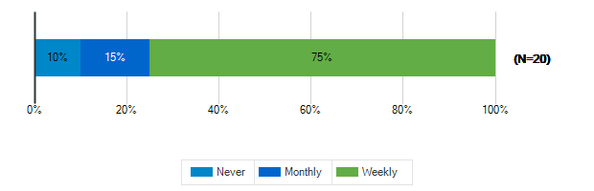

How often do you use?: Teacher Lounge
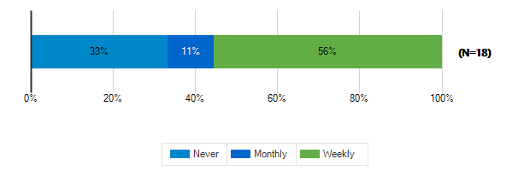

How often do you use?: Library
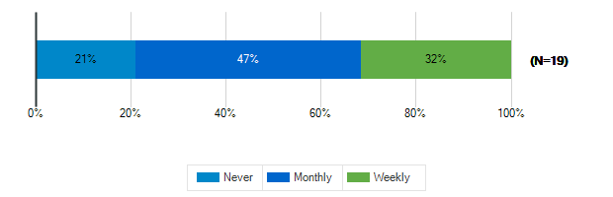

How often do you use?: Stage/Auditorium
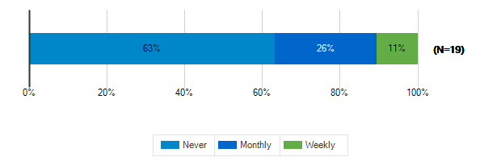

How often do you use?: Outdoor Classrooms
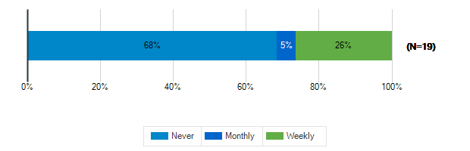

How often do you use?: Administrative Offices

How often do you use?: Conference Room
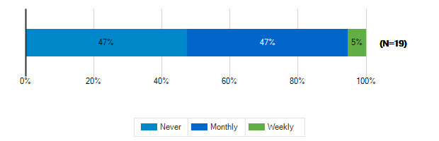

How often do you use?: Cafeteria
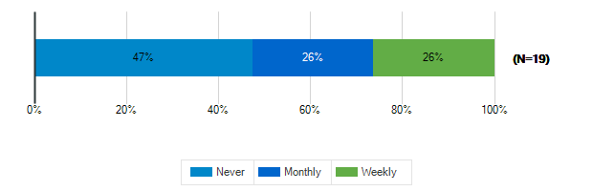

How often do you use?: Shared Spaces
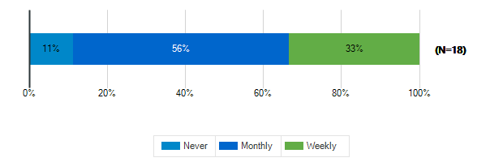

Tell us more about the following resource spaces in your school & grounds?

How would you rate the quality?: Teacher Work Rooms
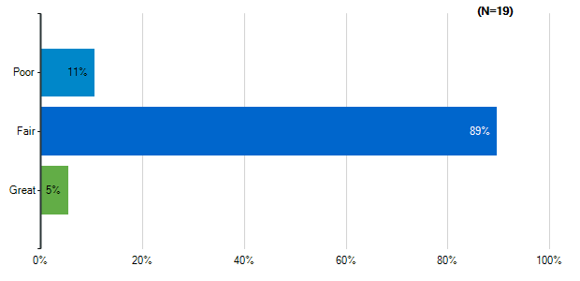
Note: Multiple answers per participant possible. Percentages added may exceed 100 since a participant may select more than one answer for this question.

How would you rate the quality?: Teacher Lounge
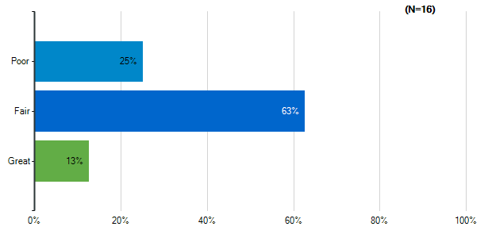
Note: Multiple answers per participant possible. Percentages added may exceed 100 since a participant may select more than one answer for this question.

How would you rate the quality?: Library
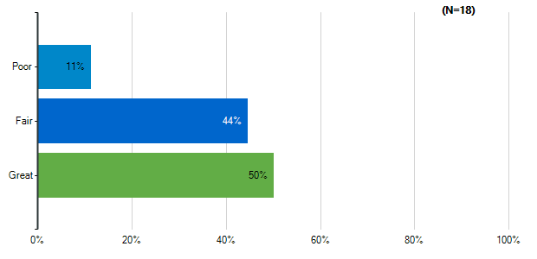
Note: Multiple answers per participant possible. Percentages added may exceed 100 since a participant may select more than one answer for this question.

How would you rate the quality?: Stage/Auditorium
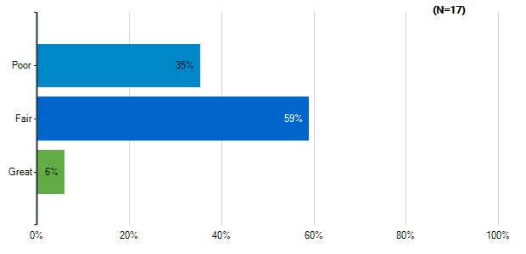
Note: Multiple answers per participant possible. Percentages added may exceed 100 since a participant may select more than one answer for this question.

How would you rate the quality?: Outdoor Classrooms
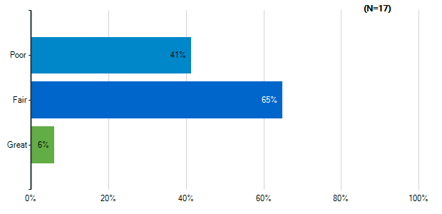
Note: Multiple answers per participant possible. Percentages added may exceed 100 since a participant may select more than one answer for this question.

How would you rate the quality?: Administrative Offices
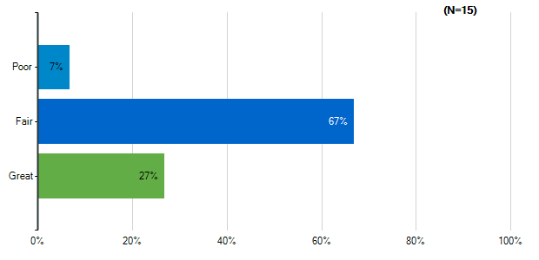
Note: Multiple answers per participant possible. Percentages added may exceed 100 since a participant may select more than one answer for this question.

How would you rate the quality?: Conference Room
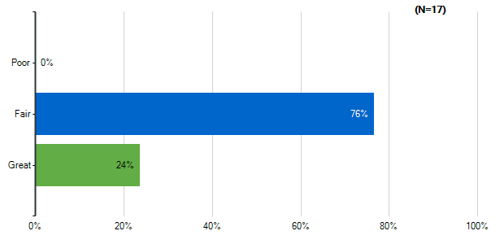
Note: Multiple answers per participant possible. Percentages added may exceed 100 since a participant may select more than one answer for this question.

How would you rate the quality?: Cafeteria
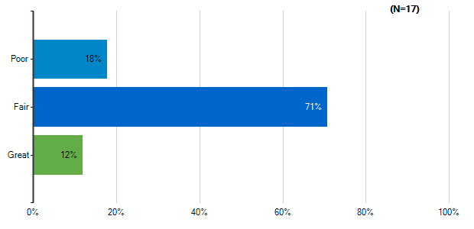
Note: Multiple answers per participant possible. Percentages added may exceed 100 since a participant may select more than one answer for this question.

How would you rate the quality?: Shared Spaces
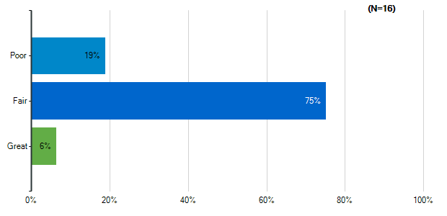
Note: Multiple answers per participant possible. Percentages added may exceed 100 since a participant may select more than one answer for this question.

Please indicate how satisfied you are with the following characteristics of your middle school building:: Cleanliness & Maintenance
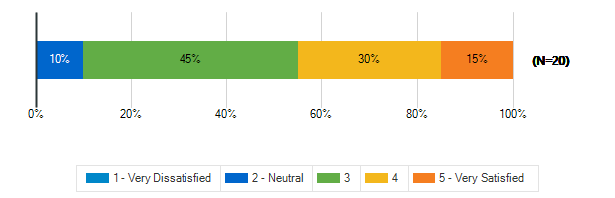

Please indicate how satisfied you are with the following characteristics of your middle school building:: Security & Safety
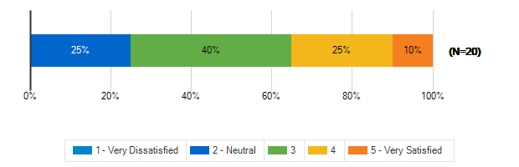

Please indicate how satisfied you are with the following characteristics of your middle school building:: Signage and Wayfinding
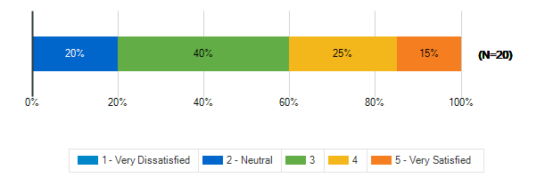

How frequently do your students engage in the following activities in your classroom: Lecture/Lessons
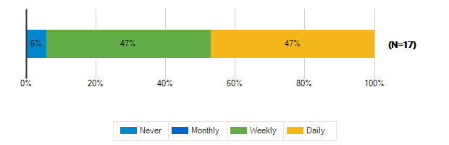

How frequently do your students engage in the following activities in your classroom: Learning Centers/Listening Stations
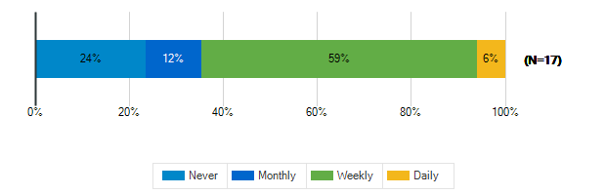

How frequently do your students engage in the following activities in your classroom: Student Presentations Performances
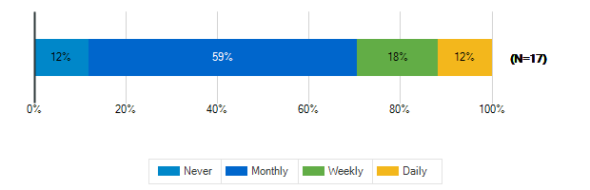

How frequently do your students engage in the following activities in your classroom: Group Activities/Projects
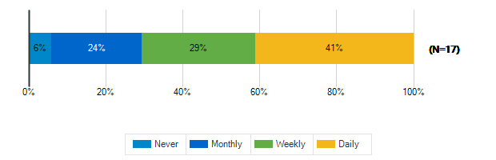

How frequently do your students engage in the following activities in your classroom: Individual Work
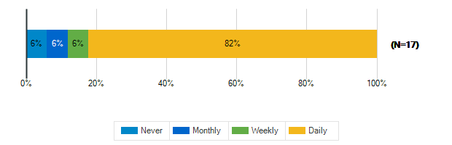

How frequently do your students engage in the following activities in your classroom: Technology/Computer
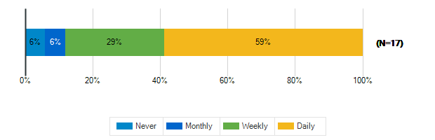

How frequently do your students engage in the following activities in your classroom: Physical Activity/Movement Breaks
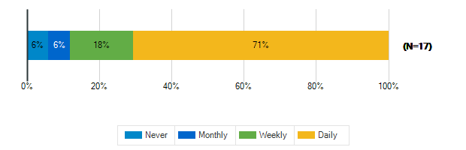

How would you describe the following characteristics of your classroom?: Location
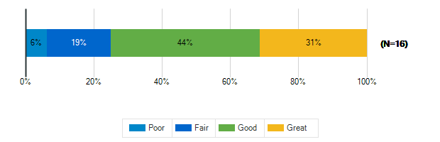

How would you describe the following characteristics of your classroom?: Size
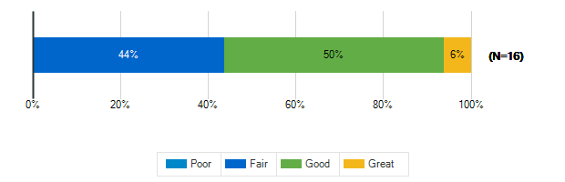

How would you describe the following characteristics of your classroom?: Security & Safety
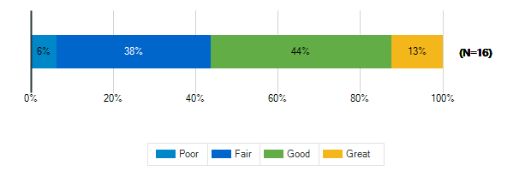

How would you describe the following characteristics of your classroom?: Storage (Amount, Design, Location)
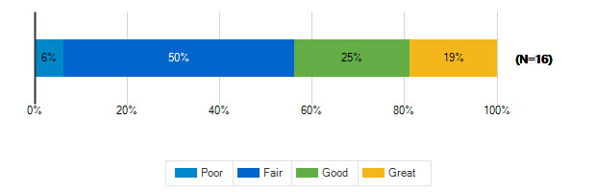

How would you describe the following characteristics of your classroom?: Cleanliness & Maintenance
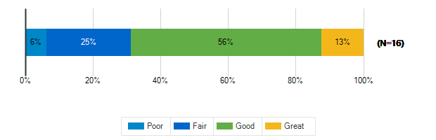

How would you describe the following characteristics of your classroom?: Availability of Technology (including WiFi & power outlets)
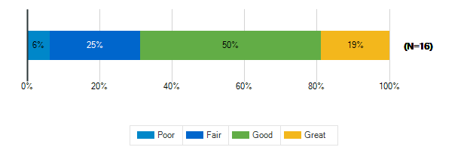

How would you describe the following characteristics of your classroom?: Functionality (including versatility and adaptability)
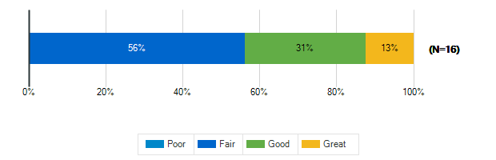

How would you describe the following characteristics of your classroom?: Natural Lighting/Ventilation
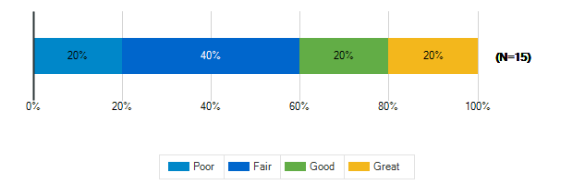

How would you describe the following characteristics of your classroom?: Access to Outdoor Spaces and/or Outdoor Visibility
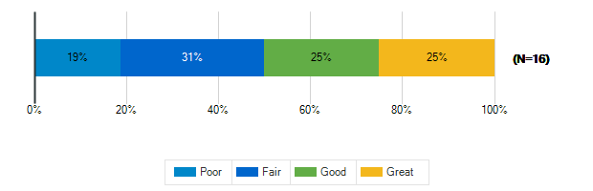

How would you describe the following characteristics of your classroom?: Electric Lighting
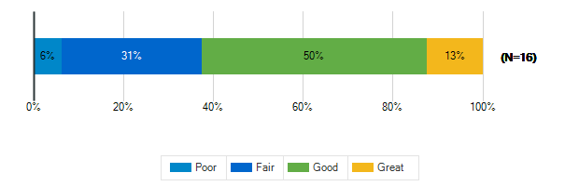

How would you describe the following characteristics of your classroom?: Air quality

How would you describe the following characteristics of your classroom?: Acoustics
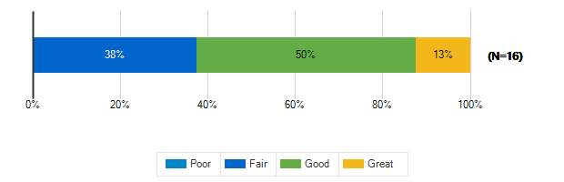

How would you describe the following characteristics of your classroom?: Furniture
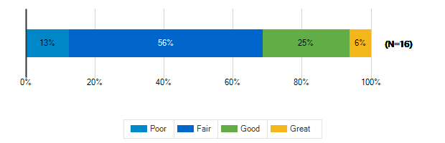

How would you describe the following characteristics of your classroom?: Dry Erase Boards/Display Boards/Bulletin Boards
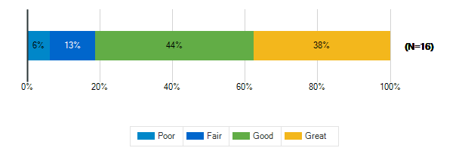

How would you describe the following characteristics of your classroom?: Finishes (Floors/Walls/Ceiling/etc.)
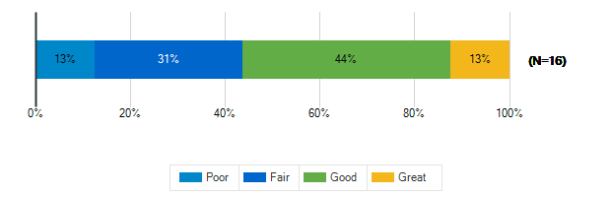

Please rank the following indoor amenities in order of priority for future spaces
Responses | Rank 1 | Rank 2 | Rank 3 | Rank 4 | Weighted Score | Relative Weighted Score | Overall Rank
Dedicated teacher work areas and personal storage area | 4 | 8 | 3 | 3 | 49 | 100 | 1
Dedicated restrooms for staff | 5 | 7 | 2 | 4 | 49 | 100 | 1
Spaces designed for versatility to accommodate a variety of uses | 8 | 0 | 3 | 7 | 45 | 92 | 2
Outdoor access for science and other specialty classrooms | 1 | 3 | 10 | 4 | 37 | 76 | 3

If you’ve taught at or seen a middle school with a feature that doesn’t exist at ACPS that you think should be here, please identify it:
1. | Outdoor access for teaching on a regular basis that is safe
2. | Turf field
3. | Library at my old school was HUGE - biggest space in the school. 20 ft walls of E/S/W windows, small stage, 2 flexible classrooms (chairs/tables for 25, smartboard, whiteboard), lots of casual seating. It was the hub of the school, ran before school hangout/game time, and had adjoining makerspace. It set the tone in the school - incredibly high checkout rates, awesome reading scores, sunny friendly attitudes. Also had large open classroom space in each grade/wing for project time & class collab.
4. | Charging stations for staff electric vehicles. Seems like a really nice perk to attract teachers. Also, some things like coffee in the workroom would be nice. Our PATSO provides it this year, but seems like a small thing which would make people happy. Companies do things like this to retain employees and attract new ones. School systems may need to start these kinds of practices too.
5. | A large enough space for the whole school to gather-- an auditorium or larger cafeteria. There's nowhere to hold a whole school assembly! Henley also needs significantly more natural light-- especially in shared spaces like the library and cafeteria.
6. | I liked the Smartboards higher on the walls-

What is your grade level?
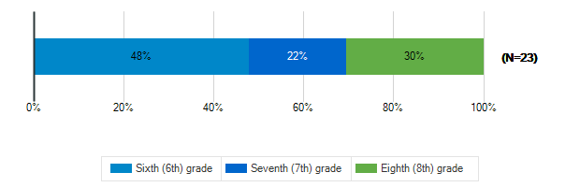

Tell us about the spaces in your school and on your school grounds:

How often do you use these spaces?: Media Center
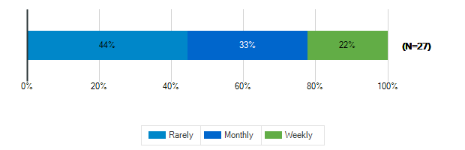

How often do you use these spaces?: Cafeteria
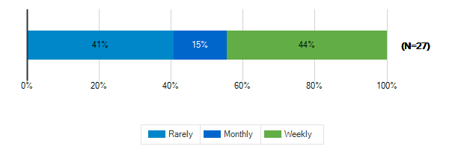

How often do you use these spaces?: Gymnasium
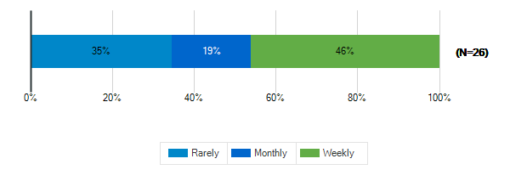

How often do you use these spaces?: tage/Auditorium
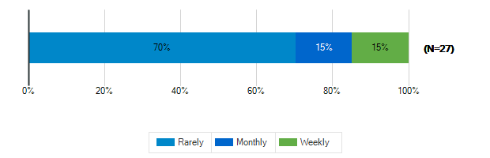

How often do you use these spaces?: Outdoor Classrooms
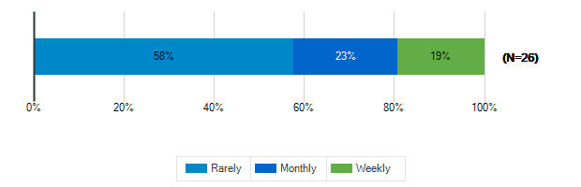

How often do you use these spaces?: Outdoor Recreation/Athletic Fields
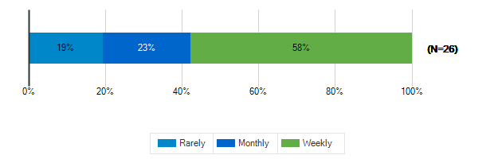

Tell us about the spaces in your school and on your school grounds:

How would you rate these spaces?: Media Center
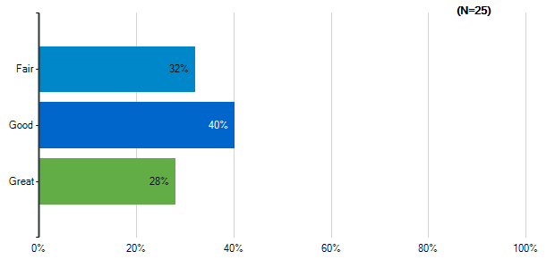
Note: Multiple answers per participant possible. Percentages added may exceed 100 since a participant may select more than one answer for this question.

How would you rate these spaces?: Cafeteria
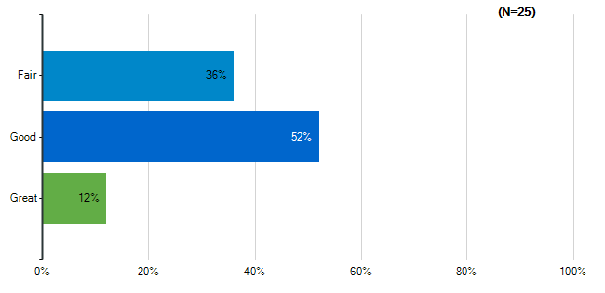
Note: Multiple answers per participant possible. Percentages added may exceed 100 since a participant may select more than one answer for this question.

How would you rate these spaces?: Gymnasium
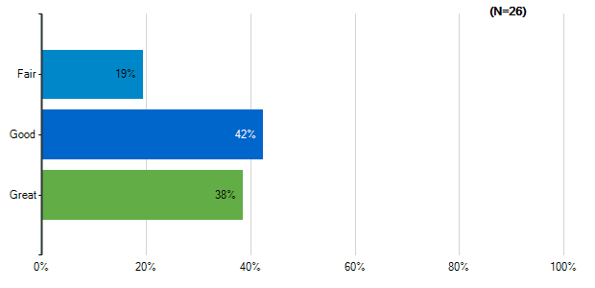
Note: Multiple answers per participant possible. Percentages added may exceed 100 since a participant may select more than one answer for this question.

How would you rate these spaces?: tage/Auditorium
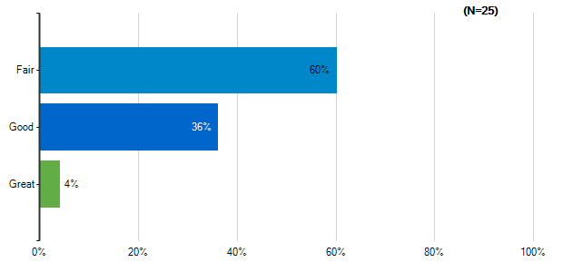
Note: Multiple answers per participant possible. Percentages added may exceed 100 since a participant may select more than one answer for this question.

How would you rate these spaces?: Outdoor Classrooms
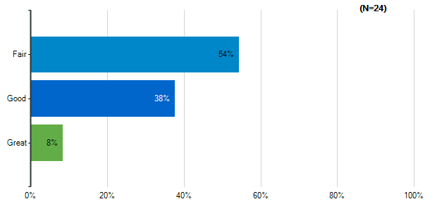
Note: Multiple answers per participant possible. Percentages added may exceed 100 since a participant may select more than one answer for this question.

How would you rate these spaces?: Outdoor Recreation/Athletic Fields
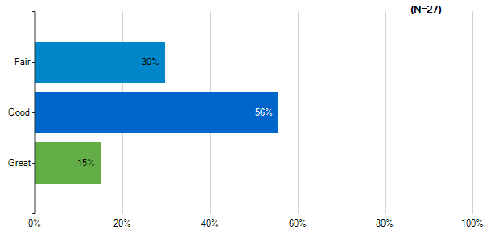
Note: Multiple answers per participant possible. Percentages added may exceed 100 since a participant may select more than one answer for this question.

How would you rate the quality of the following characteristics of your classrooms?: Size
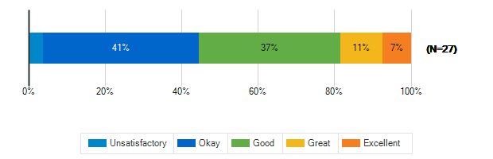

How would you rate the quality of the following characteristics of your classrooms?: Cleanliness
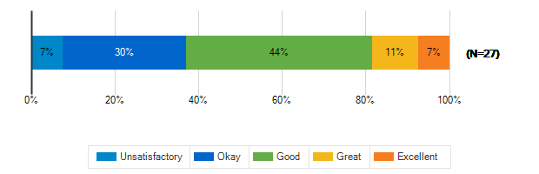

How would you rate the quality of the following characteristics of your classrooms?: Furniture
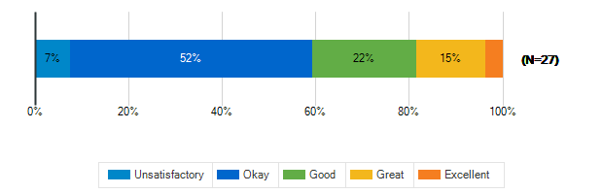

How would you rate the quality of the following characteristics of your classrooms?: Color Scheme/Décor
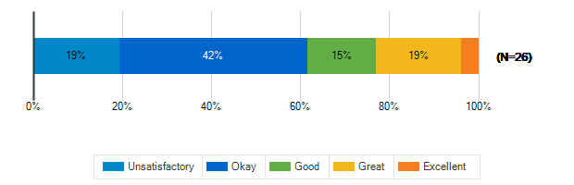

How would you rate the quality of the following characteristics of your classrooms?: Security & Safety
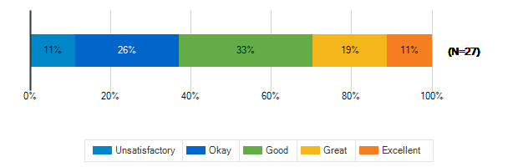

How would you rate the quality of the following characteristics of your classrooms?: Technology (including WiFi and power outlets)
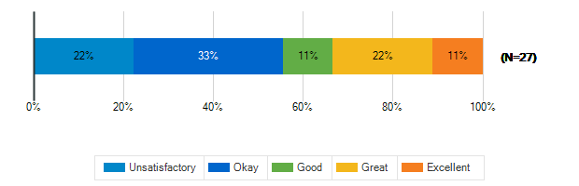

How would you rate the quality of the following characteristics of your classrooms?: Natural Lighting
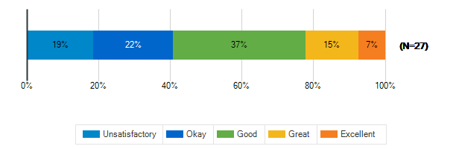

How would you rate the quality of the following characteristics of your classrooms?: Access to Outdoor Spaces and/or Outdoor Visibility
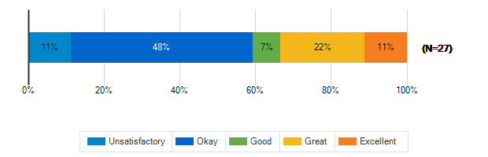

What is the best thing about your middle school?
1. | The rig room and turf room area… but not big enoug
2. | My friends
3. | The library
4. | The villas are REALLY clean and fun to learn in.
5. | Being with friends
6. | Location
7. | The community- students faculty staff and families
8. | Our teachers & staff
9. | Safe area, next to proposed rec center land
10. | The people in it (with the exception of a few)
11. | The location
12. | Students do an excellent job engaging.
13. | Supportive Parents
14. | Teacher teamwork.
15. | the students
16. | pride in the name and community
17. | Talking building- windows. People are great
18. | Unsure
19. | mr elmore

What is the worst thing about your middle school?
1. | Discrimination against black and asian americans
2. | No recess (really bad for my mental health)
3. | The bathrooms inside the school.
4. | not enough time to work on projects
5. | Too Crowded
6. | Size
7. | The space and Security
8. | lighting/color, doesn't feel welcoming/comfortable
9. | The Megjerks. They are a group of mean 6th grd boy
10. | Safety from the outside
11. | The building was built in the 60's.
12. | Lacks diversity as well as inclusion.
13. | Overall sense of entitlement of students
14. | Being so busy.
15. | The parking lot
16. | bullying

17. | No recess
18. | Bathrooms, old desks, pencil sharpeners, playgroun
19. | 82 minute classes. its very annoying

How satisfied are you with the following characteristics of your child’s school?: Availability of Parking
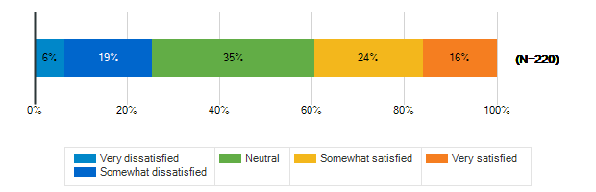

How satisfied are you with the following characteristics of your child’s school?: Design/Flow of CAR Drop-Off and Pick-Up for Students
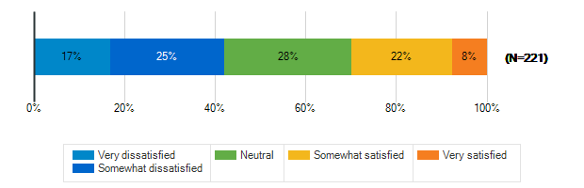

How satisfied are you with the following characteristics of your child’s school?: Design/Flow of BUS Drop-Off and Pick-Up for Students
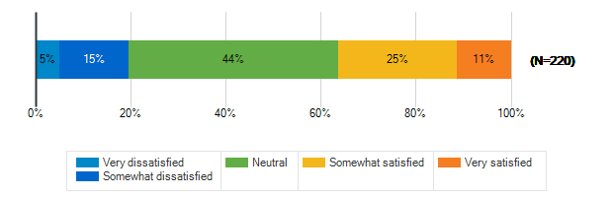

How satisfied are you with the following characteristics of your child’s school?: Entryway into the School
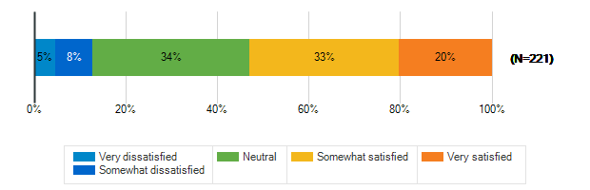

How satisfied are you with the following characteristics of your child’s school?: Classroom
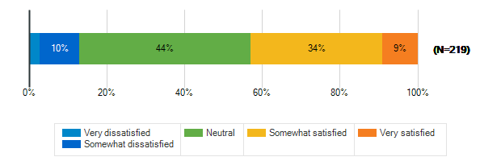

How satisfied are you with the following characteristics of your child’s school?: Security & Safety
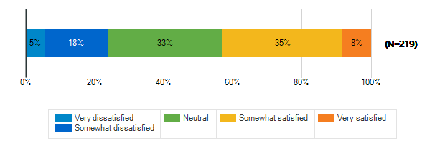

How satisfied are you with the following characteristics of your child’s school?: Technology
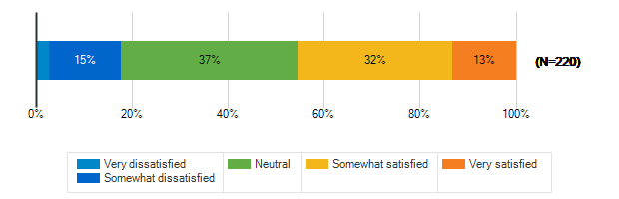

How satisfied are you with the following characteristics of your child’s school?: Learning Environment
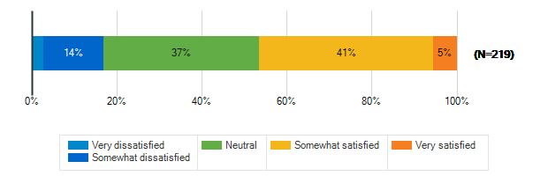

How satisfied are you with the following characteristics of your child’s school?: Natural Lighting/Outdoor Visability
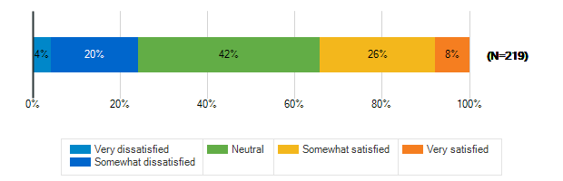

How satisfied are you with the following characteristics of your child’s school?: Performance spaces
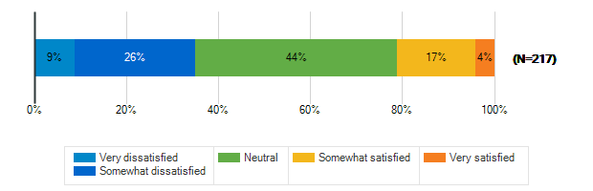

How satisfied are you with the following characteristics of your child’s school?: Outdoor spaces/Athletic fields
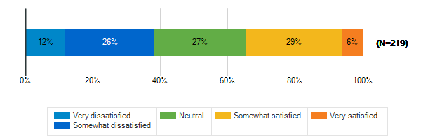

Please rank the following outdoor amenities in order of priority
Responses | Rank 1 | Rank 2 | Rank 3 | Rank 4 | Rank 5 | Rank 6 | Weighted Score | Relative Weighted Score | Overall Rank
Outdoor areas for socializing and relaxing | 56 | 46 | 49 | 37 | 16 | 15 | 920 | 100 | 1
New or improved athletic/recreational fields | 44 | 47 | 31 | 33 | 38 | 26 | 824 | 90 | 2
Protected outdoor space (fenced or in a courtyard) | 43 | 47 | 25 | 22 | 34 | 48 | 775 | 84 | 3
Covered outdoor structure for play and events during inclement weather | 33 | 31 | 45 | 42 | 38 | 30 | 765 | 83 | 4
Dedicated natural areas | 24 | 24 | 35 | 48 | 49 | 39 | 685 | 74 | 5
Walking trails/Bike paths | 19 | 24 | 34 | 37 | 44 | 61 | 630 | 68 | 6

How does your child usually get to school?
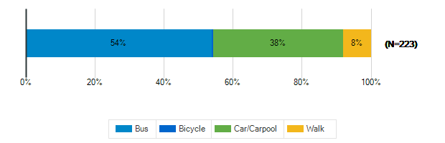

Does your child participate in any afterschool programs at their middle school?
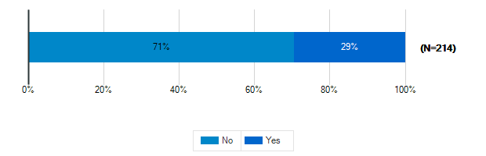

Please specify which programs
1. | EDEP
2. | Track and cross country
3. | jazz, sports, model UN, broadcast news
4. | Soccer
5. | jazz band, after school sports, WAHS sports
6. | Soccer
7. | Tutoring and volleyball
8. | Track and Cross Country, basketball
9. | Track and field
10. | Henley sports
11. | Fall, winter spring sports
12. | Drama and basketball
13. | Henley Track
14. | Basketball and soccer
15. | Cross country, track, band, SCA
16. | Basketball
17. | Sports
18. | Cross Country, Track, Tennis (walk to HS from MS), Drama
19. | Football
20. | Jazz band, volleyball
21. | Track, tennis
22. | Crozet junior strings
23. | Sports
24. | Model UN
25. | EDEP/BASE
26. | Volleyball, musicals
27. | Coding
28. | Theater practice/productions, band concerts, recreational sports
29. | Running club, tennis
30. | Football. Perhaps if there was more education for families about opportunities, we would do more. UNCLEAR where to get this - school, Parks & Rec, 3rd party programs, etc. As far as I know, after 2yrs, there no School run afterschool activities.
31. | Math Club
32. | Track
33. | Crozet sports
34. | Sports
35. | Sports-basketball
36. | Volleyball
37. | Volleyball, tennis
38. | Sports, plays
39. | Soccer
40. | Cross country
41. | Music/ orchestra/ afterschool club
42. | band
43. | Basketball, soccer
44. | Cross country. Track. Both are great programs in partnership w County rec.
45. | Tennis
46. | Jazz band
47. | Basketball
48. | Track
49. | parks and rec
50. | Tennis, model UN, band, jazz Band
51. | Flag football, model UN
52. | Model UN Cross Country
53. | Basketball Flag Football
54. | Tennis. Volleyball
55. | sports, music, dance
56. | Model UN
57. | track
58. | Football
59. | My children are in elementary school but I am sure they will participate in after school activities at school.

