

Middle School Facilities Master Plan
Survey Results

Walton Middle School

Albemarle County Public Schools
May 24 - June 5, 2023



I am:
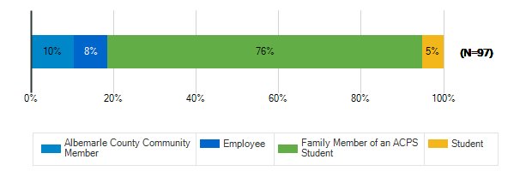

What are the most important qualities for middle school sites/grounds in the 21st century? : Safety & Security
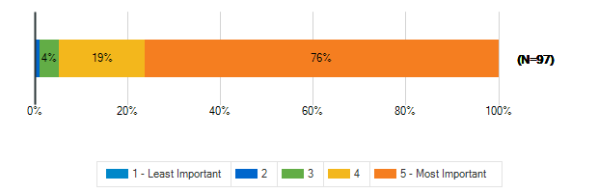

What are the most important qualities for middle school sites/grounds in the 21st century? : Growth & Capacity
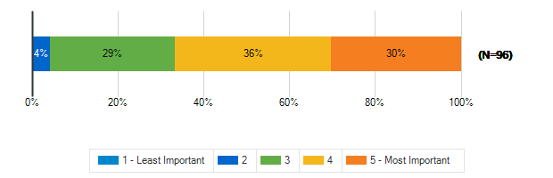

What are the most important qualities for middle school sites/grounds in the 21st century? : Outdoor Spaces
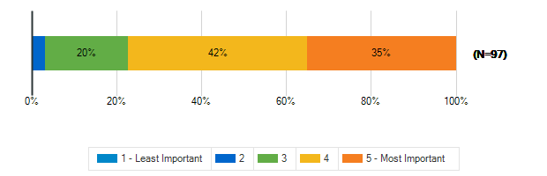

What are the most important qualities for middle school sites/grounds in the 21st century? : Sustainability & Natural Resources
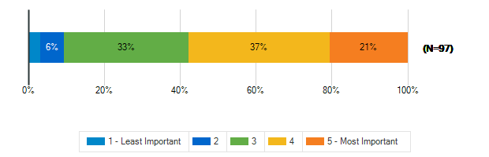

What are the most important qualities for middle school sites/grounds in the 21st century? : Community Access & Amenities
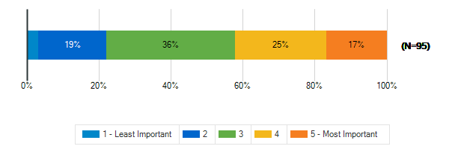

What are the most important qualities for middle school sites/grounds in the 21st century? : Positive, Healthy Culture
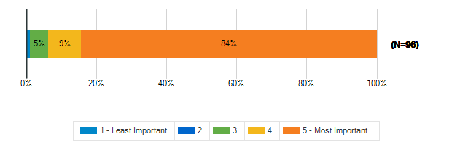

What are the most important qualities for middle school sites/grounds in the 21st century? : Welcoming, Comfortable, Aesthetic Spaces
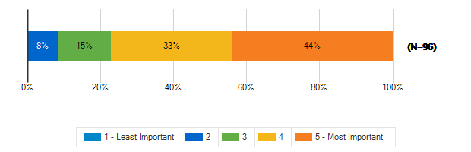

What are the most important qualities for middle school sites/grounds in the 21st century? : Durability, Flexibility, Cost-Efficiency
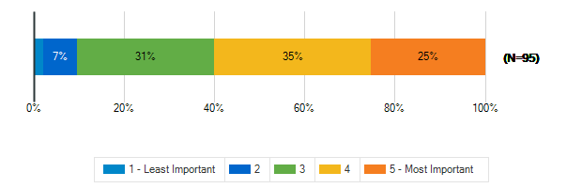

What are the most important qualities for middle school sites/grounds in the 21st century? : Sustainable/Net-Zero Construction
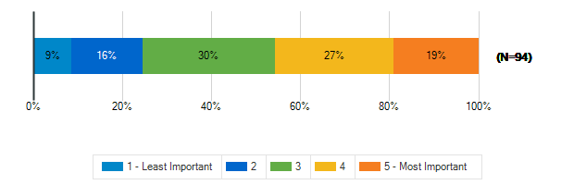

To what extent does your middle school support the following?: A sense of pride and well-being in staff and students
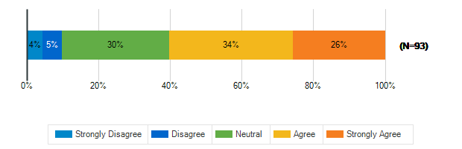

To what extent does your middle school support the following?: Prioritizing the outdoor environment
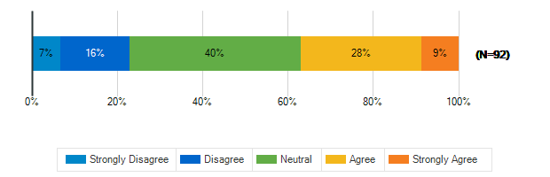

To what extent does your middle school support the following?: Natural resources available to students, staff, and the community
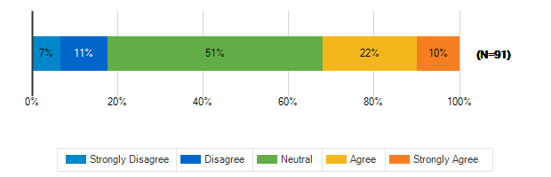

To what extent does your middle school support the following?: Educational resources available to students, staff, and the community
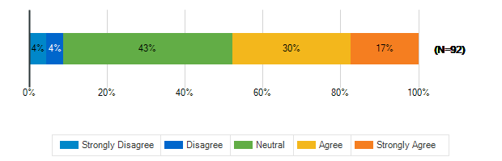

To what extent does your middle school support the following?: Health and fitness
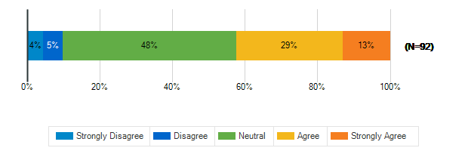

To what extent does your middle school support the following?: Diversity and inclusion
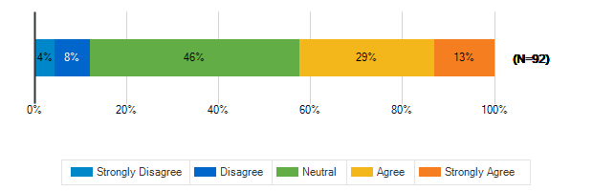

To what extent does your middle school support the following?: Environmental sustainability
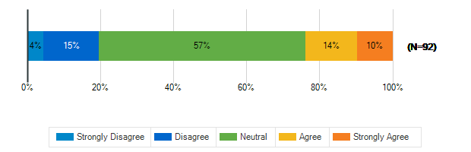

In a few words, what do you think is the greatest opportunity facing our middle school students today?
1. | Too much time on devices and screens.
2. | Loss of development in covid and the after effects
3. | Digital assets
4. | Open minded and creative students
5. | Diversity
6. | Elective choices.
7. | Variety of choices and options
8. | Learning got to communicate and solve problems.
9. | Be more involved community promote sustainability
10. | Nothing
11. | Bullying and anger
12. | Teachers that care
13. | A culture that values inclusivity
14. | Going to school without getting shot.
15. | Growing a sense of safety and inclusion for all.
16. | Safety
17. | Technology and embracing diversity
18. | forming peer bonds and learning social skills
19. | More English, Reading, Writing and Math. Work skil
20. | Confidence and understanding their impact/value
21. | Mental and social well-being
22. | College and working build character
23. | to work with new people
24. | Environmental stewardship
25. | Lack of parental engagement in the education
26. | Course opportunities, building independence,
27. | learning and collaborating in person
28. | Teaching them how to think critically
29. | Access to unlimited knowledge and resources online
30. | activism, social justice
31. | Families wanting to see improved academics
32. | The honors classes, and sports.
33. | The teachers supporting their wellbeing
34. | Access to a vast amount educational resources
35. | Idk
36. | Safe, kind, inclusive learning environment
37. | to become productive members of society
38. | Elementary students should not be separated for MS
39. | Their access to tech
40. | rapidly changing technology
41. | Smaller class sizes at Walton!
42. | Learning in a diverse, inclusive environment
43. | No after school care or experiences.
44. | Jobs
45. | social media/ internet safety and increased drugs
46. | The ease of sharing information and use of technol
47. | They have an ever evolving job market.
48. | Changing the world
49. | Access to learning resources, emphasize kindness
50. | The essentials are the greatest opportunity
51. | The opportunity to learn in a positive environmen.
52. | STEM careers
53. | Kids behind academically from Covid
54. | Learning to be more independent in a safe envir
55. | Open educational resources
56. | Critical thinking skills, creativity, flexibility
57. | Bathrooms and updates to ensure the school is stil
58. | They have access to plenty of information
59. | Use of Technology
60. | Accelerated learning through technology
61. | Potential to be a citizen of the world
62. | The availability of information
63. | It’s at rock bottom so anything would be better
64. | More active, flexible learning models
65. | dynamic learning
66. | Critical thinking skills are lacking
67. | Educational and career growth
68. | i dont know
69. | Conocer barias culturas
70. | "Facing an opportunity" is stupid corporate speak.
71. | County has amazing staff at the teacher level
72. | Opportunities to learn with other cultures

In a few words, what do you think is the greatest challenge facing our middle school students today?
1. | Bullying
2. | Not enough outdoor time
3. | Exposure to negative social media and behaviors
4. | Balancing equity with academic rigor
5. | Preparing them for the future
6. | Limited academic choices or paths
7. | Too much technology. On phones and web too much
8. | Too much technology.
9. | Too much technology and tec addiction
10. | Bullying and nobody will stop it
11. | Safety
12. | Mental health, social media
13. | Behavior
14. | Bullying
15. | Focus on knowledge over conceptual understanding
16. | Going to school without fear of getting shot.
17. | Divisiveness among the students
18. | Safety
19. | Navigating social media
20. | social media
21. | Finding free tutoring for math, english.
22. | Negative feedback and high expectations to grow up
23. | Lack of person to person social skills
24. | Drugs vaping bulling cutting social media
25. | Growth and overcrowding at school
26. | Social media woes
27. | Safety: Mass shootings, climate change.
28. | Social media
29. | Lack of work effort in classroom and life
30. | Phones! Social media as a passive distraction
31. | social media and too much screen time.
32. | Teaching them how to persevere and be respectful
33. | Mental health challenges due to social media
34. | violence, cyberbullying, racism
35. | Student/family accountability.
36. | Phones.
37. | Too many initiatives that detract from teaching
38. | Focus on learning how to learn
39. | Idk
40. | Social media, body image, wanting to fit in
41. | Social & emotional issues in a fast changing world
42. | inadequate guidance and direction from parents
43. | Separation from their friends in Elementary
44. | students having no respect, roaming the hallways
45. | social media/mental health challenges
46. | rapidly changing technology
47. | School safety; inefficient school board and admin
48. | social media
49. | Going to every other day core classes.
50. | Changes
51. | internet/ social media safety and drugs
52. | Access to technology w/o supervision
53. | Poor teaching and outdated teaching methods
54. | Self esteem and acceptance amongst peers
55. | Walton is in a remote location with old facilities
56. | Social media influences
57. | Shutting off cell phones/social media.
58. | Safety
59. | Too much focus on diversity & inclusi
60. | Kids behind academically from Covid
61. | Stunted interaction due to screens
62. | Limited outdoor resources
63. | Adults who don’t embrace differences
64. | Their phones and social media
65. | Academics not being the top priority of the county
66. | Mastery of core concepts
67. | Divided community; lack of respect for eachother
68. | The lack of clean guidance to sort through so muc.
69. | Rock bottom
70. | Outdated school buildings, that dont speak to now
71. | mental, physical and emotional saftey
72. | Critical thinking and solving real world problems
73. | Accessibility to special education services
74. | Christian values
75. | Specialized groups wanting to teach their agenda
76. | not wanting to be there
77. | Peleas entre los estudiantes
78. | Making up for the COVID learning loss.
79. | Teachers are overloaded
80. | Accessiblity of addictive, mind-altering drugs
81. | Overcrowding and not enough teachers to supervise.

To meet the needs of students, educators, families and the community, a middle school facility in Albemarle County MUST HAVE
1. | Books. And screens. Unfortunately there must also
2. | An abundance of resources
3. | Adequate outdoor learning spaces
4. | Qualified teachers
5. | A faculty that is happy, committed and appreciate
6. | Accountability
7. | High quality teachers with manageable classes
8. | Great teachers, leaders. Building is secondary
9. | Dedicated staff
10. | Internet, community space, playground/equiptment
11. | A safe place
12. | Flexible spaces
13. | Ways to handle anger stress and anxiety
14. | Parent support
15. | Well-compensated, life-balanced, respected staff
16. | Better gun control laws nationwide.
17. | Active, healthy, positive role models
18. | A good reputation
19. | spaces for kids to be kids together, eye to eye
20. | 2 english, reading, writing & work skills per day.
21. | Fresh air and supportive staff. Space to recenter
22. | Flexible spaces for teaching, learning, making
23. | A safe, stimulating environment
24. | Outdoor space and enough classrooms!
25. | Great supportive staff
26. | Flexible, clean, bright spaces
27. | Full mental health support. Libraries for all.
28. | A positive, inclusive environment for all
29. | Strong, consistent administrators
30. | An inviting design
31. | fresh air, sunshine, nutrition, teamwork
32. | resources to meet the communities needs
33. | Well-compensated, life-balanced, respected staff
34. | building safety and advanced technology
35. | SROs and strong administration.
36. | A good learning enviroment.
37. | Enough space and staff.
38. | Security, serenity, warmth, welcomeness, comfort
39. | Idk
40. | Outdoor learning space. Teach mindfulness
41. | safety and security
42. | safe and secure building (metal detectors)
43. | Feeder patterns that don't separate ES students
44. | consistancy for all students.
45. | Enough counselors to serve all students
46. | a comprehensive plan wrt technology
47. | A SCHOOL RESOURCE OFFICER!
48. | a fully stocked library
49. | internet, food, and transportation
50. | Transportation
51. | more severe consequences for bad behavior
52. | Worthwhile culture
53. | Adequate Teachers with basic classroom management
54. | Access to specials, outdoor time, soc/emo support
55. | Great educators. Accommodate connectivity of area.
56. | Access to better food
57. | Diversity and Inclusion.
58. | Safety features, positive messaging, anti-bullying
59. | Security
60. | Mental health training
61. | Good teachers; commitment to essential education
62. | Outdoors rec. facilities and art education
63. | The flexibility to expand and be sustainable
64. | Inclusivity and access
65. | Great teachers backed by supportive administration
66. | Library and maker spaces
67. | Community events that are appealing to all
68. | An outstanding principle.
69. | No support cuz if there was it’s not in albemarle
70. | inspiring, flexible indoor AND outdoor learning
71. | Small enough community for all to me known
72. | Caring and compassionate teachers and environment
73. | Accessibility to sped and inclusion for those kids
74. | Single stall/room toilets
75. | A great psychology / counseling group
76. | a safe environment and good teachers
77. | Seguridad
78. | Good intervention programs in reading and math.
79. | Safety and security
80. | Postive, healthy culture
81. | Properly paid teachers.

Tell us more about the following resource spaces in your school & grounds?

How often do you use?: Teacher Work Rooms
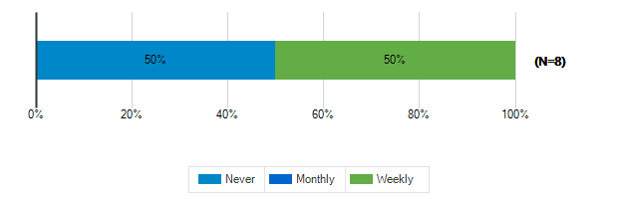

How often do you use?: Teacher Lounge
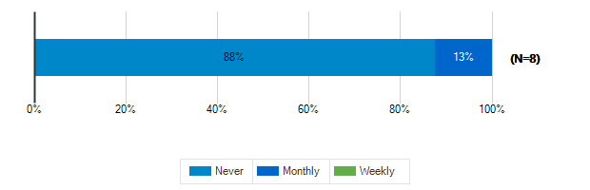

How often do you use?: Library
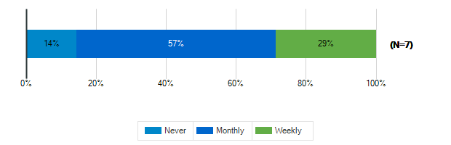

How often do you use?: Stage/Auditorium
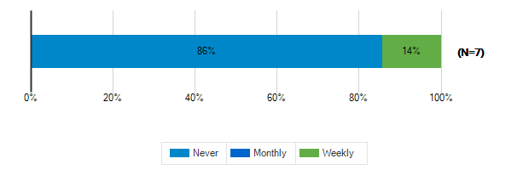

How often do you use?: Outdoor Classrooms

How often do you use?: Administrative Offices
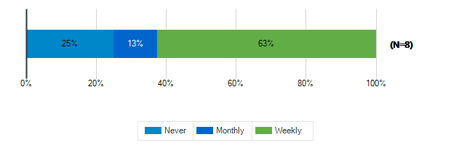

How often do you use?: Conference Room
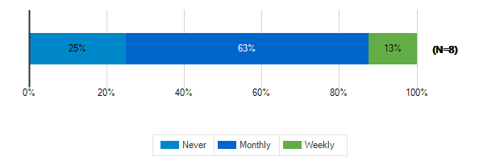

How often do you use?: Cafeteria
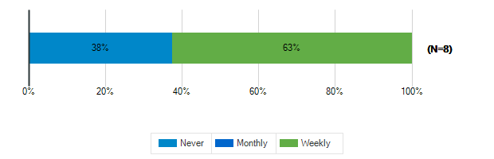

How often do you use?: Shared Spaces
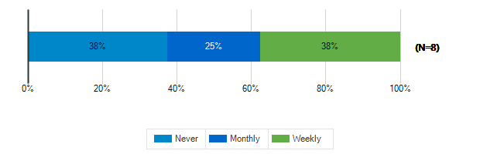

Tell us more about the following resource spaces in your school & grounds?

How would you rate the quality?: Teacher Work Rooms
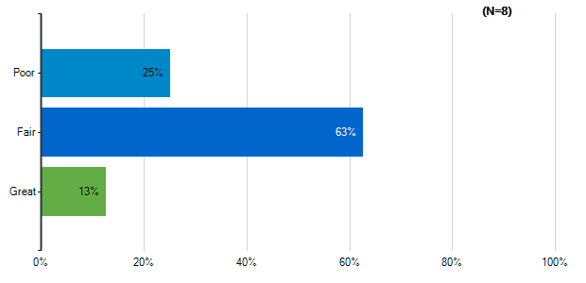
Note: Multiple answers per participant possible. Percentages added may exceed 100 since a participant may select more than one answer for this question.

How would you rate the quality?: Teacher Lounge
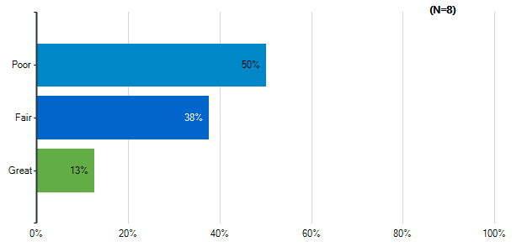
Note: Multiple answers per participant possible. Percentages added may exceed 100 since a participant may select more than one answer for this question.

How would you rate the quality?: Library
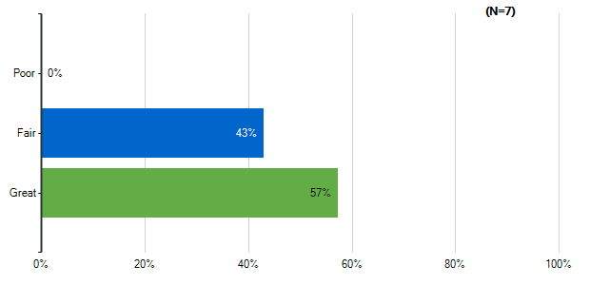
Note: Multiple answers per participant possible. Percentages added may exceed 100 since a participant may select more than one answer for this question.

How would you rate the quality?: Stage/Auditorium
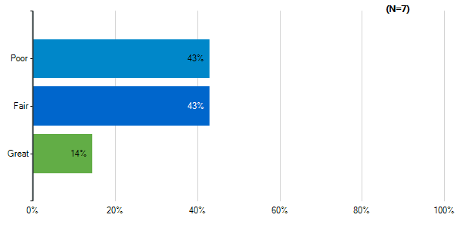
Note: Multiple answers per participant possible. Percentages added may exceed 100 since a participant may select more than one answer for this question.

How would you rate the quality?: Outdoor Classrooms
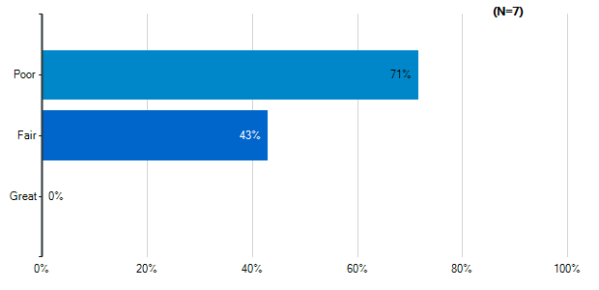
Note: Multiple answers per participant possible. Percentages added may exceed 100 since a participant may select more than one answer for this question.

How would you rate the quality?: Administrative Offices
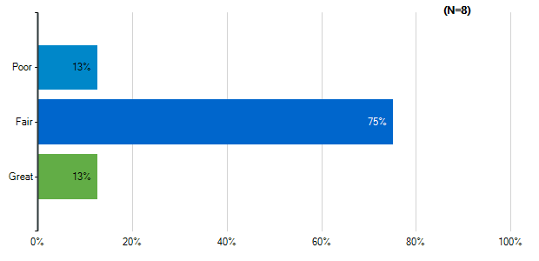
Note: Multiple answers per participant possible. Percentages added may exceed 100 since a participant may select more than one answer for this question.

How would you rate the quality?: Conference Room
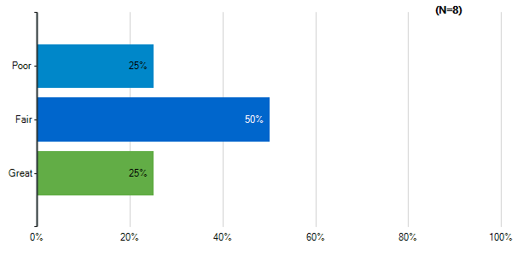
Note: Multiple answers per participant possible. Percentages added may exceed 100 since a participant may select more than one answer for this question.

How would you rate the quality?: Cafeteria
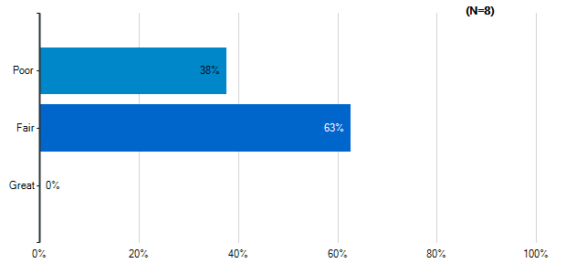
Note: Multiple answers per participant possible. Percentages added may exceed 100 since a participant may select more than one answer for this question.

How would you rate the quality?: Shared Spaces
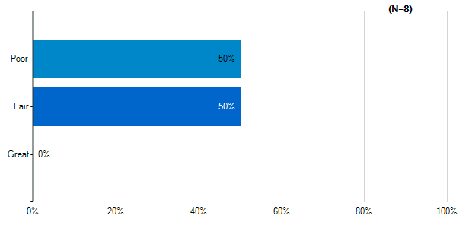
Note: Multiple answers per participant possible. Percentages added may exceed 100 since a participant may select more than one answer for this question.

Please indicate how satisfied you are with the following characteristics of your middle school building:: Cleanliness & Maintenance
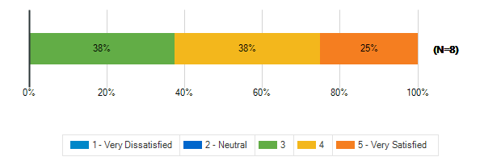

Please indicate how satisfied you are with the following characteristics of your middle school building:: Security & Safety
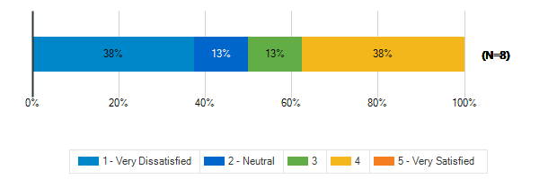

Please indicate how satisfied you are with the following characteristics of your middle school building:: Signage and Wayfinding
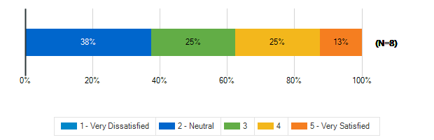

How frequently do your students engage in the following activities in your classroom: Lecture/Lessons
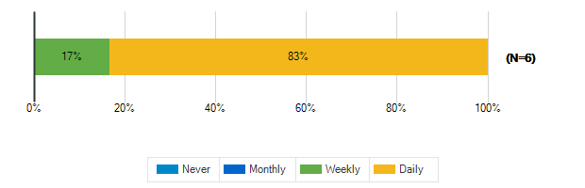

How frequently do your students engage in the following activities in your classroom: Learning Centers/Listening Stations
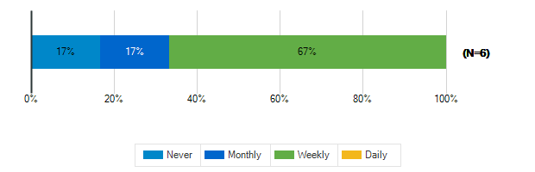

How frequently do your students engage in the following activities in your classroom: Student Presentations Performances
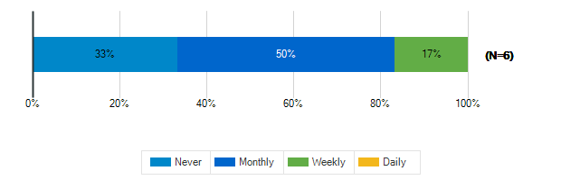

How frequently do your students engage in the following activities in your classroom: Group Activities/Projects
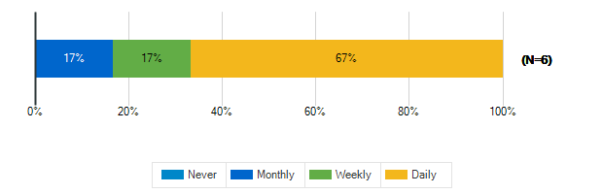

How frequently do your students engage in the following activities in your classroom: Individual Work
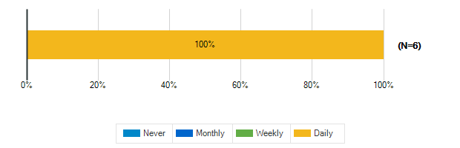

How frequently do your students engage in the following activities in your classroom: Technology/Computer

How frequently do your students engage in the following activities in your classroom: Physical Activity/Movement Breaks

How would you describe the following characteristics of your classroom?: Location
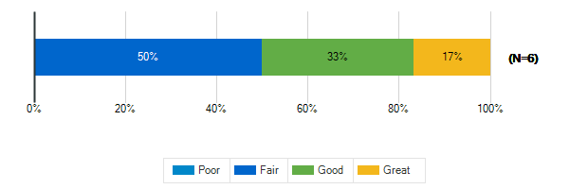

How would you describe the following characteristics of your classroom?: Size
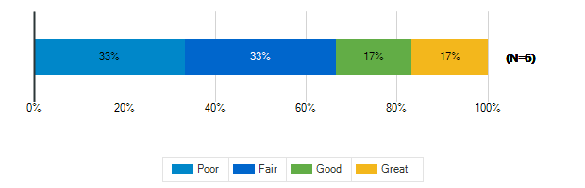

How would you describe the following characteristics of your classroom?: Security & Safety
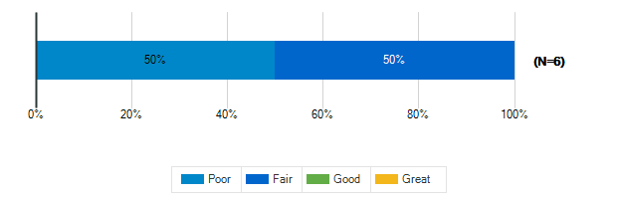

How would you describe the following characteristics of your classroom?: Storage (Amount, Design, Location)
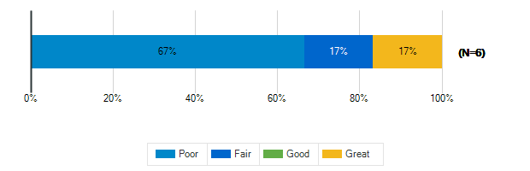

How would you describe the following characteristics of your classroom?: Cleanliness & Maintenance
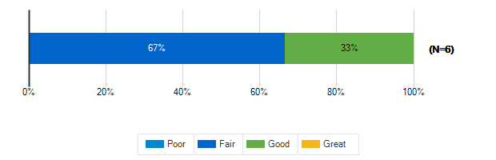

How would you describe the following characteristics of your classroom?: Availability of Technology (including WiFi & power outlets)
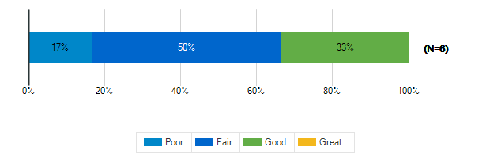

How would you describe the following characteristics of your classroom?: Functionality (including versatility and adaptability)
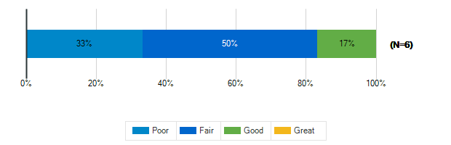

How would you describe the following characteristics of your classroom?: Natural Lighting/Ventilation
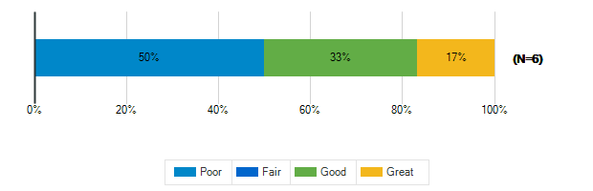

How would you describe the following characteristics of your classroom?: Access to Outdoor Spaces and/or Outdoor Visibility

How would you describe the following characteristics of your classroom?: Electric Lighting
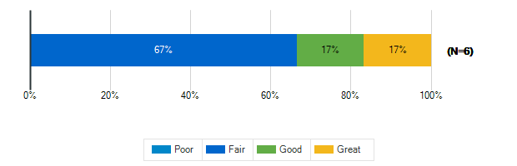

How would you describe the following characteristics of your classroom?: Air quality

How would you describe the following characteristics of your classroom?: Acoustics
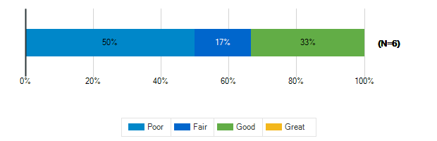

How would you describe the following characteristics of your classroom?: Furniture
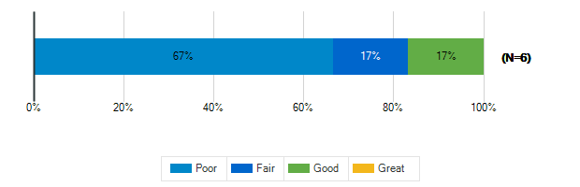

How would you describe the following characteristics of your classroom?: Dry Erase Boards/Display Boards/Bulletin Boards
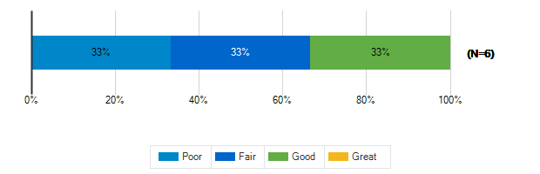

How would you describe the following characteristics of your classroom?: Finishes (Floors/Walls/Ceiling/etc.)
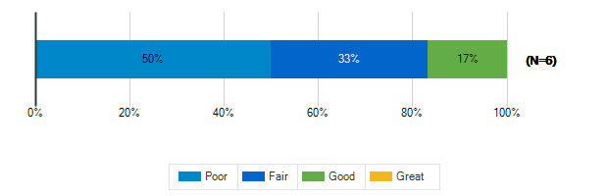

Please rank the following indoor amenities in order of priority for future spaces
Responses | Rank 1 | Rank 2 | Rank 3 | Rank 4 | Weighted Score | Relative Weighted Score | Overall Rank
Dedicated teacher work areas and personal storage area | 4 | 1 | 3 | 0 | 25 | 100 | 1
Dedicated restrooms for staff | 3 | 3 | 1 | 1 | 24 | 96 | 2
Spaces designed for versatility to accommodate a variety of uses | 0 | 3 | 3 | 2 | 17 | 68 | 3
Outdoor access for science and other specialty classrooms | 1 | 1 | 1 | 5 | 14 | 56 | 4

If you’ve taught at or seen a middle school with a feature that doesn’t exist at ACPS that you think should be here, please identify it:
1. | Ample study spaces available to students
2. | The school had a bulletproof "safe-room" that all visitors were allowed to enter before being able to actually access the building. Each classroom door had a specific key, not one key that works on every classroom in the building. Shared walls were built from cinderblocks instead of the makeshift walls that aren't sound proof.
3. | None
4. | Teacher lounge that can be used BY teachers, multiple bathrooms, lunch coverage, support from central office
5. | Wings for each grade level to help build community and for saftey, ie 4 wings/ pods 6,7,8 and an exploritiries wing with the Admin offices as the central hub.

What is your grade level?
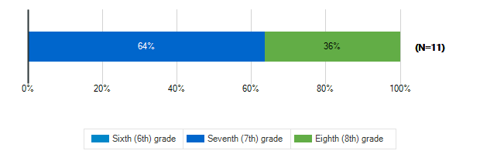

Tell us about the spaces in your school and on your school grounds:

How often do you use these spaces?: Media Center
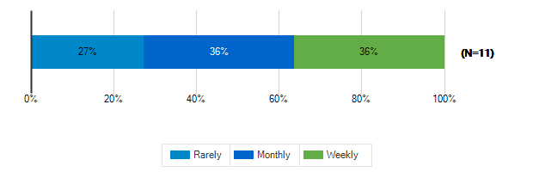

How often do you use these spaces?: Cafeteria
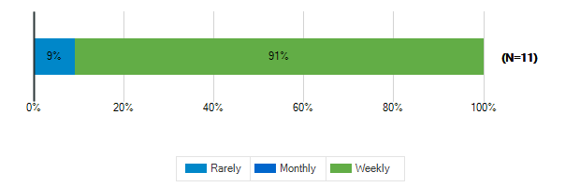

How often do you use these spaces?: Gymnasium
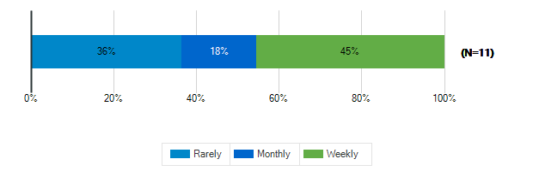

How often do you use these spaces?: tage/Auditorium
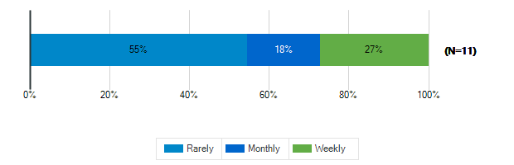

How often do you use these spaces?: Outdoor Classrooms
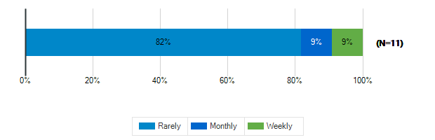

How often do you use these spaces?: Outdoor Recreation/Athletic Fields
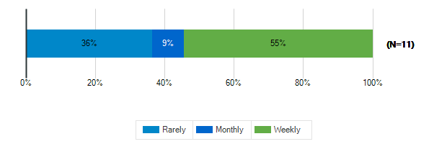

Tell us about the spaces in your school and on your school grounds:

How would you rate these spaces?: Media Center
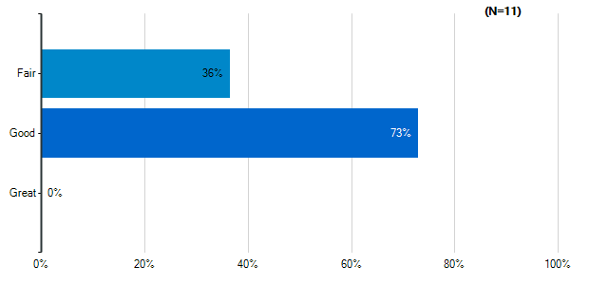
Note: Multiple answers per participant possible. Percentages added may exceed 100 since a participant may select more than one answer for this question.

How would you rate these spaces?: Cafeteria
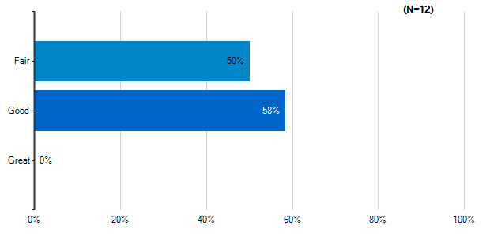
Note: Multiple answers per participant possible. Percentages added may exceed 100 since a participant may select more than one answer for this question.

How would you rate these spaces?: Gymnasium
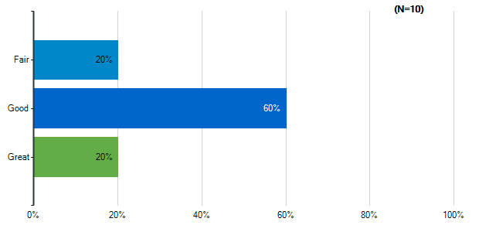
Note: Multiple answers per participant possible. Percentages added may exceed 100 since a participant may select more than one answer for this question.

How would you rate these spaces?: tage/Auditorium
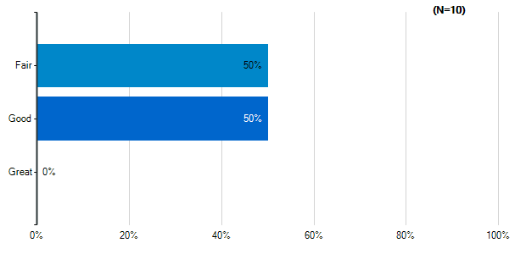
Note: Multiple answers per participant possible. Percentages added may exceed 100 since a participant may select more than one answer for this question.

How would you rate these spaces?: Outdoor Classrooms
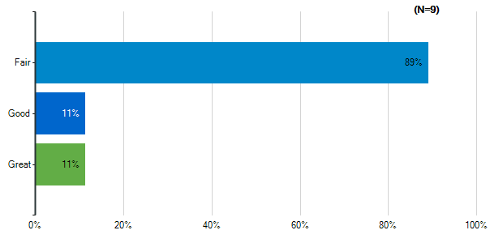
Note: Multiple answers per participant possible. Percentages added may exceed 100 since a participant may select more than one answer for this question.

How would you rate these spaces?: Outdoor Recreation/Athletic Fields
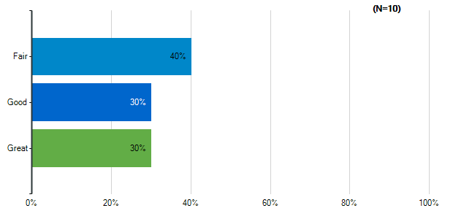
Note: Multiple answers per participant possible. Percentages added may exceed 100 since a participant may select more than one answer for this question.

How would you rate the quality of the following characteristics of your classrooms?: Size
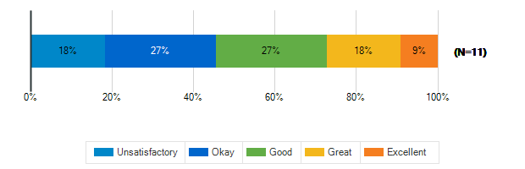

How would you rate the quality of the following characteristics of your classrooms?: Cleanliness
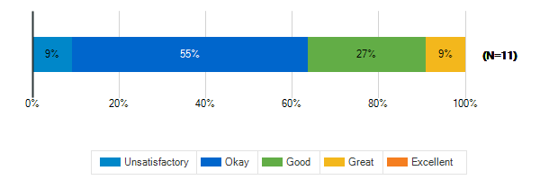

How would you rate the quality of the following characteristics of your classrooms?: Furniture
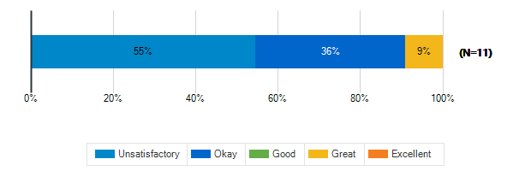

How would you rate the quality of the following characteristics of your classrooms?: Color Scheme/Décor
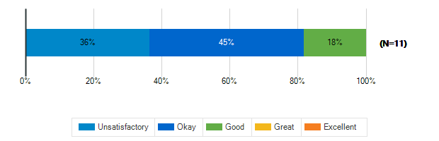

How would you rate the quality of the following characteristics of your classrooms?: Security & Safety
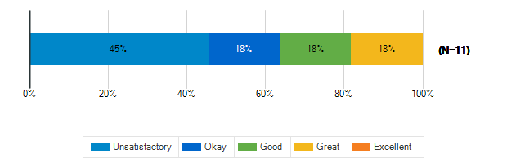

How would you rate the quality of the following characteristics of your classrooms?: Technology (including WiFi and power outlets)
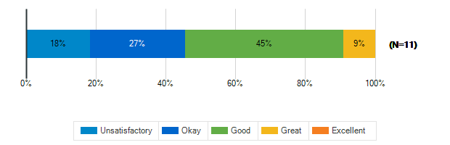

How would you rate the quality of the following characteristics of your classrooms?: Natural Lighting
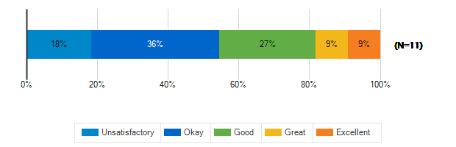

How would you rate the quality of the following characteristics of your classrooms?: Access to Outdoor Spaces and/or Outdoor Visibility
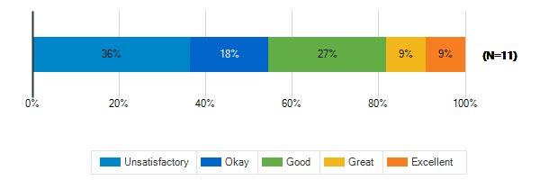

What is the best thing about your middle school?
1. | Teachers
2. | The river and outdoor spaces
3. | Principal
4. | Small Size
5. | Support from coworkers and administration
6. | My friends and the teachers.
7. | IDK
8. | The location and outside space.
9. | Lunch
10. | Small population so all learners are known by all
11. | the people

What is the worst thing about your middle school?
1. | People bullying
2. | Interior rooms without natural light and bad seats
3. | Lack of consistency in discipline matters
4. | Some gaps in resources
5. | The reputation and lack of community support
6. | I'm not sure
7. | IDK
8. | The location and lack of transportation.
9. | Teachers
10. | saftey, doors propped open, faulty facilities
11. | being there

How satisfied are you with the following characteristics of your child’s school?: Availability of Parking
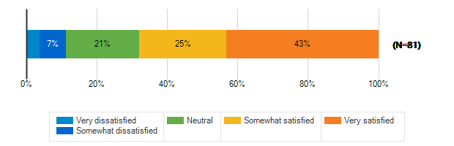

How satisfied are you with the following characteristics of your child’s school?: Design/Flow of CAR Drop-Off and Pick-Up for Students
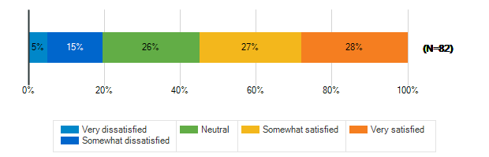

How satisfied are you with the following characteristics of your child’s school?: Design/Flow of BUS Drop-Off and Pick-Up for Students
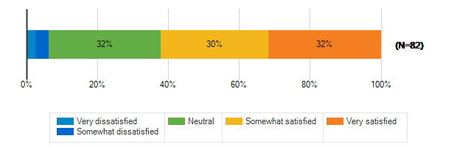

How satisfied are you with the following characteristics of your child’s school?: Entryway into the School
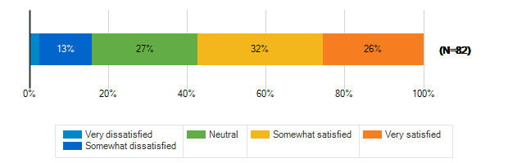

How satisfied are you with the following characteristics of your child’s school?: Classroom
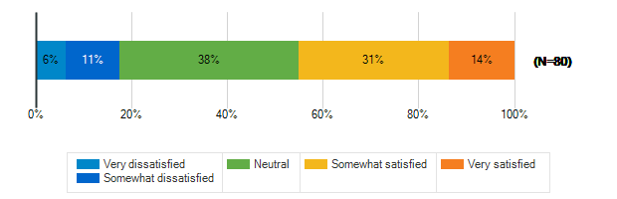

How satisfied are you with the following characteristics of your child’s school?: Security & Safety
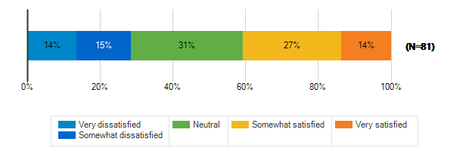

How satisfied are you with the following characteristics of your child’s school?: Technology
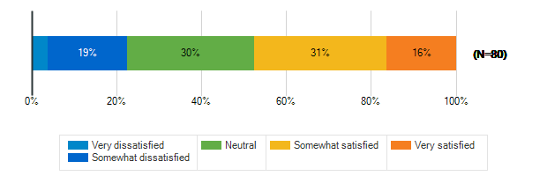

How satisfied are you with the following characteristics of your child’s school?: Learning Environment
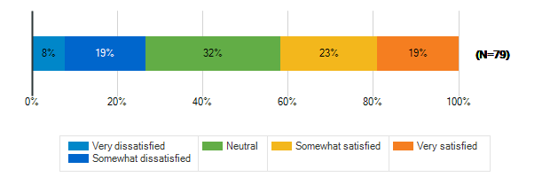

How satisfied are you with the following characteristics of your child’s school?: Natural Lighting/Outdoor Visability
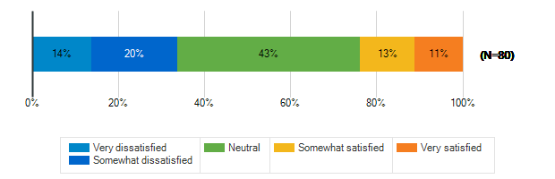

How satisfied are you with the following characteristics of your child’s school?: Performance spaces
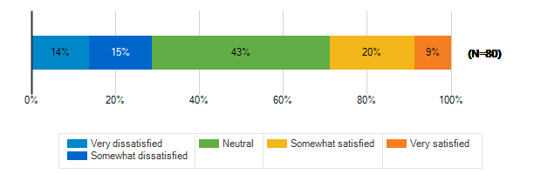

How satisfied are you with the following characteristics of your child’s school?: Outdoor spaces/Athletic fields
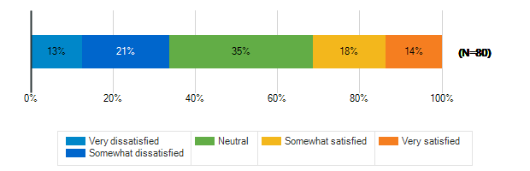

Please rank the following outdoor amenities in order of priority
Responses | Rank 1 | Rank 2 | Rank 3 | Rank 4 | Rank 5 | Rank 6 | Weighted Score | Relative Weighted Score | Overall Rank
Outdoor areas for socializing and relaxing | 11 | 17 | 18 | 13 | 10 | 8 | 290 | 100 | 1
Covered outdoor structure for play and events during inclement weather | 9 | 18 | 21 | 11 | 9 | 9 | 288 | 99 | 2
New or improved athletic/recreational fields | 16 | 17 | 6 | 13 | 11 | 14 | 280 | 97 | 3
Protected outdoor space (fenced or in a courtyard) | 27 | 5 | 7 | 7 | 12 | 19 | 279 | 96 | 4
Dedicated natural areas | 7 | 15 | 15 | 17 | 9 | 14 | 260 | 90 | 5
Walking trails/Bike paths | 7 | 5 | 10 | 16 | 26 | 13 | 220 | 76 | 6

How does your child usually get to school?
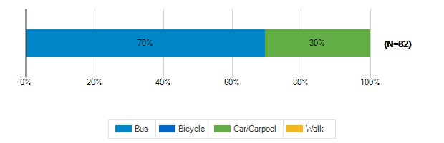

Does your child participate in any afterschool programs at their middle school?
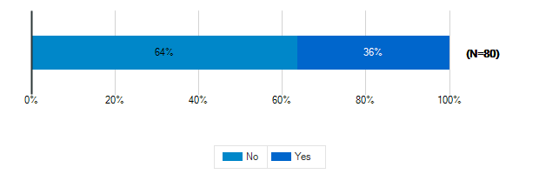

Please specify which programs
1. | D&D and sports
2. | Volleyball, ambassadors, drama
3. | Edep
4. | Basketball
5. | Basketball and track
6. | School play and volleyball
7. | EDEP
8. | Tennis; DND; band
9. | Dances, open gym, summer camp
10. | Volleyball, music programs, will do other sports next year
11. | Track/cross country
12. | He's in high school now, but he used to do track.
13. | Basketball, Track & Field
14. | Volleyball
15. | My child does not attend middle school yet.
16. | volleyball, dungeons and dragons clubs
17. | Volleyball
18. | Sports with county
19. | Sports-basketball and volleyball
20. | Athletic programs
21. | Basketball & track
22. | Volleyball
23. | Chess and origami
24. | Tiger Tones, Dance Factor
25. | My child is in elementary school. A lot of these questions are irrelevant to or unanswerable by me at this point in time. If you're going to send this survey to all families, make it relevant to all families. How much money was wasted designing this?
26. | Volleyball

