

Middle School Facilities Master Plan
Survey Results

Community Lab School

Albemarle County Public Schools
May 24 - June 5, 2023



I am:
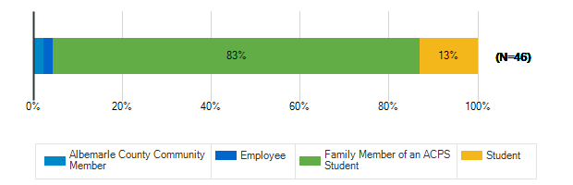

What are the most important qualities for middle school sites/grounds in the 21st century? : Safety & Security
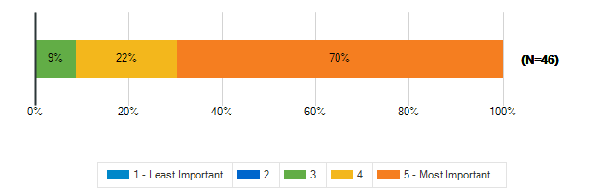

What are the most important qualities for middle school sites/grounds in the 21st century? : Growth & Capacity
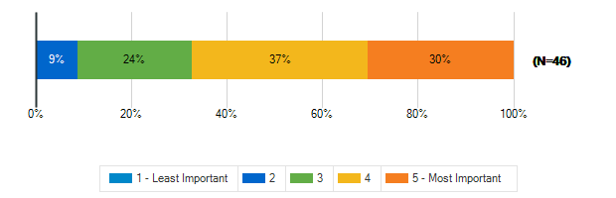

What are the most important qualities for middle school sites/grounds in the 21st century? : Outdoor Spaces
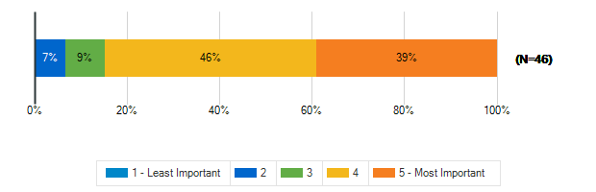

What are the most important qualities for middle school sites/grounds in the 21st century? : Sustainability & Natural Resources
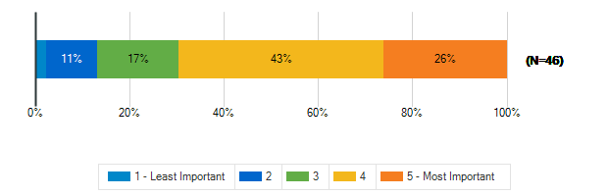

What are the most important qualities for middle school sites/grounds in the 21st century? : Community Access & Amenities
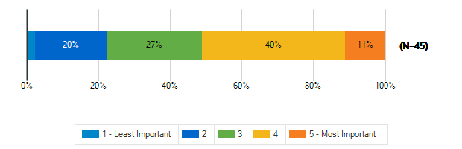

What are the most important qualities for middle school sites/grounds in the 21st century? : Positive, Healthy Culture
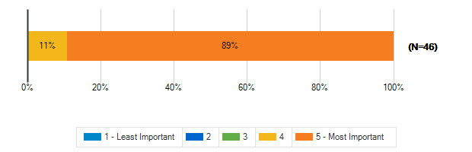

What are the most important qualities for middle school sites/grounds in the 21st century? : Welcoming, Comfortable, Aesthetic Spaces
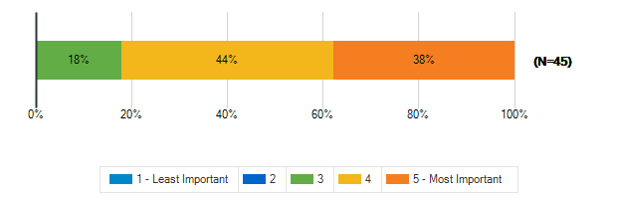

What are the most important qualities for middle school sites/grounds in the 21st century? : Durability, Flexibility, Cost-Efficiency
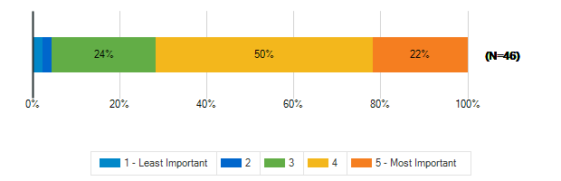

What are the most important qualities for middle school sites/grounds in the 21st century? : Sustainable/Net-Zero Construction
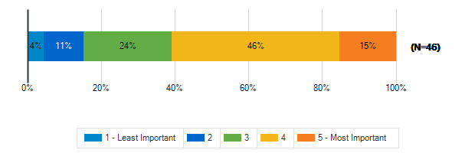

To what extent does your middle school support the following?: A sense of pride and well-being in staff and students
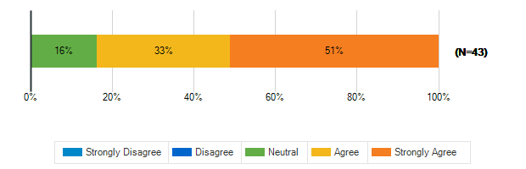

To what extent does your middle school support the following?: Prioritizing the outdoor environment
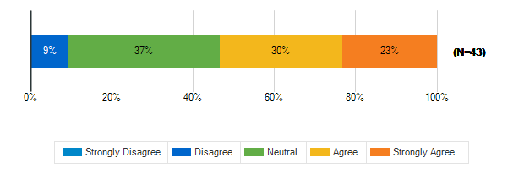

To what extent does your middle school support the following?: Natural resources available to students, staff, and the community
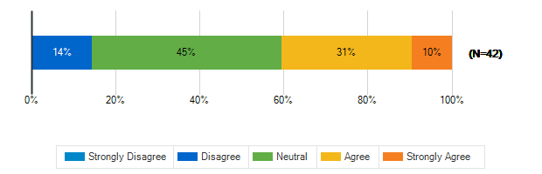

To what extent does your middle school support the following?: Educational resources available to students, staff, and the community
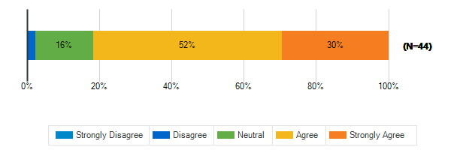

To what extent does your middle school support the following?: Health and fitness
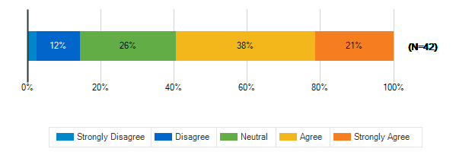

To what extent does your middle school support the following?: Diversity and inclusion
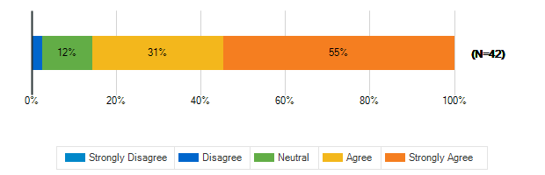

To what extent does your middle school support the following?: Environmental sustainability
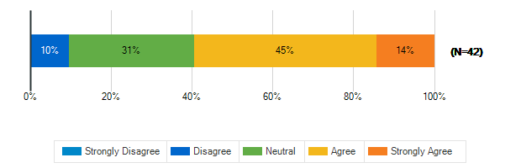

In a few words, what do you think is the greatest opportunity facing our middle school students today?
1. | ?
2. | The ability to go to a calming room and relax
3. | Bullying
4. | The chance to achieve early high school credits.
5. | Technology can provide many opportunities.
6. | project based learning
7. | Not prepared enough for higher level
8. | How to be a good neighbor and global citizen
9. | Hands on project based learning
10. | Technology, connecting with others.,
11. | Learning that each person has value.
12. | Ability to engage with the community.
13. | The trend toward personally meaningful learning
14. | They have all faced similar adversities
15. | Learning while diversifying
16. | Project based learning, self-driven learning
17. | Adaptability and resilience
18. | Balancing sedentary learning with physical health
19. | enthusiastic attitudes
20. | To have time to become independent thinkers
21. | creating the world they want to live in
22. | I got no clue.
23. | Learn in non traditional ways
24. | Rapidly evolving/changing society and technology
25. | Ability to grow and make wonderful changes
26. | technology, collaborative/ meanigful projects
27. | A balance of academic rigor and small class size
28. | Opportunity to learn, grow, and build social skill
29. | Build confidence & self-understanding
30. | access to events outside of the US
31. | Engaging middle schoolers (outside Community Lab)
32. | Healthy, face to face collaboration
33. | Cyber safety / wellness. Broadend awareness
34. | There are so many career paths available!
35. | The opportunity to shift learning styles
36. | authentic learning based on needs and preferences

In a few words, what do you think is the greatest challenge facing our middle school students today?
1. | Emotional development challenges
2. | The limited supply of materials for work
3. | Anxiety
4. | Time management I suppose.
5. | Absent or bad parenting and Bullying.
6. | growth. need bigger classrooms
7. | Need to focus more on education
8. | Connectedness to others and the world around them
9. | Gun violence and fear
10. | Lack of connection, awareness, resources
11. | social media and too much tech
12. | Safety
13. | The current governor
14. | Social media
15. | Mental health challenges
16. | Everyone feels awkward in middle school
17. | The ability to feel safe and not resort to violenc
18. | Not enough teachers
19. | Lack of motivation, self regulation, social skills
20. | Cell phones in schools
21. | human relationships an increasingly digital world
22. | mental health
23. | Too much technology and not enough outdoor time
24. | the negative impact technology has on health
25. | Incessant fear due to gun violence, bullying
26. | Issues with mental health
27. | Safety and mental health concerns
28. | technology (social media, AI), societal instabilit
29. | Emotionally disregulated adults
30. | social media and personal interactions
31. | Overly structured "standard" learning expectations
32. | self esteem and parental involvement
33. | Attention spans are short
34. | Retaining high quality teachers, over crowding
35. | Social media & mental health
36. | Foundational common sense education
37. | Feeling like they fit in somewhere
38. | Feeling safe and having structure and boundaries
39. | too great emphasis on testing and activism

To meet the needs of students, educators, families and the community, a middle school facility in Albemarle County MUST HAVE
1. | Outdoor spaces and recess
2. | More bus drivers
3. | Options
4. | Proper education, gifted area, & healthy lunches.
5. | A place for the arts.
6. | gender neutral/ single stall bathrooms
7. | Gym and computer lab
8. | A caring/active community that advocates for it
9. | Positive inviting inclusive culture
10. | Equity. Money. Green space good teachers
11. | Safe schools
12. | A strong sense of identity and purpose.
13. | Accessibility for students, families, community
14. | Security AND flexibility
15. | Compasion empathy nurturing envronmen tough love
16. | Resource officers!!
17. | Competitive pay supporting the teachers
18. | PBL, outdoor space/physical activity
19. | Strong counselors to support student mental health
20. | Qualified educators with a love for their work
21. | enough staff
22. | Enough space for everybody
23. | Restorative Practices, A supported faculty
24. | Outdoor space
25. | Learning & other resources for students
26. | Plenty of space to learn and grow. Safe and secure
27. | spaces for collaboration, recess,
28. | Trauma informed teachers
29. | enough space, great classes / programs
30. | Attract great teachers, collaboration space
31. | empathy
32. | Mental health resources
33. | Outdoor learning spaces and natural light
34. | Room to move around, including outdoors
35. | safety procedures as well spaces available for all
36. | competitive salaries for the educators
37. | Small class size, small staff size,collaboration
38. | choices, connections, support, authentic learning

Tell us more about the following resource spaces in your school & grounds?

How often do you use?: Teacher Work Rooms
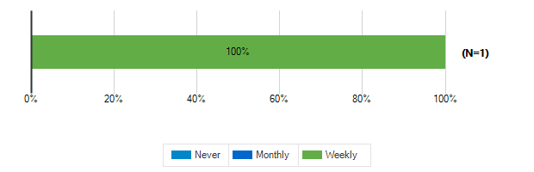

How often do you use?: Teacher Lounge
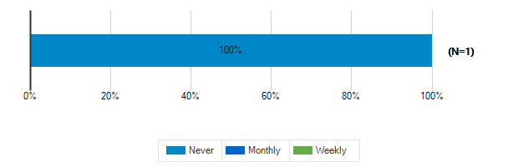

How often do you use?: Library

How often do you use?: Stage/Auditorium

How often do you use?: Outdoor Classrooms

How often do you use?: Administrative Offices

How often do you use?: Conference Room

How often do you use?: Cafeteria

How often do you use?: Shared Spaces

Tell us more about the following resource spaces in your school & grounds?

How would you rate the quality?: Teacher Work Rooms
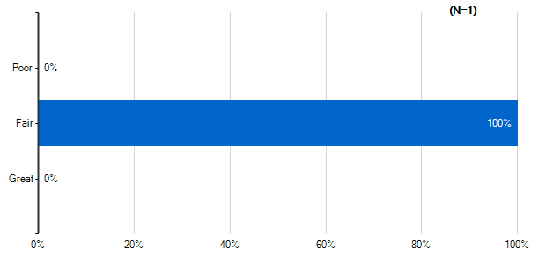
Note: Multiple answers per participant possible. Percentages added may exceed 100 since a participant may select more than one answer for this question.

How would you rate the quality?: Teacher Lounge
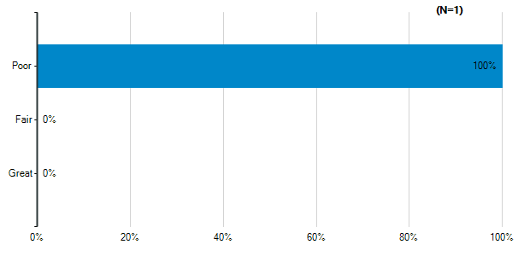
Note: Multiple answers per participant possible. Percentages added may exceed 100 since a participant may select more than one answer for this question.

How would you rate the quality?: Library
Note: Multiple answers per participant possible. Percentages added may exceed 100 since a participant may select more than one answer for this question.

How would you rate the quality?: Stage/Auditorium
Note: Multiple answers per participant possible. Percentages added may exceed 100 since a participant may select more than one answer for this question.

How would you rate the quality?: Outdoor Classrooms
Note: Multiple answers per participant possible. Percentages added may exceed 100 since a participant may select more than one answer for this question.

How would you rate the quality?: Administrative Offices
Note: Multiple answers per participant possible. Percentages added may exceed 100 since a participant may select more than one answer for this question.

How would you rate the quality?: Conference Room
Note: Multiple answers per participant possible. Percentages added may exceed 100 since a participant may select more than one answer for this question.

How would you rate the quality?: Cafeteria
Note: Multiple answers per participant possible. Percentages added may exceed 100 since a participant may select more than one answer for this question.

How would you rate the quality?: Shared Spaces
Note: Multiple answers per participant possible. Percentages added may exceed 100 since a participant may select more than one answer for this question.

Please indicate how satisfied you are with the following characteristics of your middle school building:: Cleanliness & Maintenance
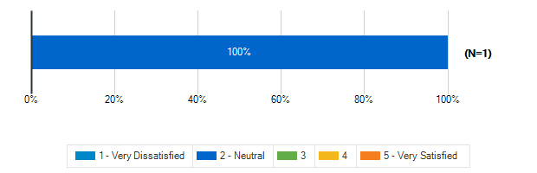

Please indicate how satisfied you are with the following characteristics of your middle school building:: Security & Safety

Please indicate how satisfied you are with the following characteristics of your middle school building:: Signage and Wayfinding

How frequently do your students engage in the following activities in your classroom: Lecture/Lessons
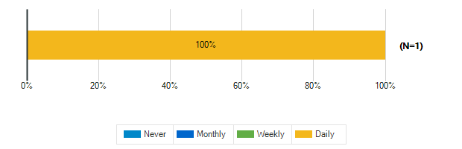

How frequently do your students engage in the following activities in your classroom: Learning Centers/Listening Stations
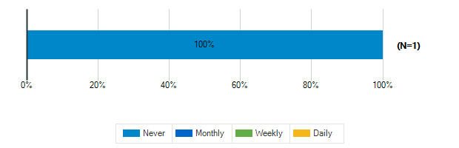

How frequently do your students engage in the following activities in your classroom: Student Presentations Performances
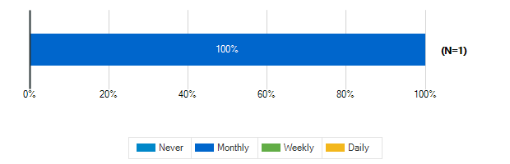

How frequently do your students engage in the following activities in your classroom: Group Activities/Projects
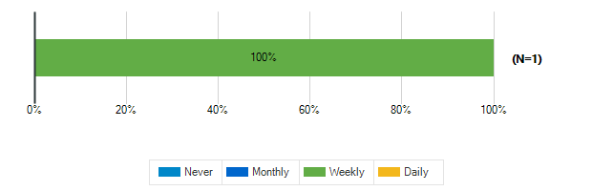

How frequently do your students engage in the following activities in your classroom: Individual Work

How frequently do your students engage in the following activities in your classroom: Technology/Computer

How frequently do your students engage in the following activities in your classroom: Physical Activity/Movement Breaks

How would you describe the following characteristics of your classroom?: Location
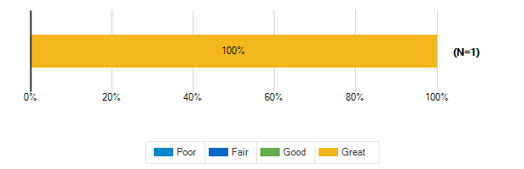

How would you describe the following characteristics of your classroom?: Size
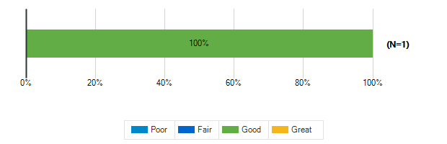

How would you describe the following characteristics of your classroom?: Security & Safety
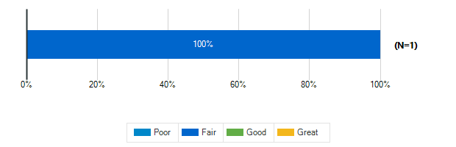

How would you describe the following characteristics of your classroom?: Storage (Amount, Design, Location)

How would you describe the following characteristics of your classroom?: Cleanliness & Maintenance

How would you describe the following characteristics of your classroom?: Availability of Technology (including WiFi & power outlets)

How would you describe the following characteristics of your classroom?: Functionality (including versatility and adaptability)

How would you describe the following characteristics of your classroom?: Natural Lighting/Ventilation

How would you describe the following characteristics of your classroom?: Access to Outdoor Spaces and/or Outdoor Visibility

How would you describe the following characteristics of your classroom?: Electric Lighting

How would you describe the following characteristics of your classroom?: Air quality

How would you describe the following characteristics of your classroom?: Acoustics

How would you describe the following characteristics of your classroom?: Furniture

How would you describe the following characteristics of your classroom?: Dry Erase Boards/Display Boards/Bulletin Boards

How would you describe the following characteristics of your classroom?: Finishes (Floors/Walls/Ceiling/etc.)

Please rank the following indoor amenities in order of priority for future spaces
Responses | Rank 1 | Rank 2 | Rank 3 | Rank 4 | Weighted Score | Relative Weighted Score | Overall Rank
Dedicated restrooms for staff | 1 | 0 | 0 | 0 | 4 | 100 | 1
Spaces designed for versatility to accommodate a variety of uses | 0 | 1 | 0 | 0 | 3 | 75 | 2
Dedicated teacher work areas and personal storage area | 0 | 0 | 1 | 0 | 2 | 50 | 3
Outdoor access for science and other specialty classrooms | 0 | 0 | 0 | 1 | 1 | 25 | 4

If you’ve taught at or seen a middle school with a feature that doesn’t exist at ACPS that you think should be here, please identify it:
No Response(s)

What is your grade level?
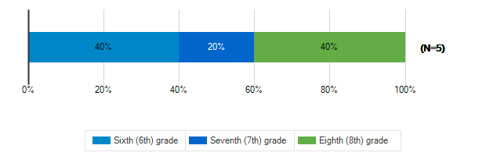

Tell us about the spaces in your school and on your school grounds:

How often do you use these spaces?: Media Center
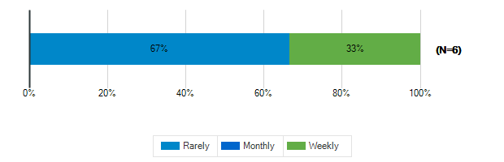

How often do you use these spaces?: Cafeteria
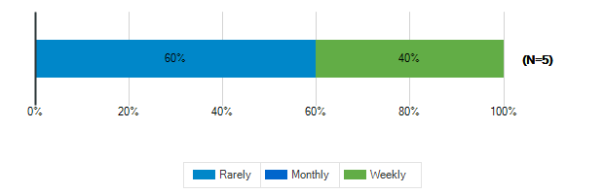

How often do you use these spaces?: Gymnasium
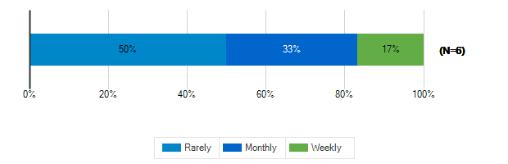

How often do you use these spaces?: tage/Auditorium
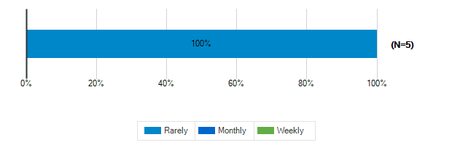

How often do you use these spaces?: Outdoor Classrooms
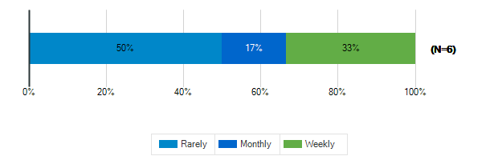

How often do you use these spaces?: Outdoor Recreation/Athletic Fields
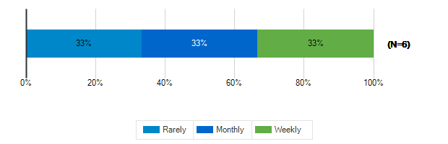

Tell us about the spaces in your school and on your school grounds:

How would you rate these spaces?: Media Center
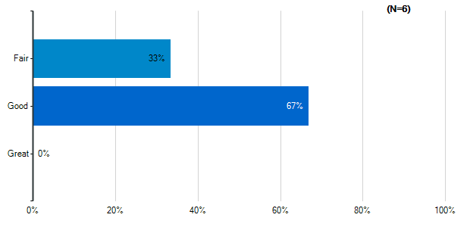
Note: Multiple answers per participant possible. Percentages added may exceed 100 since a participant may select more than one answer for this question.

How would you rate these spaces?: Cafeteria
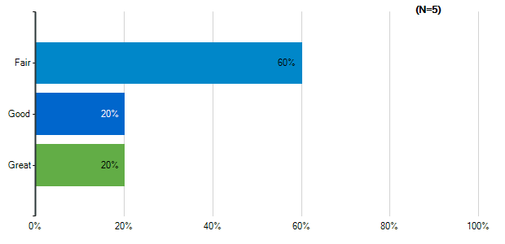
Note: Multiple answers per participant possible. Percentages added may exceed 100 since a participant may select more than one answer for this question.

How would you rate these spaces?: Gymnasium
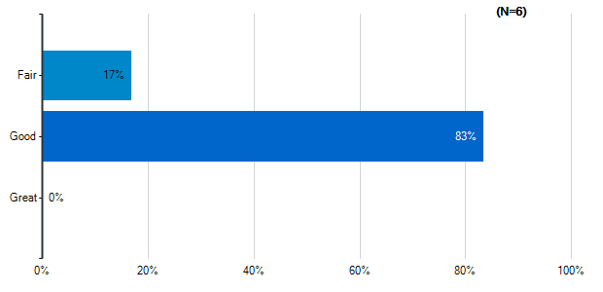
Note: Multiple answers per participant possible. Percentages added may exceed 100 since a participant may select more than one answer for this question.

How would you rate these spaces?: tage/Auditorium
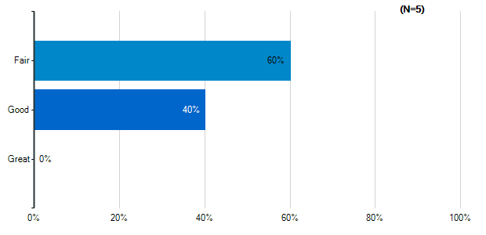
Note: Multiple answers per participant possible. Percentages added may exceed 100 since a participant may select more than one answer for this question.

How would you rate these spaces?: Outdoor Classrooms
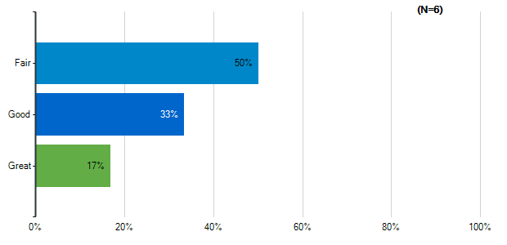
Note: Multiple answers per participant possible. Percentages added may exceed 100 since a participant may select more than one answer for this question.

How would you rate these spaces?: Outdoor Recreation/Athletic Fields
Note: Multiple answers per participant possible. Percentages added may exceed 100 since a participant may select more than one answer for this question.

How would you rate the quality of the following characteristics of your classrooms?: Size
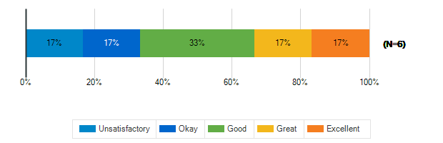

How would you rate the quality of the following characteristics of your classrooms?: Cleanliness
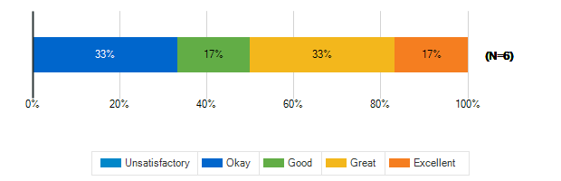

How would you rate the quality of the following characteristics of your classrooms?: Furniture
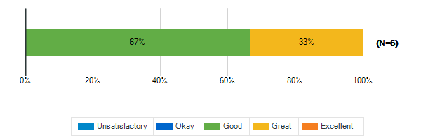

How would you rate the quality of the following characteristics of your classrooms?: Color Scheme/Décor
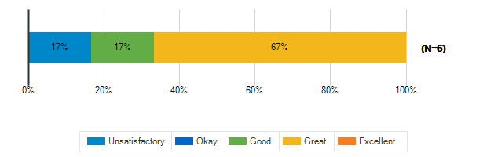

How would you rate the quality of the following characteristics of your classrooms?: Security & Safety
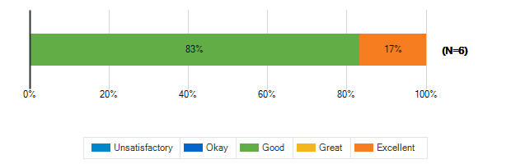

How would you rate the quality of the following characteristics of your classrooms?: Technology (including WiFi and power outlets)
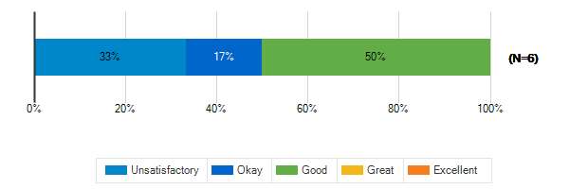

How would you rate the quality of the following characteristics of your classrooms?: Natural Lighting
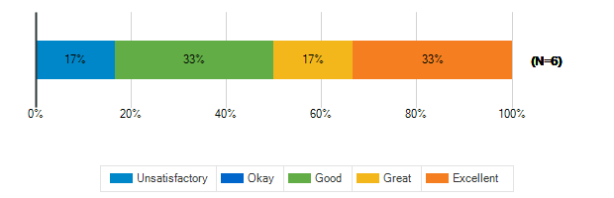

How would you rate the quality of the following characteristics of your classrooms?: Access to Outdoor Spaces and/or Outdoor Visibility
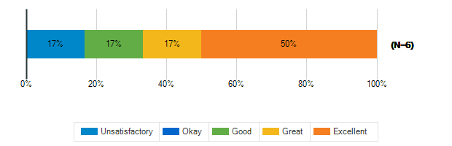

What is the best thing about your middle school?
1. | It's small so it's easy to get to classes
2. | The fact that everyone is united as a community.
3. | getting to choose your path
4. | Its small.
5. | Inclusivity

What is the worst thing about your middle school?
1. | Having too little supplies to work in class
2. | The kids computers/Wi-Fi.
3. | cramped
4. | The outdoor spaces are not the best.

How satisfied are you with the following characteristics of your child’s school?: Availability of Parking
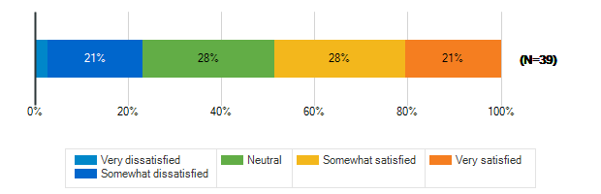

How satisfied are you with the following characteristics of your child’s school?: Design/Flow of CAR Drop-Off and Pick-Up for Students
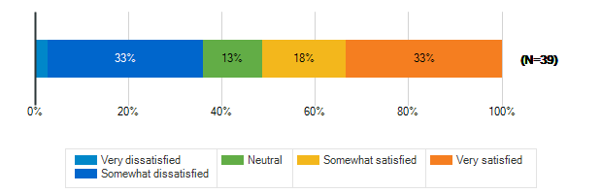

How satisfied are you with the following characteristics of your child’s school?: Design/Flow of BUS Drop-Off and Pick-Up for Students
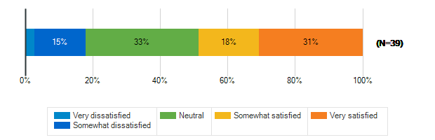

How satisfied are you with the following characteristics of your child’s school?: Entryway into the School
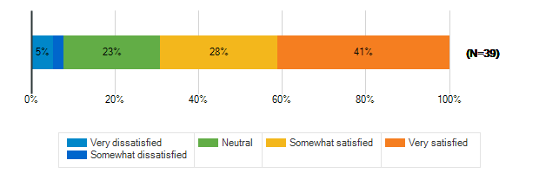

How satisfied are you with the following characteristics of your child’s school?: Classroom
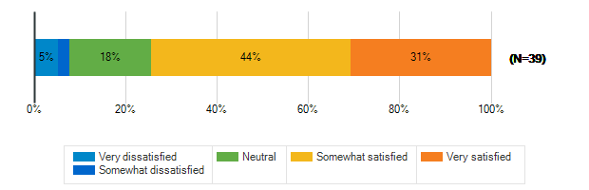

How satisfied are you with the following characteristics of your child’s school?: Security & Safety
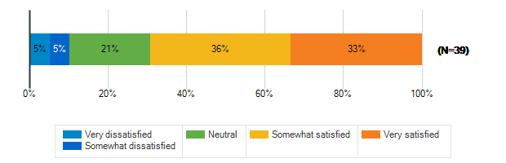

How satisfied are you with the following characteristics of your child’s school?: Technology
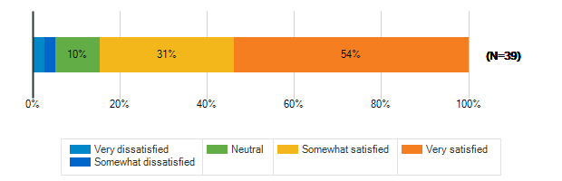

How satisfied are you with the following characteristics of your child’s school?: Learning Environment
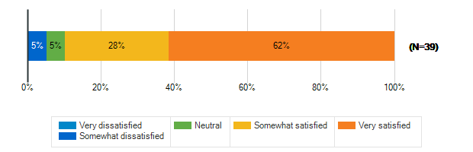

How satisfied are you with the following characteristics of your child’s school?: Natural Lighting/Outdoor Visability
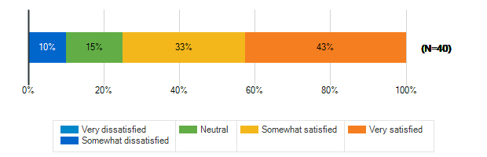

How satisfied are you with the following characteristics of your child’s school?: Performance spaces
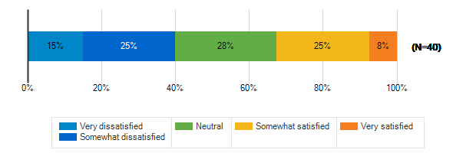

How satisfied are you with the following characteristics of your child’s school?: Outdoor spaces/Athletic fields
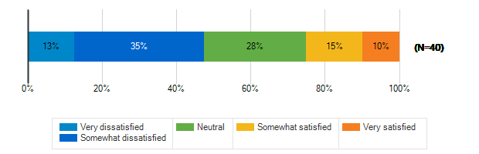

Please rank the following outdoor amenities in order of priority
Responses | Rank 1 | Rank 2 | Rank 3 | Rank 4 | Rank 5 | Rank 6 | Weighted Score | Relative Weighted Score | Overall Rank
Outdoor areas for socializing and relaxing | 20 | 6 | 2 | 5 | 3 | 5 | 184 | 100 | 1
Dedicated natural areas | 2 | 11 | 12 | 10 | 5 | 1 | 156 | 85 | 2
Protected outdoor space (fenced or in a courtyard) | 8 | 7 | 6 | 6 | 6 | 8 | 145 | 79 | 3
Covered outdoor structure for play and events during inclement weather | 4 | 7 | 8 | 7 | 13 | 2 | 140 | 76 | 4
New or improved athletic/recreational fields | 4 | 8 | 8 | 3 | 7 | 11 | 130 | 71 | 5
Walking trails/Bike paths | 3 | 2 | 5 | 10 | 7 | 14 | 106 | 58 | 6

How does your child usually get to school?
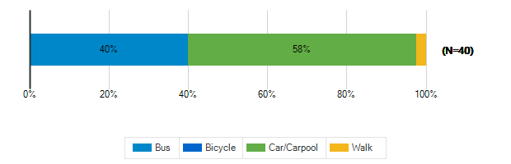

Does your child participate in any afterschool programs at their middle school?
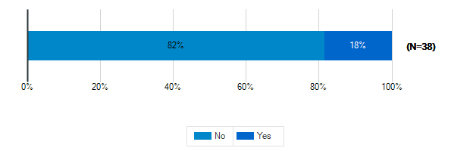

Please specify which programs
1. | YWLP
2. | My kid walks to burley to be in the singing group. She also does squash at boars head.
3. | Cross Country Track
4. | Squash
5. | Sports
6. | TBD

