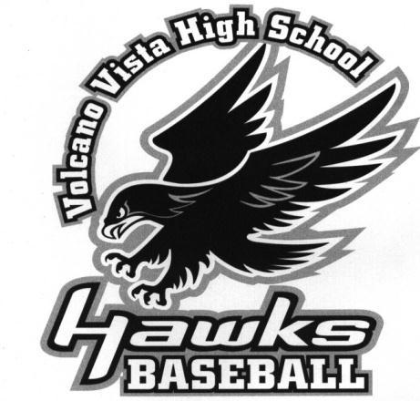







Dear Supporters of Volcano Vista Baseball,

It’s that time of year again, and the VVHS Baseball program is kicking off our fundraising drive to benefit the Volcano Vista Baseball Team for our 2023 season. As you may or may not know, APS doesn’t have the funds to help with the necessary expenses associated with a baseball team. Therefore, the money we receive from our supporters will go toward our spring season’s expenses. This includes team equipment, field and batting cage needs, and our yearly field maintenance.

We are asking businesses and individuals in our community to make a donation on the player’s behalf that has sent you this letter. We know these are trying times, and we appreciate your consideration and any donation you are able to give as it will help defray some of the upcoming seasonal costs. In addition, please consult your tax advisor as your donation may qualify as a tax deduction. We are a Non-profit organization under the federal 501 (c)(3) number 26-0651334. Our NM Tax exempt ID is CRS# 03-127748-00-9.

A donation of any amount is greatly appreciated, and your donation will not go unnoticed once our season begins. Our game sponsors will be announced frequently during the home games so that our fans and administration will know where our support is coming from. You will also be able to go to our Facebook page to see a complete list of supporters of Volcano Vista baseball.

Please return the attached page with your information filled out in full as well as the player’s name who gave you this form. Please send it with your donation payable to:

VVHS Baseball Booster Club
c/o Shelley Cortes
P.O. Box 68012
Albuquerque, New Mexico 87193

If you would like more information, or have any questions, please do not hesitate to contact the Booster Club President, Amy Zacarias (505) 259-6100.

In closing, the VVHS Baseball Program truly appreciates your sponsorship and/or donation. The program could not thrive without the generosity of businesses and individuals like you.

Sincerely,

Amy Zacarias Todd Flores
President, Booster Club Head Coach, Baseball
Volcano Vista High School Volcano Vista High School


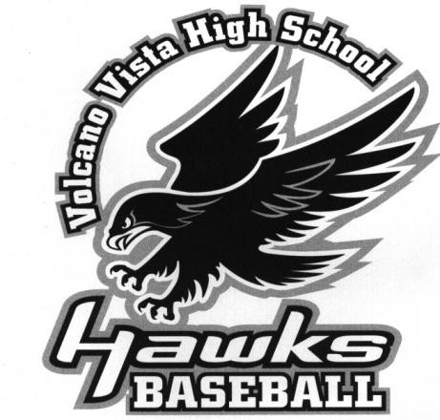





***PLEASE INCLUDE YOUR BUSINESS CARD WITH YOUR CONTRIBUTION***

We welcome sponsors all through the year, but to get your business information on the poster and
an outfield signs. We need to have your business cards or information by February 14, 2023.

Contribution levels
White Level Sponsorship: $250 - Sponsor will be listed on our Facebook page and receive a Poster Ad.
Black Level Sponsorship: $500 - Sponsor will receive a Poster Ad and an Outfield Sign (4’ x 8’)
Platinum Level Sponsorship: $1000 - Sponsor will receive a Poster Ad and an Outfield Sign (4’ x 8’) for 2 years!
Hawk Level Sponsorship: $1500 - Sponsor will receive a Poster Ad and one of only two Signs on the scoreboard, next to Championship banner!

Please make checks payable to:
VVHS Baseball Boosters
c/o Shelley Cortes
P.O. Box 68012 Albuquerque, NM 87193

Player Name: _______________________________________________
(Player will be credited 25% of the sponsorship level)
Sponsor Name: ______________________________________________
Address: ___________________________________________________
City, State & Zip: _____________________________________________
Phone Number: (____) _________________________________________

Don’t forget to include your business card for the Poster and/or outfield sign! You can email artwork for the signage to vvhawksbaseball@gmail.com

