Pre-Lab Information
Virtual Lab: Circuit Design
Student Guide
Purpose Experimentally determine how the variables in an electric circuit are related by Ohm’s law using a laboratory procedure.
Time Approximately 45 minutes
Question How do changes in voltage or resistance affect current in an electric circuit?
Hypothesis #1: If voltage in a circuit is increased under constant resistance, then current must increase because Ohm’s law states that voltage and current are directly proportional.
Variables: Independent Variable: voltage
Dependent Variable: current
Constant: resistance
Hypothesis #2: If resistance in a circuit is increased under constant voltage, then current must decrease because Ohm’s law states that resistance and current are inversely proportional.
Variables: Independent Variable: resistance
Dependent Variable: current
Constant: voltage
Summary Ohm’s law predicts that the voltage, current, and resistance of a circuit are related in that the total voltage of the circuit is equivalent to the product of the current and the resistance of that circuit. Ohm’s law can be written as

V = IR

where V is the voltage, I represents current, and R is resistance. The unit of current is the ampere (A). The unit of resistance is the ohm (Ω), which is equivalent to one volt per ampere. Every electric device has inherent resistance to the flow of current.
It is often necessary to rearrange this expression to solve for current or resistance, which gives us these variations:

I = V/R R = V/I

These formulas allow us to understand that while voltage has a directly proportional relationship to current and resistance, current and resistance have an inverse relationship to each other. In this lab, you will build circuits using a simulation to examine these specific relationships. The lab experiments you will perform today include these objectives:
- Construct functional series and parallel circuits.
- Use Ohm’s law to calculate current, voltage, and resistance.
- Calculate the power used by elements in a circuit.

Lab Procedure

Step 1: Open the simulation.

- Be sure to follow all the directions provided in the lab guide as well as on screen during the virtual lab.

- Open the Gizmo “Circuits,” and familiarize yourself with the controls (Figure 1). Locate the components that you will drag and drop into place, the meters, the buttons for current, and the voltage slider.

- Once you have familiarized yourself with the Gizmo, continue to Step 2 for the experimental setup.

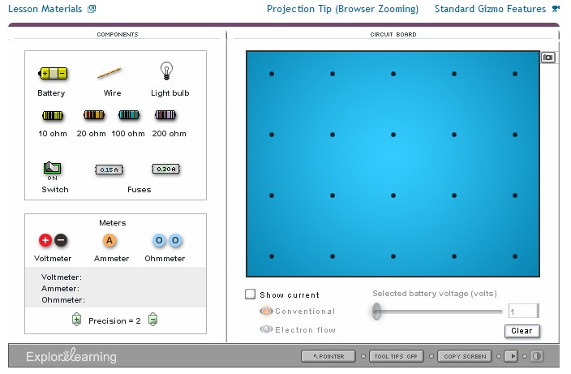

Figure 1: “Circuits” Gizmo

Step 2: Examine current as voltage changes using a series circuit.
- Create a circuit on the blue virtual circuit board as shown in Figure 2. Click the switch to turn it off. Use a 20 Ω resistor in the circuit and place an ammeter in the circuit.
- Select “Show current” and then click the “Conventional” button. This will allow you to visualize current flow.
- Clicking the battery in the circuit will select it and allow you to change its voltage using the slider. Set the voltage initially to 1.
- Use Ohm’s law to calculate the theoretical current expected for the following voltages: 1, 5, 10, 20, and 50 V. Record your results to two decimal places in Table A.
- Click the switch on your circuit to turn it on.
- Check the reading of the ammeter in the lower left of the Gizmo. Record the current in Table
  - Use the slider to select the other voltages and assess the resulting currents. Record all results in Table A.

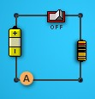

Figure 2: Series circuit

Step 3: Examine current as resistance changes using a series circuit.

- Examine the effect of changing resistance in the circuit. First, use Ohm’s law to calculate the theoretical current, using a voltage of 25 V and each of the four available resistors. Record your calculations in Table B.

- Use the slider to set the voltage to 25 V. Record the actual current using the 20 Ω resistor.

- Test the other three resistors, 10, 100, and 200 Ω, by dragging each one to the circuit to change the resistance. Record the resulting currents in Table B.

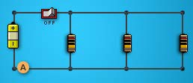

Figure 3: Parallel circuit

Step 4: Examine current in a parallel circuit by varying voltage and resistance.
- Now that you have gathered data to address your hypotheses, construct a parallel circuit to examine the effects on current. Use 20 Ω resistors and turn the switch off as shown in Figure 3.
- Calculate the total resistance in the circuit. Total resistance in a parallel circuit can be calculated as
1/R = 1/R1 + 1/R2 + …

where R1, R2, etc. are the resistances of each component. Record the total resistance in Table C.
- Use the total resistance and voltage to calculate the expected current. Record the calculated current in Table C.
- Click the switch to turn on the circuit. Place the ammeter at different points along the circuit. Record your observations of current in Table C. Then place the ammeter back at the original point in the circuit as indicated in Figure 3.
- Calculate the total resistance if you switch one of the resistors to 200 Ω, and record it in Table C.
- Use the total resistance and voltage to calculate the expected current. Record it in Table C.
- Drag a 200 Ω resister to replace one of the 20 Ω resistors, and then record the observed current in Table C.

- To achieve a current of 3.75 A while using the 20, 20, and 200 Ω resistors, what does the voltage need to change to? Use Ohm’s law to calculate this new voltage and record it in Table C.
- Test your calculation by moving the voltage slider. At what voltage is a current closest to
3.75 achieved? Record your observation in Table C.

Step 5: Calculate power used by components in a circuit.
- Switch off the circuit and replace the resistors with light bulbs as shown in Figure 4. Set the voltage to 10 V using the slider.
- Switch on the circuit and record the current in Table D. Use the ammeter to test the current flowing through each light bulb and record the value in Table D.
- Calculate the power used by an individual bulb in the circuit. Power can be calculated by the formula
P = IV

where P is power in watts, I is current in amps, and V is voltage. Record the power in watts for a single bulb in the circuit in Table D.
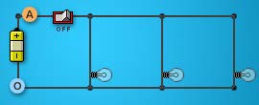

Figure 4: Parallel bulb circuit

Data
Record your data either in your lab notebook or in the space below.

Table A
Measuring Current as a Function of Voltage with a 20 Ω Resistor
Voltage (V) | Current: Calculated (A) | Current: Experimental (A)
1
5
10
20
50

Table B
Measuring Current as a Function of Resistance at 25 V
Resistance (Ω) | Current: Calculated (A) | Current: Experimental (A)
10
20
100
200

Table C
Determining Current in a Parallel Circuit
Resistor Set (Ω) | Total Resistance (Ω) | Calculated Current (A) | Observed Current (A) | Observed Current through Each Resistor (A)
20, 20, 20
20, 20, 200
Voltage needed to raise current to 3.75 A (20, 20, 200 resistor set): Calculated:
Observed:

Table D
Calculating Power of Circuit Components
Observed Total Current (A) | Current through Each Bulb (A) | Power Usage per Bulb (W)

