Virtual Lab: Electromagnetic Induction
Student Guide

Pre-Lab Information
Purpose Experimentally observe how magnet polarity affects induced current in a wire loop.
Time Approximately 30 minutes
Question How does magnet polarity affect the current flowing in a loop of wire?
Hypothesis If the polarity of a moving magnet is reversed, then the current induced in a loop of wire will reverse in direction, because magnet polarity determines the direction of the electromagnetic force.
Variables: Independent Variable: magnet polarity Dependent Variable: induced current Constant: magnet strength
Summary Faraday’s experiments in the early 1800s provided fundamental insights into the nature of electromagnetism. By moving a magnet near or through a coil of wire, he was able to demonstrate that a moving magnetic field produced a current in the wire. The process that produces a current by using a moving magnet is known as electromagnetic induction.

In this experiment, you will study electromagnetic induction in a wire coil by manipulating magnet polarity and observing changes in the current produced. This is very similar to the types of experiments that Faraday carried out more than two hundred years ago. The current produced will be assessed by using a galvanometer. Besides recording quantitative data in terms of the current produced, you will also record qualitative data in the form of observations regarding current changes.

Lab Procedure

Step 1: Open the simulation.

- Be sure to follow all the directions provided in the lab guide as well as on screen during the virtual lab.
- Open the Gizmo “Electromagnetic Induction,” and familiarize yourself with the controls.

- Locate the “Show magnetic field” checkbox and click it; magnetic field lines should be present around the magnet.

- Click on the “Show loop data” checkbox to select it. This will display current data that you will record in your table.

- Click on the “Oscillation” checkbox under the speed setting. This will allow the magnet to move back and forth without requiring manual operation, and allow for easier reading of maximum current levels.

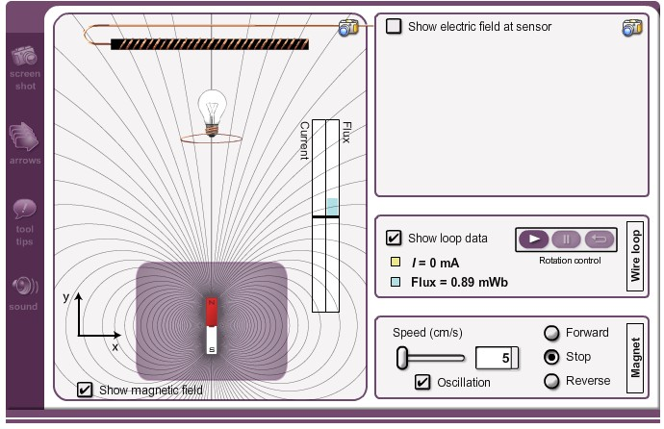

Step 2: Identify induced current when the magnet is in motion (magnetic polarity normal).

- In the “Magnet” control box in the lower right, be sure the speed is set to 10 cm/s, which is adjusted by using the slider.

- Click on the “Forward” radio button and observe the change of current value (I) in the wire loop box of the Gizmo. Current and magnetic flux will also be displayed graphically over the magnetic field lines.

- As the magnet makes its closest approach to the lightbulb and wire loop, note the maximum current (I) in milliamps (mA). The value will fluctuate, so you may need to watch the magnet approach the coil several times before approximating the maximum value. Record this value in Table A.

- Note the direction of the induced current by studying the value of the current while the magnet is moving forward. Is it a positive (+) or negative (–) direction? Record this observation in Table A. Repeat the observation while the magnet is moving in reverse, and record the observation in the data table.

Step 3: Identify induced current when the wire loop is rotated 180° and the magnet is in motion (magnetic polarity reversed).
- Click the “Play” button on the rotation control in the wire loop box, allowing the lightbulb and loop to rotate a full 180° so that it is upside down, and then click the “Pause” button. You may need to use the reset button and redo the rotation procedure until the bulb rotates as close to 180°as possible. Since you cannot rotate the magnet, rotating the bulb and wire loop has the same effect as rotating the magnet 180°.

- Note the maximum current and direction as you did in Step 2, while under reversed polarity. Record your observations in Table A.

- Now that you have data for maximum current and direction under different polarity, make comparisons between the different situations. How does current change under different polarity? How does the direction in which the magnet moves affect current direction? Can you note any trends in the data? Record your observations in Table B.

Data
Record your data either in your lab notebook or in the tables below.

Table A

 | Magnet Polarity Normal |  | Magnet Polarity Reversed
Magnet Direction | Maximum Current (mA) | Current Direction (+ or –) | Maximum Current (mA) | Current Direction (+ or –)
Forward
Reverse

Table B
Comparison of the Data between Normal and Reversed Magnet Polarity

