Dear Westerville <insert school here> family,

We are excited to introduce you to Family Connection, an online college and career portal that your student will use to discover and align their strengths and interests to postsecondary goals. Students in grades 6 through 12 will utilize Family Connection throughout the school year to discover and log their career interests, set goals, and search for postsecondary programs. Seniors will also use Family Connection to apply to colleges and universities.

We are excited to engage your family in this important postsecondary planning process! As a parent/guardian, you are able to log in to Family Connection and view your student’s career interests and goals, as well as stay updated on important information and news from your school counseling office. You can easily access Family Connection through your PowerSchool Portal and directions are below. If you have any trouble accessing your PowerSchool Portal, please contact your building for login information and assistance.

When you first access Family Connection, there will be a brief survey that your school counselors would like you to complete. Please take a few minutes to answer that survey as you explore the site. Additional information about Family Connection will continue to be shared with you throughout the school year.

Directions to access Family Connection through the PowerSchool Portal
- Login to PowerSchool (visit http://www.wcsoh.org and click on the PowerSchool link on the top right).
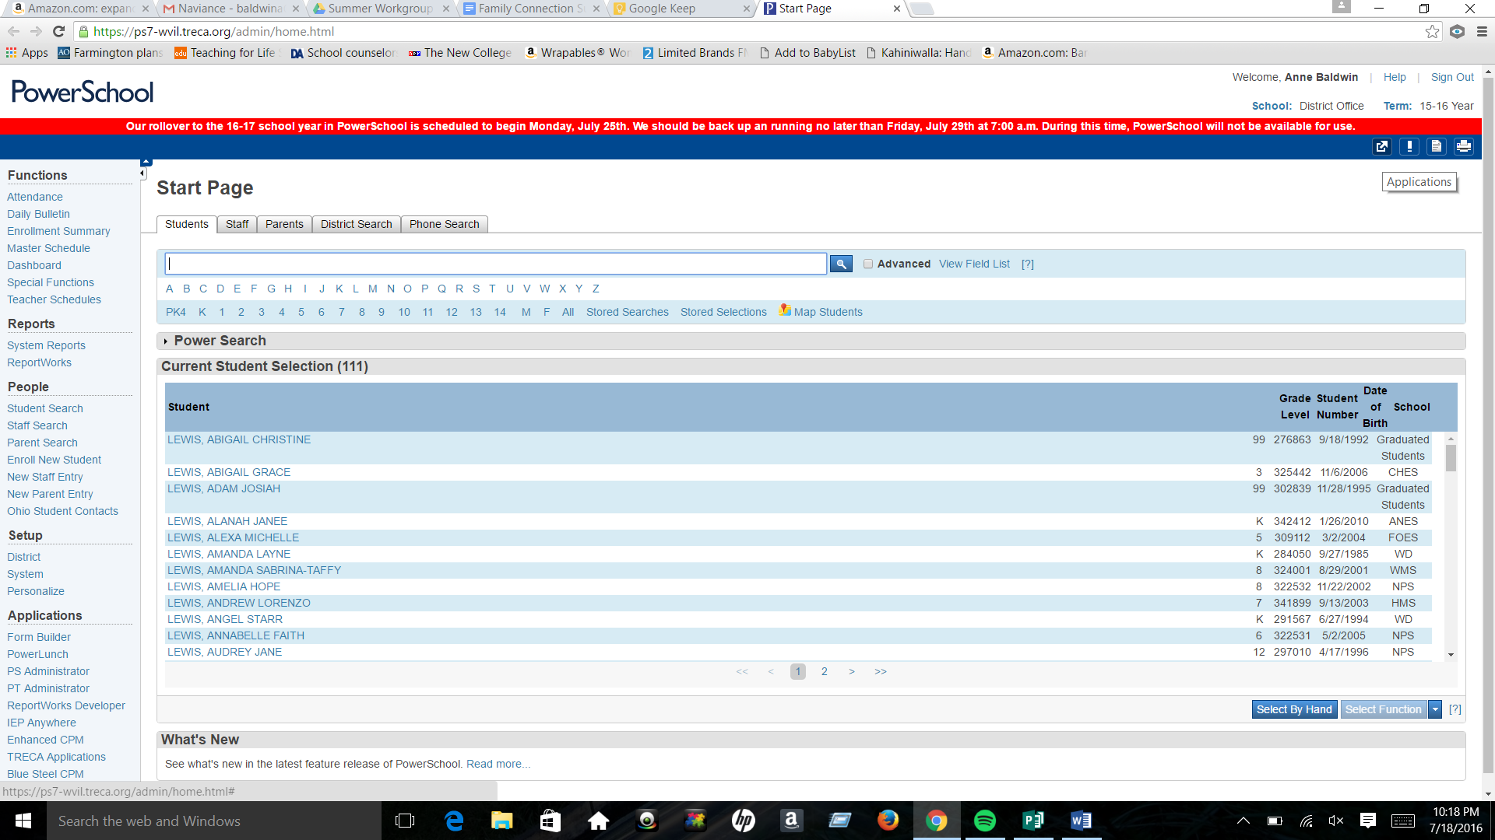
- Next, click on the Applications button found in the top right corner of the screen. The button looks like this icon:
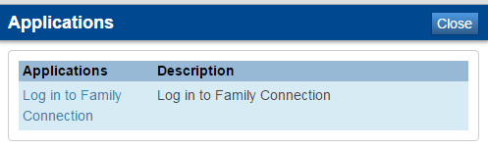
- Another screen will pop up and you will click on the Login to Family Connection link.

- You will confirm your student’s name and be logged in to Family Connection on the next screen.
- Once you are logged in to Family Connection, take some time to explore the online portal by clicking the tabs at the top of the page and ask your student to help you navigate the site! Do not forget to complete the brief introduction survey that you can access by clicking the About Me Tab and the survey link on the left.
