
Getting Started on Schoology for students
New to Schoology? Follow the steps to access your schoology account and view your courses and assignments.

Step 1: Log onto Clever
☐ Go to www.clever.com
☐ Click on Log in as a student at the top right
☐ Log into Clever with your vusd.us account (google)
☐ Click on the Schoology Tab

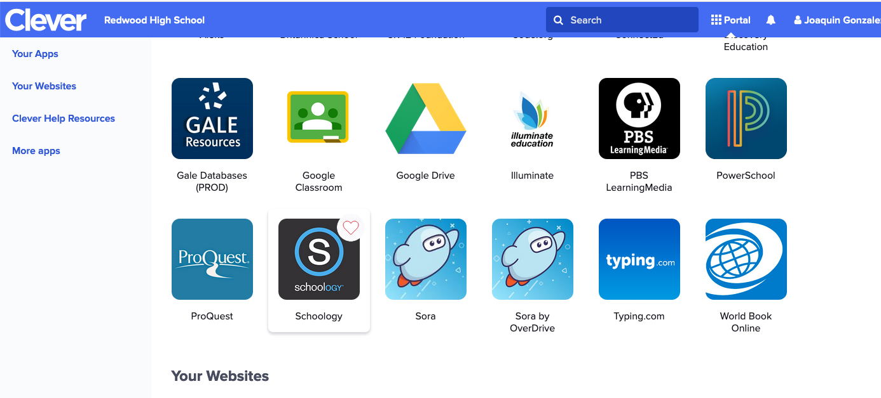

Step 2: Explore the Schoology Homepage
☐ Recent Activity – shows all comments and updates pertaining to your schools, courses, and groups.

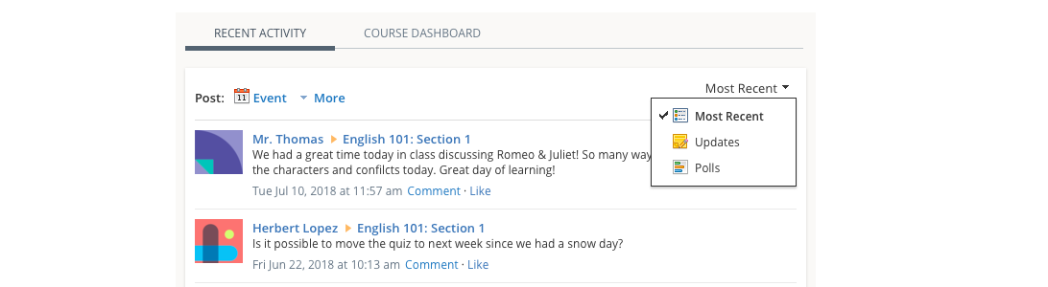

☐ Course Dashboard – enables you to view all your courses. From the Course Dashboard, click any one of your courses and go directly to its main page to see assignments, announcements, and other class materials.

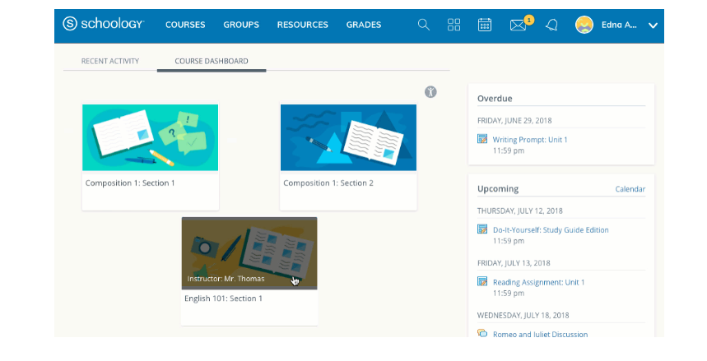

☐ Upcoming – this area on the right side of the homepage displays events, assignments, tests/quizzes, and discussions with due date. Hovering over each item displays the course associated with the item.

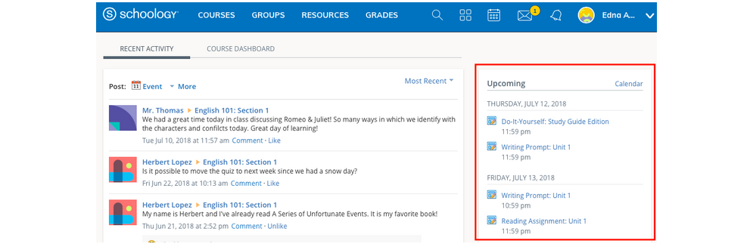

☐ Grades and Attendance – Select Grades at the top of Schoology and select either a Grade Report or Attendance

☐ Grade Report displays a breakdown of your grades for each course. Click a specific course to view each graded item, your grade, the max points, and any comments from your teacher.

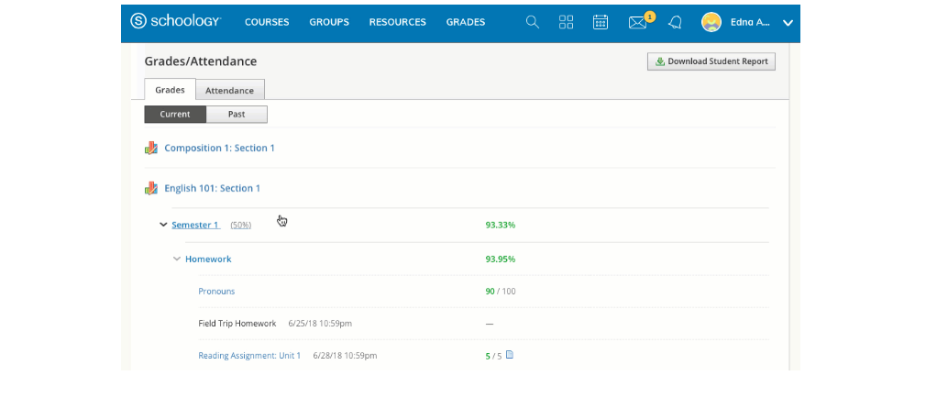

☐ The Attendance area displays a record of the days you were marked absent, late, or excused.

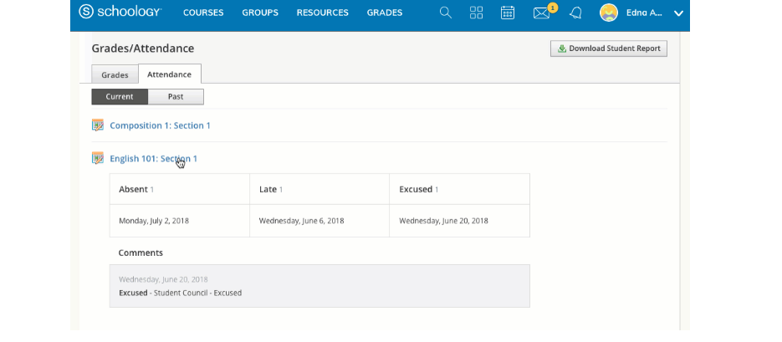

☐ Calendar – The calendar keeps events and due dates organized and easily accessible. You can your calendar by clicking on the calendar icon at the top right of the page. Each item is color-coded to your classes and due dates for assignments and assessments are automatically added to your calendar.

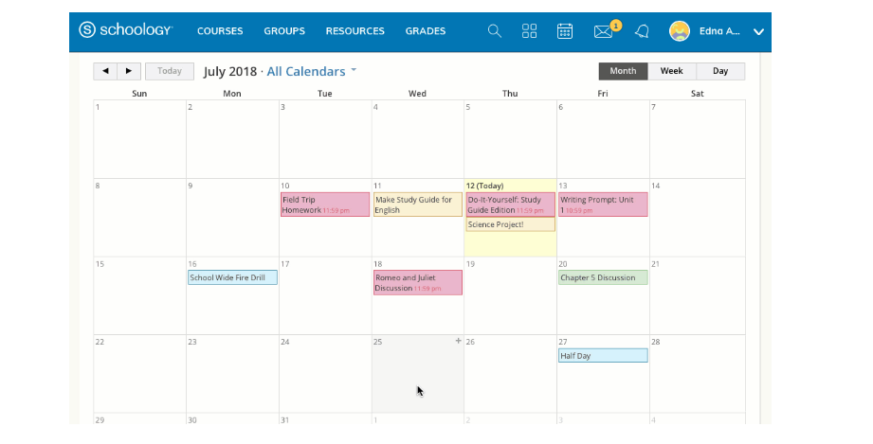

☐ Messages – The message option allows you to send and receive messages to your teachers. Click on the envelope icon at the top right to check and send messages.

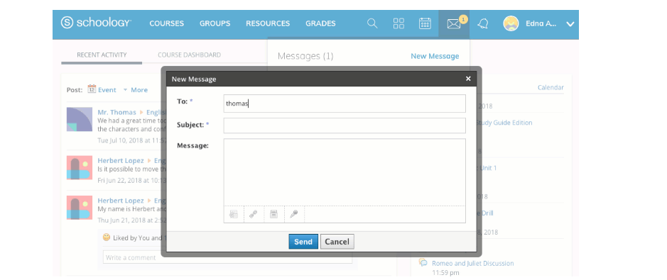

Step 3: Submitting Assignments
☐ When you click on a course, you will be taken directly to the course materials. This is where you can find all assignments, assessments, and announcements for that specific course.

☐ To submit an assignment, click on the assignment. Then click Submit Assignment. Then select one of the options: 1) Upload: select a file from your computer 2) Create: Create a document on the web using the text editor. 3) Resources: select a file from your resources, which can be a google document. 