**Setting up an account:**

In ASBWorks:

* Admin
  + Individuals

Filer list by “Teacher” under the Type column:

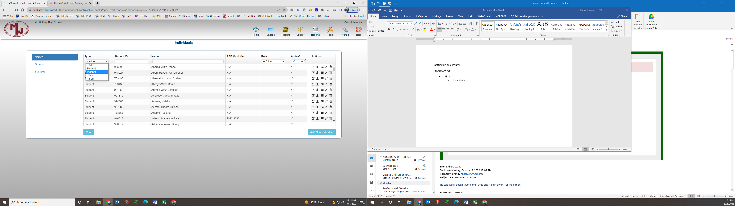

Find the person you would like to grand access to and click on the create/change login icon:

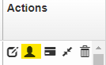

Set up parameters for the new user:

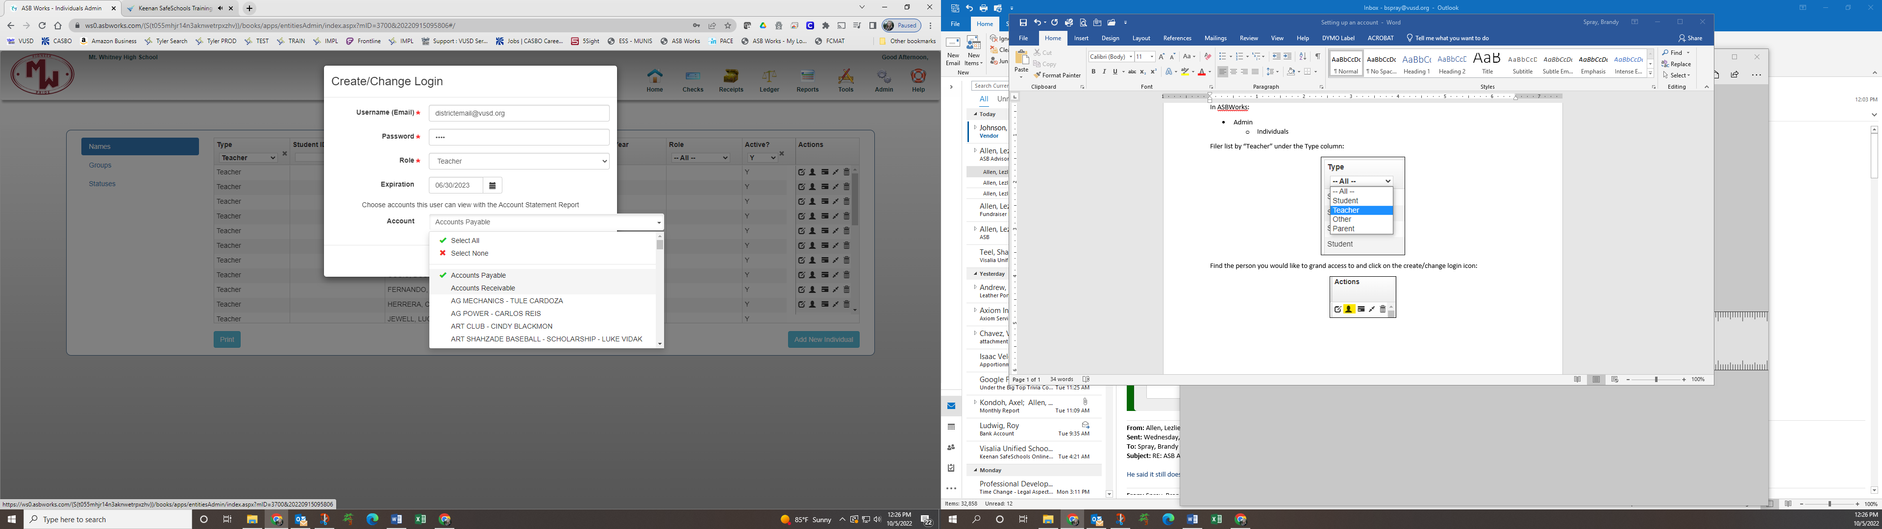

Select what accounts this person should have access to

All accounts should expire the last day of the school year

Choose what role this person should have (see roles guide)

Enter a temporary password

Use only District Email account

MAKE SURE TO CLICK WHEN DONE. OR information will NOT be saved.

ROLE GUIDE:

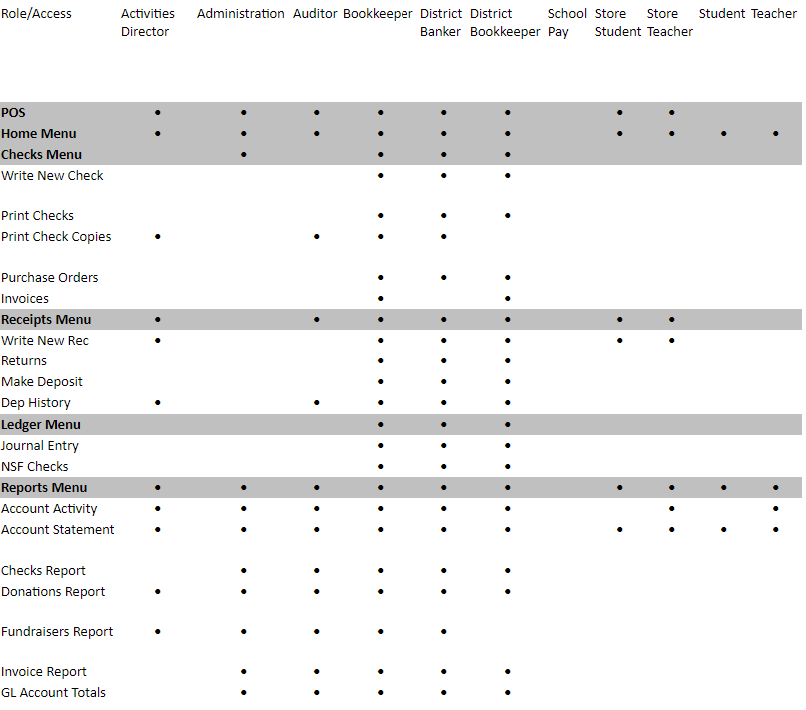

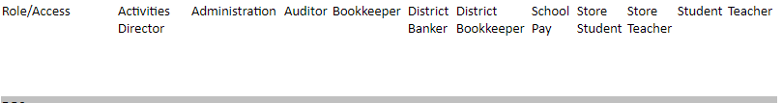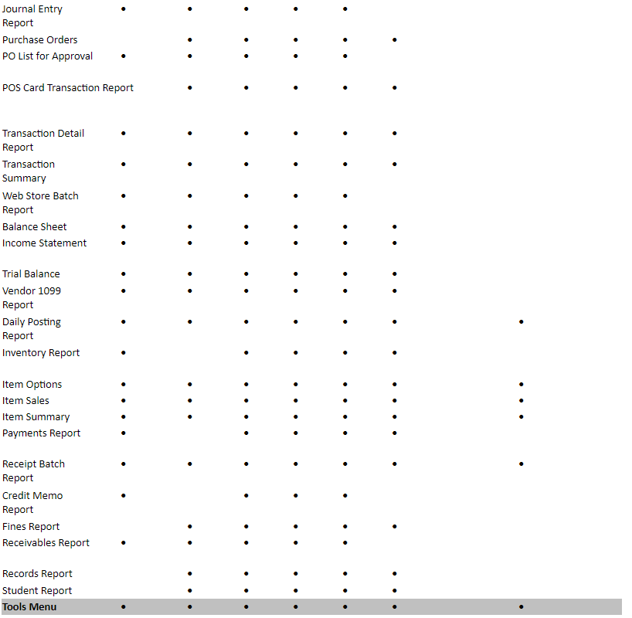

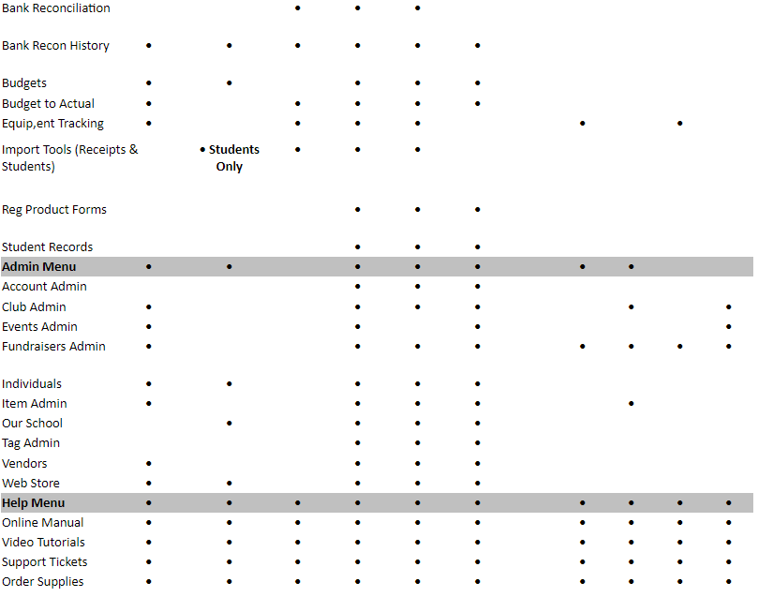

**Once complete send the following instructions to the new user:**

**Welcome to ASBWorks!**

Access the following link to login to your new account:

[https://ws0.asbworks.com](https://ws0.asbworks.com/)

Your user name is: [ENTER EMAIL HERE]

Your temporary password will be sent in a separate email for security purposes.

After your first login you will need to change your password:

Click on “**Home**” and then select “**Change Login**”

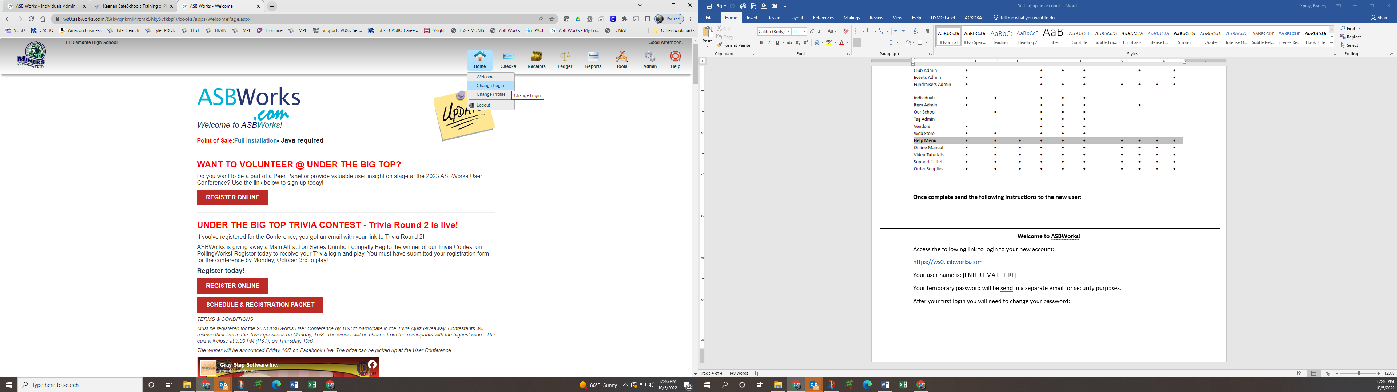

Enter your “**Current Password**” and a “**New Password**”

**DO NOT UPDATE THE USER NAME!**

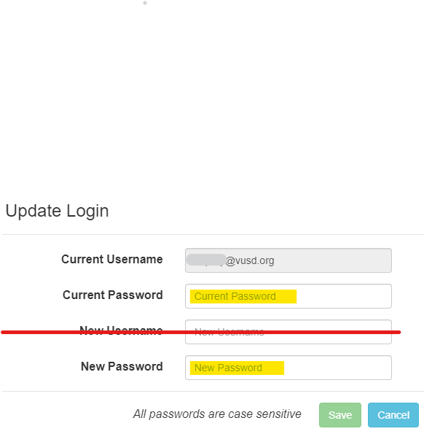

Then click on the green “Save” button.

**You have now successfully changed your login!**

Most common used report is Account Statement. Select it on the menu here:

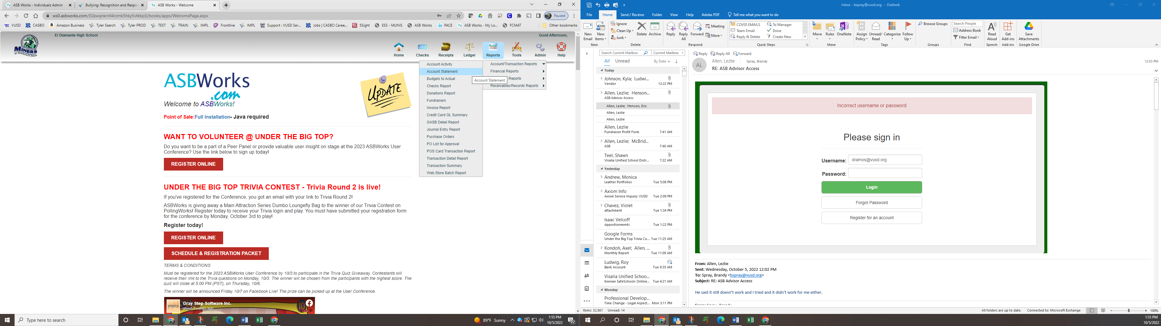

Enter the following for the report options:

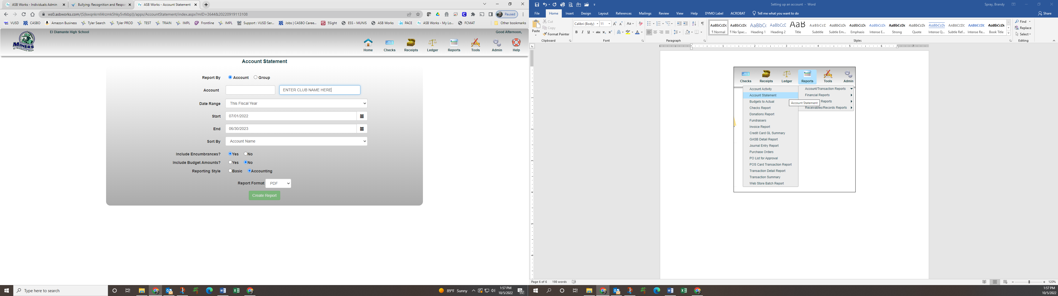

You can also enter the number here

Click Create Report.

Contact me should you have any questions.