When entering a PO or writing a check from a PO you **cannot** delete any of the lines otherwise this will disconnect the payment from the purchase order .. meaning it will not subtract the invoice/payment from the PO balance and it will not show on the PO report.

In order to see if you have any PO’s with the incorrect balance you will need to complete the following steps:

**STEP 1: RUN A PURCHASE ORDER REPORT**

To do this access the PO report from the ASBWorks menu: Reports > Account/Transaction Reports > Purchase Orders

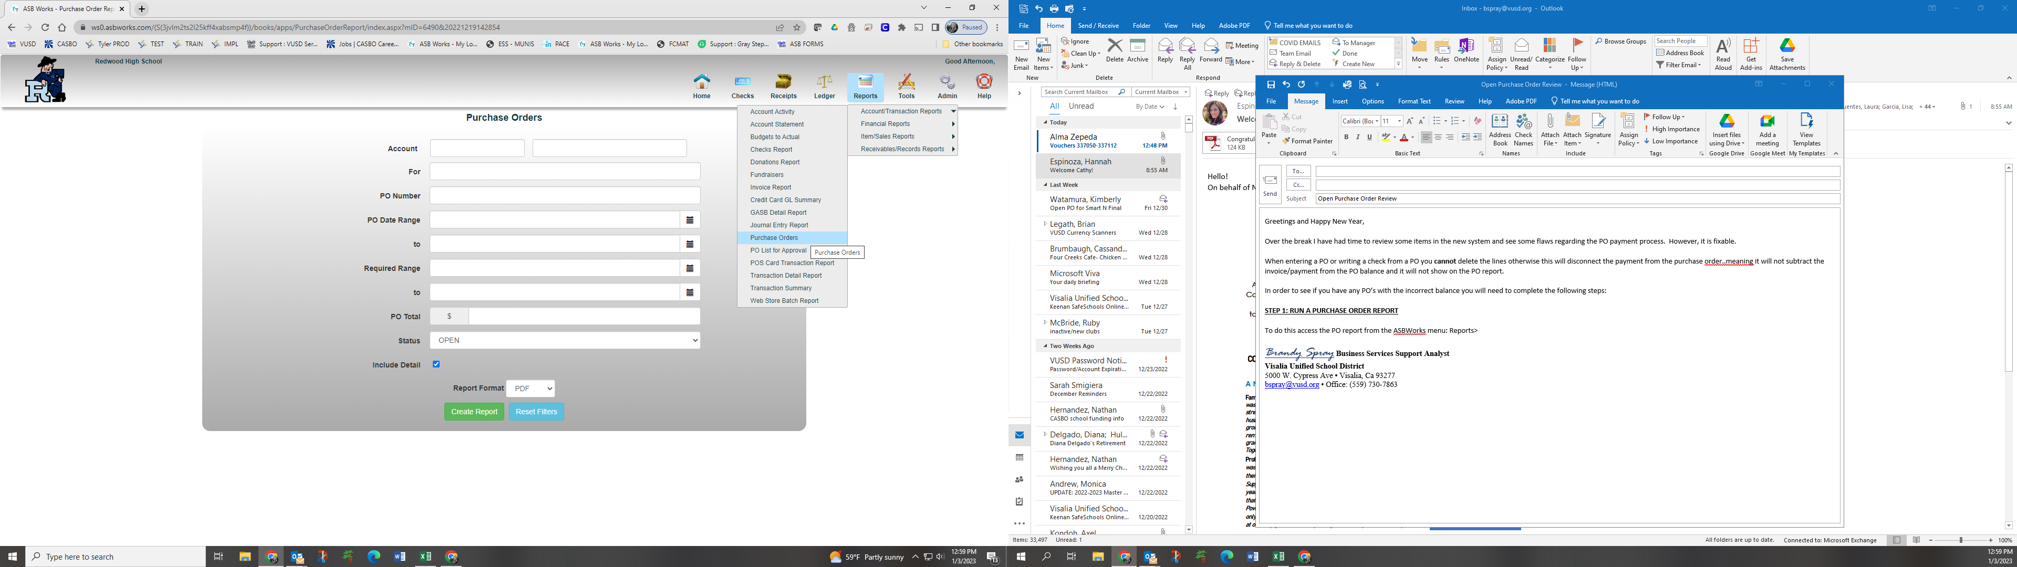

Change the status option to “**Open**” and check the box next to “**Include Detail**”, then click “**Create Report**”

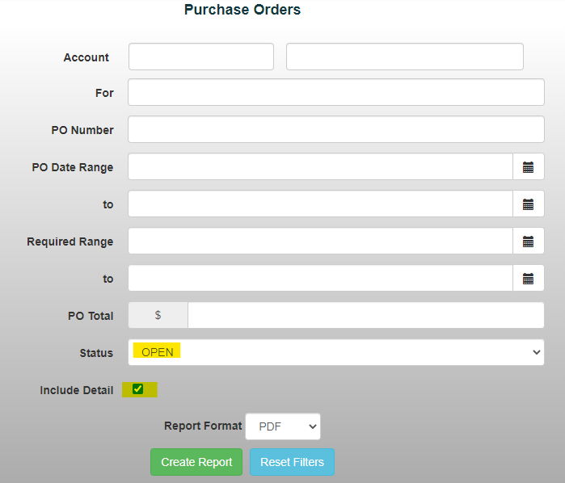

Compare the report with each original PO you have in your files:

Things to look for:

* Does the remaining balance of the PO (see highlighted example below) match your hand written balance sheet?
* If not, check to see if all invoices are listed correctly under the “Fulfilments”
* If missing items, but items were actually paid then you will need to adjust the PO… see next step!

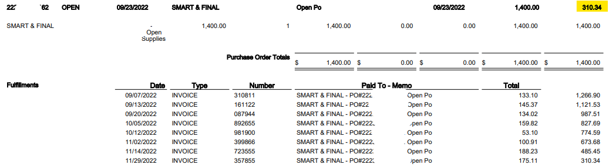

**STEP 2: PO ADJUSTMENTS**

How to adjust the balance of the Purchase Order, if needed. If no adjustments are needed then ignore this step:

Go to the Purchase Order module of the ASBWorks program: Checks > Purchase Orders

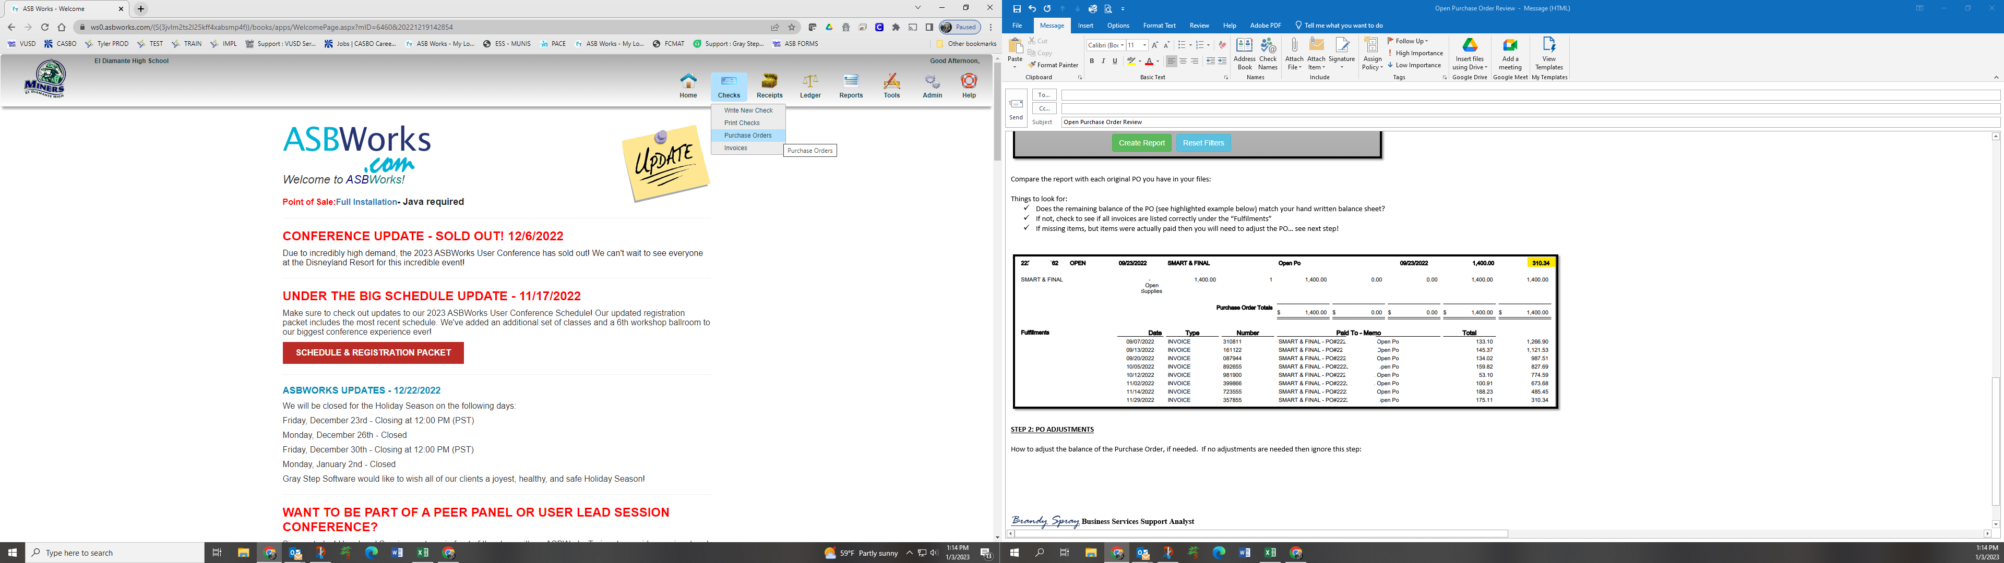

Click on the “**Find PO**” in the bottom left hand corner.

Enter the number of the PO you would like to adjust and click Search.

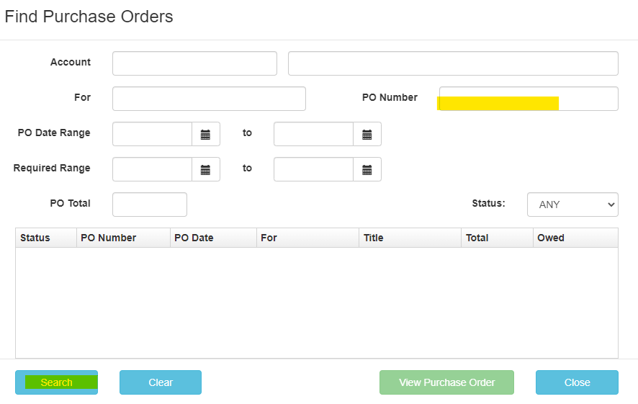

To reduce the amount of the PO click on the “Total” of the item line (if you have multiple lines select the last line total) and change the amount by the total of all invoices paid but not recorded correctly. NOTE: if you are using the QTY you can adjust the “Cost” instead of the total… OR you can delete the QTY and just adjust the “Total” (see below for example).

EXAMPLE: this PO is open for a total of $3000, there has been a total of $1500 invoices recorded correctly, however there were two invoices paid but not tied to the PO correctly in the amount of $500. So, to adjust this PO we will reduce it by $500.

BEFORE:

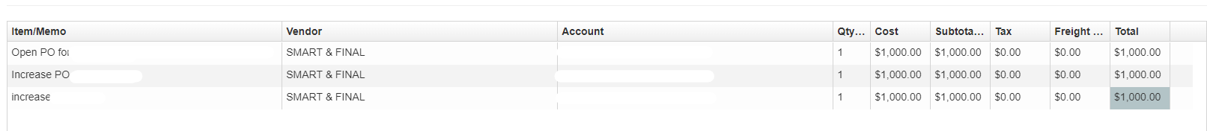

AFTER:

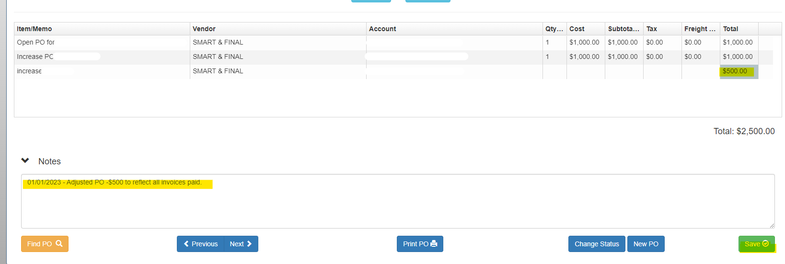

When done with adjustment make sure to enter a note stating the reason for the adjustment with the date the adjustment was made. Click Save and print a new copy of the PO – **Have Admin sign the new copy.**