DUPLICATE VENDOR REVIEW AND MERGE:

**STEP 1: RUN A VENDOR REPORT**

Access your vendor list from the ASBWorks program: **Admin > Vendors**

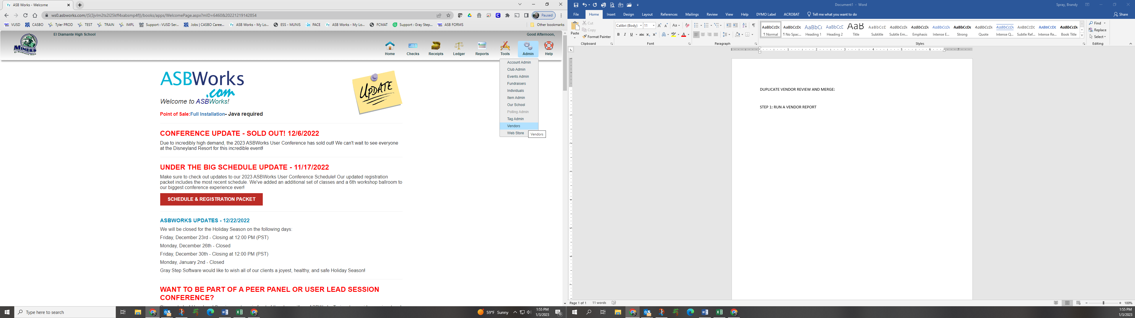

Click on 

Change the Report Format to be Excel and click on “Generate List”

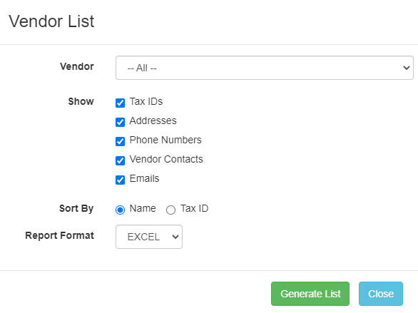

Click on the excel file that pops up in the bottom left hand corner of your screen..



Excel will open and when you get this prompt click “Yes”



You will need to click on “Enable Editing”



Click here to select your entire table

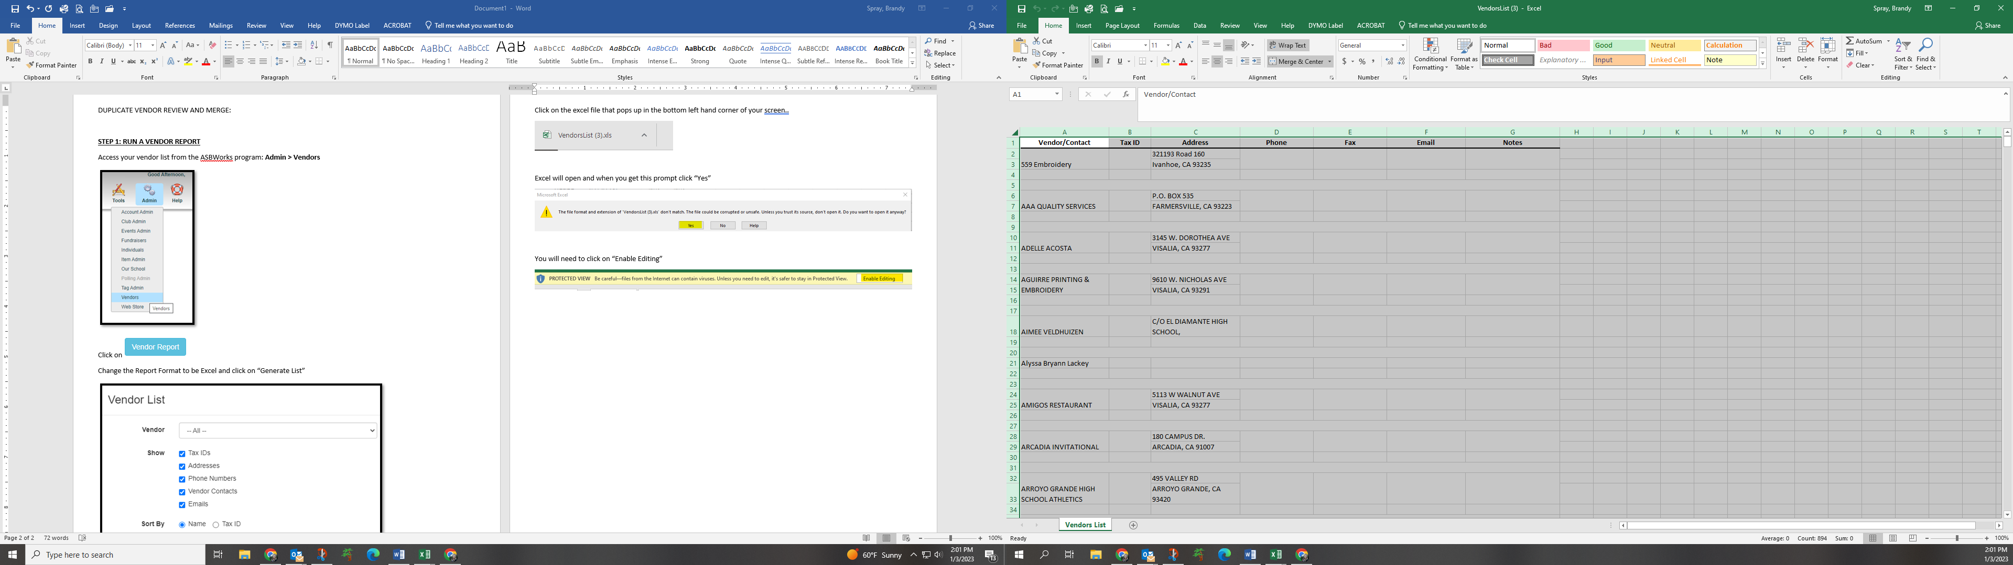

Click on the “Data” ribbon and click the “Filter” icon.

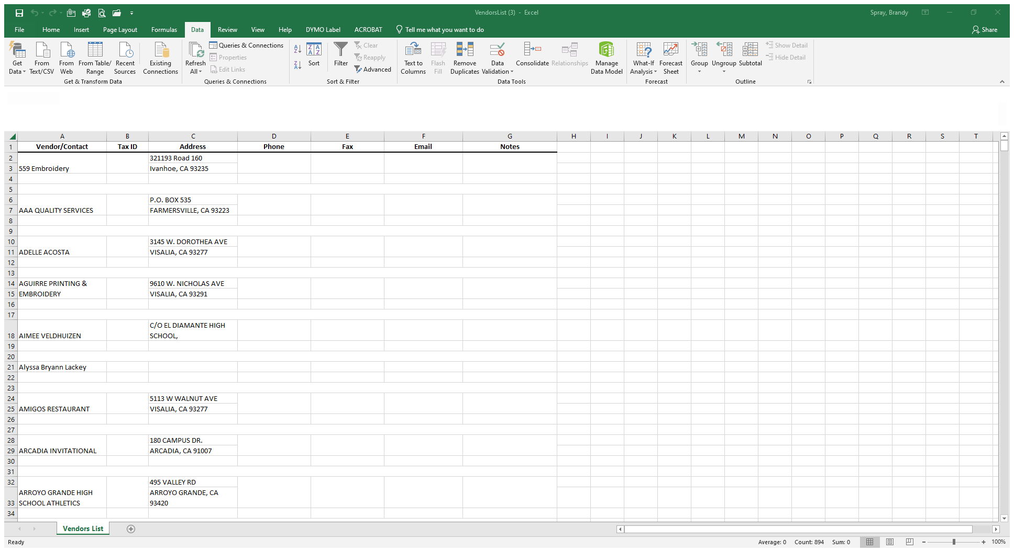

Click on column **A** and select the Conditional Formatting from the “Home” ribbon > Highlight Cell Rules > Duplicate Values …

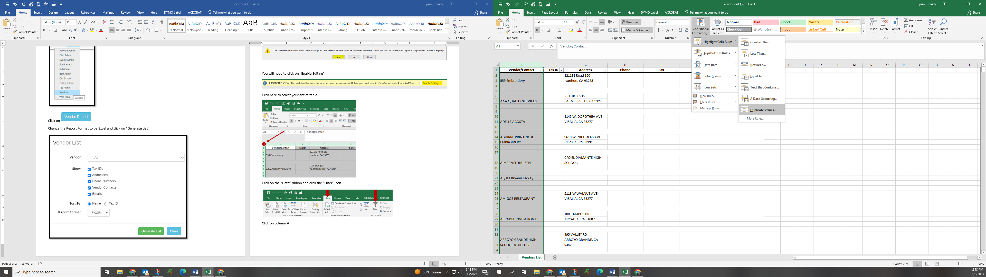

Click OK here

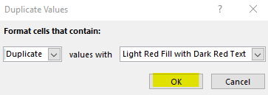

Click the drop down arrow next to “Vendor/Contact” and select “Filter by Color” and select the light red color.

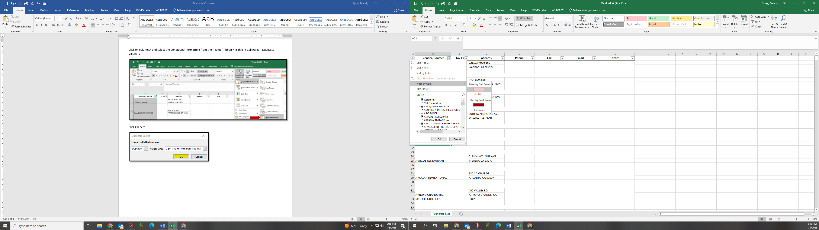

This will give you the list of vendors that have duplicate names (or are setup multiple times).

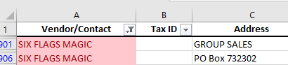

Print this list to utilize for the merge process and keep for your records.

**STEP 2: MERGE DUPLICATE VENDORS**

Merge Vendors:

* Ability to merge duplicate Vendor Entries
* History from one Vendor will move over to the other.

Look up the Vendor that you want to keep; click Merge

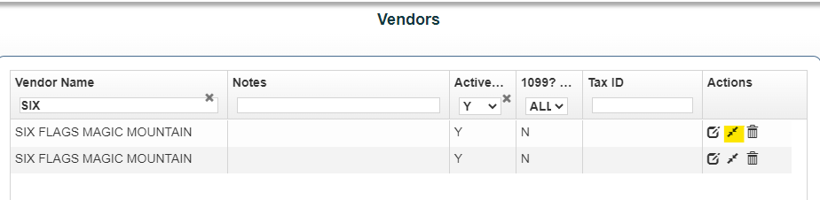

Type the name of the Vendor you want to remove (merge).  Use this feature carefully as Vendors cannot be un-merged!

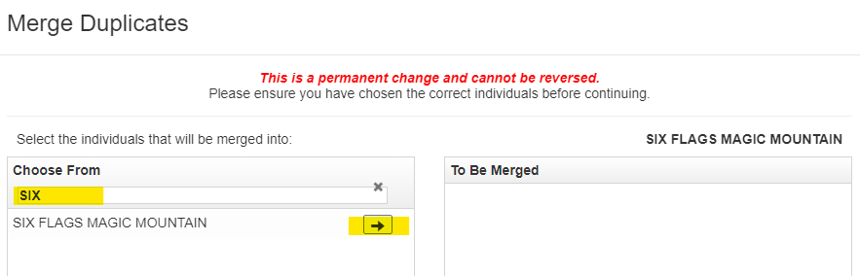

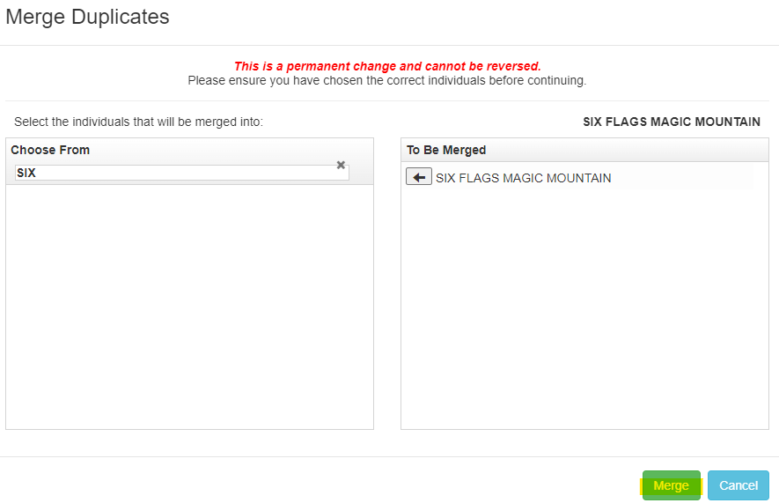

Once you select Merge the information will be combined into one vendor.

NOTE: You can select multiple names and merge all at one time!

EXAMPLE:

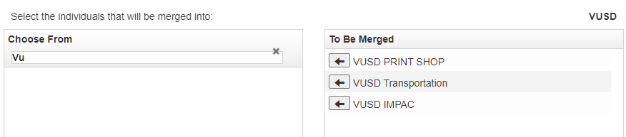

**Repeat for each vendor you need to Merge/Combine!**