DUPLICATE INDIVIDUALS REVIEW AND MERGE:

**STEP 1: RUN A INDIVIDUALS REPORT**

Access your individuals list from the ASBWorks program: **Admin > Vendors**

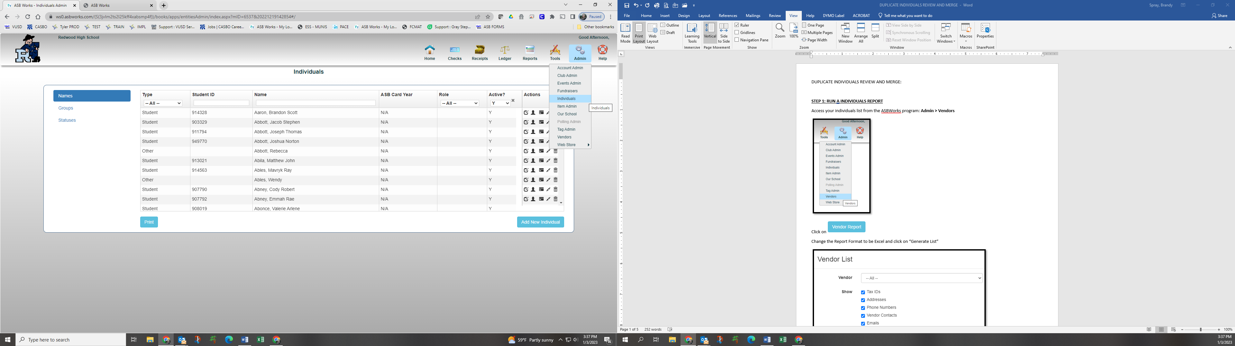

Click on 

Change the Report Format to be Excel and click on “Generate List”

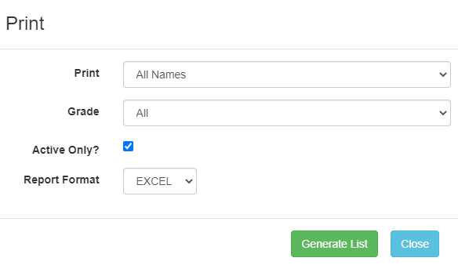

Click on the excel file that pops up in the bottom left hand corner of your screen..



Excel will open and when you get this prompt click “Yes”



You will need to click on “Enable Editing”



Click here to select your entire table

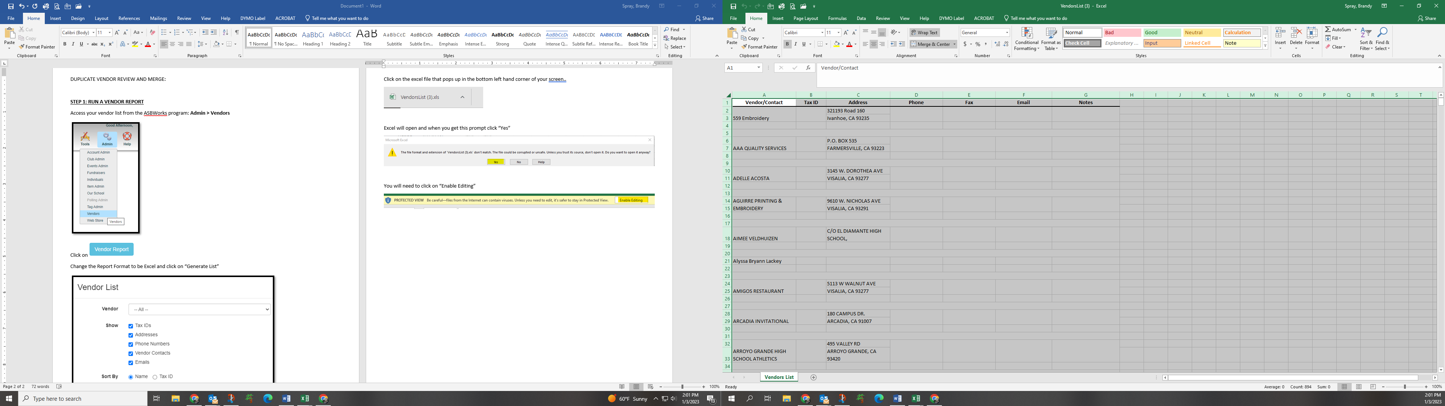

Click on the “Data” ribbon and click the “Filter” icon.

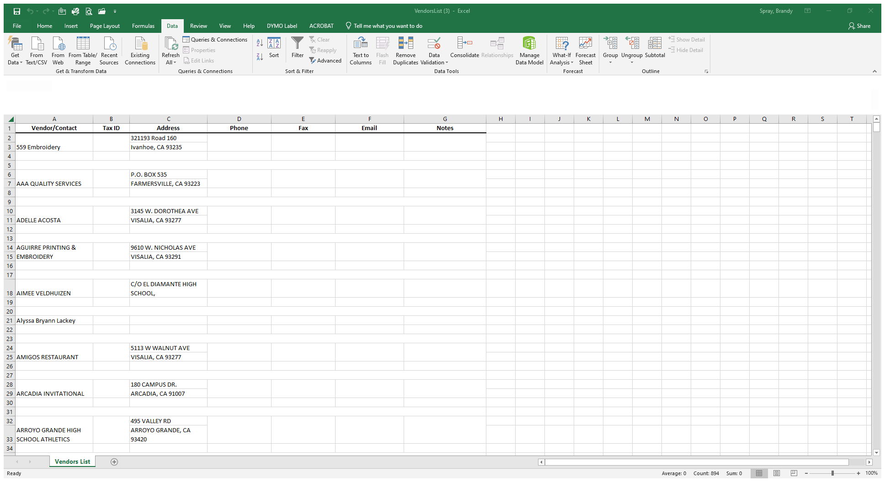

Click on column **D** and select the Conditional Formatting from the “Home” ribbon > Highlight Cell Rules > Duplicate Values …

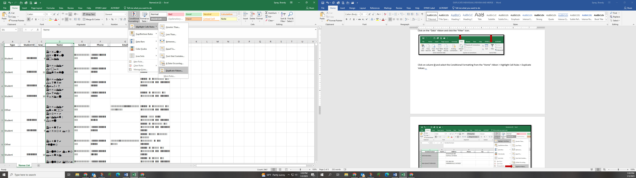

Click OK here

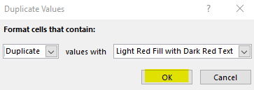

Click the drop down arrow next to “Name” and select “Filter by Color” and select the light red color.

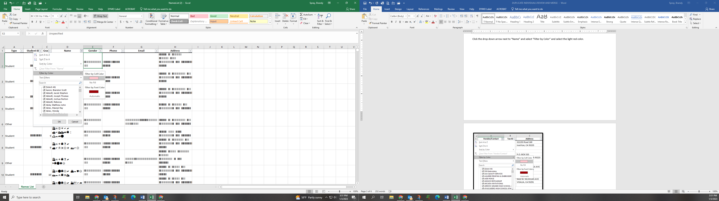

This will give you the list of Individuals that have duplicate names (or are setup multiple times).

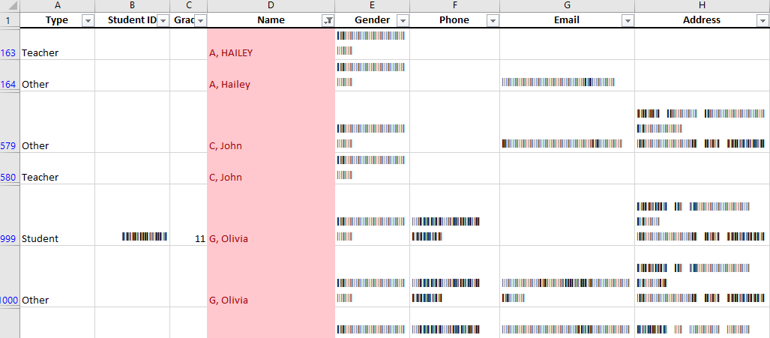

Print this list to utilize for the merge process and keep for your records.

Merge the “other” types with the duplicate “teacher” setup. – This is the most common duplicate

Do NOT merge student accounts. – You can unselect the students from your list by selecting the drop down from the “Type” in column A and uncheck “Student”.

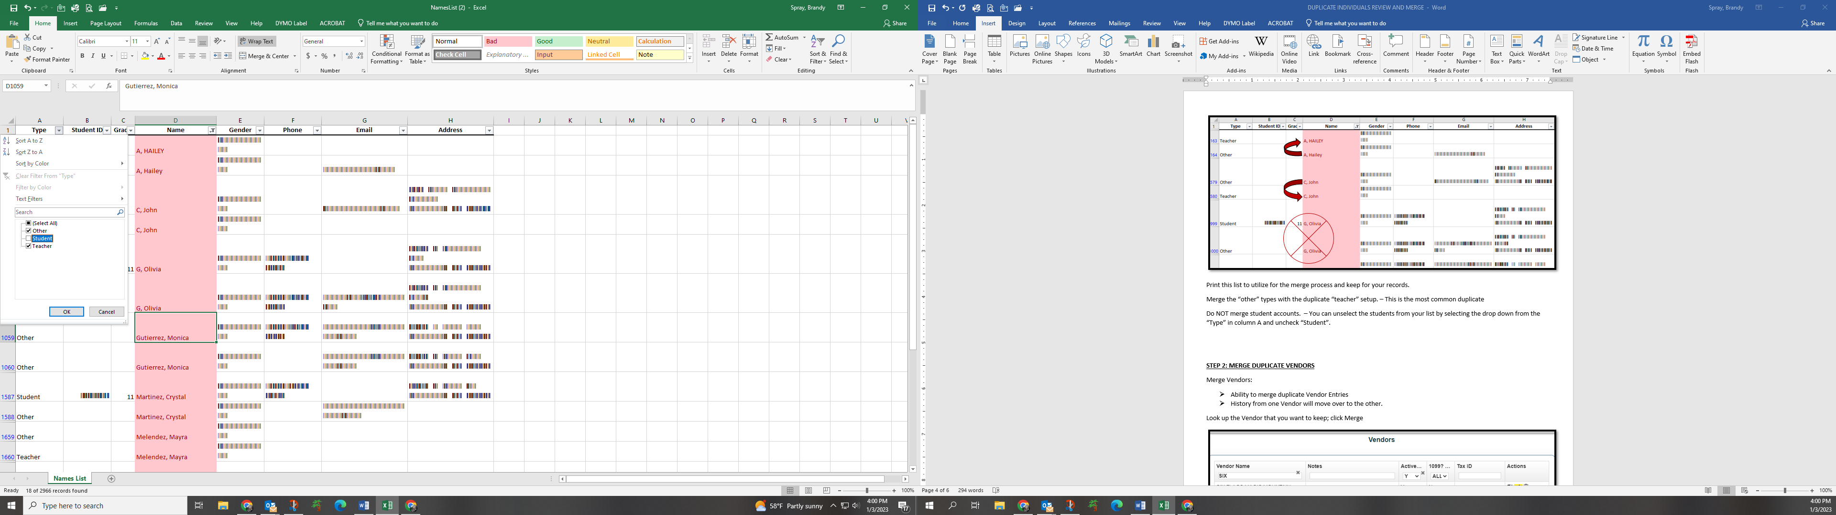

**STEP 2: MERGE DUPLICATE VENDORS**

Merge Vendors:

* Ability to merge duplicate Individuals Entries
* Merging gives you the ability to merge duplicated records in to one. NOTE: MERGING CANNOT BE UNDONE. BE VERY CAREFEIL WHEN MERGINING INDIVIDUALS!

Look up the Individual that you want to keep; click Merge

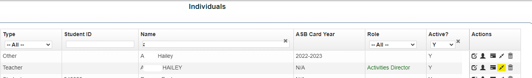

Type the name of the Individual you want to remove (merge).

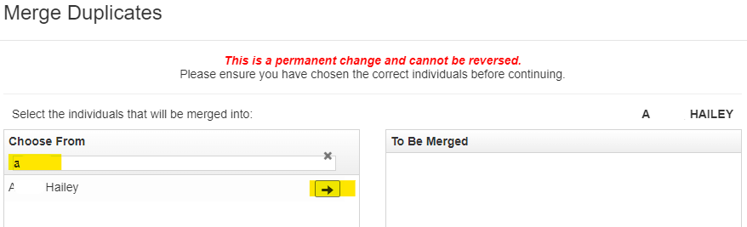

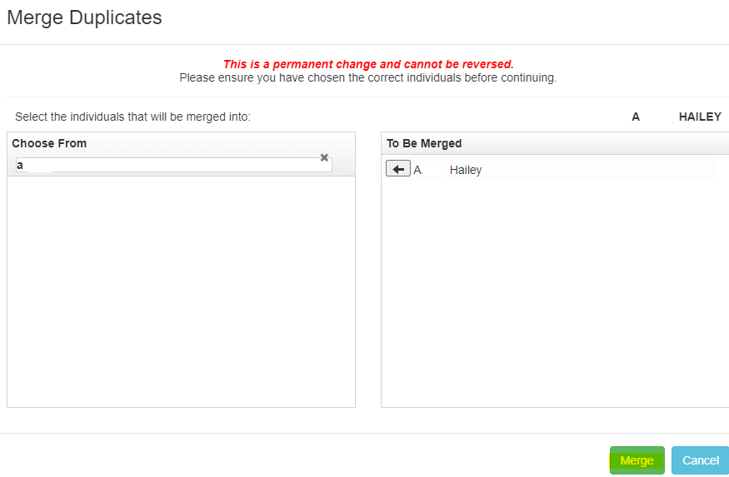

Once you select Merge the information will be combined into one person.

NOTE: You can select multiple names and merge all at one time!

EXAMPLE:

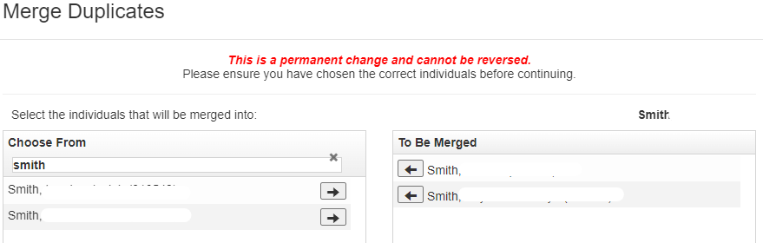

**Repeat for each person you need to Merge/Combine!**