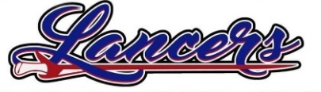
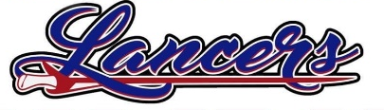
2022-2023 Coaches Directory

School: Lakewood Middle School Mascot: Lancers
Athletic Director: Jason Lee Email: jlee@lakewoodlocal.k12.oh.us Event Manager: Mat Bowen Email: mbowen@lakewoodlocal.org
Office Phone: 740-928-4526 Cell Phone: 740-644-9224 Website: https://www.lakewoodlocal.k12.oh.us/LancerAthletics.aspx

2022-2023 Middle School Boys Coaches
Basketball 7th Chris Pound Cell: 740-507-7907 Email: docpound@hotmail.com
Basketball 8th TBA
Cross Country Stephanie Pound Cell: 740-899-6527 Email: stephanie.pound@yahoo.com
Football Derek Allen Cell: 740-641-7945 Email:allenderek83@yahoo.com
Golf Jon Griffith Cell: 740-973-7006 Email: jongriffith14@gmail.com
Track Stephanie Pound Cell: 740-899-6257 Email: stephaine.pound@yahoo.com
Wrestling TBA

2022-2023 Middle School Girls Coaches
Basketball 7th Chris Lipscomb Cell: 614-556-6117 Email: Christopher.j.lipsocomb@gmail.com
Basketball 8th TBA
Cheer Nikki Earlenbach Cell: 614-657-6492 Email: LakewoodMSCheer@gmail.com
Cross Country Jeff Hartman Cell: 740-814-3527 Email: trails440@yahoo.com
Golf Jon Griffith Cell: 740-973-7006 Email: jongriffith14@gmail.com
Track Jeff Hartman Cell: 740-814-3527 Email: trails440@yahoo.com
Swimming Stephanie Allman Cell: 614-832-5958 Email: allmanss@aol.com
Volleyball 7th Chris Monroe Cell: 740-973-1987 Email: monoroe004@gmail.com
Volleyball 8th Faith Amore-Reed Cell: Email: rfait2@aol.com

