
Glen A Wilson Boys Basketball Boosters
16455 Wedgeworth Dr. Hacienda Heights, CA 91745

Wilson Boys Basketball Community
and Alumni Sponsorship Drive

Dear Community Member and Alumni

The Glen A. Wilson High School Boys' Basketball Program is beginning its 2022-2023 Sponsorship Drive. We are inviting members of our community and Alumni to join our effort to support our players and the Wildcat basketball program by advertising in our Program Book or on a retractable banner that will be displayed in our Gym on game days, or by donating directly through Venmo. Wilson High School is located in Hacienda Heights, and is a top rated high school in the San Gabriel Valley. The mission of Glen A. Wilson High School is: to maximize the academic, social, and physical potential of all students.

The motto of our school is AAA -"Academics, Athletics, and Activities".

We hope that you will support our basketball players by purchasing a space in our annual program
book, one of our advertising banners or through a direct Fair Share Donation. The levels of participation are listed on the attached pages. Any contribution would be greatly appreciated. All proceeds are going directly towards new uniforms for our 2022-2023 school Year. The cost of these uniforms are $4200 for a home and away set. Anything we make over this amount will go towards equipment needed for our basketball program.

Please consider helping our program by filling out the attached form and making a donation payable to "Wilson Boys Basketball Boosters". All donations are tax deductible (Tax I.D. #300468478).

On behalf of our players, coaches, and school, we thank you for your support! If you have any questions, please contact Coach Willie Allen 626-255-7779, Peter Galan 626-806-0635, Booster President or Rich Gurrola 626-664-0496, Booster Vice President.

Venmo – 626-806-0635

Sincerely,

Willie Allen, Head Coach
Peter Galan, Booster Club President
Rich Gurrola, Booster Club Vice President
WHS Boys' Basketball Boosters

Wilson Boys Basketball
2022-2023 Community Sponsorship Book Form
And Fair Share Donation

Wilson Player's Name:

Business/Sponsor Name:

Contact Name:

Address:

Phone Number: Email:

Levels of Sponsorship (please refer to the attached sizing page):

Diamond - $500 Retractable pop up banner displayed at all home games (23 x 66)
($400 if renewing pop up banner from previous year)

Platinum - $400 full page color ad in the program book

Digital - $250 purchase digital ad space on our BLAST fundraising website.
(ask your student/athlete to e-mail you the info)

Gold - $200 half page color ad in the program book

Silver - $100 quarter page color ad in the program book

Bronze - $50 business card size color ad in the program book

Fair Share Donation: ____ $50 ____$100 ____$200 ____$300 Other:________

Ads/artwork must be submitted along with payment and this completed form. Please e-mail Ads/artwork to katykao@yahoo.com,
werdna070401@gmail.com, & richardgur@msn.com

Resizing may be necessary

Please make checks payable to: WILSON BOYS BASKETBALL BOOSTERS
Sponsors will receive a copy of the Wilson Boys Basketball 2022-2023 Season Program Book.

Business Ads are due by December 3, 2022

Thank you for your support!

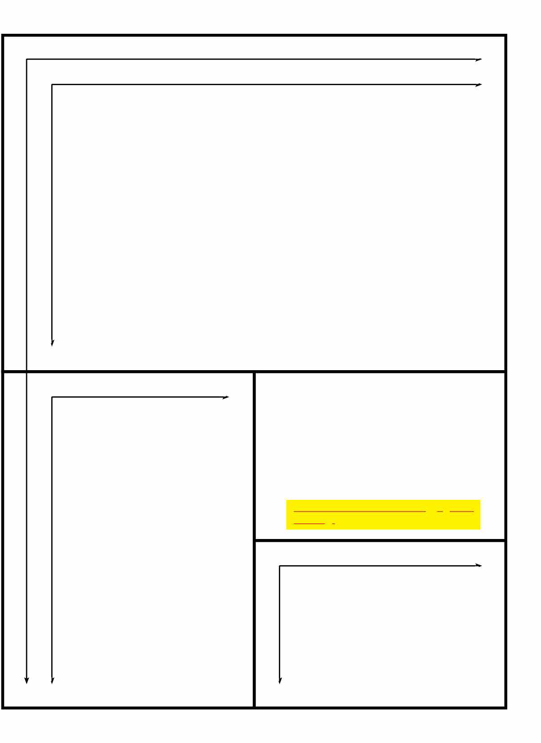
-
Full Page: 7 1/2" x 1O" -
Half Page: 7 1/2" x 5"

'

- Instructions:
Quarter Page: 3 3/4" x 5" 1. Advertisement should fit within the boundaries shown.
2. Please make sure that the ad is in digital format.
Ads should be submitted as high resolution
jpegs or PDF **No Word, Powerpoint, Publisher, or PrintShop documents** Convert full size files to jpegs at 300 dpi minimum

,
Eighth page or business card: fit within 2 1/2" x 3 3/4"

' '

rev 05/11/2022

