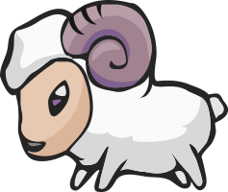
Grazide Elementary Close Reading Annotations
 | Unknown Word
 | Confusing
 | Interesting
 | Important
_____________ | Key Words – Main Idea and Details
 | New Information
 | Agree
 | Connection – Text to Self, Text to Text, Text to World

We are RAMS – Be Respectful and Make Good Choices to Be Safe!

