  BEHAVIOR EXPECTATIONS  - Be on time and ready to learn, get fit and have fun!  - Follow all rules of the activity being taught.  - Respect yourself, others, and the school.  *--At all grade levels we emphasize sportsmanship, team spirit, accepting personal responsibility, setting and meeting personal goals for fitness, honoring differences, collaboration and cooperation.  *--For more information about the California Physical Education Standards, please visit the CA Department of Education website at: http://www.cde.ca.gov/ci/pe/ |  |  | 6TH GRADE BAND STUDENTS  - Must attend PE class outside of the regular school day in order to meet the California Ed Code minutes requirement.  - Each site has set time for band students to obtain those mins.  - Chooses not to attend PE during these times will risk losing their privilege to participate in band.  ELEMENTARY ATHLETICS  - Provide all students the opportunity to participate in sports outside of the school day.  - Students will improve their skill level and learn the values of sportsmanship, teamwork, dedication, and the joy of competition along with other important life lessons such as respect, responsibility, perseverance and self-discipline.
  CONTACT: PE TEACHER
  Name: Federico Santillan
  Phone: 559-595-7290
  Email: Federico.santillan@dinuba.k12.ca.us
   |  | [Company Name]  [Address]  [City, ST ZIP Code]
  
  Dinuba Unified Elementary Physical Education Handbook
  Grades: K-6th
  Grades K-6th

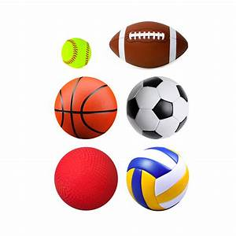  General Overview  - Unit-lessons are based on California State Standards  - Game Day curriculum approved by DUSD School Board  - Curriculum designed for all 6 elementary schools  - District PE Pacing Guide developed for all sites  - Copy of PE Pacing Guide may be obtained by child’s PE teacher  CURRICULUM & STUDENT PRACTICE/OPPORTUNITIES  - All students use a variety of age-appropriate equipment to practice skills  - Students will be able to understand the fitness components, fitness assessments, and the need for a lifetime of physical activity |  |  | - 5th Graders experience the California Statewide Physical Fitness Test (PFT)  *--Games, sports, and skills for the Grade Level Year:  Volleyball, Football, Soccer, Softball,  Dance, Frisbee, Physical Fitness,  Yard Games, Basketball, Track  PROPER DRESS AND SHOE ATTIRE  - All students must wear comfortable athletic shoes and clothes  - If student wears sandals, slippers, dress shoes, or any non-athletic shoe please have your child bring athletic shoes in a bag to change into for PE and recess  - If student does not wear or bring athletic shoes, students will participate in an alternative activity  - Shorts or leggings can be worn under skirts or dresses 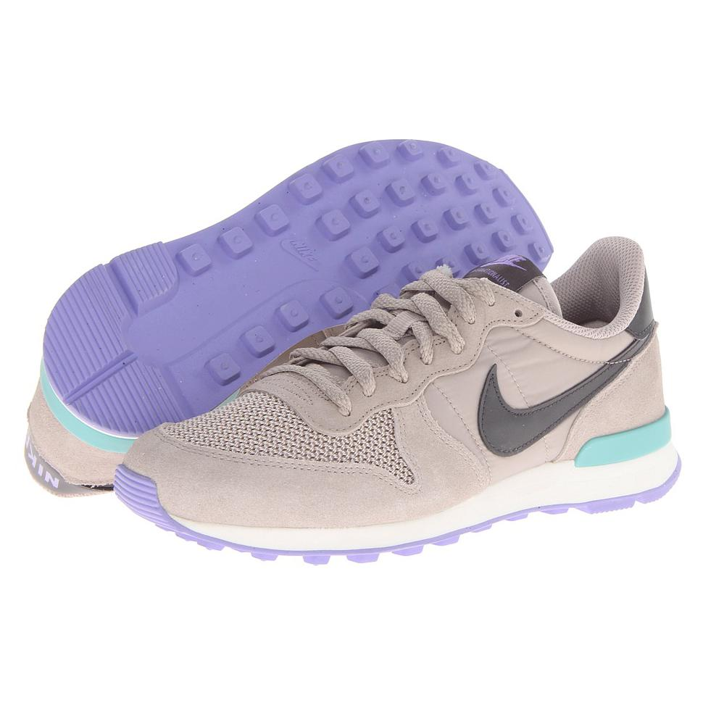 |  |  | ATTENDANCE   - Attendance and participation is required of all students according to California Education Code 51223  - Medical, sick, or injury notes brought to school nurse/clerk to be documented first before given to PE teacher  - For Excused notes, please include the following:  - Describe the reason for missing PE?  - How many days will your child be sitting out of PE? More than 3 days requires doctor’s note. Parents may only request up to 6 days of non-participation  - What is the best way to contact you should we have any questions?  *--Without a note, student will not be excused from PE  *--Students that are excused from PE will participate in an alternative non-physical activity, such as reading or a writing activity associated with physical education

