 How to register for EAP

Employee Assistance Program (EAP)

WEBSITE: www.anthemeap.com

TOLL-FREE: 800-999-7222

- Click the link above. Company Code = SISC
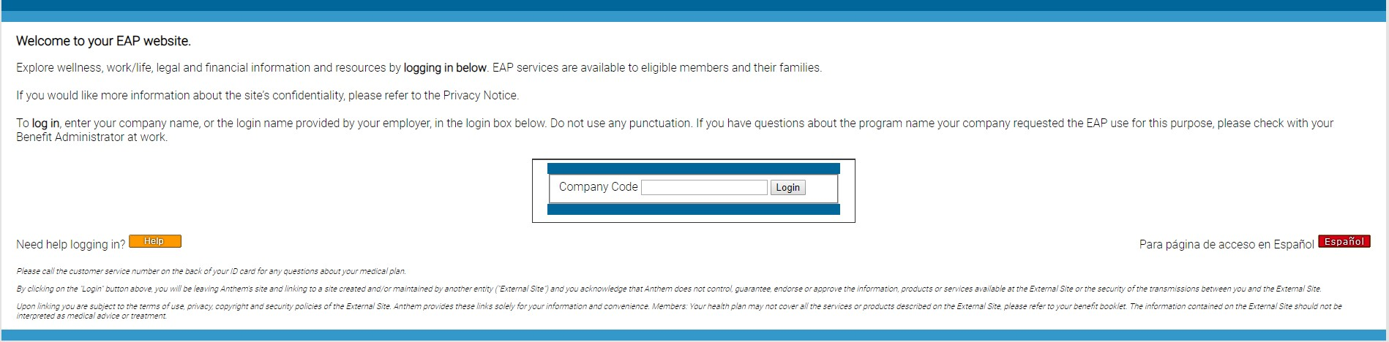
- Click “Member Center”
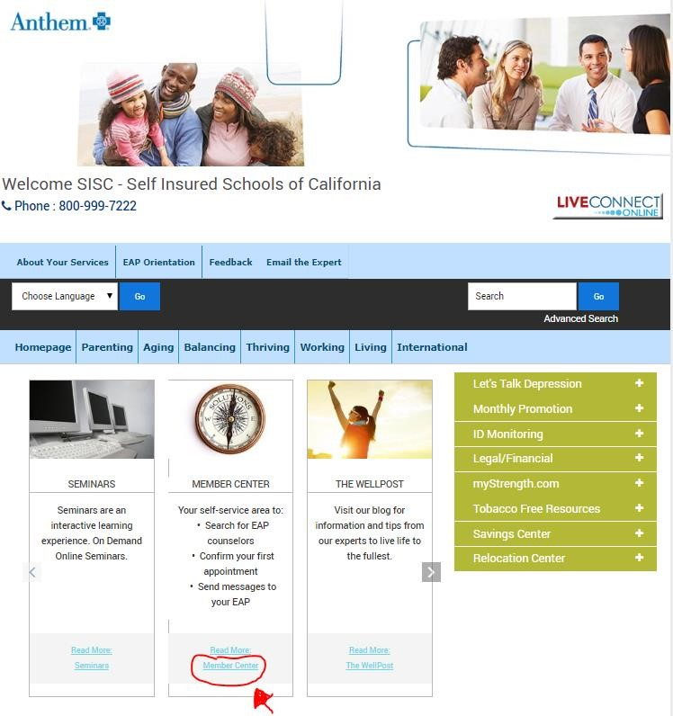

Register
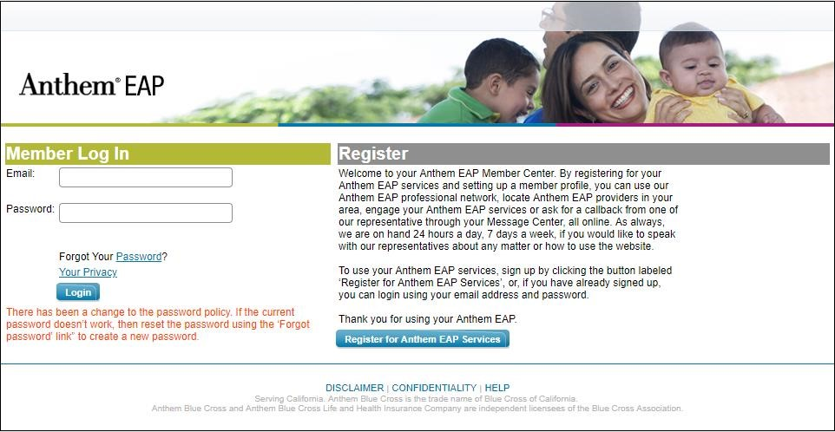

4.

Accept Terms

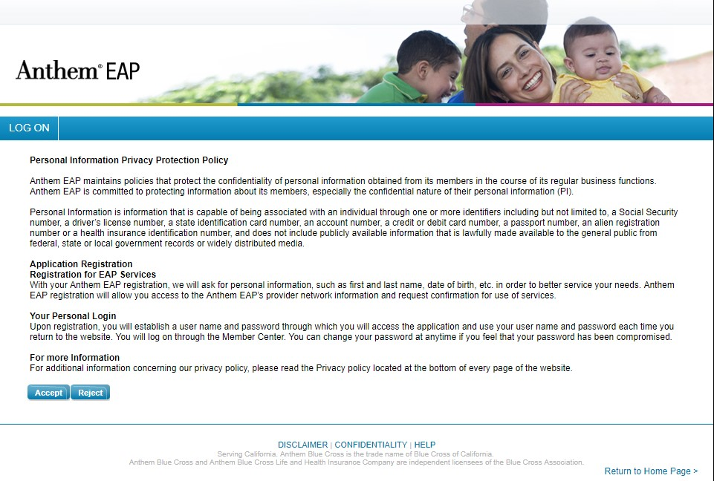

- Register for Full Access
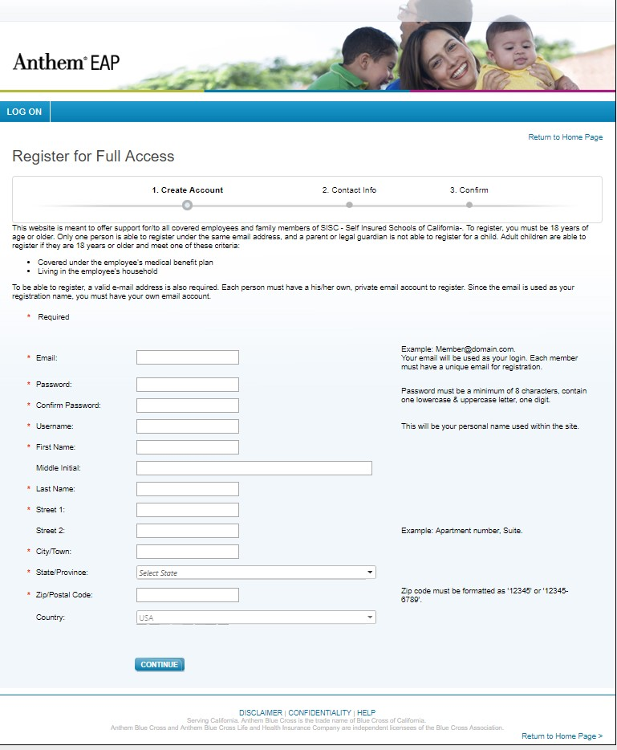

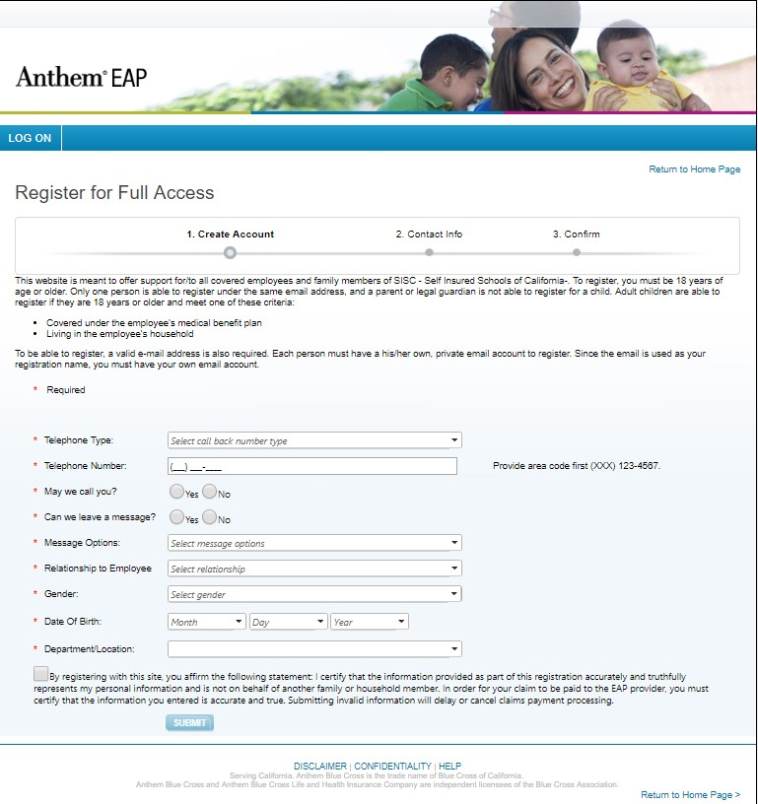

- Check the email you provided; open the message and follow the instructions to complete your registration.

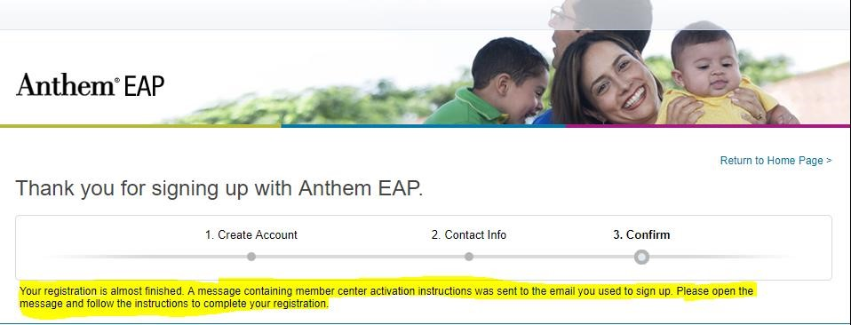

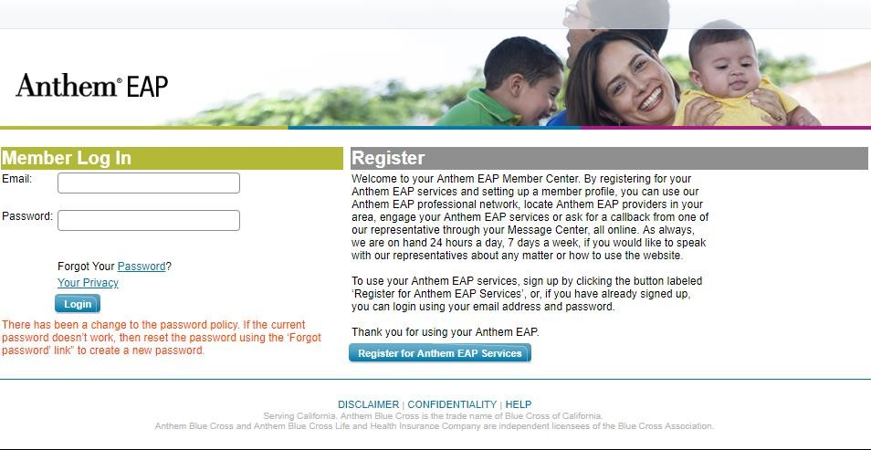

7.

It will take you back the Member Log In page.

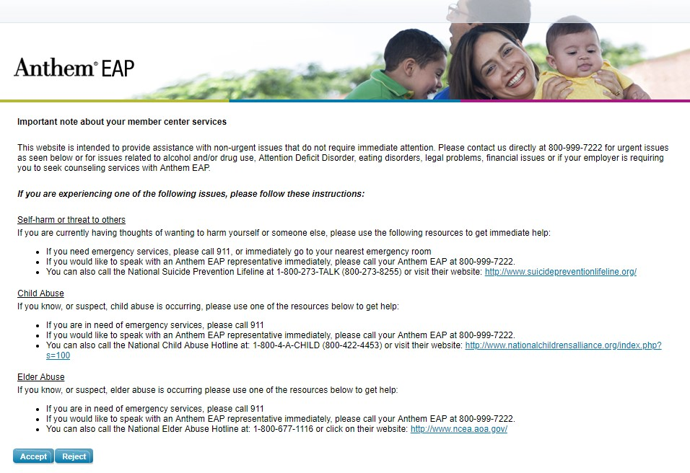
8.

Accept Terms

9. Welcome to Anthem EAP
