Griffith Public Schools
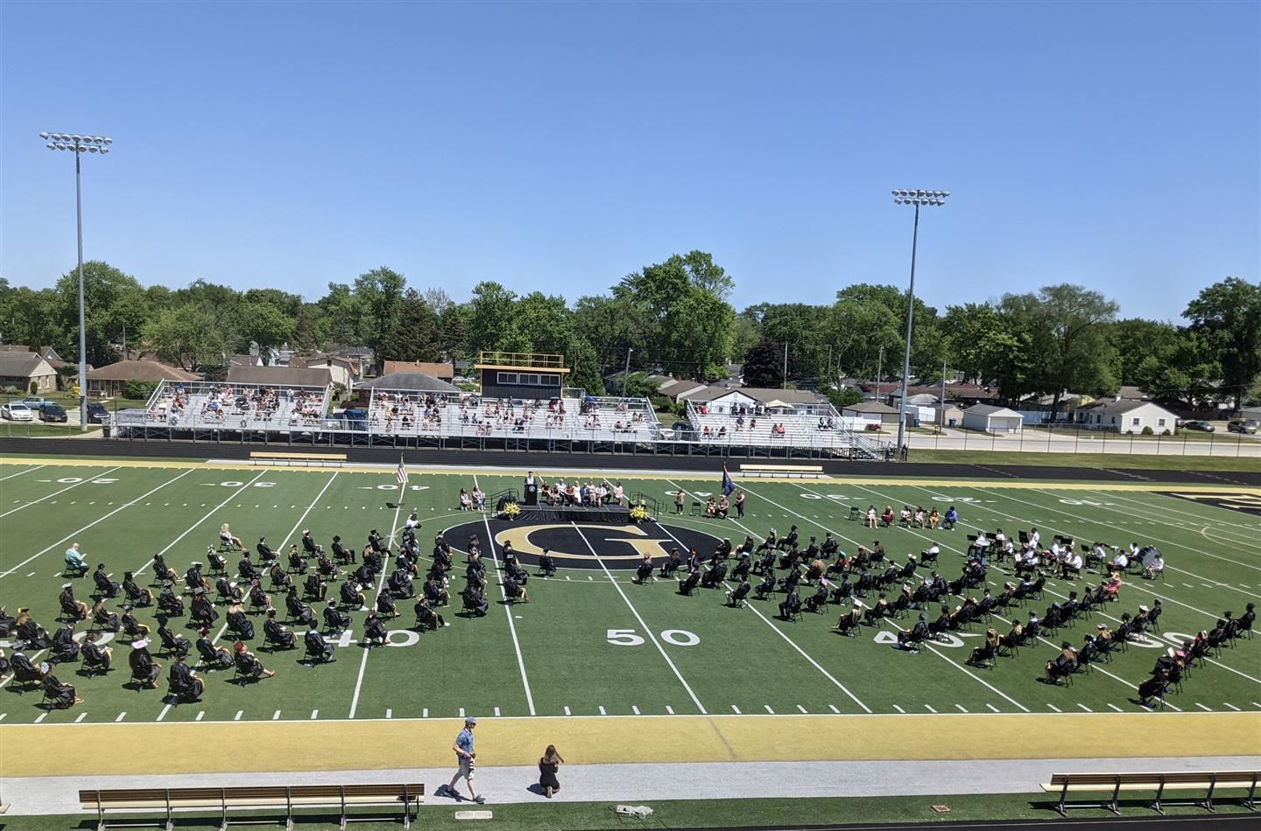

2021/22 Return to Learn Plan
Griffith Public Schools
2021/22 Return to Learn Plan

Overview:
Griffith Public Schools successfully and to the best of their ability navigated through the COVID-19 pandemic during the 2020/21 school year. Thanks to all that helped create, develop, implement, and follow our re-entry plan as we were able to continue to have staff and students attend in-person without closure. Thank you to all who helped in this endeavor!
As Griffith Public Schools prepares for a new school year in 2021/22, the plan has been amended to reflect the current state of the COVID-19 pandemic and will serve as a guiding document for school operations as we move forward in our preparation for the 2021/22 school year.
Due to the evolving nature of the COVID-19 pandemic, this document may be revised and updated on an as needed basis. Griffith Public Schools is committed to providing ongoing communication to students and their families, as well as our entire staff.
Thank you for your continued support, patience, and feedback as we continue to work together through this unprecedented time.
Griffith Public Schools Administration and School Board

Griffith Public Schools will return to five-day (full-time) instruction during the 2021/22 school year. School Hours are as follows:
Wadsworth Elementary School:
Start Time: 8:40 am
End Time: 3:10 pm

Beiriger Elementary School:
Start Time: 8:15 am
End Time: 2:50 pm

Griffith Jr./Sr. High School:
Start Time: 7:30am
End Time: 2:30 pm

School Calendar:

Griffith Public Schools will follow the calendar that was adopted on February 11, 2021. The school calendar is available on the Griffith Public Schools website.

Current Indiana Executive Order:

Executive Order 21 - 15 (Expires June 30, 2021)

https://www.in.gov/gov/files/Executive-Order-21-15-Continuation-of-Health-and-Welfare-Provsions.pdf

Health Protocols:

COVID-19 Testing Locations
COVID-19 Vaccination Locations or Dial 211
You can also text your ZIP code to 438829
You will receive a list of sites near you.
The reply will also ask you if you need free child are at one of several sites.
If you reply with “care”, you will receive information on free child are near you.

Back to School Guidance by Indiana Department of Health

After July 1, 2021, local school boards will be responsible for implementing whatever measures and restrictions deemed necessary and prudent to address the impact and spread of COVID-19 for their buildings, facilities, and grounds, including transportation. Educational governing bodies are encouraged to follow Centers for Disease Control and Prevention (CDC) and Indiana Department of Health (IDOH) guidance.

IDOH has released preliminary fall guidance for K-12 schools. A summary of this guidance can be found below. The full guidance can be found here. This guidance includes additional recommendations regarding hand washing, daily cleaning, ventilation, nursing clinic procedures, daily screening, food service, water system maintenance, and extra-curricular activities. To view a recorded webinar explaining this guidance, as well as question and answer session, click here and scroll to the June 4, 2021, Back to School video.
K-12 Schools:

Unvaccinated staff and students
Masks recommended indoors (except when eating); social distance at least 3 feet if all students are facing forward in the classroom; social distance at least 6 feet in all other areas of the school; and quarantine if identified as having had close contact with someone who tested positive for COVID-19.
Vaccinated staff and students
Masks are not necessary; use good judgment regarding social distancing; and no quarantine needed if identified as a close contact as long as they remain asymptomatic.
Symptoms of COVID-19 Illness:
Fever or chills
Cough
Shortness of breath or difficulty breathing
Fatigue
Muscle or body aches
Headache
New loss of taste or smell
Sore throat
Congestion or runny nose
Nausea or vomiting
Diarrhea

Track and Isolate Positive Cases:
Individuals should stay home for 10 days following the onset of symptoms or a positive test result.
Who is a close contact?:
If all students are masked and facing forward in the classroom, only individuals within 3 feet of a person diagnosed with COVID-19 for a total of 15 minutes or more over a 24-hour period.
If all students are not masked and facing forward in the classroom, all individuals within 6 feet of a person diagnosed with COVID-19 for a total of 15 minutes or more over a 24-hour period.
Quarantine:
Vaccinated close contacts do not have to quarantine, but should monitor for symptoms and isolate if symptoms develop.
Unvaccinated individuals who are identified as a close contact must quarantine.
Asymptomatic close contacts may return on day 8 (with specific negative testing and precautions), day 11 (with precautions), or day 15 (without testing or precautions).

Griffith Public Schools Re-entry Plan for 2021/22
Face Coverings:
Face coverings are optional for students and staff. Although families may supply their own face coverings, Griffith Public Schools will have an ample supply of face coverings for any who is need of one. Cloth face coverings should be laundered each day.
The building principal will make the final decision as to the appropriateness of a face covering.

Student Attendance:
Griffith Public Schools personnel will request specific symptom information when absences are reported along with COVID-19 diagnoses and/or potential COVID-19 exposure. Information obtained will be shared with our nursing staff.
In regard to quarantining, Griffith Public Schools will not be doing so unless CDC or state government issue an executive order to warrant the change. However, our families will be made aware of a “positive” case within a classroom through communication by administrator and/or classroom teacher, but we will not be sending students home to quarantine due to being a “close contact”. Parents will have every right to make that decision to keep his/her child home in this situation; however, absences will be counted according to our guidelines Griffith Student/Parent Handbook. We trust that parents will make the determination of keeping his/her child home based solely on his/her child’s symptoms at that time. We believe wholeheartedly that a child’s attendance and being present at school greatly impacts the child’s achievement and progress.

Staff Attendance:
Staff who experience the onset of any COVID-19 symptoms at work should immediately notify a school nurse or school administrator.
Since COVID-19 vaccines are readily available, staff absences due to COVID-19 will be addressed through the use of the staff member’s accumulated benefit days.

Extra-Curricular and Athletics (IHSAA):
IHSAA:
Last updated March 1, 2021
For workouts, practices and competitions to continue, physical distancing and other preventative measures, such as face covering/masking, and frequent sanitizing of hands, implements and equipment are strongly encouraged.
This will likely remain in place until a cure, vaccine, or very effective treatment is readily available or so-called herd immunity is confidently reached.
Spread of COVID-19 is more likely when people are in close contact with one another (within about 6 feet).
Griffith Public Schools athletic teams will meet on a regular scheduled basis. Specific guidelines for each team will be shared by the coach.

Performing Arts and Other Extra-Curriculars:
Griffith Public Schools extra-curricular teams, clubs, and organizations will meet on a regular scheduled basis. Specific guidelines for each team will be shared by the coach/sponsor.
IHSMA aerosal update 3-19-21:
Does not recommend a change in physical distancing guidance for performing arts activities that have increased exhalation.
Reduced time in performing arts activities recommended.
Indoors - 30-minute restriction followed by a minimum of one air exchange
Outdoors - 60-minute restriction followed by a five minute break
Rehearsal space recommendations in order of preference:
Outdoor rehearsals, using individual mitigation techniques described above.
Indoors with elevated outdoor air exchange rate from HVAC.
Indoors with typical outdoor air exchange rate from HVAC plus recirculation air through MERV 13 filters or addition of appropriately sized HEPA air cleaners.
Indoors with outdoor air exchange rate from open windows supplemented with appropriately sized HEPA air cleaners when airflow is reduced under certain outdoor wind conditions.
Resources
https://www.ashrae.org/technical-resources/resources
https://www.nfhs.org/articles/unprecedented-international-coalition-led-by-performing-arts-organizations-to-commission-covid-19-study/

Daily Operations:

Buildings may utilize signs and other visual cues to direct traffic flow and encourage social distancing for staff and students.

Visitors:

At this time, visitors are welcomed and encouraged to visit. Since COVID-19 vaccines are readily available, face coverings for visitors is optional. If at any time CDC or state government issue an executive order to warrant the change of visitors within a school building, we may have to issue a no visitor policy throughout the district; however, this will be communicated immediately so that parents and community are aware.

Special Education Case Conferences & 504 Committee Meetings:

Case Conference Committee and Section 504 meetings are deemed essential and require parent/guardian to meet with the team on an as-needed basis. Parents can attend in-person, by telephone, or request to participate via virtual option. The decision to participate via an alternative format rests with the parent/guardian.

Field Trips:

As field trips provide a memorable and educational experience for all students, Griffith Public Schools will allow field trips unless at any time CDC or state government issue an executive order to warrant a change.

Recess:

Griffith Public Schools believes recess is an important part of the school day for elementary students. Students will be able to run, play on playground equipment, and be able to socialize without the need for restrictions.

Hallways/Passing Periods/Transition Periods:

During substantial spread, visual cues for expected traffic flow may be used by Griffith Public Schools. In addition, operational procedures at each school may be analyzed with the intent to reduce student transitions (if possible).

Sanitation station will still be available for staff and student usage.

Safety Drills:

Safety drills are required by the Indiana law (IC 20-34-3-20). As a result, Griffith Public Schools will continue to prepare and drill for potential emergencies.

Student Supplies:

At this time, student supply lists are available on our website for students in grades preK - 5. Griffith Jr./Sr. High School staff will share what is needed for the class on the first day of school.

During substantial spread, parents might want to make every effort to reduce the amount of materials, supplies, and personal belongings going to and from school each day. Staff members will be cognizant of this requirement and limit required school supplies to only essential items if warranted. Griffith Public Schools will may make a concerted effort to reduce student exposure to high-touch and shared resources at school, such as art supplies, books, etc. Supplies utilized by students which are owned by Griffith Public Schools will be cleaned and sanitized on a regular basis. iPads will be taken home daily; however, there are sanitation devices available at school if needed.

Drinking fountains:

Drinking fountains are available throughout the district. These will be cleaned and sanitized on a regular basis.

Student Nutrition:

Some of the strategies that may be utilized during substantial spread include:

Grab and go meals which eliminates self-served food items and utilizes disposable utensils;
Assigned seating;
Visual cues placed throughout the cafeteria to control movement;
Prohibit food sharing; and
Sanitation station availability in all cafeterias.

Transportation:

Griffith Public School’s school bus is a student’s first contact with the school in the morning and the last point of contact in the afternoon. Griffith Public Schools understands the importance of establishing safety protocols regarding student transportation as required by CDC.

Social Distancing:
The Transportation Department will attempt to social distance students when possible. However, it is important to note the three feet of social distance will be difficult depending on the number of students who ride a bus.

Bus Cleaning and Sanitation:
All buses will be cleaned and/or sanitized at the end of every day using a Griffith Public Schools approved cleaning agent.

Facilities:

Griffith Public Schools facilities will be cleaned and sanitized on a regular basis with cleaning supplies with the capability to kill COVID-19.

Daily disinfecting of high-touch surfaces in and around the building will take place daily. High-touch areas include, but not limited to the following:

doorknobs,
playground equipment,
restroom sinks,
toilets,
light switches,
desks,
pencil sharpeners,
media centers,
phones,
walls, and
locker rooms.

Ventilation:
Griffith Public Schools will ensure ventilation systems operate properly and will increase circulation of outdoor air as much as possible, as long as this does not pose a safety or health risk to students or staff. Air filers will be replaced more frequently.

Mental Health:
Griffith Public Schools understands the importance of mental health and the role that it plays in the lives of students, faculty, staff, and our families. Griffith Public Schools is supporting the mental health of students and families during the COVID-19 pandemic and will continue to do so even after the pandemic is over. We will provide resources, services, and professional development opportunities.

All Griffith Public Schools are staffed with at least one licensed school counselor. Students needing social or emotional assistance should reach out to a school counselor or administrator.

Griffith Public Schools Counselor Contact Information:

Wadsworth Elementary School
Michaela Johnson at mjohnson@griffith.k12.in.us

Beiriger Elementary School
Melissa Marquez at mmarquez@griffith.k12.in.us

Griffith Jr./Sr. High School
Michael Kepchar, St. Support Advisor at mkepchar@griffith.k12.in.us
Michelle Udichtz, Director of Guidance at mudichtz@griffith.k12.in.us
Julie Martoccio at jmartoccio@griffith.k12.in.us

Please check out more resources at this link on our website:
https://in01000714.schoolwires.net/domain/794

Resources for Staff:
Griffith Public Schools values the mental health and well-being of all staff. If you need assistance, please reach out to your administrator or supervisor as he/she will be able to assist you by getting you in touch with the resources we have available to you.

Technology:
Griffith Public Schools believes that the integration of technology into classroom instruction promotes real world skills and prepares students for life after Griffith Public Schools. This belief has allowed our students to continue learning during the pandemic. As Griffith Public Schools moves forward into the new school year, the below information will provide some helpful information.

Technical Support:
Griffith Public Schools works hard to make sure the the technology works for all students and staff, but it is not always perfect. If students run into any issues, Griffith Public Schools recommends double checking all of the directions that the teacher has posted. If issues remain, students can use either of the methods below to request technical support:
Email classroom teacher
Check out our eLearning page on our website: https://in01000714.schoolwires.net/domain/772
Check out our FAQ page on our website: https://in01000714.schoolwires.net/Page/3366

If the student’s device is damaged and needs to be physically repaired, please have your child notify the school administration or their classroom teacher immediately. More information can be found on our website under “Departments” and Click on the word, “Technology”.

Can I Disinfect my School IPAD? How?:
We encourage regular cleaning of your iPad.
Ensure the device is turned off and unplug all cables.
Clean the iPad/laptop screen using a small amount of alcohol on a microfiber cloth or use 70% isopropyl alcohol wipes or Clorox Disinfecting Wipes you may gently wipe the hard, nonporous surface of your iPad.
Don't use bleach.
Keep liquids away from the iPad.
Do not get moisture into any of the openings.
Learn more on how to clean all Apple products at https://support.apple.com/en-us/HT204172

The following chart will be utilized to determine protocols based on community spread:

preK-12 Recommendations | Low to Moderate Spread | Substantial Spread
School Status | In-person learning | In-person learning
Health Screening | All staff/students screen prior to coming to school | All staff/students screen prior to coming to school
Mask Status | Optional | Optional, unless mandated by local, state, or federal health officials
Physical Distancing | Social distancing is encouraged whenever possible | Social distancing is encouraged whenever possible
Cafeteria | Normal spacing | Lunch in cafeteria with reduced capacity of tables
Hand Sanitizing/Washing | Hand hygiene and respiratory etiquette is taught and encouraged | Hand hygiene and respiratory etiquette is taught and encouraged
Cleaning | Increased cleaning and focus on high-touch surfaces throughout the day | Increased cleaning and focus on high-touch surfaces throughout the day
Contact Tracing | Notify parents of close contact exposure | Notify parents of close contact exposure
Bus | Masks optional | Masks optional, unless mandated by state, local, or federal health officials
Extra-curricular Activities | Masks optional | Masks optional, unless mandated by state, local, or federal health officials

Griffith Public Schools is forever grateful for the continued support, understanding, patience, and flexibility our students, staff, families, and community have provided us throughout the COVID-19 pandemic. As we prepare for 2021/22 school year, we are confident that this plan will assist us to do what we do best…Provide the best education for ALL students that attend Griffith Public Schools! Let’s make Griffith a magical place to learn and create unforgettable memories along our journey together! Let’s Go Panthers! #PantherPride!

