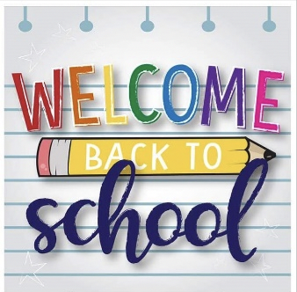

PreK Class Supplies
- Extra set of clothes
- 2 Extra masks
- Kleenex box
- Baby wipes
- Clorox Wipes
- Gallon Ziploc bags
- Hand sanitizer
- 1 Bottle of Hand Soap
- Water bottle
- Backpack

