Recommended Repair or Replacement Fees
If a student device has been defaced or damaged beyond the normal wear, families may be fined for repairs or replacements. Families may be charged for repairs and replacements if devices are damaged, lost, or stolen due to failure to secure the device. Damage may occur accidentally, and theft is possible, even under a watchful eye. Students should notify teachers or administration as soon as possible so an investigation may take place for negligence . Below are recommended repair costs for student devices. Learn more about lost and stolen device processing

Note: As an alternative to charging fees, schools can allow Parents to purchase cheaper aftermarket chargers that are 65w and made for USB-C ports on APS student Chromebooks.

Device | Item | Cost
ChromeBook
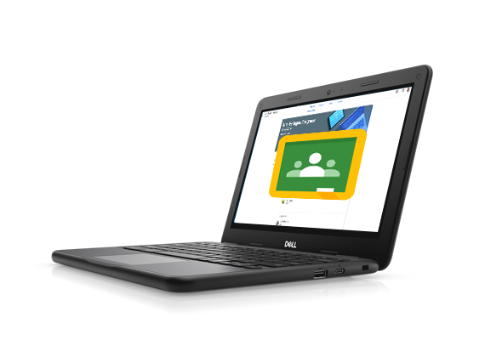 | Screen repair | $129.00
 | Charging port replacement | $99.00
 | Battery replacement | $99.00
 | Keyboard replacement | $99.00
 | Charger minimum 65w | $45.00
 | Complete Replacement  (depends on age of device) | 1 year old – $435.00  2 years old – $335.00  3 years old – $235.00  4 years old – $135.00
iPad
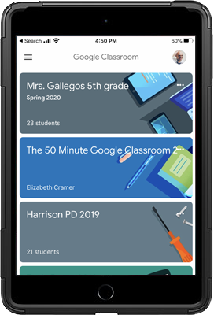 | Screen repair | $69.00
 | Charging Port replacement | $89.00
 | Power/Home button replacement | $89.00
 | Charger | $20.00
 | Complete Replacement  (depends on age of device) | 1 year old – $400.00  2 years old – $300.00  3 years old – $200.00  4 years old – $100.00

